Roll No: 160123733174 Exp. No: 08 Date:
EXPERIMENT-8
- Aim: To connect two PCs in different networks using routers and enable communication through static routing.
Description:
  - Two routers connect two different networks.
  - PC0: 192.168.1.2/24, GW: 192.168.1.1.
  - PC1: 192.168.2.1/24, GW: 192.168.2.1.

  - Routers are linked with an inter-network connection and configured with static routes for communication.
Diagram:
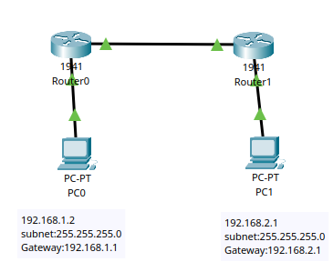
Table:
 | Device | IP address | Subnet | Gateway
 | PC0 | 192.168.1.2 | 255.255.255.0 | 192.168.1.1
 | PC1 | 192.168.2.2 | 255.255.255.0 | 192.168.2.1
Procedure:
- Connect two PCs to routers and link routers.
- Assign IPs:
  - Router0 LAN: 192.168.1.1/24
  - Router1 LAN: 192.168.2.1/24
  - Inter-router link: 10.0.0.1/30 & 10.0.0.2/30
- Enable interfaces (no shutdown).
- Configure static routes:
  - R0: ip route 192.168.2.0 255.255.255.0 10.0.0.2
  - R1: ip route 192.168.1.0 255.255.255.0 10.0.0.1
- Test with ping.
Result:
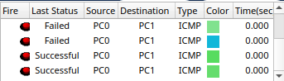
CLI console message:
Page No. 45 Signature of the Faculty………………………...

Roll No: 160123733174 Exp. No: 08 Date:
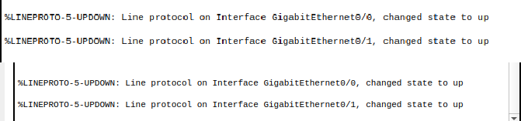
Conclusion: PCs in different networks can communicate via routers using proper IP configuration and static routing.

2)Aim: To design and configure a network of multiple PCs connected through hubs, switches, and routers, and enable communication between different networks using static routing.
Description:
- Two networks are connected via Router0 and Router1.
- Each router connects to a switch, and switches connect to hubs with multiple PCs.
- PCs in the left network: 192.168.1.x/24.
- PCs in the right network: 192.168.2.x/24.
- Routers use an interconnection link for communication and static routing is used to share routes.
Diagram:
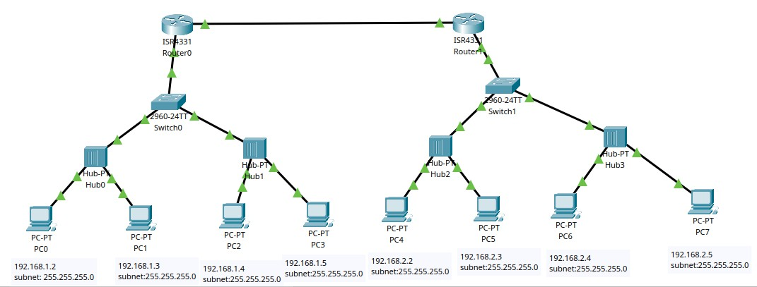
Table:
 | Device | IP address | Subnet | Gateway
 | PC0 | 192.168.1.2 | 255.255.255.0 | 192.168.1.1
 | PC1 | 192.168.1.3 | 255.255.255.0 | 192.168.1.1
 | PC2 | 192.168.1.4 | 255.255.255.0 | 192.168.1.1
 | PC3 | 192.168.1.5 | 255.255.255.0 | 192.168.1.1
 | PC4 | 192.168.2.2 | 255.255.255.0 | 192.168.2.1
 | PC5 | 192.168.2.3 | 255.255.255.0 | 192.168.2.1
 | PC6 | 192.168.2.4 | 255.255.255.0 | 192.168.2.1
 | PC7 | 192.168.2.5 | 255.255.255.0 | 192.168.2.1
Procedure:
- Topology Setup: Connect PCs → Hubs → Switches → Routers, and link both routers.
- Assign IPs:
  - Left PCs: 192.168.1.2 – 192.168.1.5, GW: 192.168.1.1.
  - Right PCs: 192.168.2.2 – 192.168.2.5, GW: 192.168.2.1.
Page No. 46 Signature of the Faculty………………………...

Roll No: 160123733174 Exp. No: 08 Date:
- Router-to-Router link: 10.0.0.1/30 & 10.0.0.2/30.
- Configure Routers: Assign IPs to all router interfaces, run no shutdown.
- Static Routes:
  - On Router0: ip route 192.168.2.0 255.255.255.0 10.0.0.2.
  - On Router1: ip route 192.168.1.0 255.255.255.0 10.0.0.1.
- Testing: Ping from any PC in 192.168.1.x to any PC in 192.168.2.x.
Result:
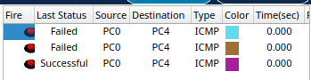

CLI console message:
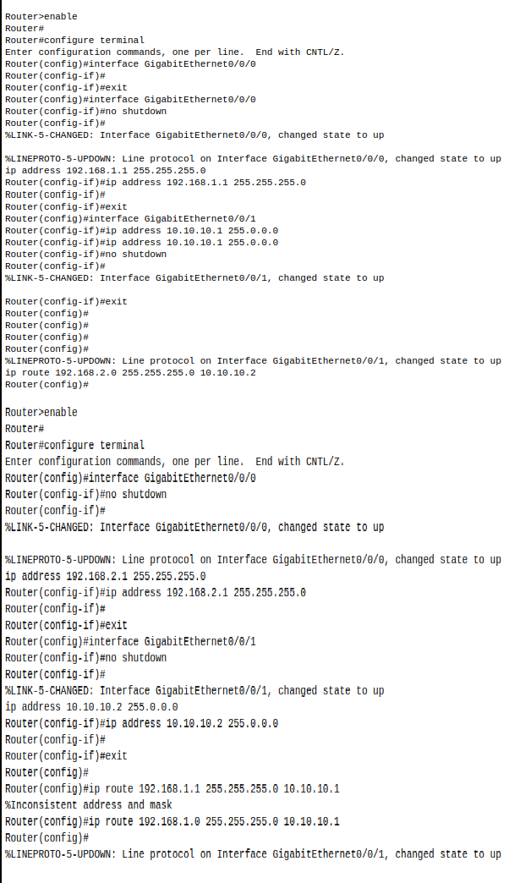
Conclusion:
The network allows multiple PCs from two different LANs to communicate via routers using switches, hubs, and static routing. Proper IP addressing and routing ensure successful inter-network communication.

Page No. 47 Signature of the Faculty………………………...

