Excel Portfolio Project

*Syed Haris Ahmed*

# **Data Source Description:**

The dataset used in this analysis is provided by atomcamp. Dataset contains school records across various in Punjab. It consists on critical information including but not limited to school names, enrollment, number of teaching and non-teaching staff, amenities. The dataset provides a comprehensive overview of the educational landscape across Punjab.

# **Cleaning And Data Manipulation**

The cells containing NULL was changed to blank for consistency of the data. Apart from that the dataset was used as is.

# **Analysis And Insights**

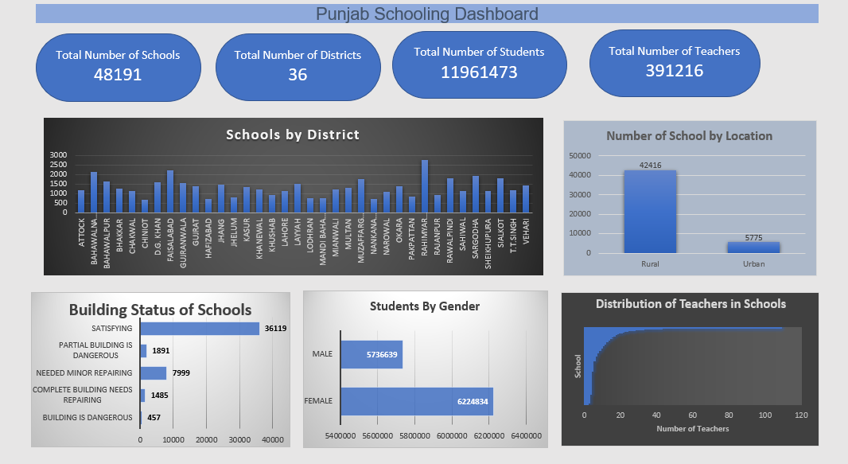

* The total number of schools in the dataset is 48191 across 36 districts.
* Total numbers of teachers are 391216 while students are 11961473 leading to a calculation of 1 teacher per 30 students.
* It is found that 42416 schools are in rural areas while only 5775 schools are in urban areas.
* There are 69% urdu medium schools and only 11% English medium schools while 19% of them have both the mediums to offer.
* 74.95% of school have a satisfactory building condition.
* 33871 out of 48191 schools had satisfactory security measures.
* The district of Attock have the highest enrollment in primary and secondary schools while Bahawalpur have highest enrollment in higher secondary schools since there establishment.
* Top 5 districts with the lowest availability of drinking water facilities in schools with respective percentages,

D.G. KHAN 5.4%

RAJANPUR 3.4%

RAWALPINDI 2.6%

MIANWALI 2.3%

BAHAWALNAGAR 1%

* Top 5 districts with the lowest availability of electricity in schools with respective percentages,

BAHAWALPUR 5.12%

RAHIMYAR KHAN 4.15%

RAJANPUR 3.89%

BAHAWALNAGAR 3.73%

MUZAFFARGARH 3.59%

* Top 5 districts with the lowest presence of boundary walls in schools with respective percentages,

RAWALPINDI 9.75%

BAHAWALNAGAR 8.59%

T.T.SINGH 8.38%

SAHIWAL 8.38%

JHANG 8.32%

* Top 5 districts with the lowest availability of toilets in schools with respective percentages,

BAHAWALNAGAR 2.05%

RAJANPUR 1.68%

D.G. KHAN 1.06%

RAHIMYAR KHAN 0.61%

MUZAFFARGARH 0.46%

# **Allocation of funds**

1. **School Level Upgradation (10 Million Rs)**

As per the dataset only 1.56% of schools are Higher secondary while 66.5% are primary.

Rs 7 Million should be allocated to upgrade school from primary to higher secondary.

While Rs 3 Million should be allocated to upgrade primary to middle level.

Because of very lower numbers of Higher Secondary school most of the budget should be allocated to upgrade schools to Higher Secondary level.

1. **Infrastructure (Rs 5 Million)**

According to the dataset 90% of schools have less than 12 functional classrooms. 0.32% schools do not have toilets. 24.5% schools do not have satisfying building conditions. While 2.68% of schools do not have completed school boundary walls and 13.3% of school boundary wall are either incomplete or need repairing. Rs 2.0 Million should be allotted to increase functional classrooms to an average of 16 classrooms. 0.5 Million should be allotted to build toilets in schools which do not have any toilets. While another 0.5 should be allocated to increase and repair toilets for the schools that already have toilets. The remaining 2.0 Million should be allocated for repairs of buildings and boundary walls to satisfying conditions.

1. **Facilities (Rs 2 Million)**

It is found that 86% of schools do not have any care giver appointed. While there are a low number of schools having water and electric issues. 30% of the budget should be allocated to appoint care givers for every school. Moreover 20% should be allocated to basic necessities like water and electric to every school. While remaining 50% of the budget should be allocated to create new playgrounds and labs to improve the quality and experience of education.

1. **More Middle & High Schools in Rural Areas, Separate Schools for genders (Rs 20 Million)**

63.48% of the schools in rural areas have both of the gender studying in them. While 47% of total students in rural areas are enrolled in a co education system. But as per the culture of Pakistan, co-education system is not considered the best and people in rural areas do not like to have their children in co-education schools especially in middle and High Schools. 80.62% of the schools in rural area are of level primary and secondary. While 17% are middle and only 1.25% High Schools. 60% of the budget should be allocated to development of High Schools as there is very low number of Higher Secondary Schools. While 40% of the budget should be kept for development of more middle schools.

1. **New Primary Level School (Rs 10 Million)**

This budget should not only go in creating new primary schools as 66.5% of the schools already there are of primary level. While there only 13% secondary schools. Budget of Middle and high School levels new development is already allocated. While there is no budget for secondary schools. It is suggested that 70% of this budget should be allocated to develop more secondary school and 30% of this budget should be kept for developing new primary schools specifically in the district which have a low number of these schools.

# **Data-Driven Marketing Strategies**

* Launch campaigns to highlight the infrastructure improvement especially in the districts having low number of enrollments like HAFIZABAD, KHUSHAB, LODHRAN etc.
* Launch campaigns to highlight the development of school for separate genders especially in rural areas for a female friendly environment.
* Highlight the facilities that are being added to the schools like safe drinking water, toilets and playground. Community leaders should be involved in these activities in Rural area for a better result and impact on education.
* Awareness campaign should to launched for bilingual education. Highlighting the importance of education in different languages.
* A digital campaign should also be launched to promote the use of tech in education. This campaign should outline the use of tech in making education easier and more affordable.

# **Budget Plan**

|  |  |  |
| --- | --- | --- |
| Initiative | Fund Allocated Rupee (Million) | Justification |
| School Level Upgradation | 10 | Developing new infrastructure and hiring Staff for new levels |
| Infrastructure | 5 | Repair and maintenance of infrastructure |
| Facilities | 2 | Facilities like water, electricity |
| More Middle & High Schools in Rural Areas (Separate Gender) | 20 | Developing separate schools for males and females |
| New Primary Level School | 10 | New school across all districts |

# **Summary**

The posture of education system of Punjab requires monitoring and maintenance. The budget allocated for schools will play a crucial role for the future on educational system in Punjab. The development of new infrastructure and initiatives for maintenance of the schools along with marketing campaigns will an effective way to increase enrollment resulting in increasing literacy rates in the Province of Punjab.