[CS252]-Algorithms II Spring 2021-22

[CS250]-Operating System Spring 2021-22

**Assignment : 02**

Name: Sharishth Singh Roll No: 12041370 email:sharishthsingh@iitbhilai.ac.in

**Homework: 02**

**Solution of Part A:**

*ls*

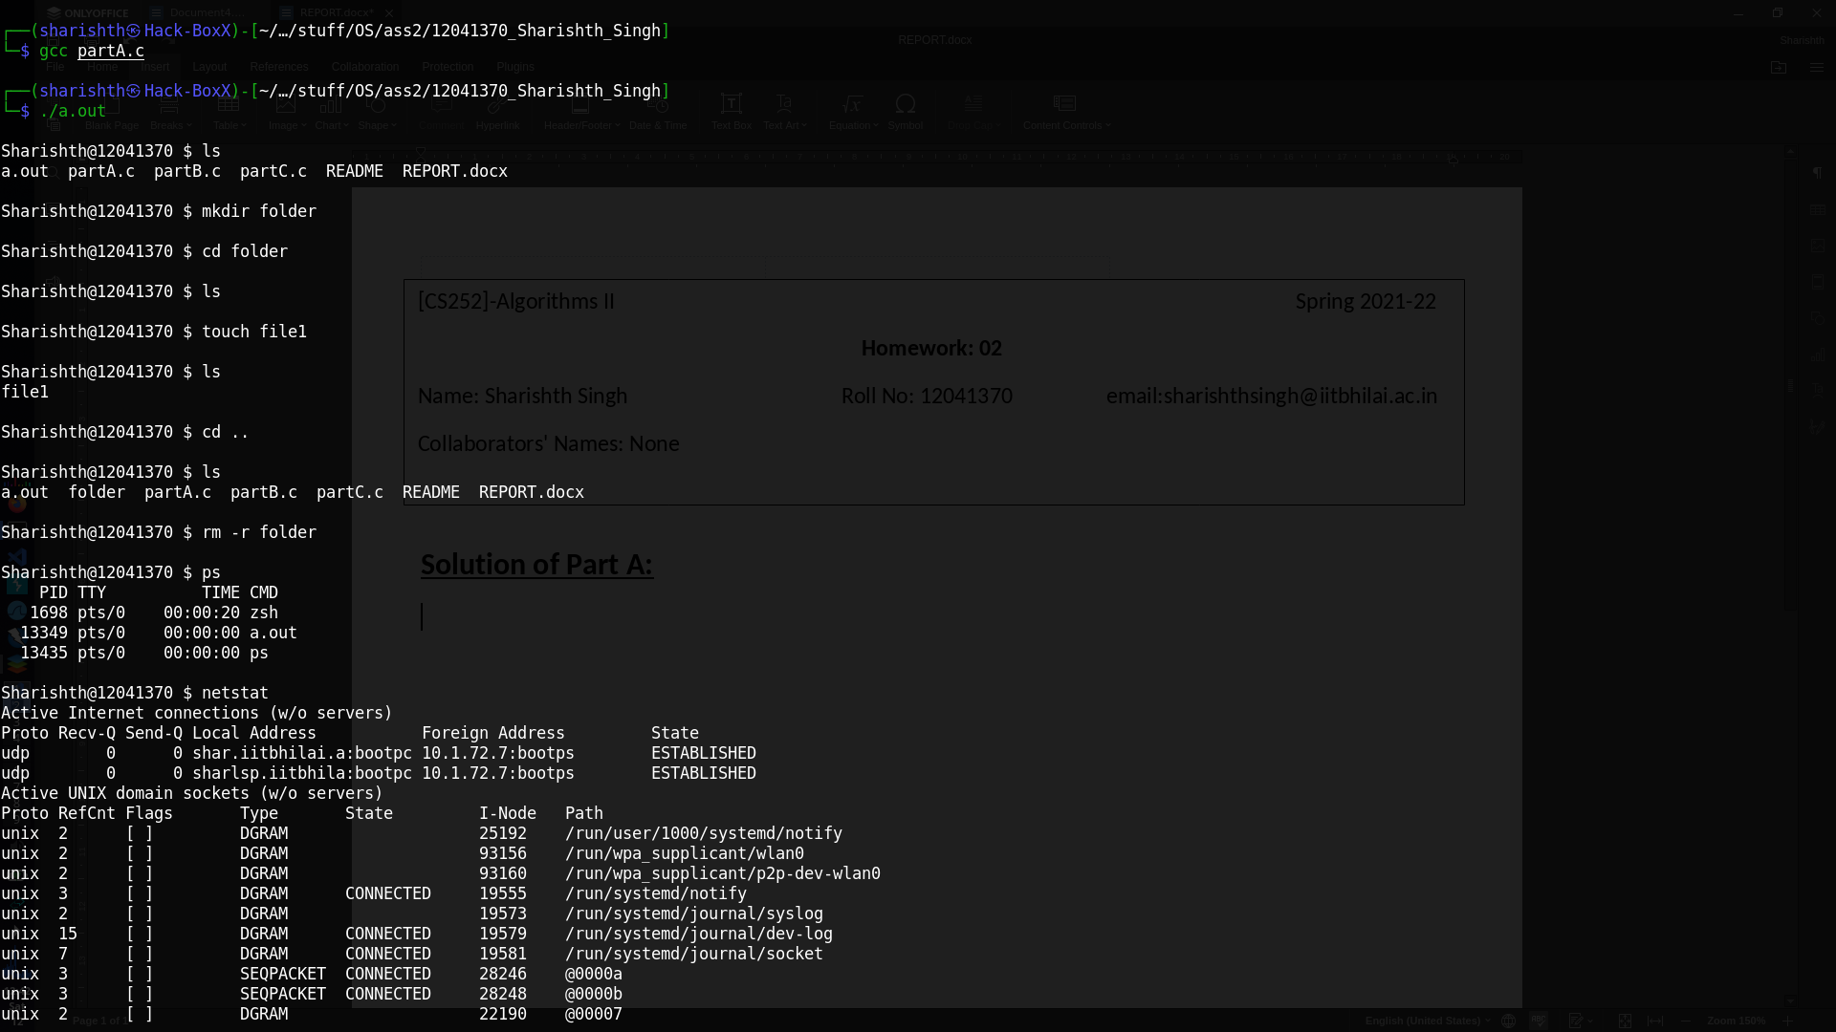

*mkdir*



*cd*



*touch and rm*



*ps*



*netstat*



**Solution of Part B:**

Extended the code to run *ls && ls*

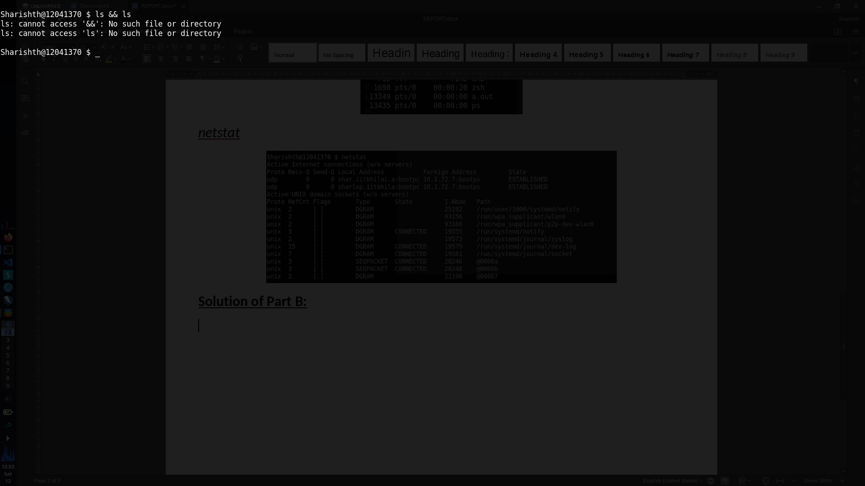

Screen shot before extending the code

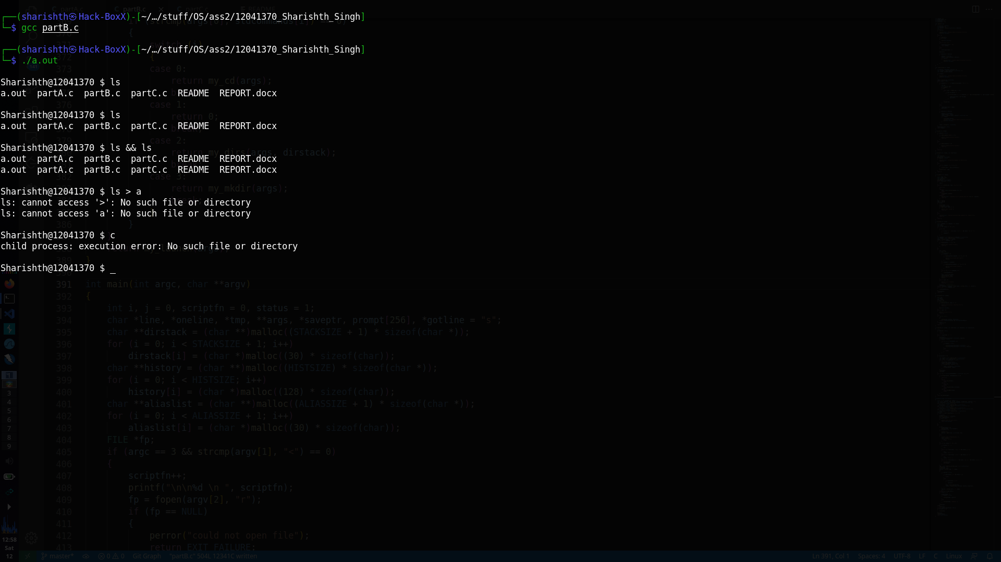

Screen shot after extending the code

*ps –aux | grep “bash”*

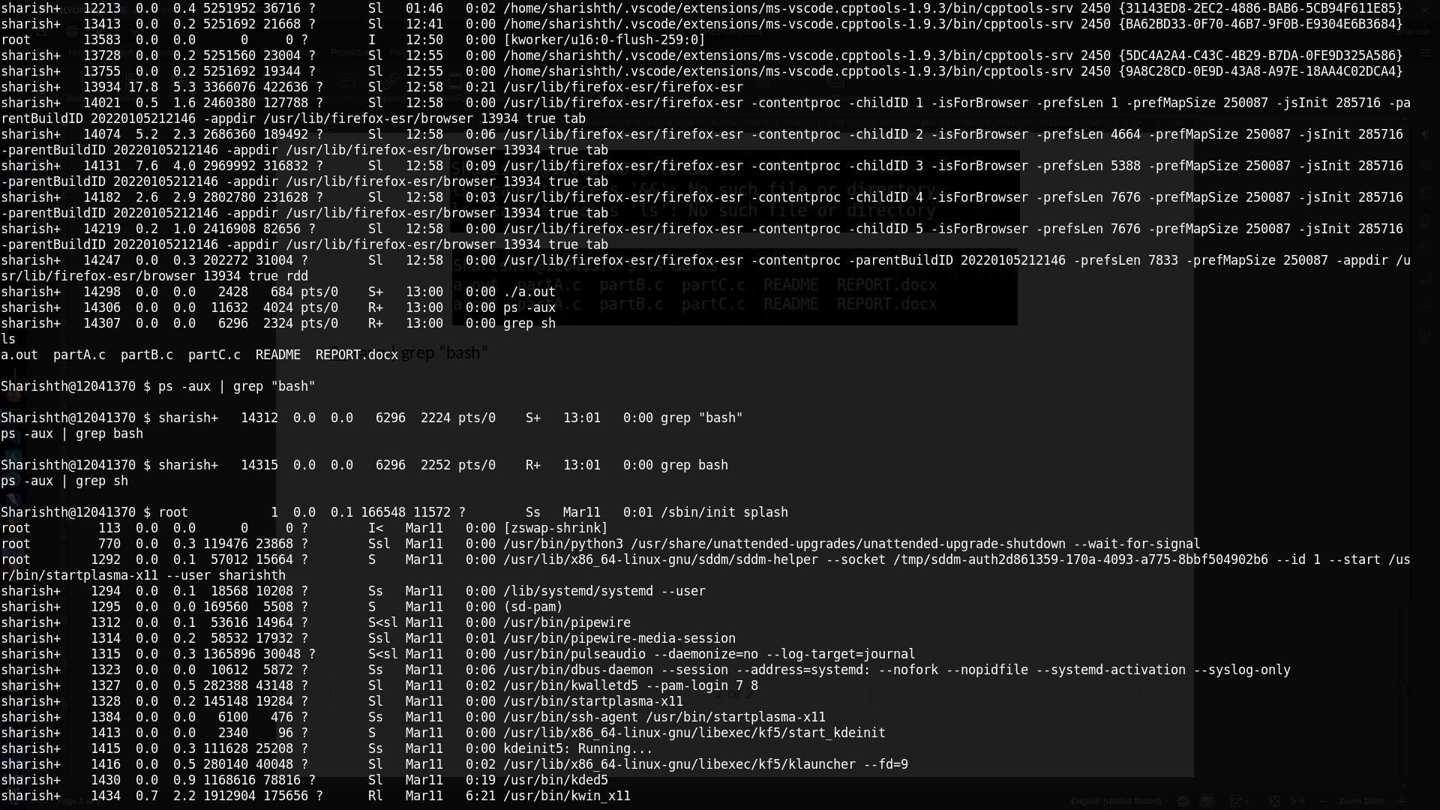

*ps –aux | grep sh | grep bash*

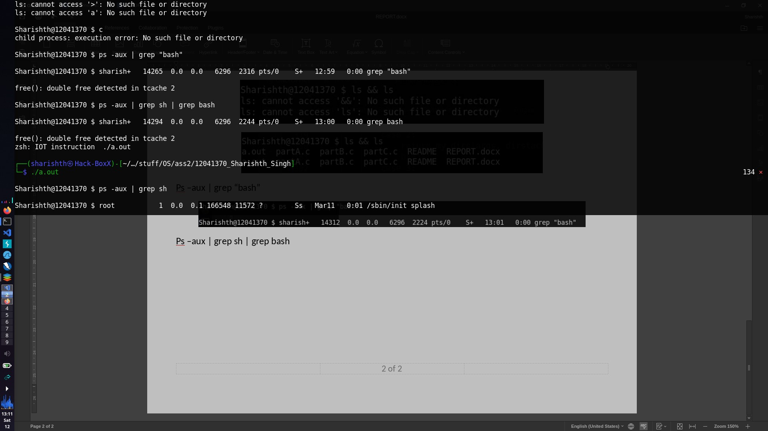

*ls | wc –l*

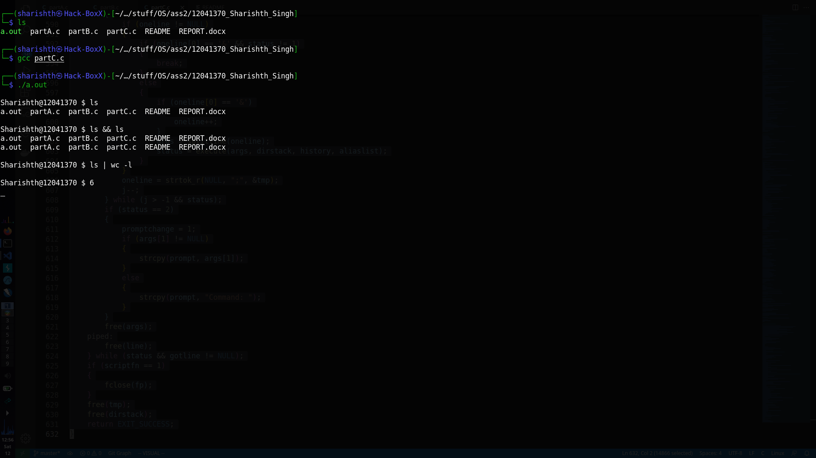

*sudo apt update && sudo apt upgrade*

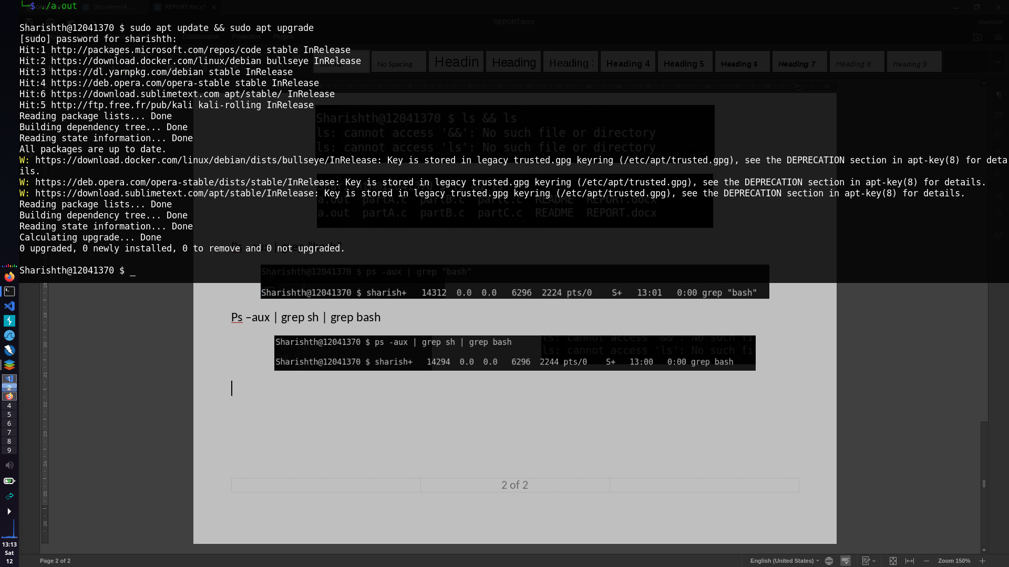

**Solution of Part C:**

Extended the code to support file redirection

*ls > a*



Before

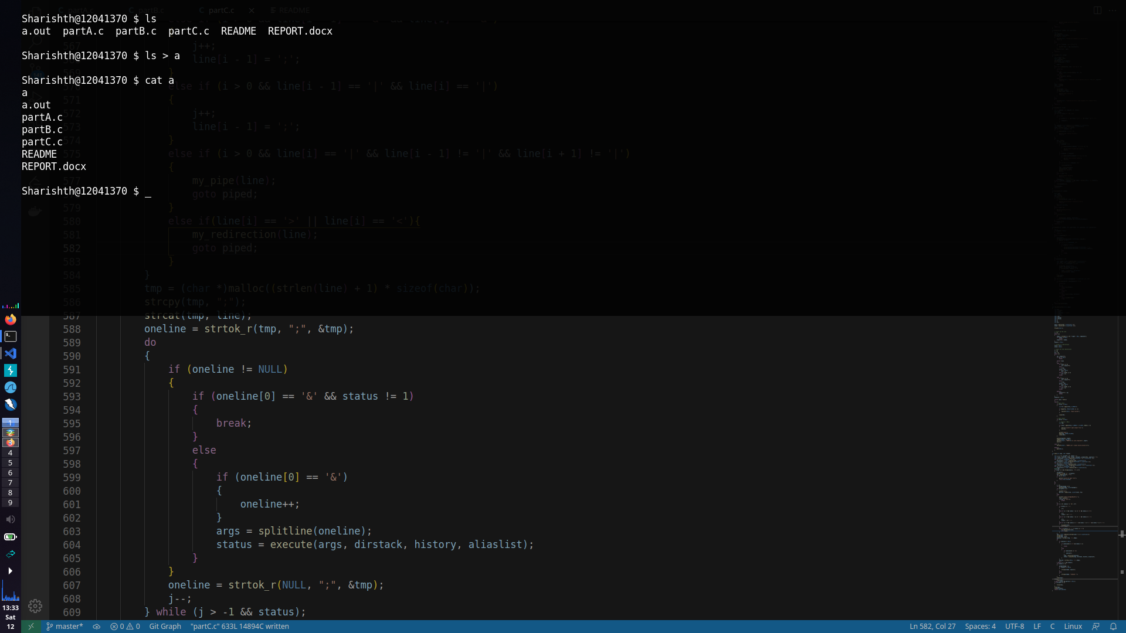

After

*ls –al > list.txt*

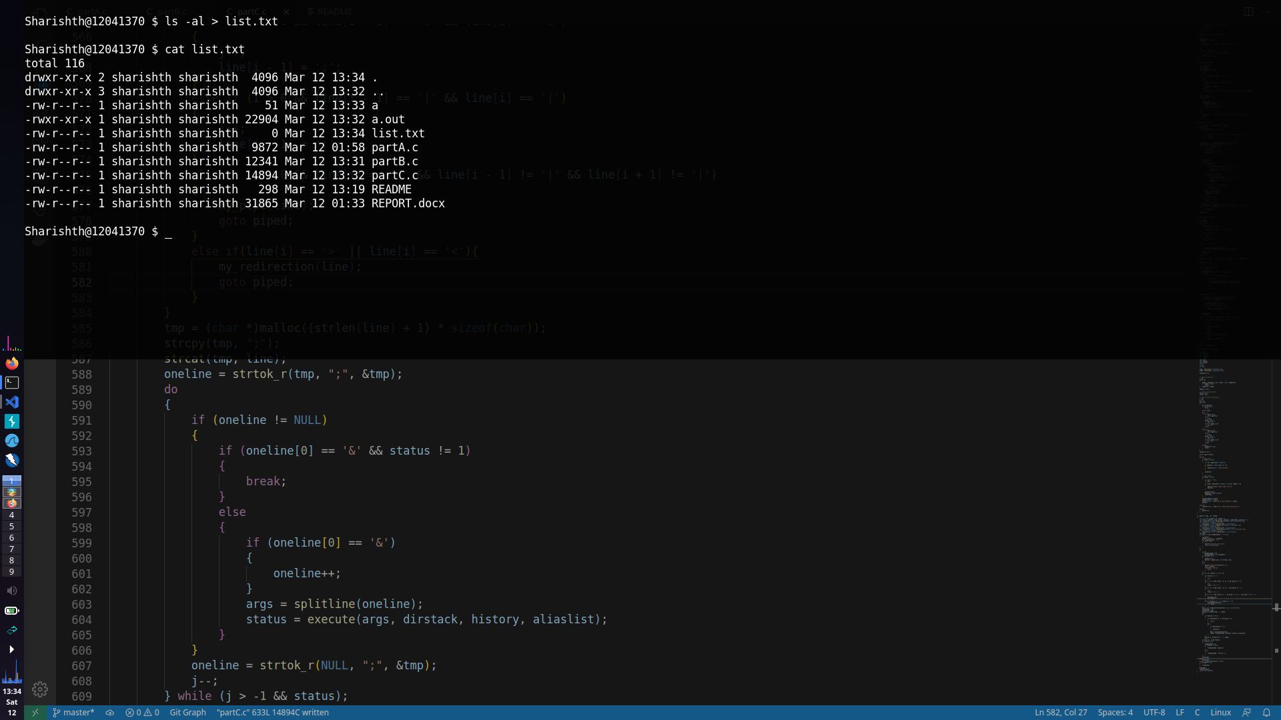

*cat < list.txt*

