

**GROUP MEMBERS:**

* **SH M SHARJEEL – BSE173090**
* **USMAN MAZHAR – BSE173095**
* **ASIM FAROOQ – BSE173074**
* **HAMZA AFZAAL – BSE173131**

**SECTION: S2**

**ASSIGNMENT # 3**

**SUBMITTED TO: SIR SAMIR OBAID**

Table of Contents

**ATM (AUTOMATIC TELLER MACHINE)** 3

**BRIEF DESCRIPTION** 3

**CAUSE EFFECT GRAPHING** 4

**FUNCTION 1:** 4

**CAUSE EFFECT GRAPH:** 4

**DECISION TABLE:** 4

**Test Cases 1** 5

**FUNCTION 2:** 5

**CAUSE EFFECT GRAPH:** 5

**DECISION TABLE:** 6

**Test Cases 2:** 6

**FUNCTION 3:** 6

**CAUSE EFFECT GRAPH:** 7

**DECISION TABLE:** 7

**Test Cases 3:** 7

# **ATM (AUTOMATIC TELLER MACHINE)**

## **BRIEF DESCRIPTION**

Basically, it is an electronic device that is used by the Bank for transection purpose. The user insert there plastic card which is encoded with the user information on a magnatic strip. The strip contains an identification code that is transmitted to the bank’s central computer by modem. The user insert the plastic card to access the account to access the services provided by the Bank.

There were problems like when the banks were closed at night or you have to write a check before you withdraw your money. Suppose you are facing some problem and you need money urgent and the banks are closed what to do know. To overcome this situation ATM were introduced, they were invented by the Shepherd-Barron in 1960. Now even if banks are closed or its late night everyone can access their money.

The ATM basically, provides many services to the user.

Following are some listed below:

1. Transection of money any time you want.

2. Transfer of money from your account to another.

For the transection of money one only need to insert card enter pin and then enter the amount he wants. It should be noted that there is a limit of how much money one can withdraw from the account. Because ATM is not for the transection of heavy money but for simple scenarios, and also there must be at least Rs.500 present in the account. If someone thinks that he can withdraw all the money or the amount that is not sufficient in the account he cannot.

Transfer money is another service that ATM provides like you want to send someone money very urgently ATM can help you, no need to worry. To transfer money first you will enter the account number where you want to send money to, the system will verify the account number that weather it exists or not, you will also enter the amount it will also check that weather the entered amount is not less than the current balance and also there must always be Rs.500 present in the account. Then in the last you also have to provide your PIN for verification or say security purpose.

## **CAUSE EFFECT GRAPHING**

### **FUNCTION 1:**

|  |  |
| --- | --- |
| **CAUSE** | **EFFECT** |
| C1: Card Insertion | E1: Login successful |
| C2: Enter PIN | E2: Login not successful |

### **CAUSE EFFECT GRAPH:**

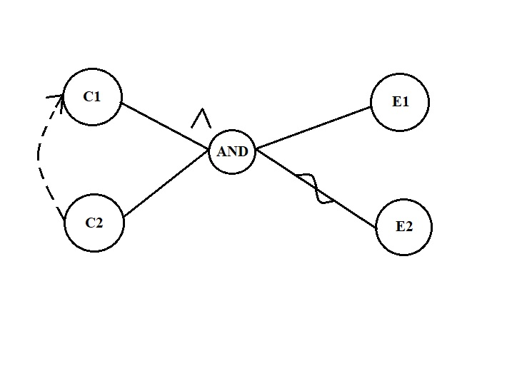

### **DECISION TABLE:**

|  |  |  |  |  |
| --- | --- | --- | --- | --- |
| **ACTION** | **T1** | **T2** | **T3** | **T4** |
| C1 | 0 | 1 | 0 | 1 |
| C2 | 0 | 0 | 1 | 1 |
| E1 | 0 | 0 | 0 | 1 |
| E2 | 1 | 1 | 1 | 0 |

### **Test Cases 1**

|  |  |  |  |  |
| --- | --- | --- | --- | --- |
| **Test case** # |  | | **Expected Output (Effects)** | |
| **Pin** |  | |
| **T1** | 1111 | Invalid Range | |
| **T2** | 2222 | Invalid Range | |
| **T3** | 3333 | Invalid Range | |
| **T4** | 4444 | Valid | |

### **FUNCTION 2:**

|  |  |
| --- | --- |
| **CAUSE** | **EFFECT** |
| C3: Enter amount < Current balance | E3: Transection successful |
| C4: Current balance > 500 | E4: Transection not successful |

### **CAUSE EFFECT GRAPH:**

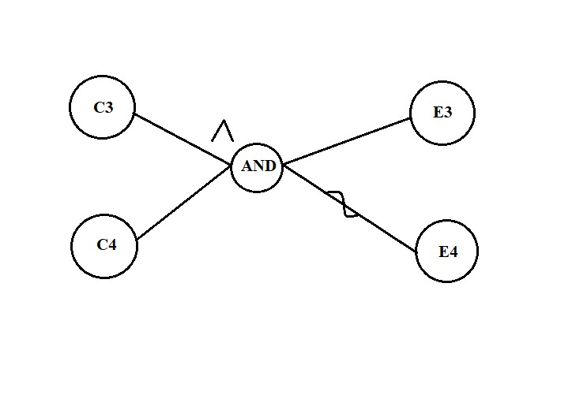

### **DECISION TABLE:**

|  |  |  |  |  |
| --- | --- | --- | --- | --- |
| **ACTION** | **T1** | **T2** | **T3** | **T4** |
| C1 | 0 | 1 | 0 | 1 |
| C2 | 0 | 0 | 1 | 1 |
| E1 | 0 | 0 | 0 | 1 |
| E2 | 1 | 1 | 1 | 0 |

### **Test Cases 2:**

|  |  |  |  |  |  |
| --- | --- | --- | --- | --- | --- |
| **Test case** # |  | |  | **Expected Output (Effects)** | |
| **Amount** | **Tempbal** | | |  | |
| **T1** | 16000 | 400 | | | Invalid Range | |
| **T2** | 10000 | 400 | | | Invalid Range | |
| **T3** | 16000 | 15000 | | | Invalid Range | |
| **T4** | 10000 | 15000 | | | Valid | |

### **FUNCTION 3:**

|  |  |
| --- | --- |
| **CAUSE** | **EFFECT** |
| C3: Enter amount < Current balance | E5: Money transfer successful |
| C4: Current balance > 500 | E6: Money transfer not successful |
| C5: Account number valid (where you will transfer money) |  |

### **CAUSE EFFECT GRAPH:**

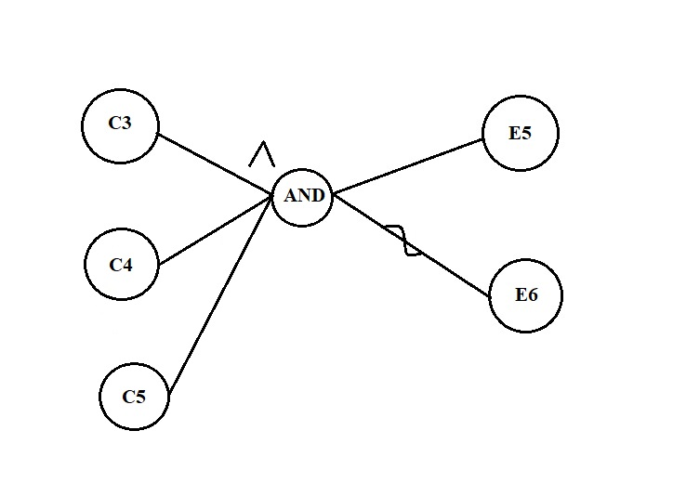

### **DECISION TABLE:**

|  |  |  |  |  |  |  |  |  |
| --- | --- | --- | --- | --- | --- | --- | --- | --- |
| **ACTION** | **T1** | **T2** | **T3** | **T4** | **T5** | **T6** | **T7** | **T8** |
| C3 | 0 | 1 | 0 | 0 | 1 | 0 | 1 | 1 |
| C4 | 0 | 0 | 1 | 0 | 1 | 1 | 0 | 1 |
| C5 | 0 | 0 | 0 | 1 | 0 | 1 | 1 | 1 |
| E5 | 0 | 0 | 0 | 0 | 0 | 0 | 0 | 1 |
| E6 | 1 | 1 | 1 | 1 | 1 | 1 | 1 | 0 |

### **Test Cases 3:**

|  |  |  |  |  |
| --- | --- | --- | --- | --- |
| **Test case** # | **Input (Causes)** | | | **Expected Output (Effects)** |
| **Amount** | **Tempbal** | **Acccountnum** |
| **T1** | 16000 | 400 | 1000 | Invalid Range |
| **T2** | 1000 | 3000 | 1000 | Invalid Range |
| **T3** | 20000 | 15000 | 1000 | Invalid Range |
| **T4** | 18000 | 200 | 1234 | Invalid Range |
| **T5** | 5000 | 15000 | 2000 | Invalid Range |
| **T6** | 30000 | 15000 | 1234 | Invalid Range |
| **T7** | 10000 | 400 | 1234 | Invalid Range |
| **T8** | 10000 | 15000 | 1234 | Valid Range |