NATIONAL UNIVERSITY OF COMPUTER AND EMERGING SCIENCES
[KARACHI CAMPUS]
FAST School of Computing - Spring 2026
ARTIFICIAL INTELLIGENCE

Assignment 3: Machine Learning
Kaggle Competition Report
Playground Series - Season 6 Episode 4
Predicting Irrigation Need

Student Information
Name: | Sharjeel Memon
Roll No: | 24K-0555
Section: | BCS-4E
Submission Date: | 26 April ,2026

Submitted To
Miss Anaum Hamid

Executive Summary
This report presents the complete workflow for Assignment 3, a Kaggle multiclass classification task for predicting irrigation need as Low, Medium, or High. The work began with baseline models such as Decision Tree, Naive Bayes, K-Means as classifier, and Logistic Regression, then improved through HistGradientBoosting, feature engineering, ensemble learning, and class probability adjustment. The final selected submission was submission_iter4_high_plus_12.csv with a Kaggle public score of 0.96933.
The report is organized around the required assignment template and includes a separate section for each practical iteration so that progress from the first baseline submission to the final tuned ensemble can be clearly seen.

Table of Contents
1. Competition Overview
2. Data Preprocessing
3. Models Attempted
4. Cross Validation Strategy
5. Iteration Results and Improvements
6. Failed Attempts and Insights
7. Final Model Selection
8. Leaderboard Performance
9. Conclusion and Learnings
Appendix A: Submission Files and Outputs

1. Competition Overview
Item | Description
Competition Name | Playground Series - Season 6 Episode 4: Predicting Irrigation Need
Problem Type | Multiclass classification
Target Variable | Irrigation_Need
Class Labels | Low, Medium, High
Evaluation Metric | Balanced accuracy
Submission Format | CSV file with columns: id, Irrigation_Need

Brief understanding of the dataset: The dataset contains agricultural, soil, crop, weather, and irrigation-related features. The goal is to learn patterns from train.csv and generate predictions for test.csv. The class distribution was imbalanced, with Low and Medium appearing much more frequently than High, so balanced accuracy was the correct metric to optimize.

2. Data Preprocessing
Requirement | Work Done
Missing values handling | The dataset was checked for missing values. No missing values were found in the original train.csv columns. Imputation steps were still kept in the pipeline as a safety measure.
Encoding techniques | Categorical variables such as Soil_Type, Crop_Type, Season, Region, Water_Source, and Mulching_Used were encoded so that models could process them. Later iterations also used combined categorical features.
Feature scaling | StandardScaler was used for models that need scaling, such as Logistic Regression and K-Means. Tree-based models did not require scaling.
Train-validation split | An 80-20 stratified split was used so that Low, Medium, and High classes remained represented in both training and validation sets.
Feature engineering | Additional features were created: dryness-related indicators, water availability features, crop/season combinations, and probability-adjustment logic for the minority High class.

3. Models Attempted
Model | Purpose / Reason for Trying
Decision Tree | Used as a simple supervised tree model and a strong baseline.
Naive Bayes | Used as a fast probabilistic classifier to compare against tree methods.
K-Means as Classifier | Used because the assignment required trying K-Means, although it is naturally unsupervised.
Logistic Regression | Used as a linear supervised classification model.
HistGradientBoosting | Used as the main advanced model because boosted trees handle nonlinear patterns well.
HistGradientBoosting Ensemble | Used in Iteration 4 by combining multiple tuned models and adjusting probabilities for the High class.

4. Cross Validation Strategy
The main validation method was an 80-20 stratified train-validation split. Balanced accuracy was used because it matches the Kaggle evaluation metric and handles class imbalance better than normal accuracy.
A 5-Fold cross-validation test was also performed during Iteration 1 on the best baseline model. The folds were run on a sample of 150,000 rows to keep the process practical on a local machine.
Fold | Balanced Accuracy
1 | 0.95741
2 | 0.95650
3 | 0.96063
4 | 0.96382
5 | 0.96134
Mean | 0.95994
Std | 0.00267

LOOCV observations: Leave-One-Out Cross Validation was not used on the full dataset because the training set has 630,000 rows, making LOOCV computationally impractical. K-Fold validation was more suitable for this dataset size.

5. Iteration Results and Improvements
This section records the practical improvement process. Instead of using many screenshots, the main results are summarized in tables and only the final confusion matrix and leaderboard screenshot are included.

5.1 Iteration 1 - Baseline Models
The first iteration trained multiple required models and selected the best local validation model. This iteration also generated confusion matrices for the required models.
Model | Validation Balanced Accuracy | Normal Accuracy | Main Insight
Decision Tree | 0.96456 | 0.97643 | Best baseline model, but may overfit because it is a single tree.
HistGradientBoosting Advanced | 0.96394 | 0.98463 | Very strong advanced model with better generalization potential.
Logistic Regression | 0.81166 | 0.81360 | Could not capture nonlinear feature interactions well.
Naive Bayes | 0.69106 | 0.82752 | Feature independence assumption was too simple for this dataset.
K-Means as Classifier | 0.40413 | 0.61726 | Weak because it does not directly learn class labels.

Kaggle Output | Value
Submission file | outputs_iter1/submission.csv
Public score | 0.96160
Observation | Good first valid submission, but room for improvement.

5.2 Iteration 2 - Tuned HistGradientBoosting
The second iteration moved from a single Decision Tree to a tuned HistGradientBoosting classifier. This improved local validation balanced accuracy and the Kaggle score.
Model | Validation Balanced Accuracy | Normal Accuracy
HistGradientBoosting Tuned V2 | 0.97017 | 0.98294
Decision Tree | 0.96456 | 0.97643
HistGradientBoosting Advanced | 0.96394 | 0.98463

Kaggle Output | Value
Submission file | outputs_iter2_safe/submission.csv
Public score | 0.96622
Improvement over Iteration 1 | +0.00462

5.3 Iteration 3 - Feature Engineering and Probability Adjustment
The third iteration added more engineered features and class-probability multipliers. Since the High class was underrepresented, probability adjustment was tested to improve balanced accuracy.
Model | Normal Balanced Accuracy | Tuned Balanced Accuracy | Best Multipliers
HistGradientBoosting V3 Balanced | 0.96906 | 0.97147 | Low=1.0, Medium=0.8, High=2.2
HistGradientBoosting V3 Smooth | 0.97040 | 0.97106 | Low=1.0, Medium=0.925, High=1.65

Kaggle Output File | Public Score
submission.csv | 0.96793
submission_less_high.csv | 0.96811
submission_more_high.csv | 0.96823

Insight: The best Iteration 3 Kaggle score came from submission_more_high.csv. This suggested that increasing sensitivity toward the High class improved the public leaderboard score.

5.4 Iteration 4 - Ensemble Tuned Model
The fourth iteration combined several HistGradientBoosting models into an ensemble and tuned the class probability multipliers again. This became the final selected approach.
Single Model | Validation Balanced Accuracy | Normal Accuracy
hgb_balanced_smooth | 0.97046 | 0.98335
hgb_balanced_main | 0.96998 | 0.98302
hgb_less_weighted | 0.96977 | 0.98333
hgb_high_sensitive | 0.96949 | 0.98310

Iteration 4 Submission File | Kaggle Public Score
submission_iter4_ensemble.csv | 0.96834
submission_iter4_high_plus_02.csv | 0.96834
submission_iter4_medium_plus_high_plus.csv | 0.96836
submission_iter4_high_plus_08.csv | 0.96888
submission_iter4_high_plus_12.csv | 0.96933

Final Iteration 4 validation balanced accuracy from threshold tuning was approximately 0.97143. The best Kaggle public score was 0.96933 from submission_iter4_high_plus_12.csv.

Figure 1: Final Iteration 4 Ensemble Tuned Confusion Matrix
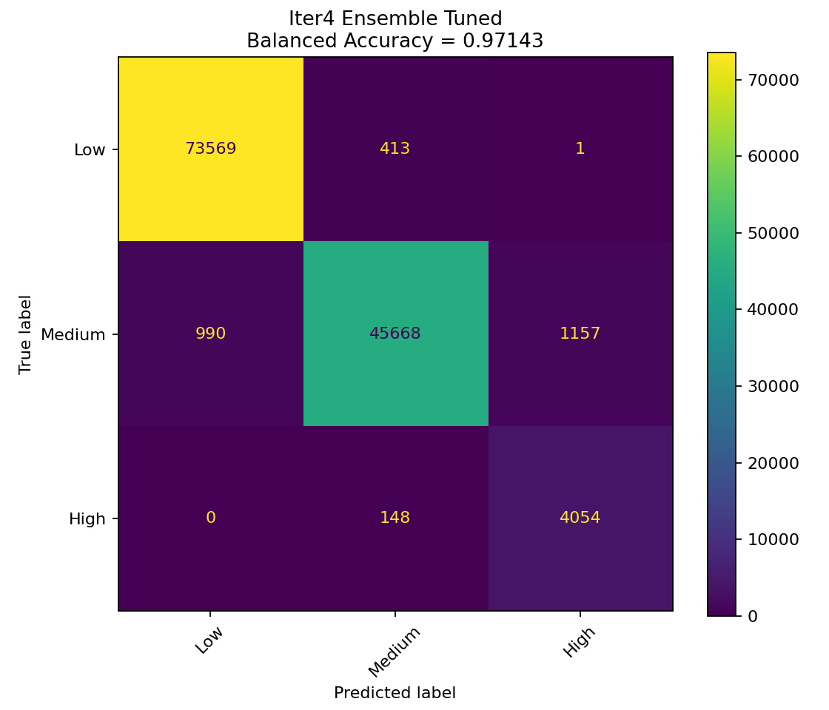
The final confusion matrix shows strong classification across all three classes. Most errors occurred between Medium and Low or between Medium and High. The High class had the fewest samples, but the final model still achieved strong recall because probability adjustment increased attention toward the minority class.

6. Failed Attempts and Insights
The following table summarizes the failed or weaker attempts. Instead of inserting many separate screenshots, the report uses the validation scores and discusses what went wrong. The generated confusion matrix files are available inside the output folders.
Model Used | Accuracy Obtained | What Went Wrong? | What Was Improved?
K-Means as Classifier | Balanced accuracy: 0.40413 | K-Means is unsupervised and did not learn the Low/Medium/High target labels directly. It struggled especially with the High class. | Supervised models were used afterward because they directly learn from labels.
Naive Bayes | Balanced accuracy: 0.69106 | The independence assumption was too simple for agricultural data where features like rainfall, moisture, and temperature interact. | Tree-based models were used to capture nonlinear relationships.
Logistic Regression | Balanced accuracy: 0.81166 | The model was too linear for the feature interactions in the dataset. | Boosted trees were used to model nonlinear boundaries.
Decision Tree | Balanced accuracy: 0.96456 | Strong validation result, but a single tree can overfit and may not generalize as well as ensembles. | HistGradientBoosting and ensemble tuning improved Kaggle performance.

Confusion matrix screenshot note: The final model confusion matrix is included in Section 5.4. Additional confusion matrices generated for failed attempts are stored in outputs_iter1 and outputs_iter2_safe, but were not inserted here to keep the report concise and readable.

7. Final Model Selection
Requirement | Final Answer
Best model | Iteration 4 HistGradientBoosting Ensemble Tuned
Final submission file | submission_iter4_high_plus_12.csv
Validation balanced accuracy | Approximately 0.97143
Kaggle public score | 0.96933
Why selected? | It achieved the highest Kaggle public score among all submitted iterations and improved over all previous attempts.

Hyperparameters / model idea: The final version used multiple HistGradientBoosting classifiers with different balancing settings. Their probability outputs were combined as an ensemble. Additional probability adjustment was applied to improve balanced accuracy, especially for the minority High class.

8. Leaderboard Performance
Item | Value
Best Kaggle score | 0.96933
Best submission | submission_iter4_high_plus_12.csv
Rank | Approximately around 962 out of 3141 participants during testing
Screenshot attached | see Figure 2 below.

Figure 2: Kaggle submission outputs and public scores
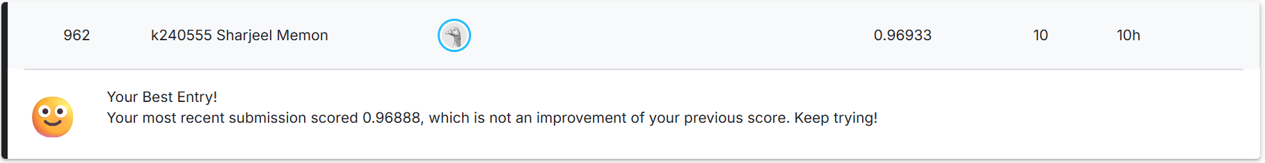

9. Conclusion and Learnings
Point | Explanation
Key insights | Balanced accuracy was more useful than normal accuracy because the High class was much smaller than Low and Medium. Boosted tree models performed better than linear and probabilistic baselines.
Challenges faced | Setting up the Python environment, handling class imbalance, improving minority-class prediction, and comparing several Kaggle submissions.
Future improvements | Future work could include more careful hyperparameter search, stronger feature selection, LightGBM/XGBoost experiments, and more robust cross-validation.

Overall, the project successfully followed the complete machine learning workflow: data loading, preprocessing, baseline modeling, validation, failed-attempt analysis, model improvement, final training, Kaggle submission, and result reporting.

Appendix A: Submission Files and Outputs
Iteration | Folder / File | Purpose
Iteration 1 | outputs_iter1/submission.csv | First baseline Kaggle submission.
Iteration 2 | outputs_iter2_safe/submission.csv | Tuned HistGradientBoosting submission.
Iteration 3 | outputs_iter3_boosted/submission_more_high.csv | Feature engineered submission with High-class probability adjustment.
Iteration 4 | outputs_iter4_ensemble/submission_iter4_high_plus_12.csv | Final best submission selected for assignment.
Final confusion matrix | outputs_iter4_ensemble/confusion_matrix_Iter4_Ensemble_Tuned.png | Final model validation confusion matrix.
Final code | ass3_solution_iter4.py / ass3_solution_iter4_ensemble_safe.py | Python training and prediction code.

Final files submitted: Python source code, final CSV submission_iter4_high_plus_12.csv, Kaggle leaderboard screenshot, and this report.

