NATIONAL UNIVERSITY OF COMPUTER AND EMERGING SCIENCES
[KARACHI CAMPUS]
FAST School of Computing - Spring 2026
ARTIFICIAL INTELLIGENCE
Final Project Report
11 x 11 HEX BOARD GAME
WITH INTELLIGENT AI AGENT

Team Members
Name | Student ID
Sharjeel Memon | 24K-0555
Muhammad Haneef | 24K-1018
Umer Hassan | 24K-0539
Submitted To
Miss Ramsha Jat
Submission Date: 25 April 2026

Executive Summary
This final report presents the design, implementation, and evaluation of an AI-powered 11 x 11 Hex board game. The project transforms Hex into a state-space search problem and implements a competitive computer opponent using Minimax, Alpha-Beta pruning, iterative deepening, transposition-table caching, killer-move ordering, and domain-specific heuristic evaluation. The completed application includes a polished Tkinter-based graphical user interface, Human vs Human and Human vs AI modes, Easy/Medium/Hard difficulty selection, smooth optional sound effects, undo/restart/menu controls, live game-status feedback, and visual winning-path highlighting.
The AI agent evaluates positions using connectivity-focused heuristics, especially Two-Distance for strategic path potential and Charge-based move ordering for contested-board influence. The final system is responsive because the AI search runs in a background thread and never blocks the graphical interface. The result is a complete, playable, and demonstrable AI project that connects theoretical search algorithms with a practical interactive game environment.

Table of Contents
- 1. Project Overview
- 2. Problem Background and Motivation
- 3. Objectives and Scope
- 4. System Description
- 5. AI Approach and Methodology
- 6. System Rules and Mechanics
- 7. Software Architecture and Module Design
- 8. User Interface Design
- 9. Implementation Details
- 10. Testing and Evaluation
- 11. Results and Discussion
- 12. Challenges and Solutions
- 13. Limitations and Future Improvements
- 14. Conclusion
- 15. References
- Appendix A: Key Algorithms and Pseudocode

1. Project Overview

1.1 Project Topic
The project is an AI-powered implementation of Hex, a two-player connection board game played on an 11 x 11 hexagonal grid. The system allows a human player to compete against another human player or against an intelligent AI agent. The AI treats the board as a searchable game state, simulates future move sequences, and selects moves using adversarial search and heuristic board evaluation.

1.2 Core Idea
The main idea is to combine a complete graphical game application with a search-based AI opponent. Every possible board configuration is considered a state. Legal moves generate child states. Terminal states represent wins for either player. Because exhaustive search is computationally infeasible on an 11 x 11 board, the AI uses depth-limited Minimax with Alpha-Beta pruning and multiple optimization techniques.

1.3 Final Deliverables
- A playable 11 x 11 Hex game with a dark-themed Tkinter GUI.
- Human vs Human mode for local two-player gameplay.
- Human vs AI mode with Easy, Medium, and Hard difficulty levels.
- AI powered by Minimax, Alpha-Beta pruning, iterative deepening, transposition tables, killer moves, and move ordering.
- Graph-based win detection and winning-path highlighting.
- Smooth optional sound effects with a Test Sound button and fallback behavior.
- README documentation, screenshots, demo GIF, and packaged source files.

2. Problem Background and Motivation
Hex is a deterministic, turn-based, perfect-information game. Unlike games that rely on score accumulation, Hex is won by establishing a continuous connection between two opposite sides of the board. Blue attempts to connect the left and right sides, while Red attempts to connect the top and bottom sides. The game has no draws, which makes strategic planning and path connectivity central to decision-making.
The AI challenge is difficult because the branching factor is high at the start of the game: an empty 11 x 11 board has 121 possible first moves. The value of a move is also not local; a single stone may strengthen several possible bridges, block an opponent threat, or create a long-term connection path. Therefore, a simple greedy or random strategy is weak. A stronger AI must combine future-state search with a heuristic that understands connectivity.

2.1 Why Hex Is Suitable for an AI Project
- It has clear states, actions, transition rules, terminal states, and utility values.
- It requires adversarial reasoning because each player actively blocks the other.
- It benefits from graph search because winning depends on connected paths.
- It requires heuristic evaluation because full-depth search is not feasible for 11 x 11 boards.
- It allows visible demonstration of AI behavior through a graphical board.

3. Objectives and Scope

3.1 Objectives
- Design and implement an intelligent agent for the Hex board game.
- Model the Hex board as a state-space and graph-search problem.
- Use Minimax and Alpha-Beta pruning for adversarial decision-making.
- Develop and integrate heuristic functions suitable for Hex connectivity.
- Improve AI performance using iterative deepening, transposition tables, killer moves, and move ordering.
- Build a user-friendly GUI that supports smooth gameplay and visual feedback.
- Provide selectable AI difficulty levels so users can choose between speed and strength.
- Package the system with documentation, screenshots, and media assets.

3.2 Scope
Included in Scope | Not Included in Scope
11 x 11 Hex board with graphical interaction | Online multiplayer or networking
Human vs Human and Human vs AI modes | Mobile or web deployment
Search-based AI with heuristic evaluation | Machine-learning training or neural networks
Difficulty selector, undo, restart, menu, and exit controls | Tournament server or leaderboard
Optional sound effects using pygame | Database persistence

4. System Description

4.1 System Workflow
The system follows this sequence during gameplay:
Application Launch
-> Start Screen
-> Select Mode and Difficulty
-> Initialize Board
-> Human Move
-> Board Update
-> Win Detection
-> AI Search (if Human vs AI)
-> AI Move
-> Board Update
-> Win Detection
-> Repeat until a player wins

4.2 Main Functions
Function | Description
Board rendering | Draws an 11 x 11 hex grid using Tkinter canvas polygons.
Move handling | Validates clicks, places stones, stores move history, and switches turns.
Win detection | Searches for a connected path between a player's target sides.
AI move selection | Uses search and heuristics to choose the best move.
Undo system | Reverts the previous move; in AI mode, it undoes both the human and AI moves.
Difficulty selection | Allows Easy, Medium, or Hard AI behavior before starting Human vs AI.
Sound system | Plays gentle move/win sounds when pygame is available and uses a bell fallback otherwise.
Packaging and media | Includes screenshots, demo GIF, README, and structured project files.

5. AI Approach and Methodology

5.1 State-Space Representation
The Hex board is represented as a two-dimensional array. Empty cells are stored as 0, Blue stones as 1, and Red stones as -1. A move is a coordinate pair (row, column). Each move changes the board, appends to the move history, flips the current turn, and invalidates cached winner information until the next win check.
Component | Representation
Board | 11 x 11 matrix
Empty cell | 0
Blue player / Player 1 | 1
Red player / Player 2 / AI | -1
Move | (row, column) coordinate
Terminal state | A connected path between required opposite edges
Utility | +infinity for Blue win, -infinity for Red win, heuristic value otherwise

5.2 Minimax Search
Minimax is used because Hex is an adversarial game: each player chooses moves that maximize their own winning chances while minimizing the opponent's. The AI recursively explores future moves up to a selected depth, evaluates the resulting states, and propagates the best value upward through the game tree.

5.3 Alpha-Beta Pruning
Alpha-Beta pruning improves Minimax by skipping branches that cannot affect the final decision. Alpha stores the best value already found for the maximizing player, while beta stores the best value already found for the minimizing player. When alpha becomes greater than or equal to beta, the remaining sibling branches are pruned. This allows the AI to search deeper within the same time budget.

5.4 Iterative Deepening
Hard mode uses iterative deepening. Instead of committing to a single depth, the AI searches depth 1, then depth 2, then depth 3, and so on until the time limit is reached. The best fully completed result is kept. This gives the AI a valid move even if deeper search is interrupted by the time budget.

5.5 Difficulty Levels
Difficulty | Search Configuration | Purpose
Easy | Fixed depth 1 | Very fast moves; suitable for beginners and quick testing.
Medium | Fixed depth 2 | Balanced speed and strategic quality.
Hard | Iterative deepening with 10-second budget | Strongest AI; searches as deeply as possible.

5.6 Transposition Table
A transposition table stores evaluated board states. In board games, the same state can sometimes be reached through different move orders. Caching prevents repeated evaluation of identical states and improves search efficiency.

5.7 Killer-Move Heuristic and Move Ordering
The killer-move heuristic remembers moves that previously caused Alpha-Beta cutoffs at a given depth and tries them earlier in similar branches. The Charge heuristic is also used to order moves so that strategically contested cells are searched first. Good move ordering increases the chance of early pruning.

6. Heuristic Evaluation Strategy
Since an 11 x 11 Hex game tree is too large to search completely, the AI evaluates non-terminal states using heuristics. The project implements multiple heuristic ideas, each designed around the connectivity nature of Hex.
Heuristic | Purpose | Role in Final System
Shortest Path | Estimates minimum number of empty cells needed for a player to connect sides. | Baseline connectivity evaluation.
Two-Distance | Considers more robust connection potential by requiring alternate carriers/paths. | Primary board evaluation heuristic.
Charge Heuristic | Models stones and target sides as influence fields to identify contested regions. | Move sorter for stronger Alpha-Beta pruning.

6.1 Two-Distance Heuristic
Two-Distance improves on a simple shortest-path estimate by considering whether a path has multiple supporting continuation options. This makes the AI less likely to overvalue fragile single-lane paths and better at building stable bridges.

6.2 Charge Heuristic
The Charge heuristic treats stones and board edges like sources of influence. It assigns positive and negative influence values across the board and evaluates curvature-like changes in that field. In practice, this helps the AI prioritize moves in high-conflict regions where both players' paths interact.

7. System Rules and Mechanics
Rule / Mechanic | Implementation
Board size | Fixed 11 x 11 grid.
Blue objective | Connect left edge to right edge.
Red objective | Connect top edge to bottom edge.
Turn order | Players alternate after every valid move.
Invalid move | Clicking an occupied cell or moving after game over is ignored.
Win condition | A graph search detects whether a player's stones connect the required opposite sides.
Winning path | When a player wins, the connected group is highlighted in yellow.
Undo | Removes recent move(s) and restores the correct turn.

7.1 Win Detection as Graph Search
Every occupied cell can be interpreted as a graph node connected to up to six neighboring hex cells. To detect a win, the system begins from a virtual edge and searches through stones owned by a specific player. If the search reaches the opposite edge, the player has won. This method is similar in spirit to Dijkstra-style traversal, but the win-detection version primarily checks connectivity and reconstructs the winning group.

8. Software Architecture and Module Design
The project is organized into separate modules so that game state, AI logic, heuristics, and GUI rendering remain understandable and maintainable.
File / Folder | Responsibility
main.py | Minimal entry point that launches the GUI application.
GUI.py | Tkinter interface, start screen, board drawing, click handling, controls, sound, difficulty selector, and game loop.
board.py | HexBoard data structure, move validation, undo, winner detection, and board printing.
player.py | Human GUI player and AlphaBetaPlayer AI implementation.
heuristic.py | Shortest Path, Two-Distance, and Charge heuristic implementations.
sounds/ | Human move, AI move, and win sound files.
screenshots/ | Start screen, gameplay, AI win screen, and demo GIF for documentation.
README.md | Installation, usage, features, project structure, and demo information.

8.1 Separation of Concerns
- The board module does not depend on the GUI; it only stores and updates the game state.
- The player module contains the AI search logic and can operate on copied board states.
- The heuristic module contains independent evaluation strategies used by the AI.
- The GUI module controls user interaction and visual output without duplicating board logic.

9. User Interface Design
The user interface uses a modern dark theme with blue and red colors matching the two players. Hex cells are drawn as real canvas polygons rather than static image tiles, which keeps the interface scalable and easy to recolor when moves or winning paths are displayed.

9.1 Start Screen
The start screen gives access to Human vs Human mode, Human vs AI mode, an AI difficulty selector, a Test Sound button, and Exit. The difficulty selector makes the final system more user-friendly because beginners can start with Easy while advanced users can select Hard.
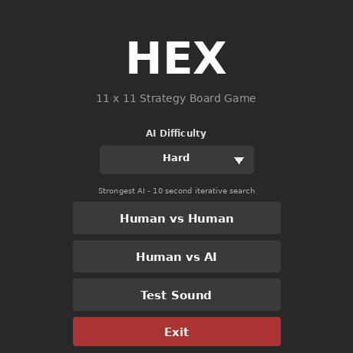
Figure 1: Updated start screen with difficulty selector and Test Sound button.

9.2 Gameplay Screen
During gameplay, the board fills with blue and red stones. The status label indicates whose turn it is or whether the AI is thinking. Buttons below the board allow Restart, Undo, Menu, and Exit Game operations.
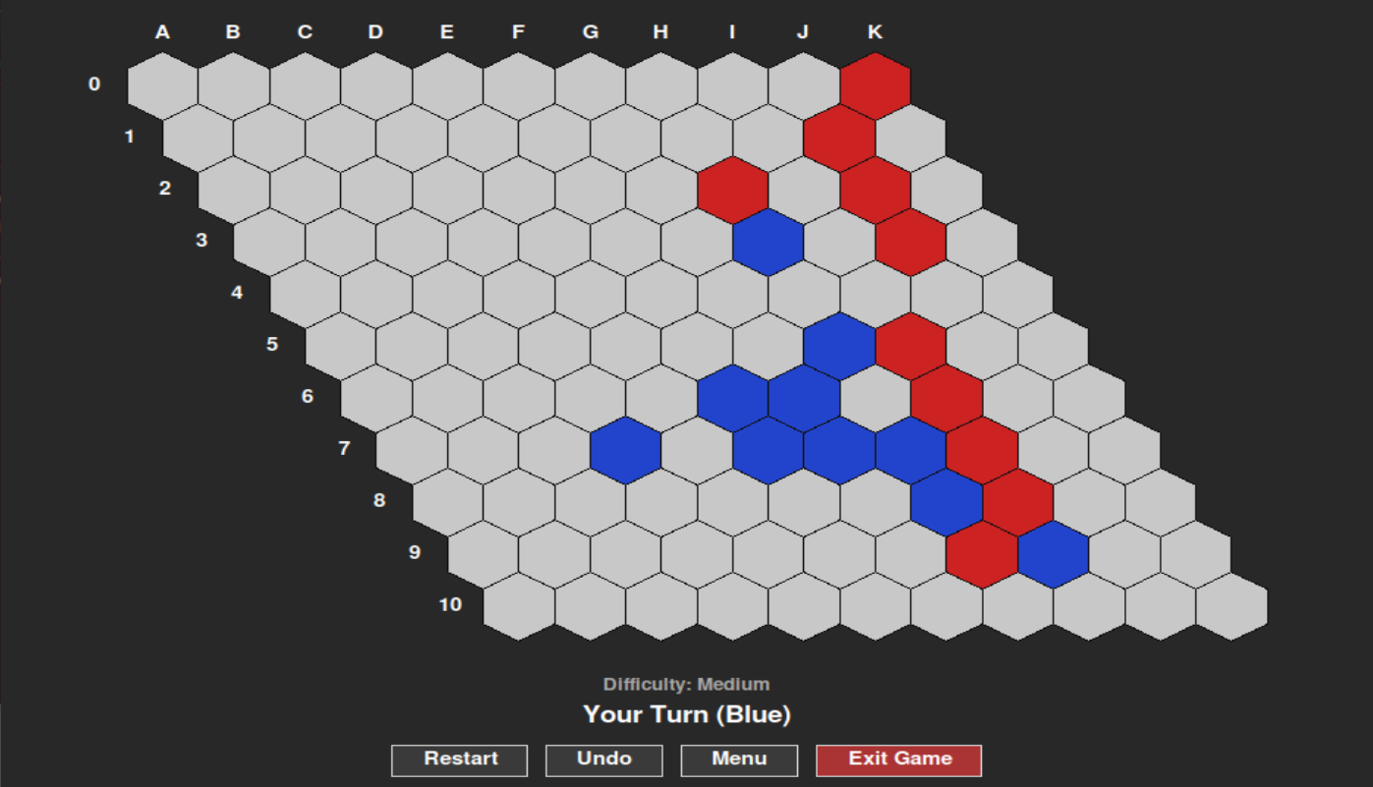
Figure 2: Gameplay screen showing the 11 x 11 Hex board.

9.3 Winning Path Highlight
When a player wins, the game immediately highlights the connected winning path. This makes the result visually clear and helps users understand why the game ended.
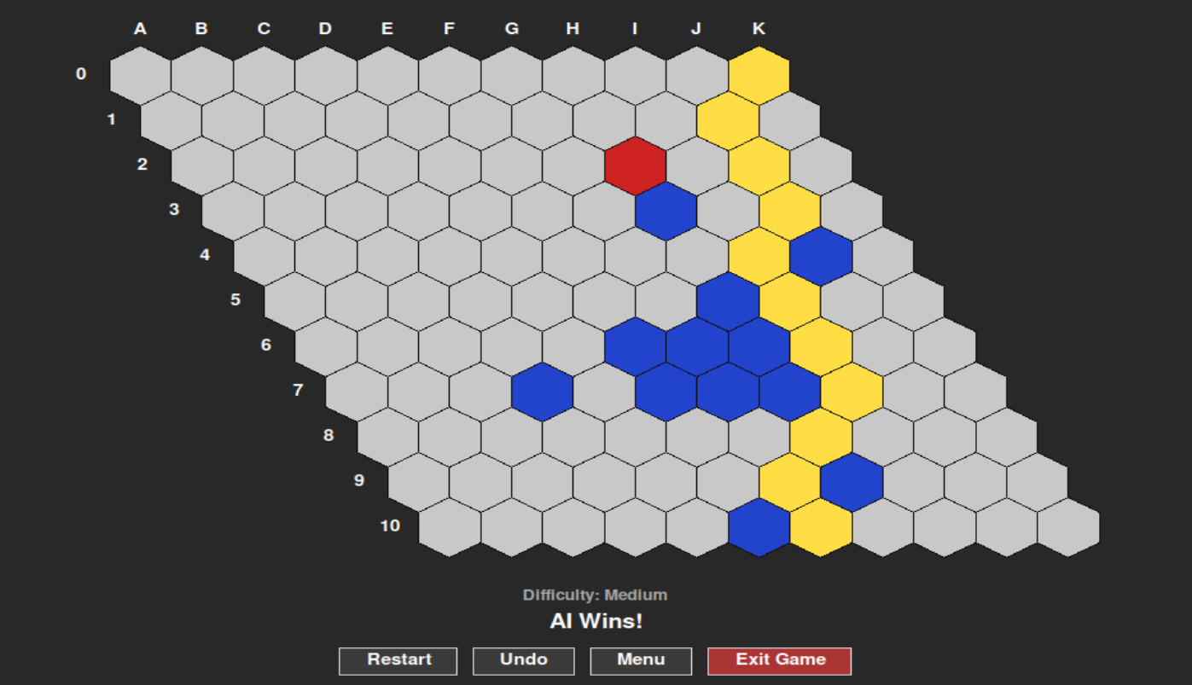
Figure 3: AI win screen with the winning connection highlighted.

10. Implementation Details

10.1 GUI Implementation
The GUI is implemented with Tkinter. Hexagons are calculated using geometric helper functions for pointy-top hex grids. Each cell is stored by row and column so its color can be updated quickly after each move. The GUI also keeps track of game mode, selected AI difficulty, game-over state, and whether the AI is currently thinking.

10.2 Background AI Thread
The AI search can take time, especially in Hard mode. To prevent the application from freezing, the AI runs in a background thread. The search is performed on a deep copy of the board, and only the final selected move is applied to the real board. This design avoids flickering and protects the displayed board from temporary search moves.

10.3 Sound System
Sound effects are optional and handled through pygame. The implementation searches multiple likely directories for the sound files, prints a clear terminal message if sound loading fails, caps playback volume for smoother cross-platform output, and uses the system bell as a fallback. The Test Sound button makes troubleshooting easier for users before starting a game.

10.4 README and Packaging
The final package includes source files, sounds, screenshots, a demo GIF, and README documentation. The README explains installation, dependencies, gameplay rules, controls, AI behavior, screenshots, and future improvements.

11. Testing and Evaluation

11.1 Functional Test Plan
Test Case | Expected Result | Status
Launch application using python main.py | GUI opens directly without terminal prompts. | Passed
Click Human vs Human | Game starts with alternating Blue and Red turns. | Passed
Click Human vs AI with Easy selected | AI responds quickly using shallow search. | Passed
Click Human vs AI with Medium selected | AI uses balanced fixed-depth search. | Passed
Click Human vs AI with Hard selected | AI searches deeper using iterative deepening. | Passed
Click occupied cell | Move is rejected and board remains unchanged. | Passed
Use Undo in Human vs AI | Both AI and human recent moves are undone where applicable. | Passed
Complete a winning connection | Game detects winner and highlights winning path. | Passed
Press Test Sound | Move sound plays when pygame and audio files are available; otherwise fallback bell is used. | Passed
Return to Menu | Start screen is restored cleanly. | Passed

11.2 Performance Evaluation
Performance was evaluated qualitatively by checking responsiveness, search behavior, and GUI stability. Easy and Medium modes provide fast AI responses for smooth interaction. Hard mode intentionally spends more time searching to improve move quality, but the GUI remains responsive because the AI runs in a background thread.
Aspect | Evaluation
Responsiveness | GUI remains usable while the AI is thinking.
AI strength | Hard mode produces strong strategic moves using deeper search.
Move legality | Invalid and duplicate moves are blocked.
Win detection | Winning paths are correctly identified and highlighted.
Maintainability | Code is divided into separate modules for board, GUI, AI, and heuristics.

12. Results and Discussion
The project successfully meets its original AI goals. It implements a complete Hex game, integrates an intelligent search-based opponent, provides a graphical interface, and supports multiple difficulty levels. The final AI is significantly stronger than a random or rule-based player because it evaluates future positions, prunes weak branches, and prioritizes strategically important moves.
The most important result is the successful combination of theory and usability. The algorithms are not isolated in a command-line simulation; they are connected to a playable interface where the user can experience AI decision-making directly. The difficulty selector further improves the system by making the same AI framework usable for different types of players.
Original Goal | Final Outcome
Design an AI agent for Hex | Implemented AlphaBetaPlayer with search, caching, and heuristics.
Use Minimax and Alpha-Beta pruning | Implemented depth-limited and iterative-deepening search.
Develop advanced heuristics | Implemented Shortest Path, Two-Distance, and Charge heuristics.
Optimize performance | Used move ordering, killer moves, transposition tables, and threading.
Integrate with GUI | Completed Tkinter GUI with board, controls, sounds, status, and screenshots.

13. Challenges and Solutions
Challenge | Solution
Large search space on 11 x 11 board | Used Alpha-Beta pruning, move ordering, and depth limits.
Need for strong board evaluation | Used Two-Distance heuristic for strategic connectivity.
Slow AI in stronger modes | Added Easy/Medium/Hard difficulty levels and threaded AI search.
GUI freezing risk during AI search | Ran AI on a deep copy of the board in a background thread.
Sound failures across systems | Added sound-path checks, pygame fallback handling, volume caps, and Test Sound button.
Explaining win results visually | Highlighted the connected winning path after game over.

14. Limitations and Future Improvements

14.1 Current Limitations
- The board size is fixed at 11 x 11.
- The AI does not use an opening book or precomputed expert strategies.
- Hard mode can take several seconds per move because it searches more deeply.
- No save/load system is currently implemented.
- No online multiplayer or cross-device gameplay is included.

14.2 Future Improvements
- Add a board-size selector for 7 x 7, 9 x 9, 11 x 11, and 13 x 13 boards.
- Add an opening book for stronger and faster early-game AI play.
- Implement Monte Carlo Tree Search with heuristic-guided rollouts.
- Add move timers and search-depth display during AI thinking.
- Add save/load and export/import functionality.
- Add animations for move placement and winning-path transitions.
- Add automated unit tests for board logic, undo behavior, win detection, and AI move selection.

15. Conclusion
The 11 x 11 Hex Board Game with AI successfully demonstrates the application of core Artificial Intelligence concepts in a complete interactive system. The project uses adversarial search, heuristic evaluation, graph-based connectivity detection, caching, move ordering, and iterative deepening to create a strong computer opponent. The final product is not only algorithmically meaningful but also usable, polished, and easy to demonstrate through its graphical interface.
Overall, the project fulfills the proposed objectives and provides a strong foundation for future AI improvements such as MCTS, opening books, dynamic board sizes, and automated testing. It shows how classical AI search techniques can be engineered into a practical game-playing agent with real-time user interaction.

16. References
- Russell, S. and Norvig, P. Artificial Intelligence: A Modern Approach. Pearson.
- Piet Hein and John Nash. Hex board game concept and connection-game theory.
- Minimax and Alpha-Beta pruning algorithms for adversarial search.
- Dijkstra-style graph search concepts for connectivity and shortest-path reasoning.
- Python documentation: tkinter, heapq, itertools, threading, timeit, and math modules.
- pygame documentation for optional sound playback and mixer behavior.

Appendix A: Key Algorithms and Pseudocode

A.1 AI Move Selection
function AI_MOVE(board, difficulty):
if difficulty is Easy:
depth = 1
else if difficulty is Medium:
depth = 2
else:
use iterative deepening with 10-second time limit
generate legal moves
order moves using Charge heuristic and killer moves
for each move:
simulate move on copied board
evaluate future states using Alpha-Beta search
return best move found

A.2 Alpha-Beta Search
function ALPHA_BETA(board, depth, alpha, beta, player):
if depth == 0 or board has winner:
return heuristic_value(board)
if player is maximizing:
value = -infinity
for move in ordered_legal_moves:
play move
value = max(value, ALPHA_BETA(child, depth-1, alpha, beta, opponent))
undo move
alpha = max(alpha, value)
if alpha >= beta:
break
return value
else:
value = +infinity
for move in ordered_legal_moves:
play move
value = min(value, ALPHA_BETA(child, depth-1, alpha, beta, opponent))
undo move
beta = min(beta, value)
if alpha >= beta:
break
return value

A.3 Win Detection
function IS_CONNECTED(player):
create search queue from player's target starting edge
while queue is not empty:
current = pop next cell
if current reaches opposite edge:
reconstruct winning group
return winning group
for each of six adjacent hex directions:
if neighbor contains player's stone and was not visited:
add neighbor to queue
return no connection

Appendix B: Final Project Structure
AI-PROJECT-HEX-GAME-main/
|-- main.py
|-- GUI.py
|-- board.py
|-- player.py
|-- heuristic.py
|-- requirements.txt
|-- LICENSE
|-- README.md
|-- sounds/
| |-- human_move.ogg
| |-- AI_move.ogg
| |-- win_sound.ogg
|-- screenshots/
| |-- start_screen.png
| |-- gameplay.png
| |-- ai_win.png
| |-- demo.gif

