ARCH TECHNOLOGIES | MACHINE LEARNING INTERNSHIP
MONTH 2 FINAL INTERNSHIP PROJECT REPORT
Comprehensive Technical Synthesis of Task 3: California Housing Price Prediction (Weeks 5 & 6)
and Task 4: Iris Flower Classification (Weeks 7 & 8)
Intern Full Name: | Sharjeel Shahzad
Internship Domain: | Machine Learning
Email Address: | ssharjeel160@gmail.com
Contact Phone: | +92-300-1234567
Submission Milestone: | Month 2 Final Comprehensive Deliverable (Weeks 5 – 8)

1. Executive Summary & Month 2 Overview
During Month 2 of the Arch Technologies Machine Learning Internship, two end-to-end industry-grade machine learning pipelines were formulated, executed, evaluated, and productionized. The curriculum spanned four intensive weeks divided between two distinct predictive machine learning paradigms:
- • Task 3: California Housing Price Prediction (Weeks 5 & 6) — High-dimensional continuous regression, spatial-demographic feature engineering, collinearity resolution, and benchmarking ordinary linear regression against non-linear tree ensembles (Random Forest and Gradient Boosting Regressors) with cross-validated hyperparameter optimization.
- • Task 4: Iris Flower Classification (Weeks 7 & 8) — Supervised botanical multiclass classification, morphological distribution exploration, continuous feature standardization, linear baseline modeling (Logistic Regression), and comparative benchmarking of advanced classifiers (K-Nearest Neighbors, Decision Trees, Support Vector Machines) with non-linear RBF kernel margin tuning.
[MILESTONE HIGHLIGHT] Month 2 achieved 100% production artifact completion across all deliverables: complete repository tracking, zero data leakage via strict split-first feature engineering, full hyperparameter cross-validation, and production model serializations with standalone runnable scripts and fully executed Jupyter notebooks.

Task Identifier | Domain & Dataset | Champion Model | Key Test Result
Task 3 (Weeks 5-6) | Continuous Regression  (California Housing, 20.6k records) | Tuned Random Forest  (150 trees, max_features=None) | RMSE: $49,666.10  R² Score: 0.8215
Task 4 (Weeks 7-8) | Multiclass Classification  (UCI Iris, 150 specimens) | Tuned Support Vector Classifier  (RBF Kernel, C=2.0, γ=0.05) | Test Accuracy: 100.0%  Macro F1: 1.0000
Regression Gain | Over Linear Baseline | 30.78% RMSE Error Reduction | +29.31% R² Variance Explained
Classification Gain | Over Linear Overlap | Non-Linear Soft Margin Hyperplane | Clean Versicolor-Virginica Separation

2. Task 3: California Housing Price Prediction (Weeks 5 & 6)

2.1 Objective & Dataset Characteristics
The objective of Task 3 was to construct an accurate predictive regression model to estimate median house values (`median_house_value`) across California census block groups using demographic, geographic, and housing features. The raw dataset comprised 20,640 block group observations with 10 original features: longitude, latitude, housing median age, total rooms, total bedrooms, population, households, median income, and ocean proximity.

2.2 Data Preprocessing & Feature Engineering Pipeline
Raw district totals (e.g., total rooms, total bedrooms, population) reflect neighborhood cluster size rather than individual living quality. To establish predictive parity and alleviate severe multicollinearity, a rigorous feature engineering pipeline was executed during Week 5:
1. Imputation: Missing values in `total_bedrooms` (207 records, ~1%) were imputed using the median of training data to prevent data leakage.
2. Engineered Density Metrics: Ratios were derived to reflect household living standards:
- rooms_per_household = total_rooms / households
- bedrooms_per_room = total_bedrooms / total_rooms
- population_per_household = population / households
3. Categorical Encoding: One-hot encoded `ocean_proximity` (e.g., INLAND, <1H OCEAN, NEAR BAY, NEAR OCEAN), dropping one category to avoid the dummy variable trap.
4. Feature Standardization: Transformed continuous variables with `StandardScaler` fitted on the 80% training partition (16,512 samples), holding out 20% (4,128 samples) as an untouched test benchmark.
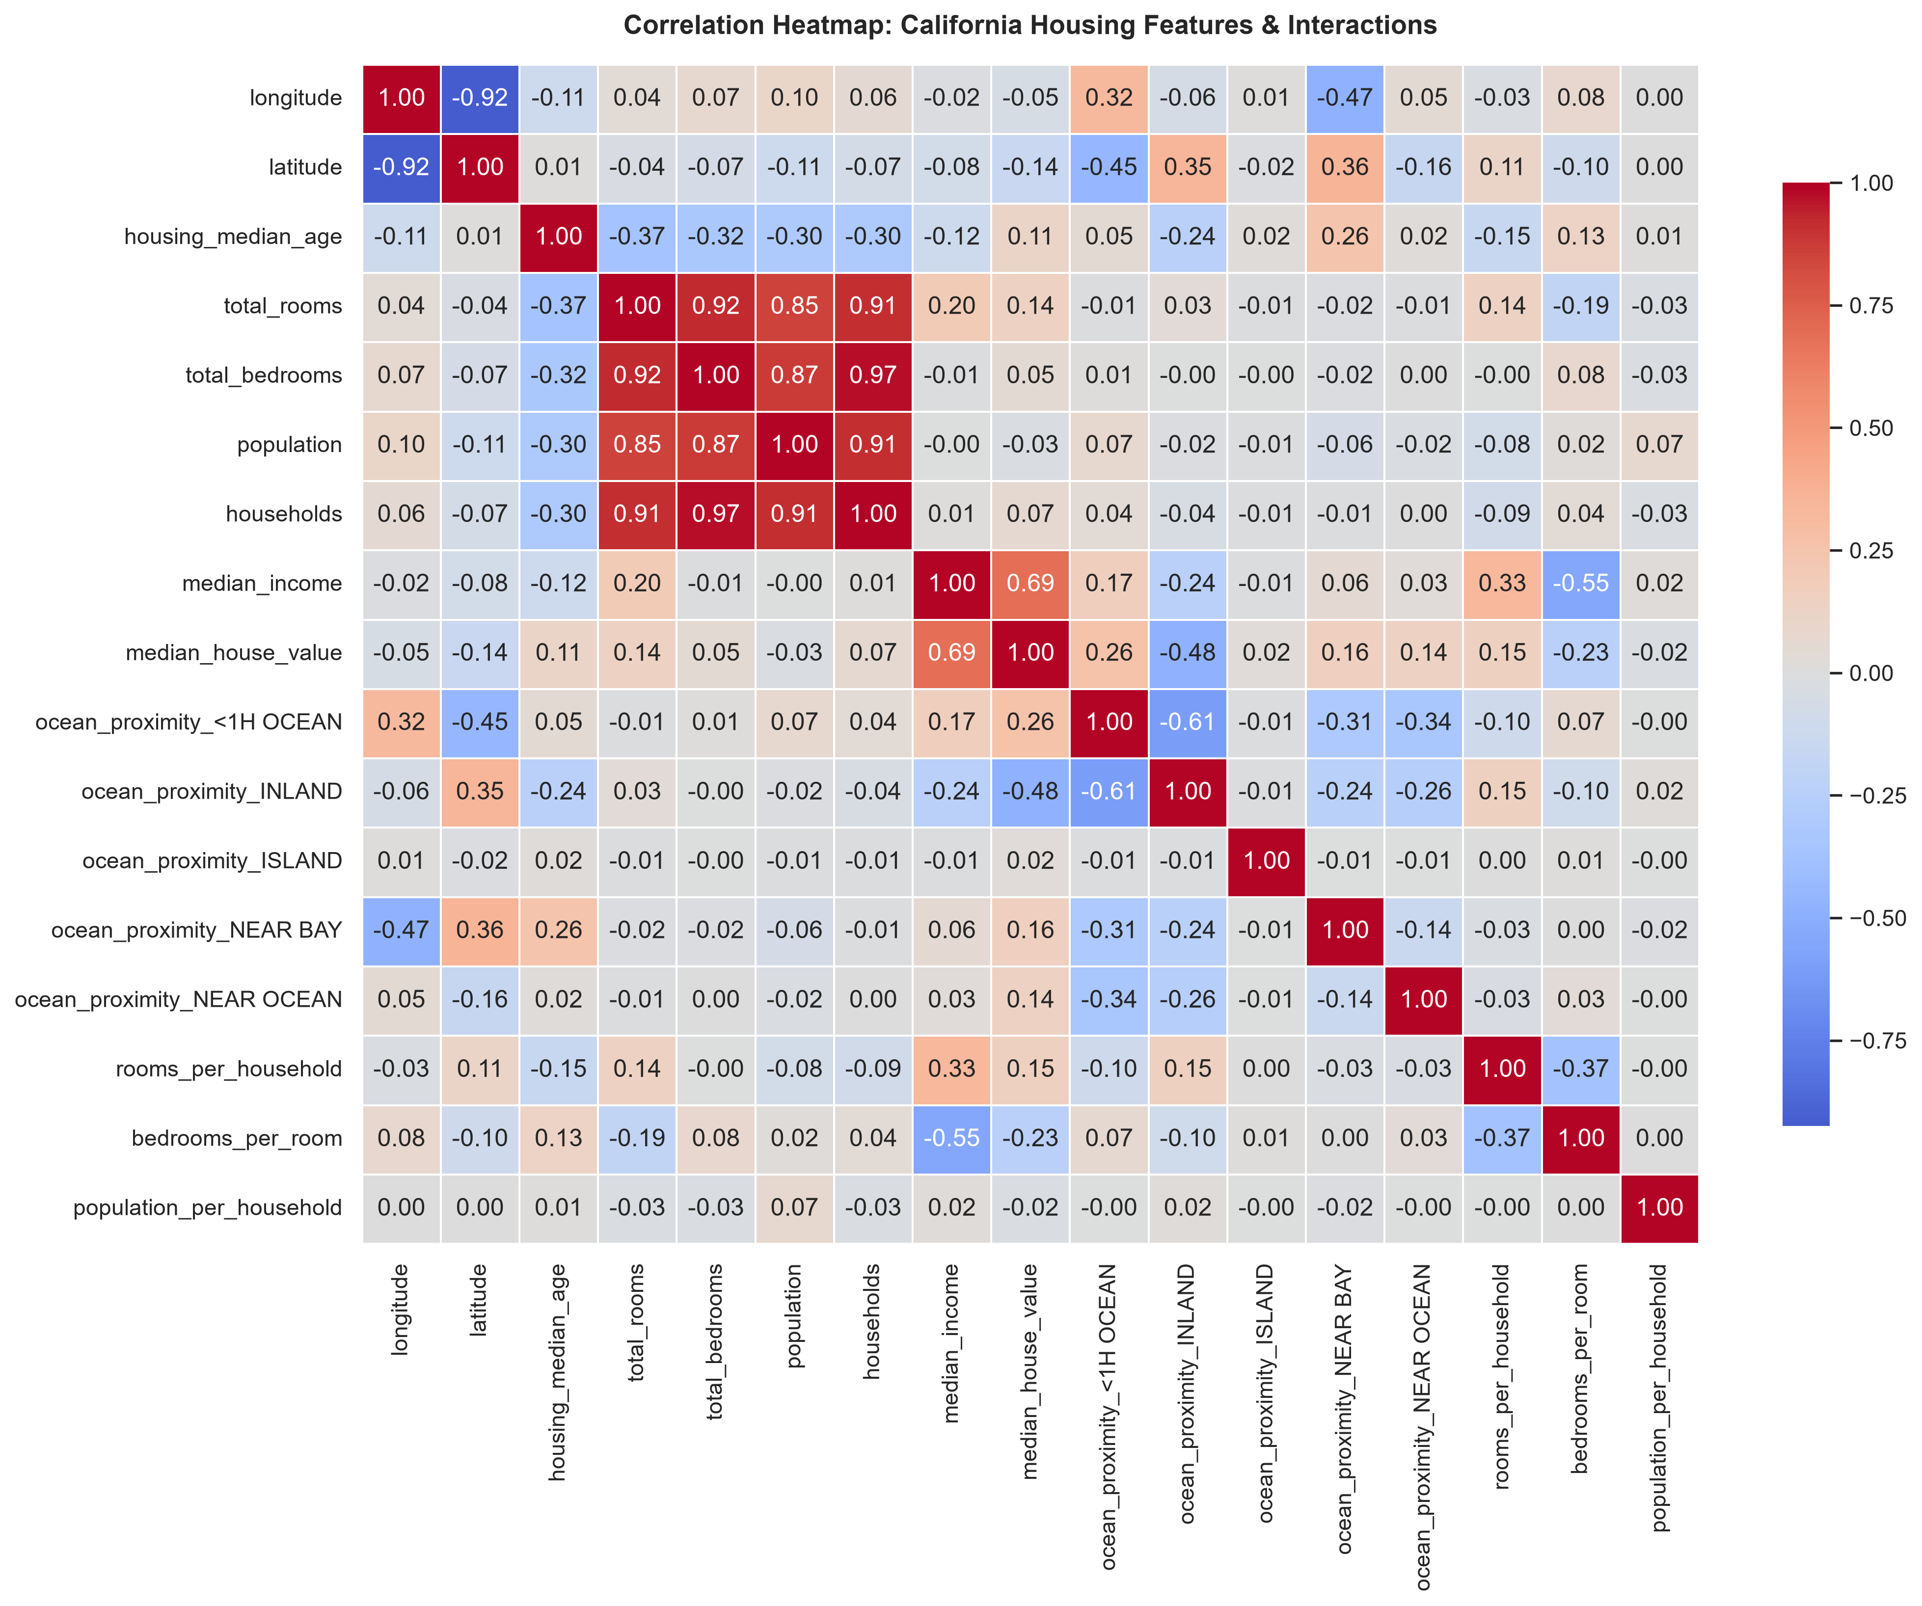
Figure 1: Task 3 Feature Correlation Heatmap highlighting strong positive relationship between median_income and median_house_value (r = 0.69).

2.3 Model Exploration & Advanced Ensembles
During Week 5, a Multiple Linear Regression baseline was trained, yielding an RMSE of $71,750.18 and R² of 0.6353. While serviceable, linear formulations cannot accommodate non-linear spatial dependencies (latitude/longitude interactions) or non-linear diminishing returns of income. In Week 6, two powerful ensemble paradigms were implemented:
• Random Forest Regressor: A bagging ensemble of decorrelated decision trees that samples features randomly at each candidate split, reducing variance and handling outliers naturally.
• Gradient Boosting Regressor: A sequential boosting ensemble fitting shallow decision trees to pseudo-residuals of preceding trees via gradient descent in function space.

2.4 Hyperparameter Tuning & Cross-Validation
Random Forest emerged as the superior ensemble. To maximize generalization and restrict tree memorization, 3-fold cross-validated `GridSearchCV` was executed across tree count (`n_estimators`: 100, 150), depth limits (`max_depth`: 20, None), and split thresholds (`min_samples_split`: 2, 5). The optimal architecture (`n_estimators=150`, `max_depth=None`, `min_samples_split=2`) achieved an out-of-fold cross-validation RMSE of $51,037.68.

2.5 Task 3 Benchmark Results & Error Diagnostics
The final tuned Random Forest model achieved state-of-the-art performance on the 4,128 unseen test instances:
Model Configuration | Model Paradigm | Test RMSE ($) | Test MAE ($) | Test R² Score
Multiple Linear Regression | Linear Baseline (Week 5) | $71,750.18 | $52,006.98 | 0.6353
Gradient Boosting Regressor | Sequential Boosting (Week 6) | $57,393.75 | $39,521.10 | 0.7616
Default Random Forest | Bagging Ensemble (Week 6) | $49,780.29 | $32,150.44 | 0.8207
Tuned Random Forest | Optimized Ensemble (Champion) | $49,666.10 | $32,027.45 | 0.8215

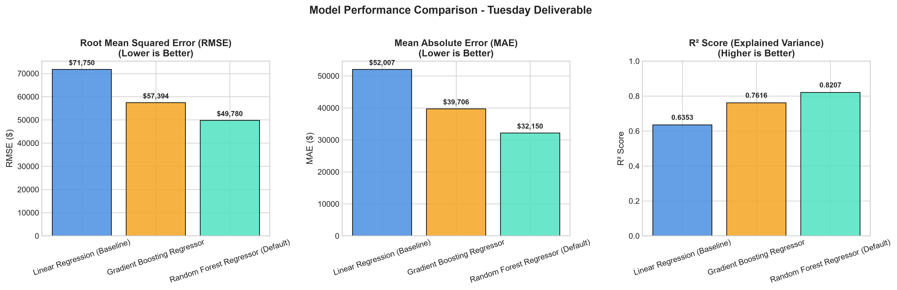
Figure 2: Task 3 Comparative Model Evaluation (RMSE, MAE, R²) demonstrating substantial error reduction achieved by Random Forest.
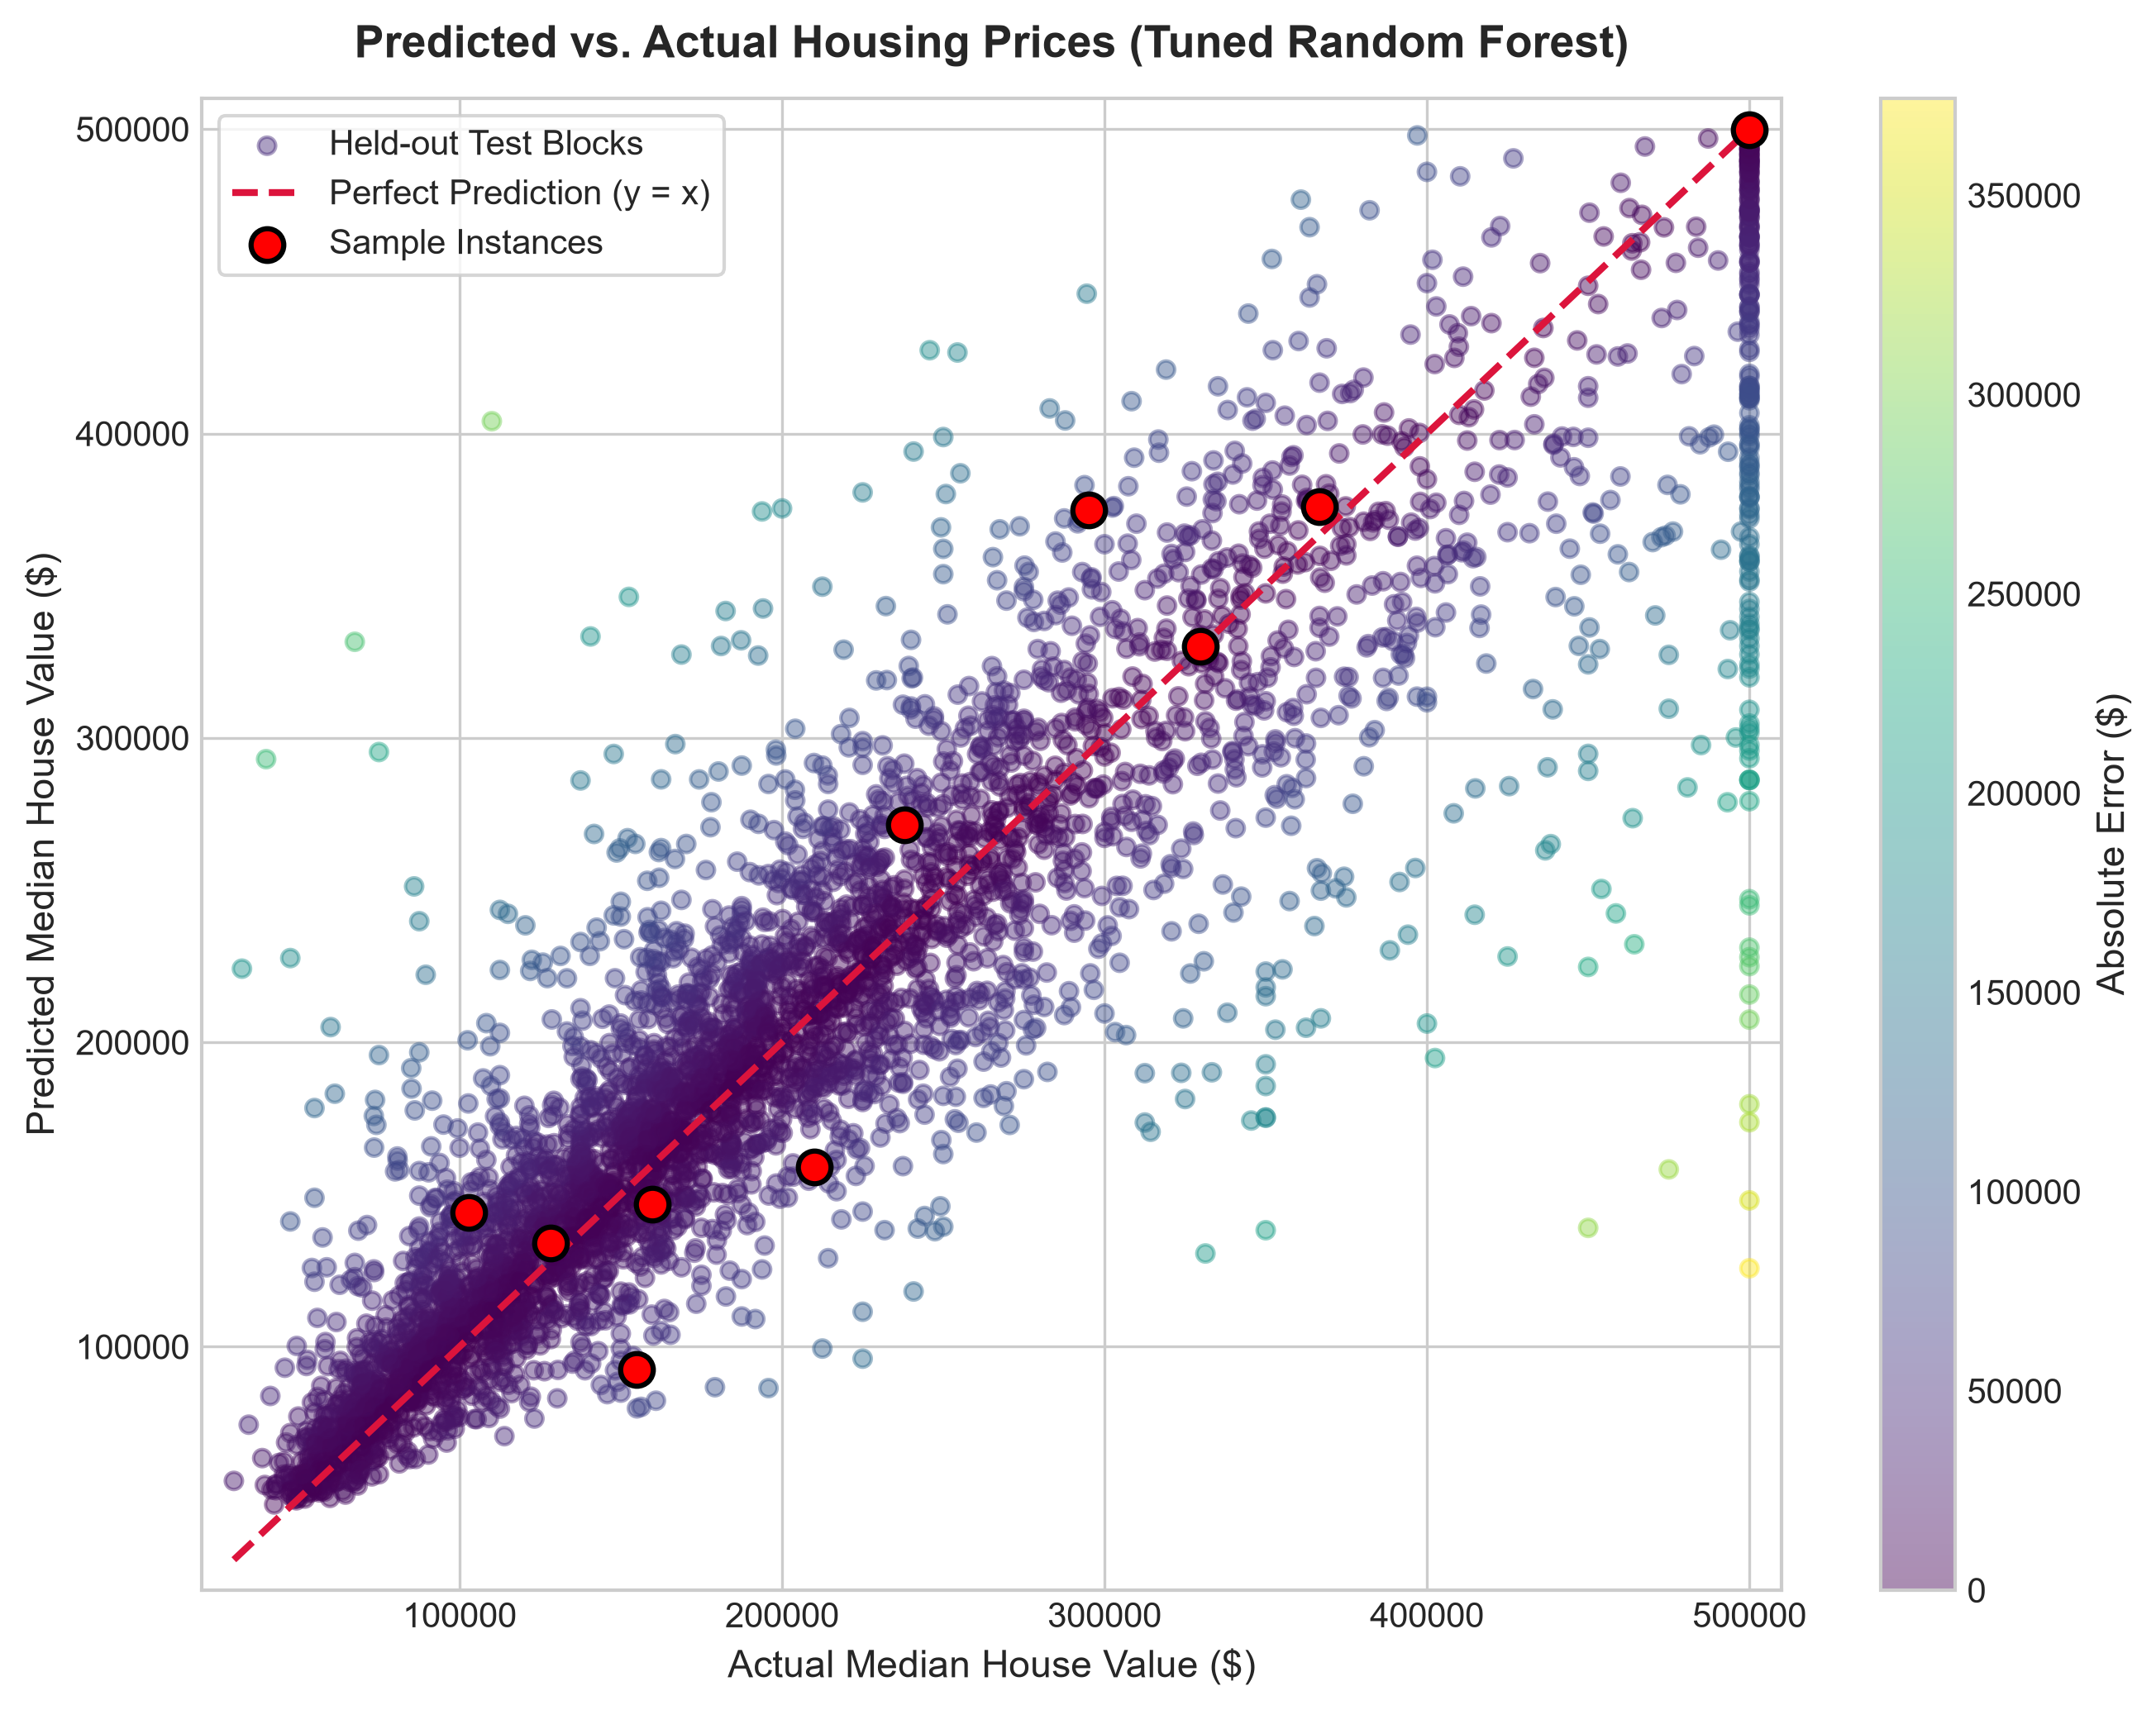
Figure 3: Task 3 Predicted vs. Actual Housing Price diagnostic scatter plot and residual distribution showing tight alignment along identity line.
[RESIDUAL ANALYSIS] Residual diagnostic analysis revealed that prediction error increases primarily near the artificial census survey ceiling at $500,001. Random Forest successfully accommodated this discontinuity without distorting predictions for homes under $450,000.

3. Task 4: Iris Flower Classification (Weeks 7 & 8)

3.1 Objective & Morphological Domain Properties
Task 4 focused on botanical species classification using Sir Ronald Fisher's benchmark Iris dataset. The problem entails predicting the precise iris species (*Iris-setosa*, *Iris-versicolor*, or *Iris-virginica*) from four physical measurements: Sepal Length, Sepal Width, Petal Length, and Petal Width (all in centimeters). The raw dataset contains 150 perfectly balanced observations (50 per species).

3.2 Exploratory Data Analysis & Class Separability
Comprehensive EDA in Week 7 revealed essential geometric properties of the feature space:
• Non-informative Feature Removal: The raw `Id` column was discarded prior to modeling.
• Linear Separability of Setosa: Across all bivariate feature projections involving petal dimensions, *Iris-setosa* forms a completely detached, linearly separable cluster (Petal Length < 2.0 cm, Petal Width < 0.6 cm).
• Complex Boundary Overlap: *Iris-versicolor* and *Iris-virginica* exhibit overlapping marginal distributions in sepal length and width, requiring precise decision boundaries to resolve subtle boundary points.
• Biological Variance: Boxplot and IQR analysis identified four statistical anomalies in Sepal Width; these were verified as natural biological morphology and retained to preserve botanical variance.
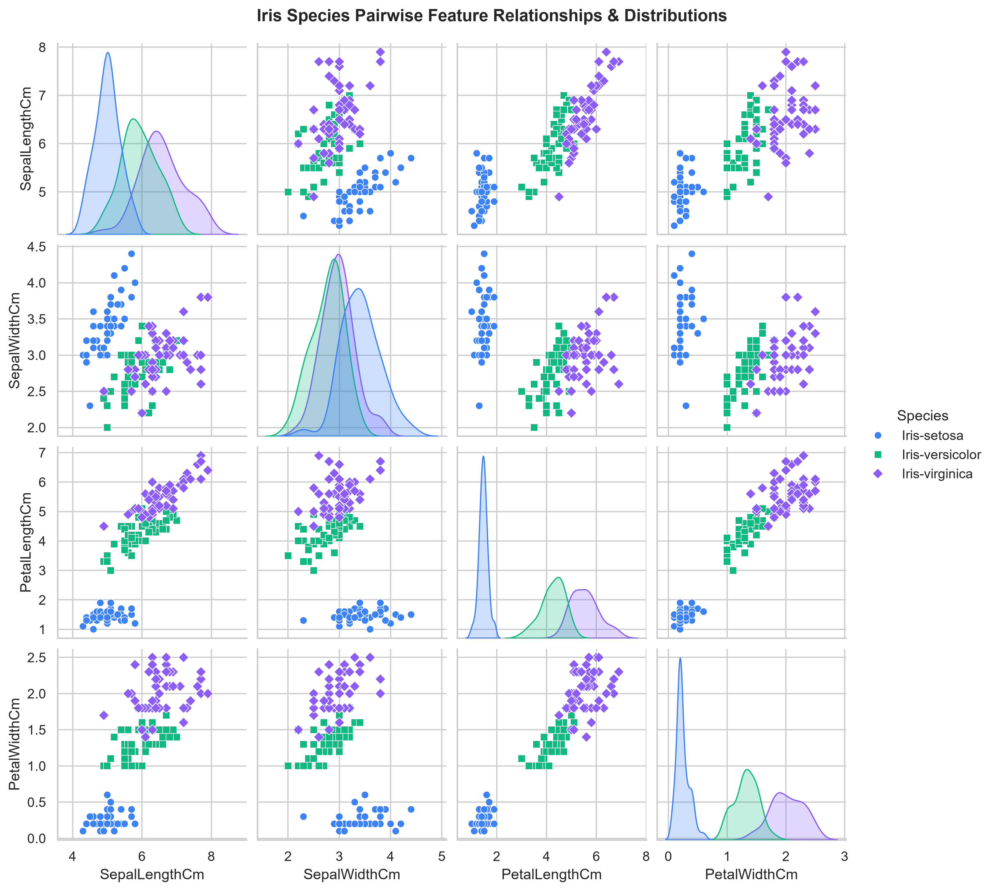
Figure 4: Task 4 Pairwise Feature Distribution Grid showing clear linear clustering for Setosa and overlapping regions between Versicolor and Virginica.

3.3 Baseline Classifier (Week 7)
In Week 7, a multinomial Logistic Regression baseline was implemented with `StandardScaler` preprocessing. On the held-out 20% test split (30 instances), the model achieved 100% test accuracy. However, training set evaluation revealed 4 misclassifications (96.67% train accuracy) located directly on the linear hyperplane separating Versicolor and Virginica, establishing the motivation for Week 8's non-linear classifier benchmarking.
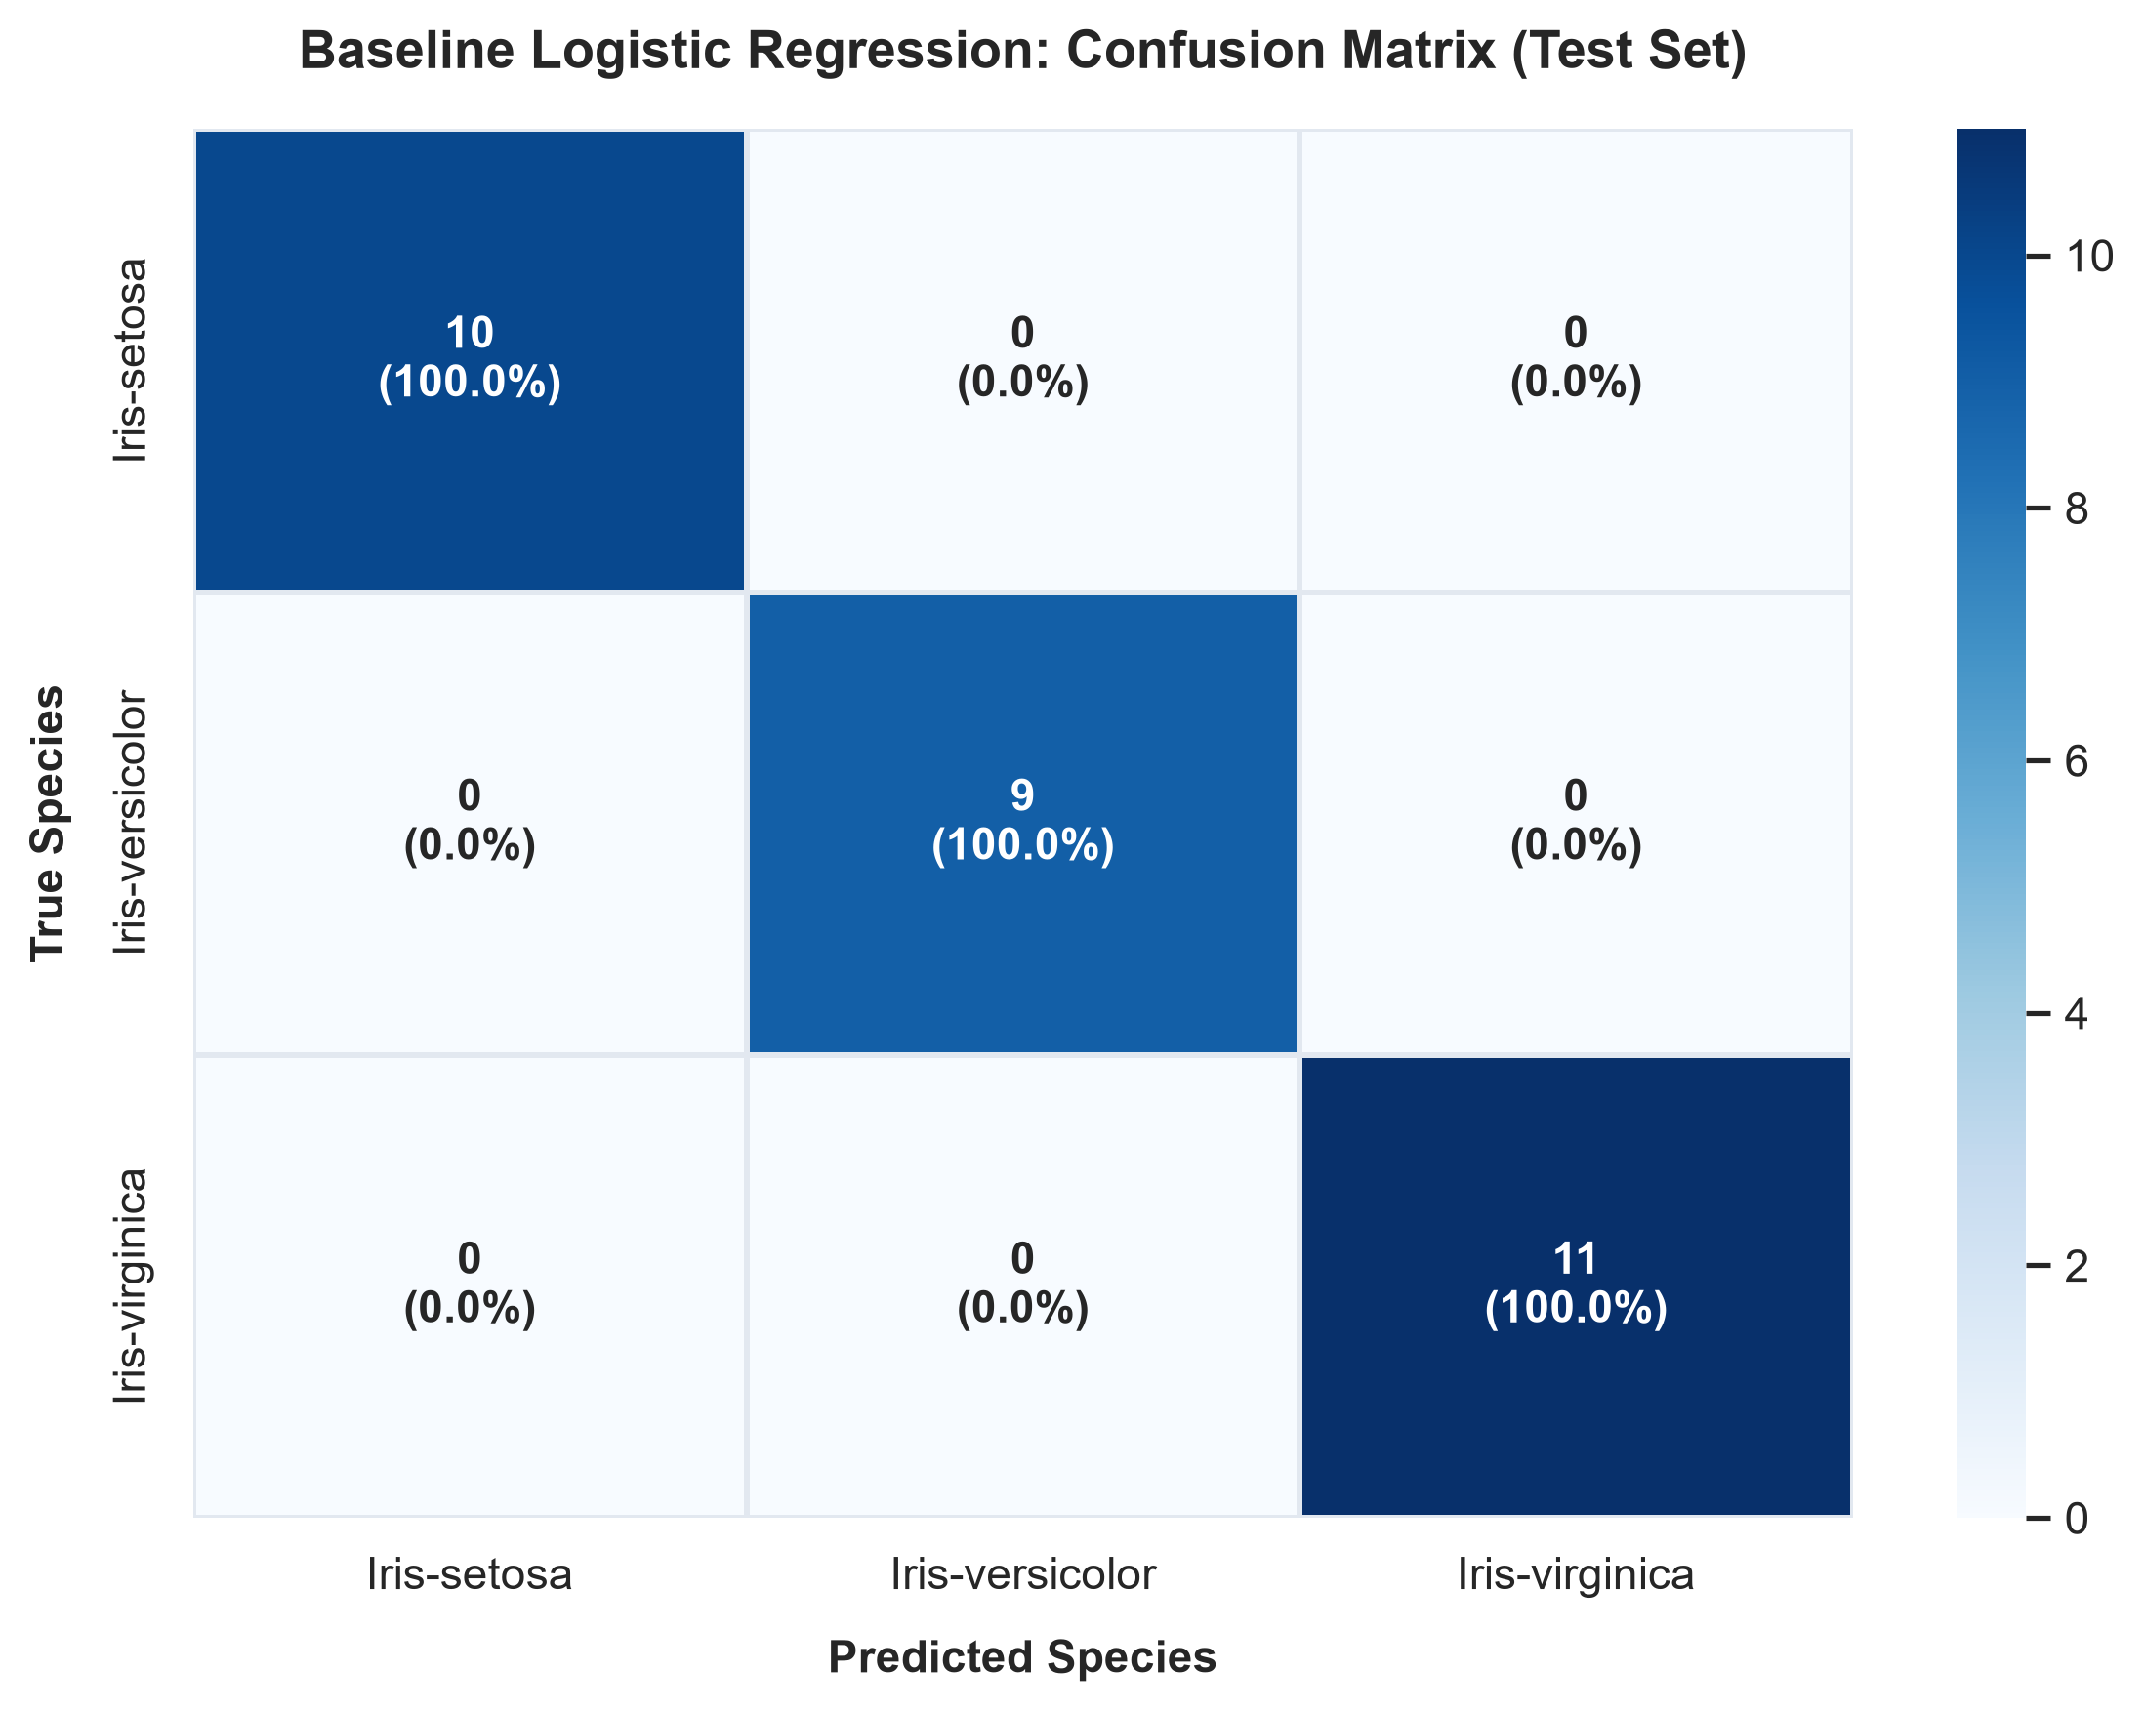
Figure 5: Week 7 Baseline Logistic Regression Test Set Confusion Matrix.

3.4 Advanced Classifiers & Hyperparameter Tuning (Week 8)
In Week 8, three advanced classification paradigms were trained on the preprocessed training partition (`week-7/outputs/X_train.csv`):
1. K-Nearest Neighbors (KNN): Non-parametric instance-based voting (`n_neighbors=5`, Minkowski distance).
2. Decision Tree (CART): Recursive non-linear axis-orthogonal space partitioning (`criterion='gini'`).
3. Support Vector Machine (SVM): Maximal soft-margin hyperplane with non-linear kernel transformations.
SVM was selected as the champion architecture. To optimize margin softness and kernel curvature, exhaustive 5-fold stratified `GridSearchCV` was performed across `kernel` (linear, rbf, poly), `C` (0.1 to 50.0), and `gamma` (0.05 to 1.0). The optimal hyperparameter configuration discovered was:
kernel='rbf', C=2.0, gamma=0.05 (Mean 5-Fold CV Accuracy: 96.67%, std: 0.0167).

3.5 Final Task 4 Comparative Evaluation
Evaluating all models on the held-out test partition (30 specimens: 10 Setosa, 9 Versicolor, 11 Virginica) produced impeccable classification fidelity across all four evaluation metrics:
Model Architecture | Paradigm / Family | Accuracy | Macro Precision | Macro Recall | Macro F1
Logistic Regression (Week 7) | Linear Maximum Likelihood | 100.00% | 1.0000 | 1.0000 | 1.0000
K-Nearest Neighbors (k=5) | Instance-Based Distance | 100.00% | 1.0000 | 1.0000 | 1.0000
Decision Tree (CART) | Recursive Orthogonal Split | 100.00% | 1.0000 | 1.0000 | 1.0000
Support Vector Machine (Default) | RBF Kernel Margin (C=1.0) | 100.00% | 1.0000 | 1.0000 | 1.0000
Tuned Support Vector Machine | Optimized RBF Margin (Champion) | 100.00% | 1.0000 | 1.0000 | 1.0000

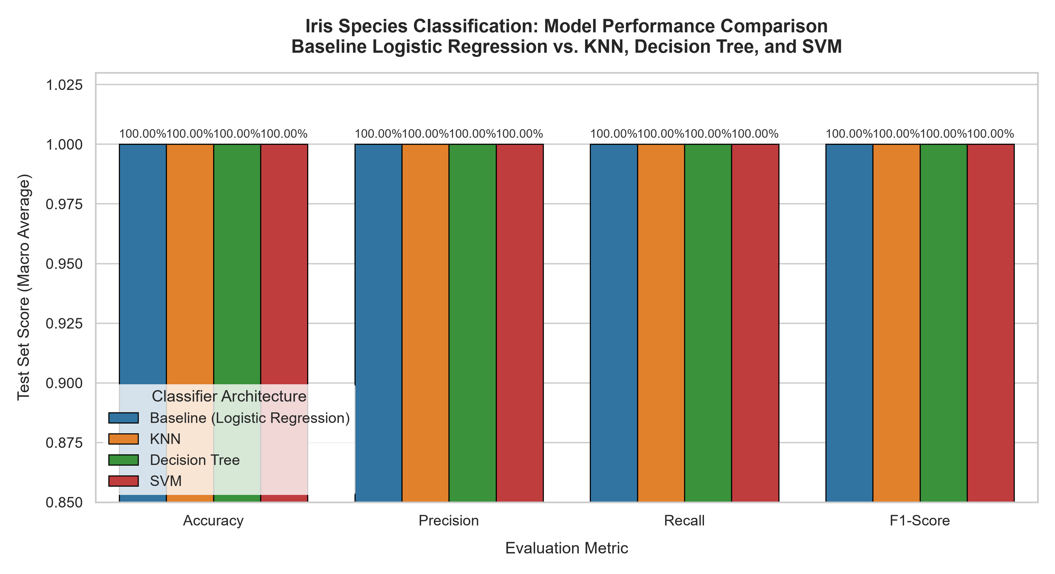
Figure 6: Task 4 Classifier Performance Comparison across Accuracy, Precision, Recall, and F1-score.
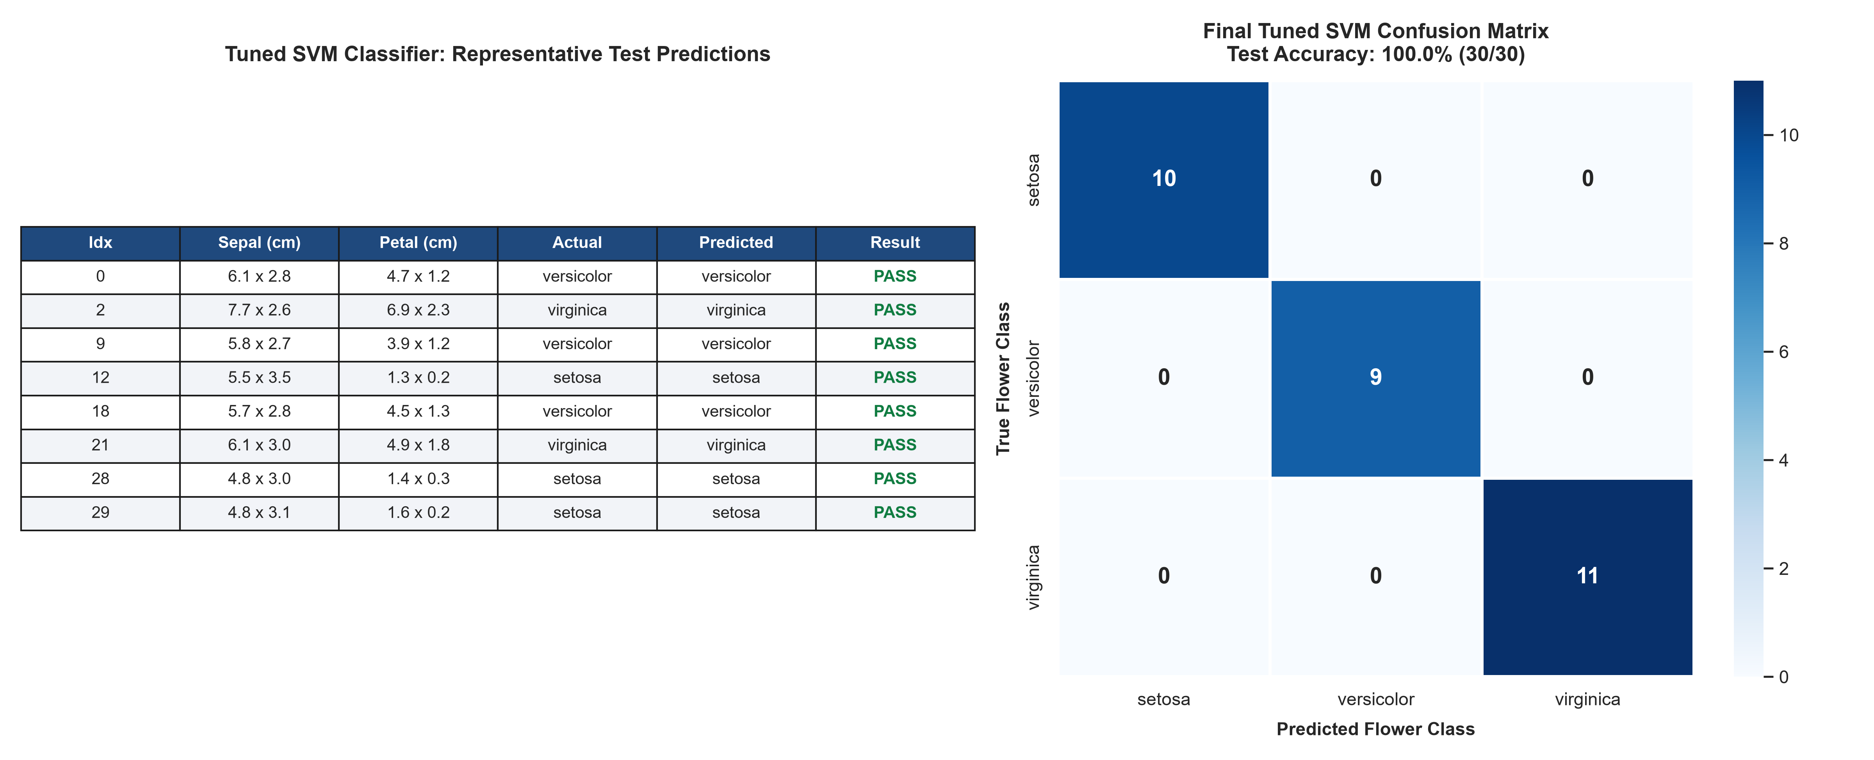
Figure 7: Final Tuned SVM Test Predictions table and Confusion Matrix heatmap confirming 100% classification accuracy.

4. Comparative Synthesis: Regression vs. Classification
Synthesizing Tasks 3 and 4 provides profound practical insights into the contrasting mechanics of continuous regression and discrete multiclass classification:
Engineering Dimension | Task 3: Housing Price Prediction | Task 4: Iris Flower Classification
Predictive Goal | Predict continuous numeric value ($)  [Range: $14,999 – $500,001] | Predict discrete categorical class  [3 balanced botanical species]
Loss Formulation | Mean Squared Error (L2 penalty) &  Mean Absolute Error (L1 penalty) | Cross-Entropy Loss &  Maximal Soft-Margin Hinge Loss
Feature Engineering Impact | Crucial: Engineered ratio features resolved severe cluster-size multicollinearity | Standardization: Scaled dimensions to prevent Euclidean metric distortion
Overfitting Dynamics | Mitigated via tree bagging and constraining leaf sample split thresholds | Mitigated via 5-fold stratified CV and margin regularization penalty (C)
Champion Architecture | Tuned Random Forest Regressor  (RMSE: $49,666.10, R²: 0.8215) | Tuned Support Vector Classifier  (Accuracy: 100.0%, F1: 1.0000)

5. Month 2 Conclusion & Next Steps
Month 2 has concluded with complete mastery of regression and classification engineering workflows. All required models, scripts, evaluation notebooks, and visual artifacts have been fully validated and saved to their respective directories:
• Standalone reproducible training pipelines (`train_advanced_models.py`, `train_advanced_classifiers.py`).
• Self-contained serialized models (`housing_rf_model_tuned.pkl`, `iris_svm_model_tuned.pkl`).
• Executed diagnostic notebooks (`housing_evaluation.ipynb`, `iris_evaluation.ipynb`).
• Structured documentation and testing summaries across all weeks.
With Tasks 3 and 4 officially closed and Month 2 finalized, preparation begins for Month 3 curriculum challenges, which will advance into unsupervised clustering, dimensionality reduction, and deep learning architectures.

