1. select\* from dept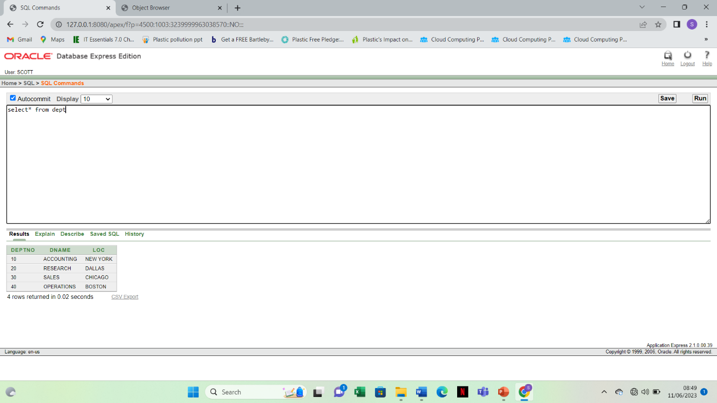

2. select ename,sal,sal+300 from emp

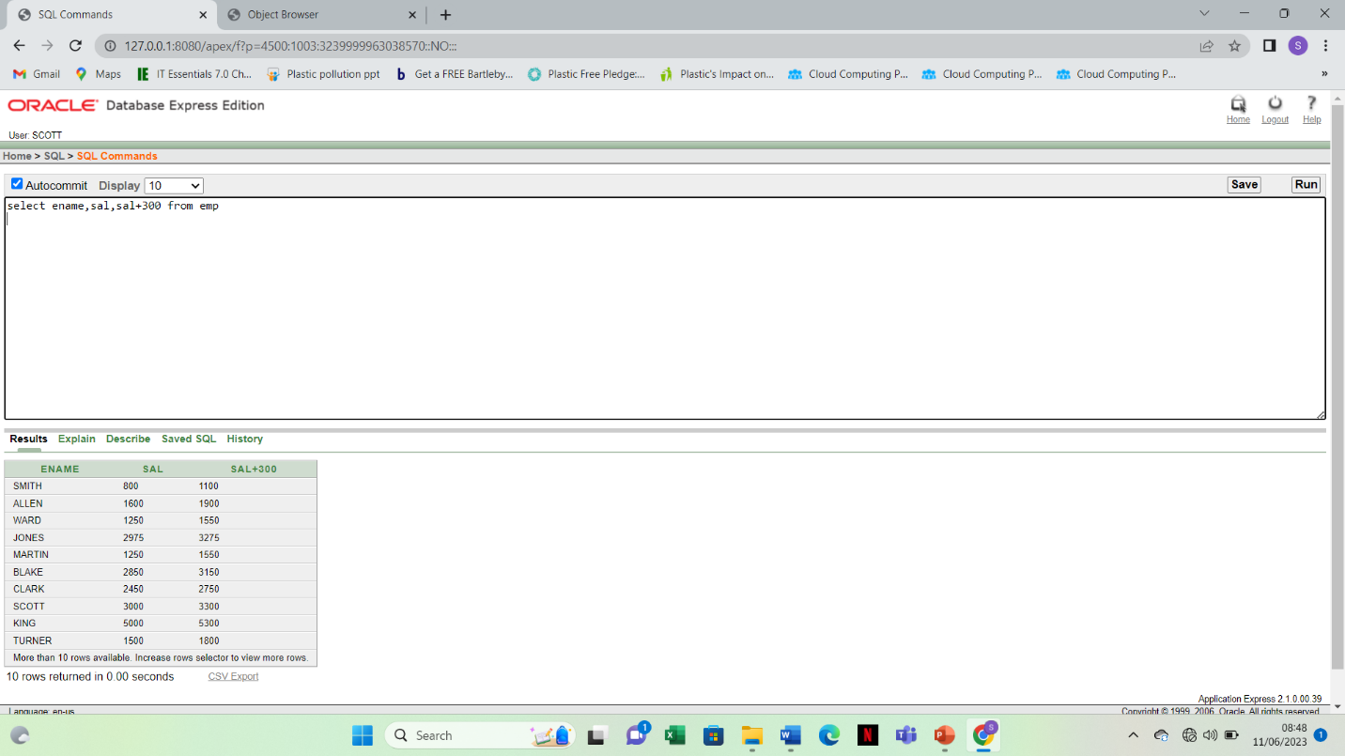

3. select dept no,loc from dept;

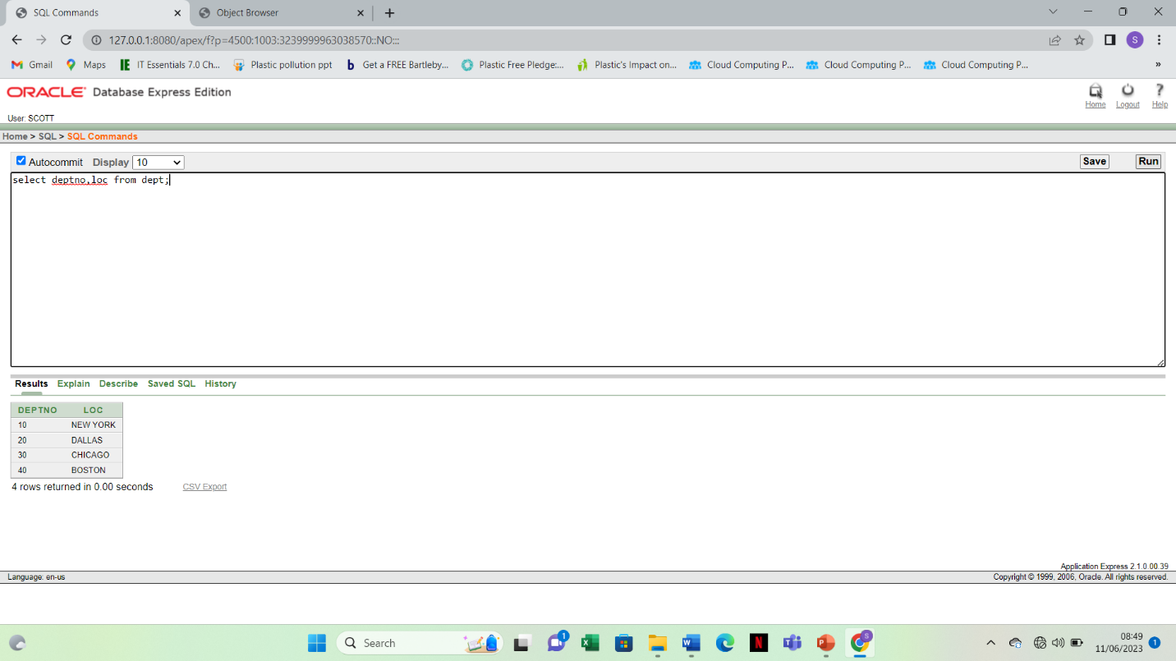

4. select ename, sal, 12\*sal+200 from emp

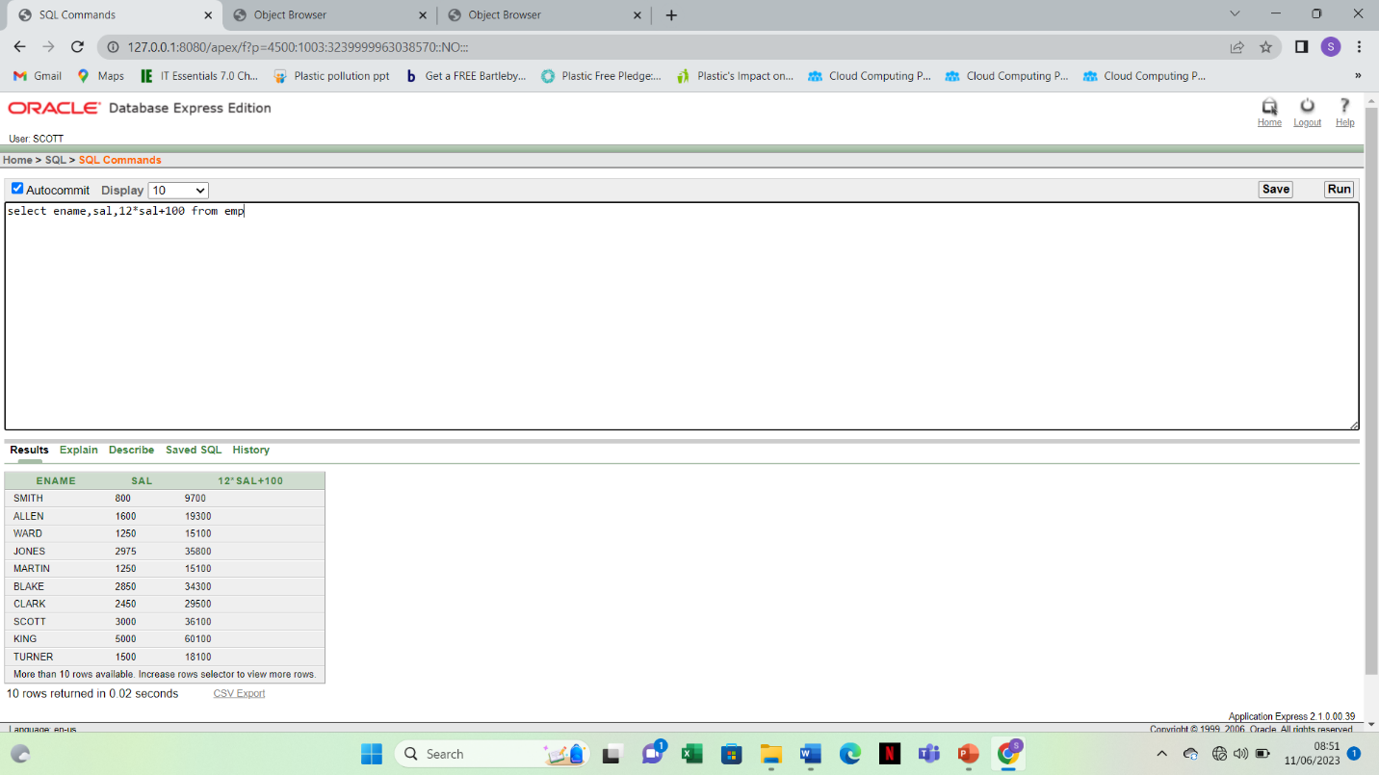

5. select ename , sal, 12\*(sal+100) from emp

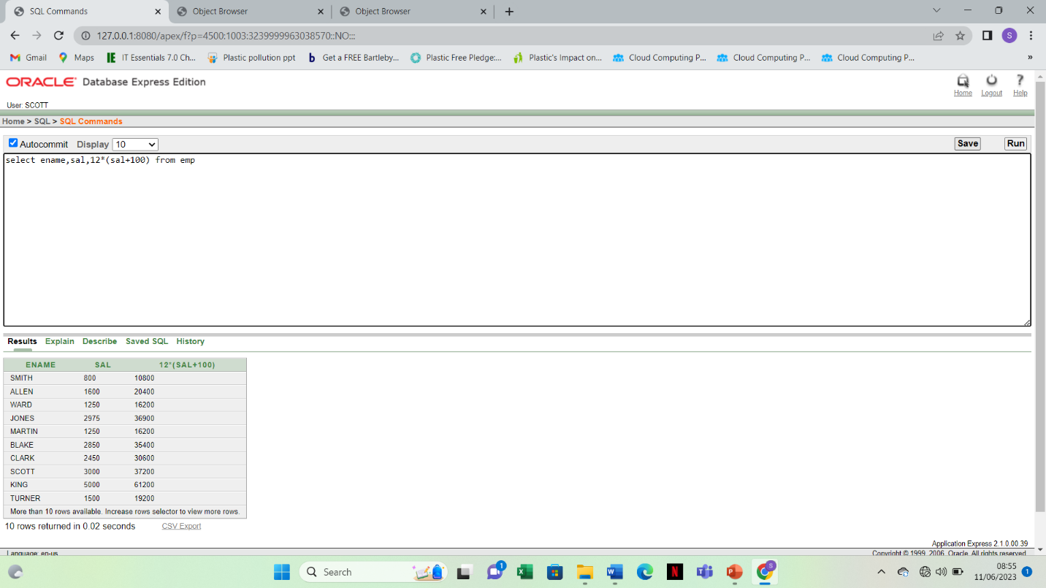

6. select ename , 12\*sal+comm from emp where ename = ‘KING’

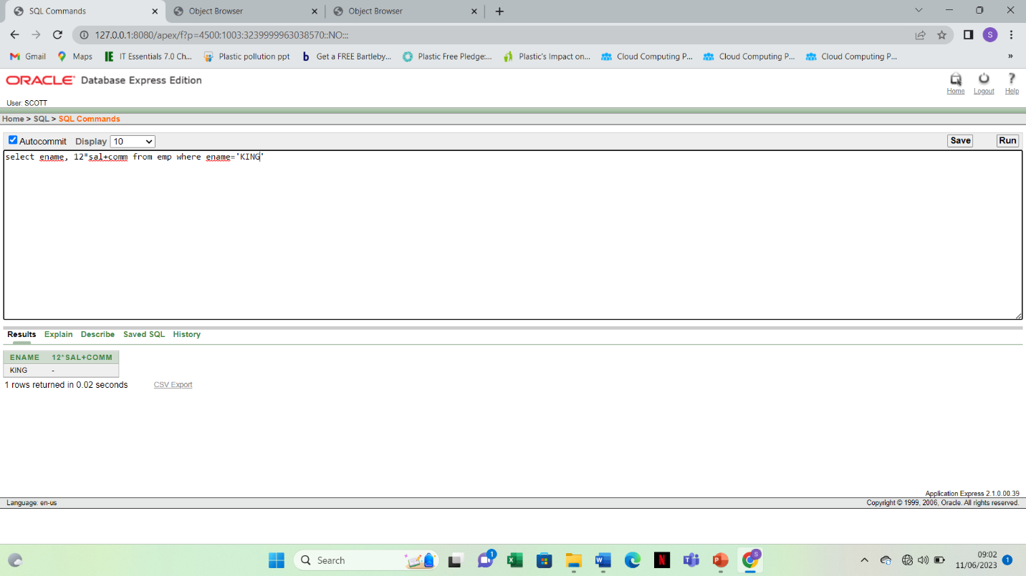

7.select ename as name,sal salary from emp

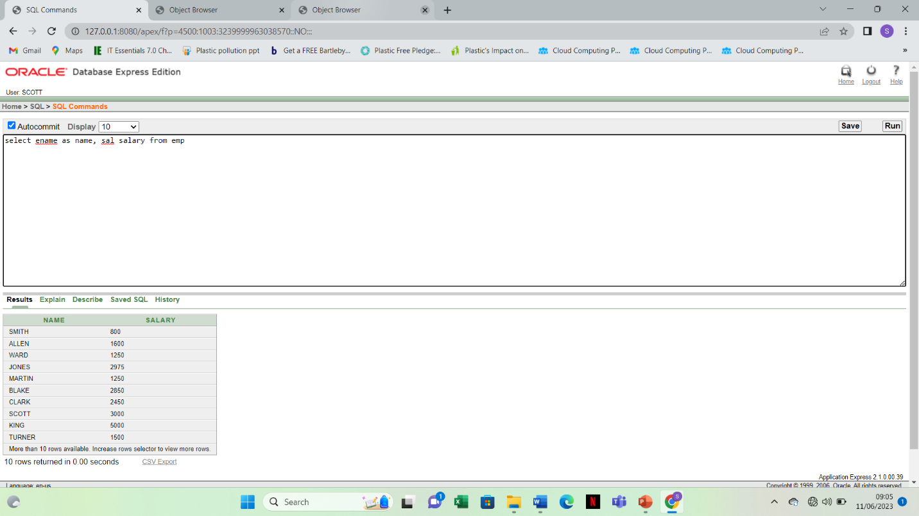

8. select ename “Name”,sal\*12”Annual Salary” from emp

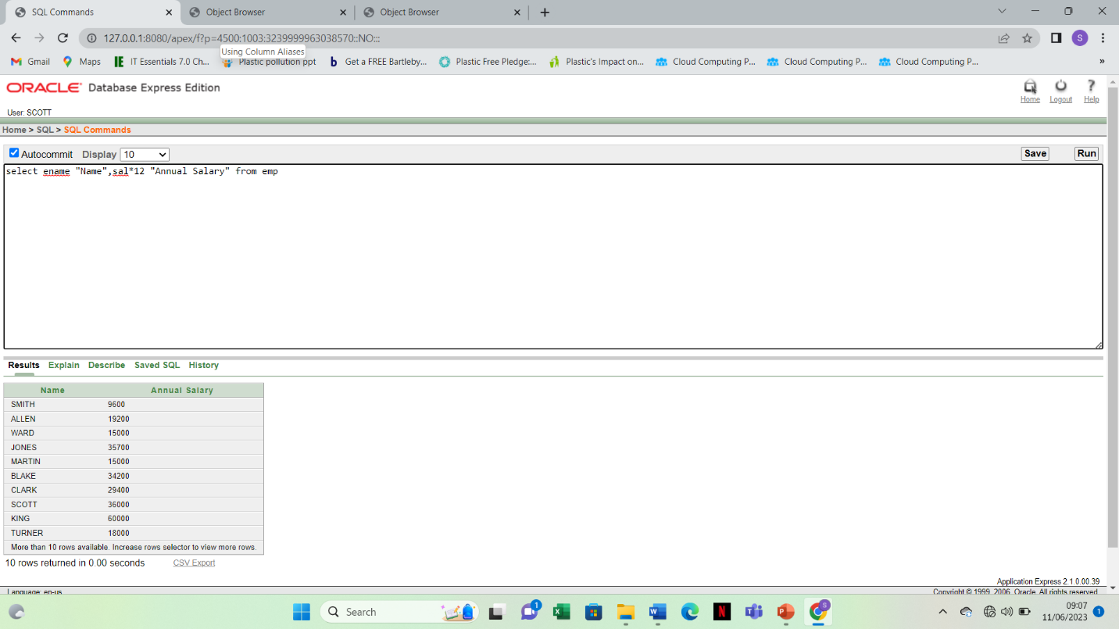

9. select ename || job as “EMPLOYEES” from emp

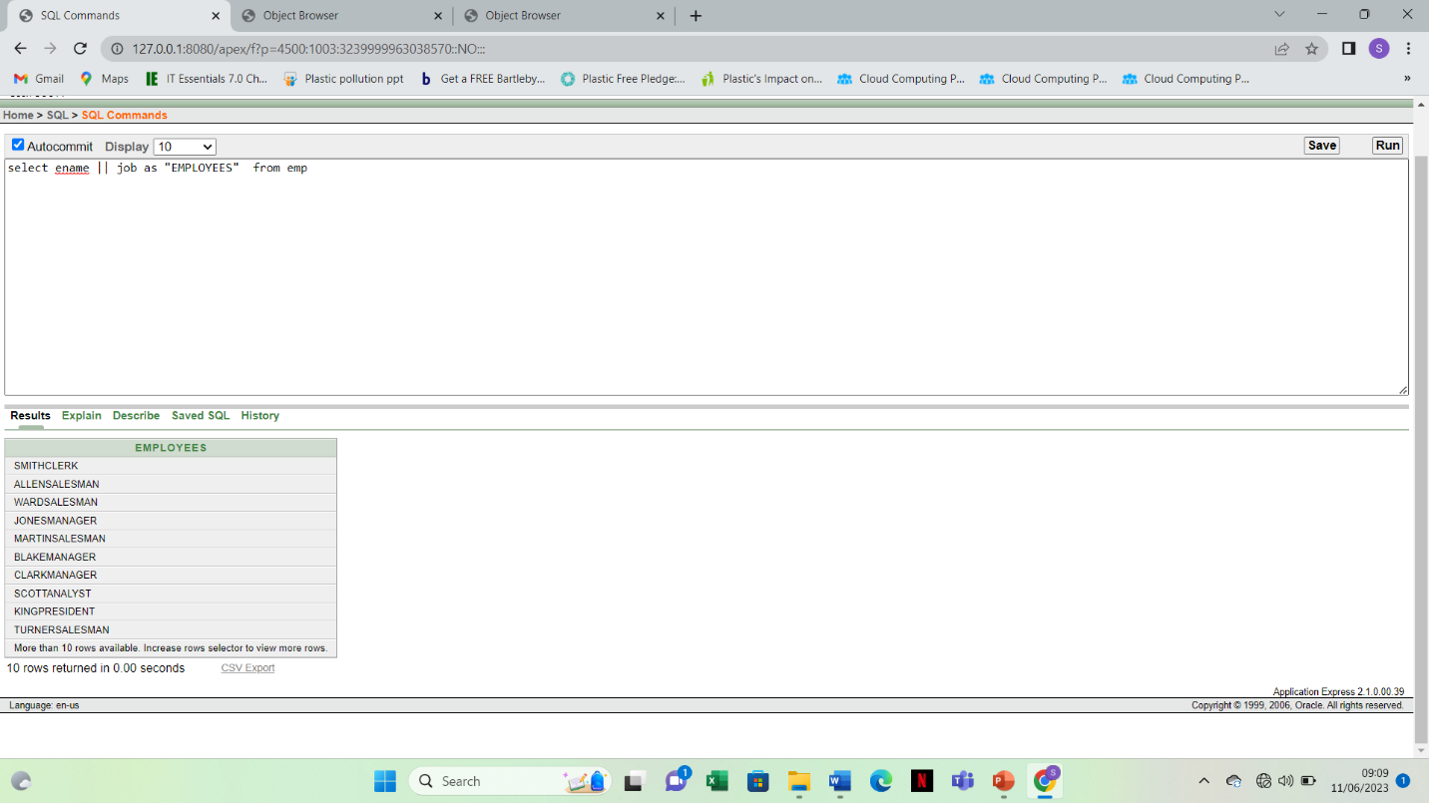

10. select ename || ‘ ’||’is a’ ||’ ’||’Excellent’||’ ’|| job as “Employee Details” from emp

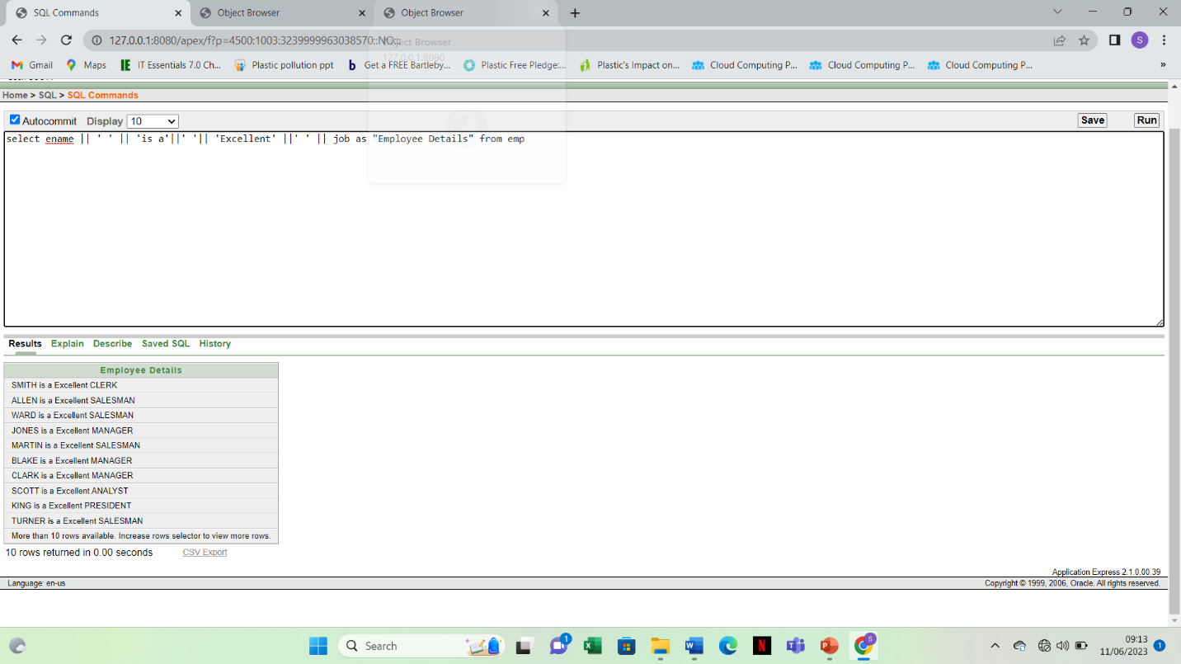

11.select distinct deptno from emp

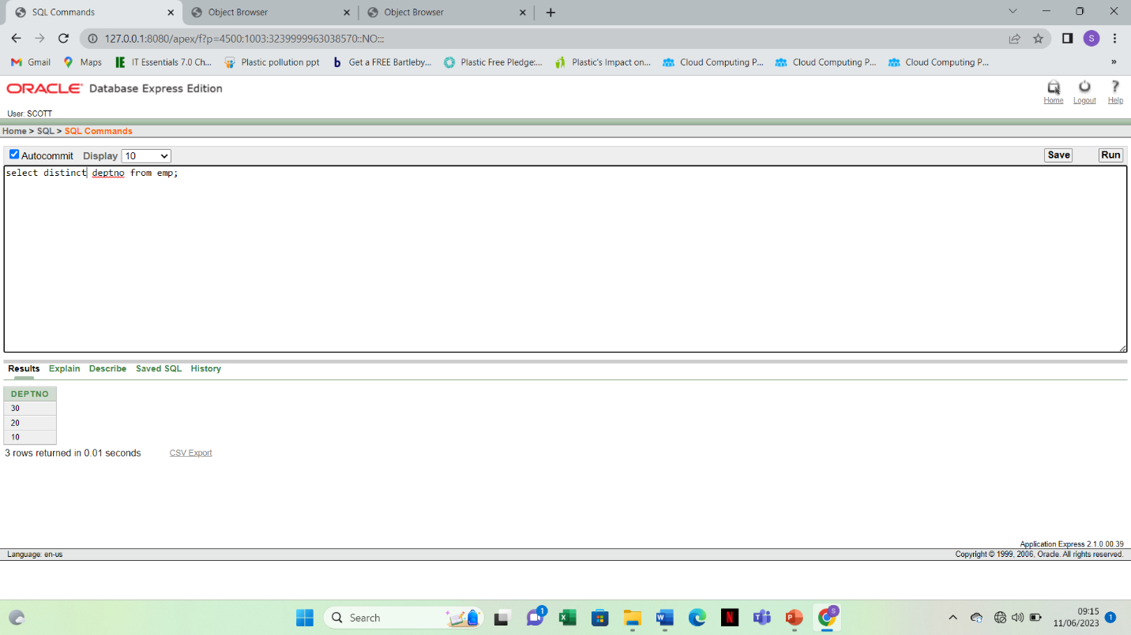

12 describe dept

