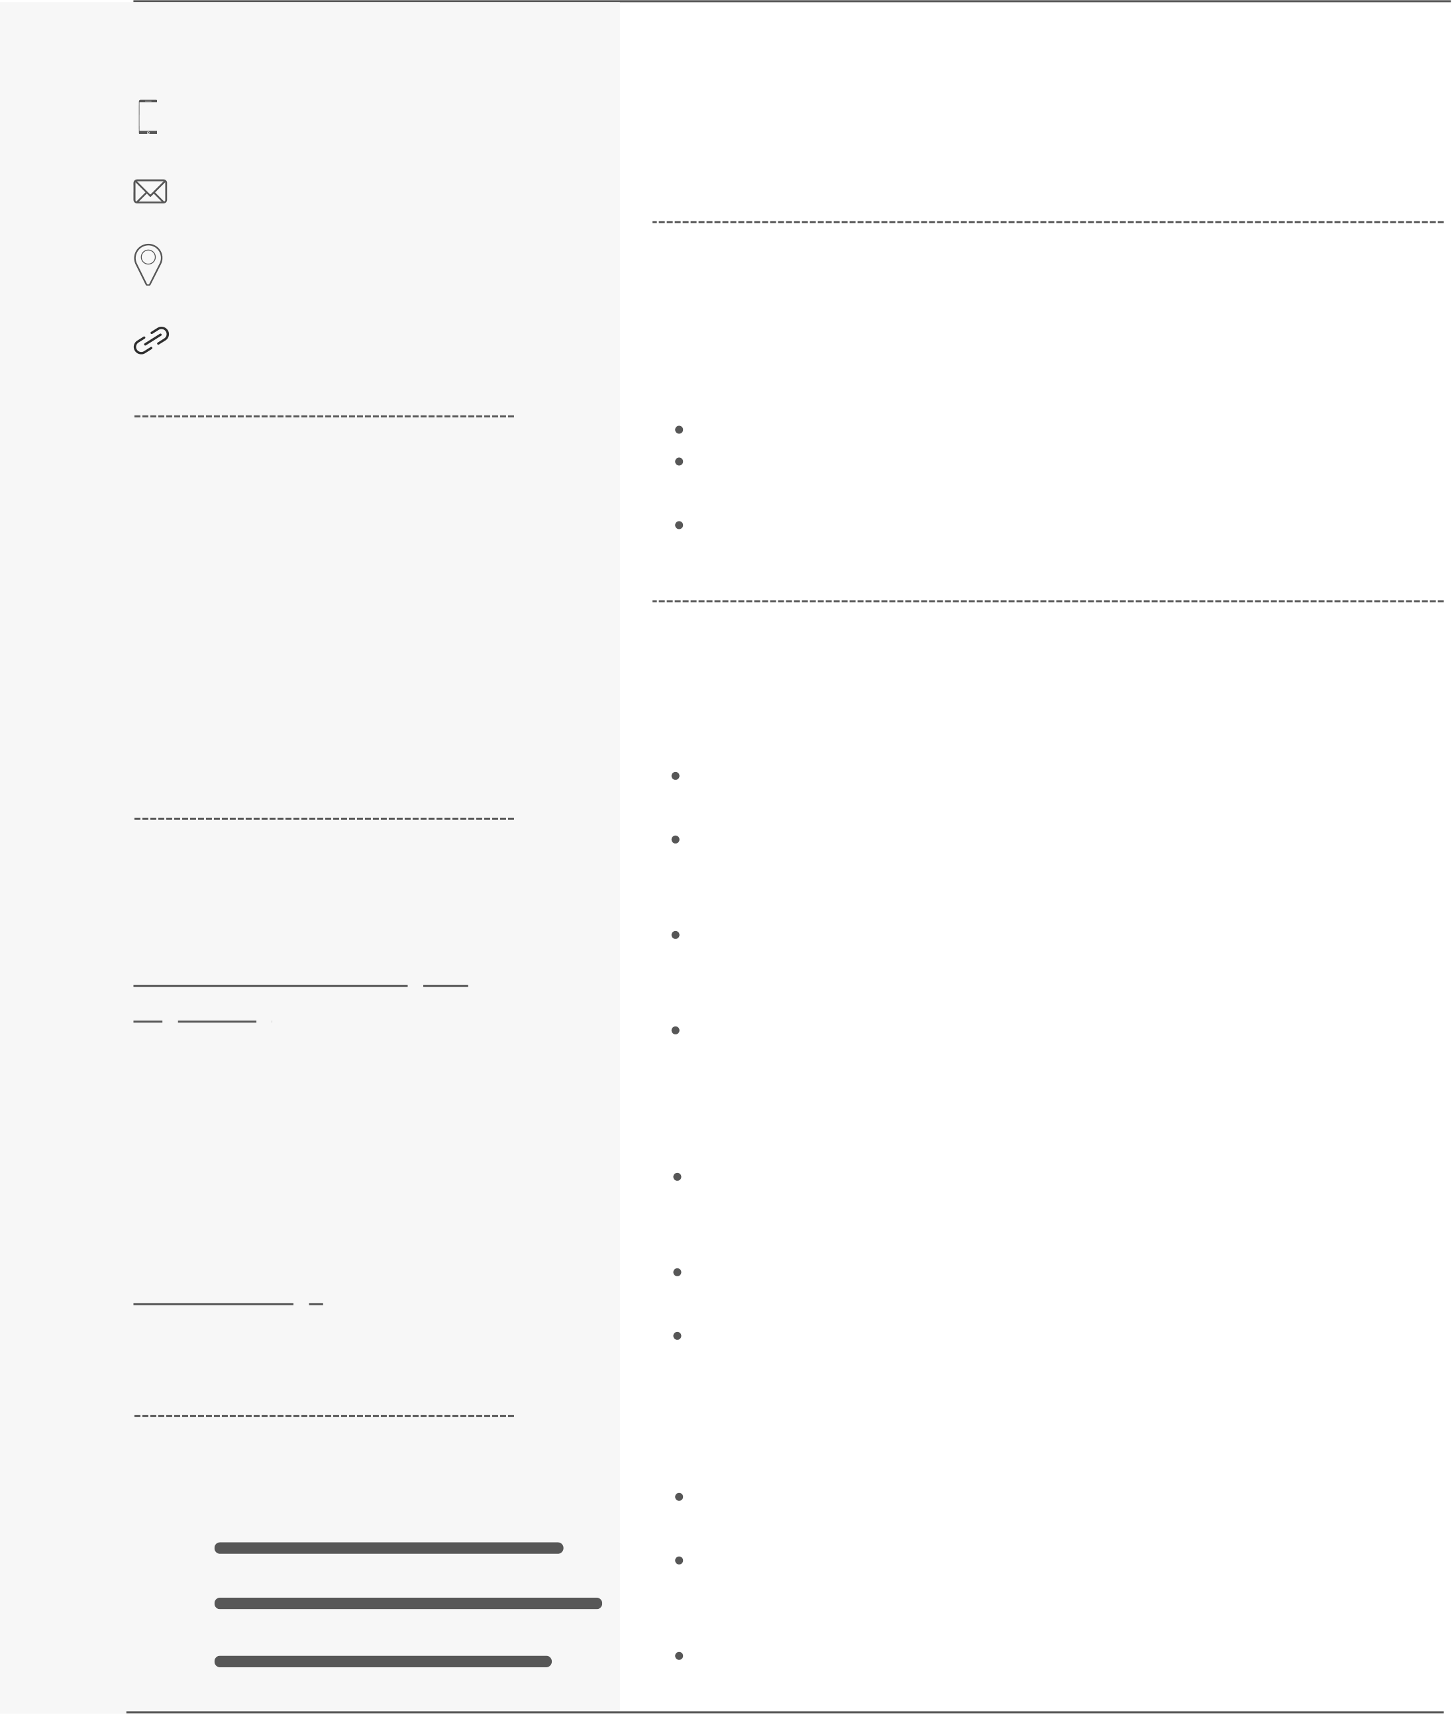

S H A R J E E L A L I M O M I N

C O M P U T E R E N G I N E E R

|  |  |  |
| --- | --- | --- |
| **s h a r j e el.3119030.co@mhssce.ac.in**   9987252182  9987252182  Mumbai, India  [Gathering and attracting people th](https://www.linkedin.com/in/sharjilali133/)rough social media platforms to join CSI. | **P R O F I L E**  Goal oriented, focused computer science student with bachelor's degree in B.E (CS) from MH Saboo Siddik College of Engineering. I aspire to become a professional data analyst and python developer..  **w w w . l i n k e d i n . c om/in/sharjeelali133**  **Mithibai College** | |
| 2017-2019 71.85% | Urdu |

Analysing and managing all social media platforms for the organisation. **M u m b a i, India**  English

Python Django Hindi

Python Django

Data-Analysis pandas sklearn

|  |  |
| --- | --- |
| Database SQL MySQL ML Django-REST-framework | **P R O J E C T S**  **Ecommerce Website (MyAwesomeCart) using Django** Designed and developed a fully functional e-commerce website using |

Django ensuring seamless user experience.

|  |  |
| --- | --- |
| **E D U C A T I O N** | Different essential functionalities like shopping cart, checkout process, product page, Search engine, bill generation and payment gatewa |

**Database SQL MySQL ML** HTML/CSS OOPS Javascript jQuery Engineering

y inetgration(paytm) were implemented.

Different technologies used in implementation process are Django, Python, HTML/CSS, JavaScript, jQuery, Sqlite, payment gatewa y integration(i.e. paytm)   
Utilized Django's admin panel for easy management of products,

2019-2023 CGPA-8.3 orders, and user accounts.

M.H Saboo Siddik College of Enginee ring

**2021-2022**   
Computer Society of India MHSS Chapter

|  |  |
| --- | --- |
| **HSC**  Studied and developed new technical skills and acquired knowledge of the computer field. | Analysing and managing all social media platforms for the organisati on. |

2017-2019 71.85%

Analysing all the data from all platforms to enhance user- engag ement and draw a conclusion out of it.

**A python program that can analyze all of your chatting data for each single user as well as for overall group to gain insights of on the data that are being shared.**

|  |  |
| --- | --- |
| **G o a l o r i ented, focused computer science student with bachelor's degree in B.E (CS) from MH Saboo Siddik College of Engineering. I aspire to become a professional data analyst and python developer..** English  Hindi  Urdu | Analysis includes analyzing emojis used, most busy user, month ly and daily time line, total massages, total link shared etc etc.  cleaned and manipulated data and then performed all the ana lysis using python libraries such as pandas, matplotlib, seaborn e tc  different python libraries are used to filter and manipulate data |

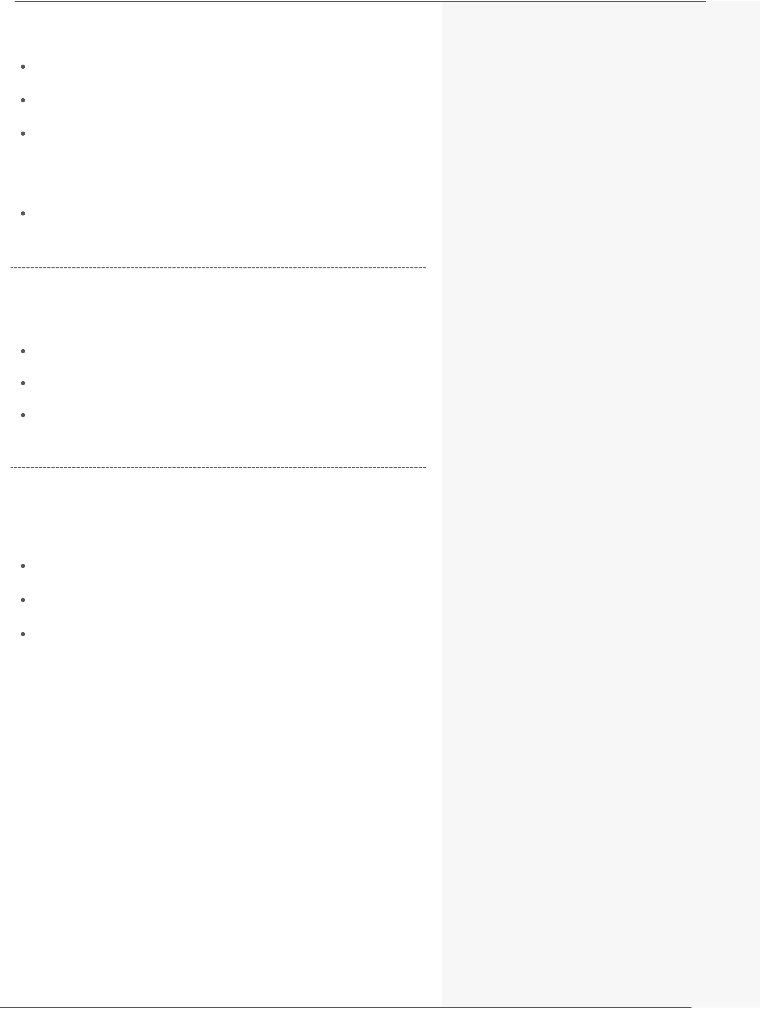

**LinkedIn : www.linkedin.com/in/sharjeelali133**

Cleaned and manipulated a data and performed Exploratory data analysis (EDA)   
Coding learning new skills Cycling

Gym & Fitness Cooking Travelling

**Portfolio Website**

Cleaned and manipulated a data and performed Exploratory data an alysis (EDA)

**A p o r t f o l i o W e b s i t e w i t h a ll the academic details about projects and certifications is created using HTML, CSS and Javascript**

imporoved customer experience by identifying potential customers across different states, occupation, age groups and gender

Programming with JavaScript by Meta

improved sales by identifying most selling product categories, which can help to plan inventory and hence meet the demands.

**S O C I A L P A G E S A N D W E B S I T E S**

**Data Analytics** Training Program by Godrej

**Programming** with JavaScript by Meta

**HTML and CSS** [in depth by Meta](https://www.linkedin.com/in/sharjilali133/)

**H O B B I E S A N D I N T E R E S T** Portfolio : https://sharjeel30.github.io/Portfolio-Website/

GitHub : https://github.com/Sharjeel30