Practice Lab 04

Q1. Consider a database system for company management system. Draw ERD on the given scenarios. If you think that any information is missing in scenario, you can take sensible assumption and solve. The data requirements are summarized as follows:
Business Case: Company Management system
Company has several departments. Each department may have several Locations. Departments are identified by a name, d_no, Location. A Manager control a particular department. Each department is associated with number of projects. Employees are identified by name, id, address, job, date_of_joining. An employee works in only one department but can work on several project. We also keep track of number of hours worked by an employee on a single project. Each employee has a dependent Dependent has D_name, Gender, and relationship.
Draw ERD on the above-mentioned scenario
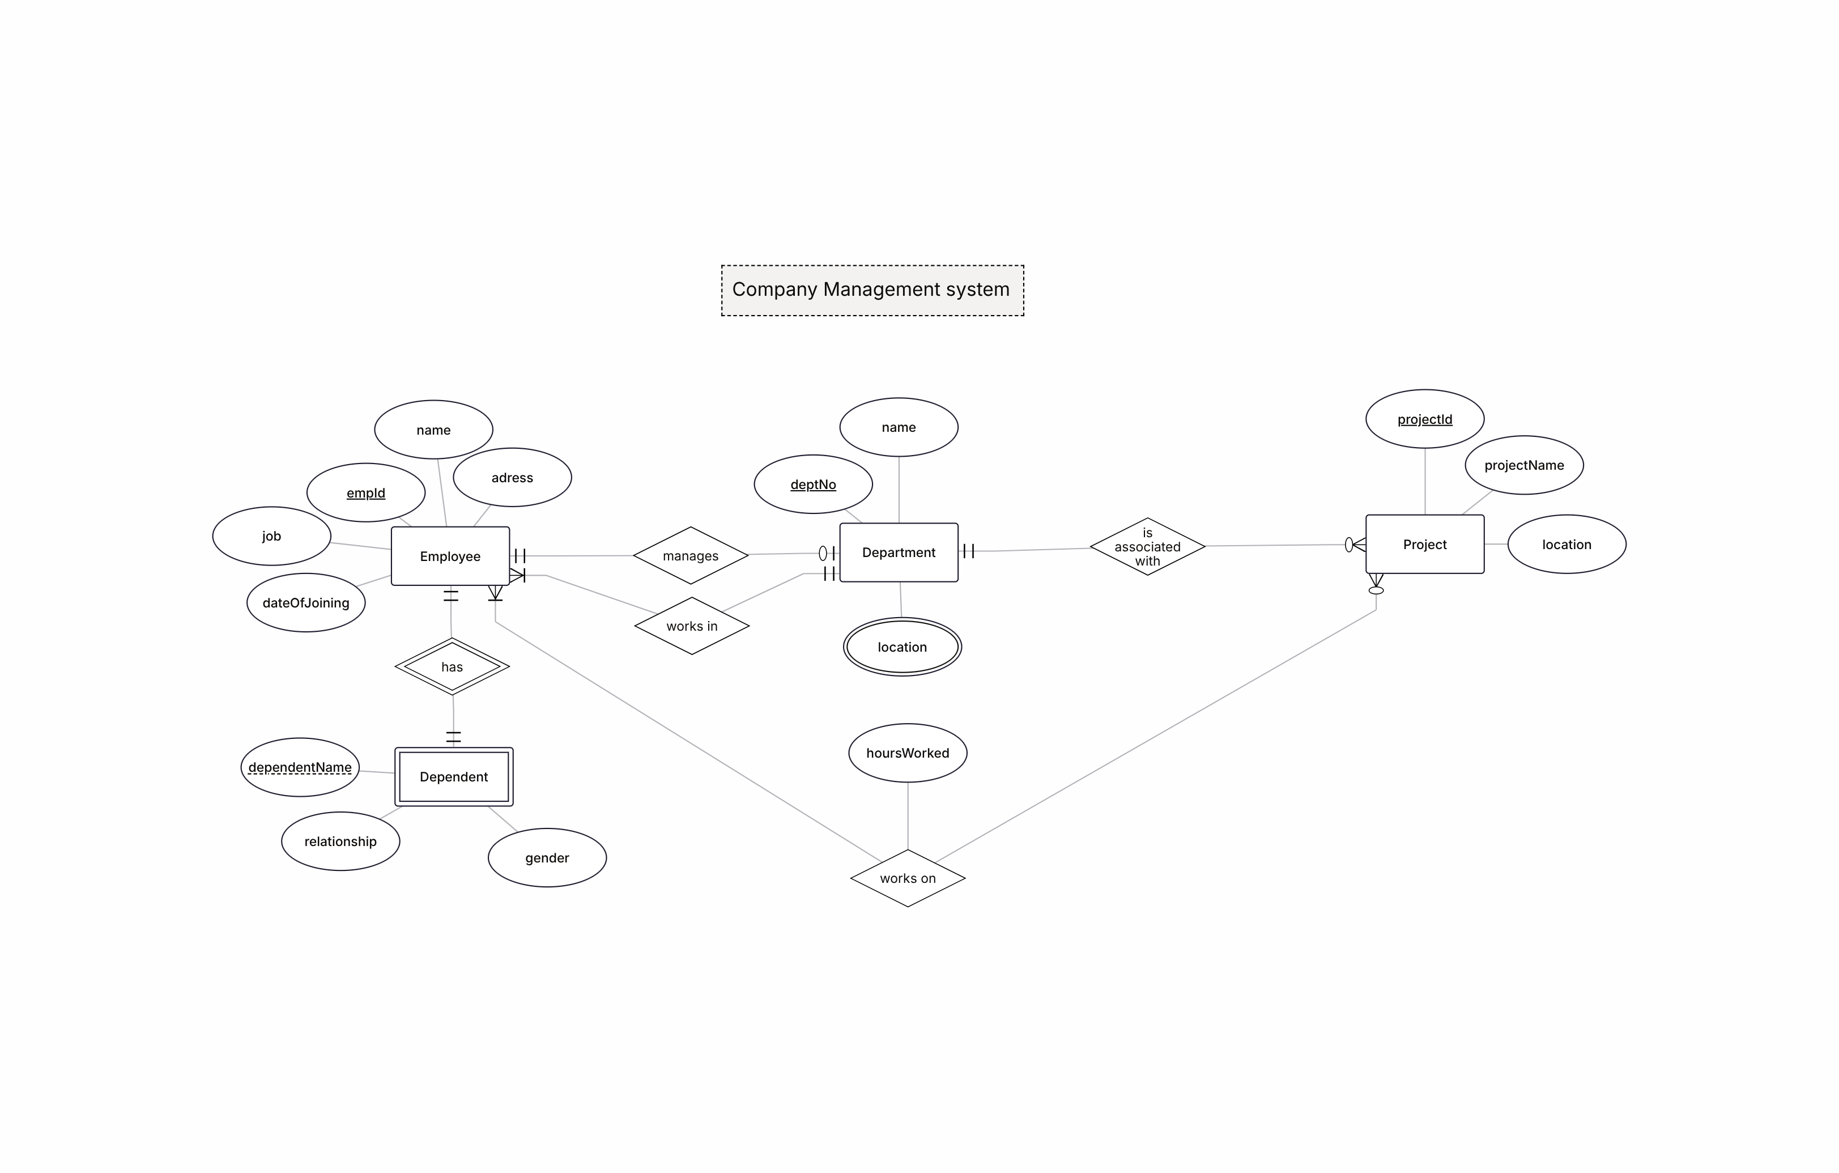

Q2. Dental Clinic Management System
A dental clinic wants to maintain a computerized system to manage patients, appointments, treatments, prescriptions, and materials used during treatments. The clinic keeps patient details such as patient ID, name, date of birth, sex, blood group, nationality, email, mobile number, address, and place. A patient can take appointments with the clinic. Each appointment has an appointment ID, appointment date, appointment time, patient ID, and patient name. When a patient visits the clinic, the dentist may perform a treatment. Each treatment record includes treatment number, treatment date, treatment name, notes, fees, and a material list. A treatment is associated with a specific patient and is also linked with a treatment master that stores the standard information about different treatments. During treatment, the dentist may write a prescription for the patient. The prescription contains details such as prescription date, medicine name, dosage, number of days, category, and patient ID. Some materials may also be required during treatment. These materials are recorded in the system. The system also stores medicine types, which include medicine ID, medicine name, and medicine type. Treatments may use different medicine types depending on the patient’s condition. This system helps the clinic manage patient records, appointments, treatments, prescriptions, and materials efficiently.
Draw ERD on the above-mentioned scenario
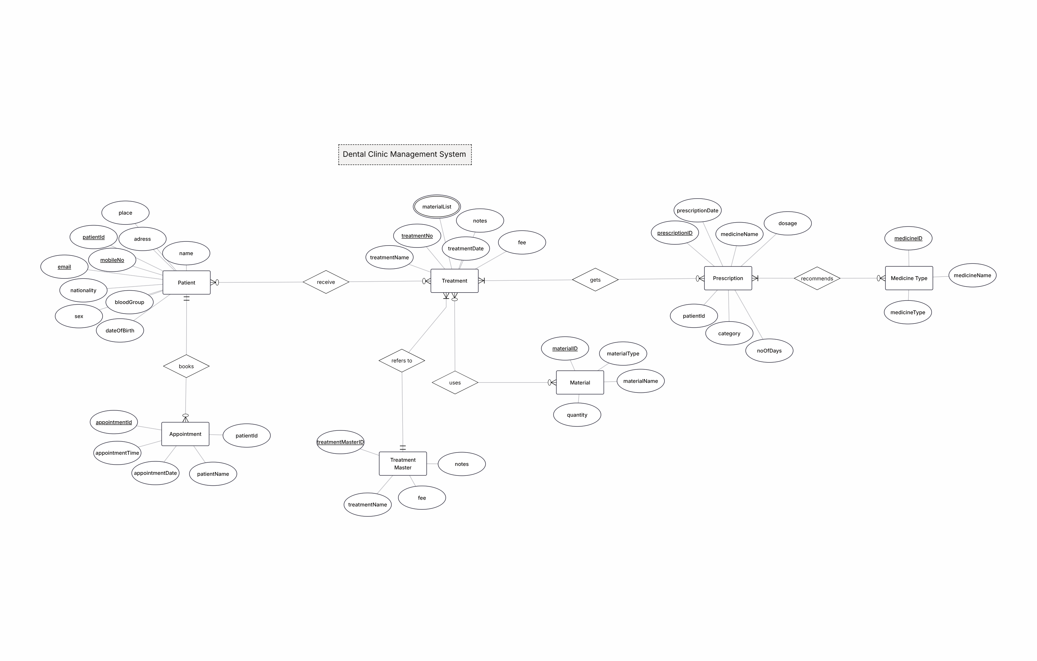
Q3. Faculty Information System
A university wants to develop a Faculty Information System to manage and store information about faculty members. The system keeps basic details of each faculty member such as ID, name, department, school, and telephone number. The system has different types of users. One type is Common User, who can access the system to make inquiries about faculty information. Each common user has a user ID, username, and password. Many common users can search or inquire about faculty information stored in the system. Another type of user is the Administrator. The administrator manages the system and provides different services related to faculty records. Each administrator also has a user ID, username, and password. The system also includes Teacher Users, who are faculty members themselves. Teacher users can modify or update their faculty information when needed. Each teacher user also has a user ID, username, and password. Through this system, common users can view faculty information, administrators can manage the system services, and teacher users can update their own records. This helps the university maintain accurate and organized faculty information.
Draw ERD on the above mentioned scenario
