
Programming Fundamentals
Class Assignment # 1

Total Marks: 30 Instructor Name: Faiza Khadim Deadline: 31-03-25 till 11:59 PM

Instructions:
- You have to submit two files i.e.
  - CPP file of the program
  - CPP should be combined with files into zip folder.
- You have to upload your assignments on CMS.
- All program codes should be written in C/C++. Students should use Visual studio compiler for coding.
- Plagiarism in the work is Professional dishonesty which leads to strict disciplinary action and zero in grading of Assignment.

CLO NO | CLO STATEMENT | PLO | Taxonomy LEVEL
2 | Be able to apply fundamentals building blocks of a programming language to solve problems. | 2 | C3
Question 1: [10-Points]
Write a program that reads the file sample.txt. The format of the file is full name, registration number, and obtained marks of Assignment, Quiz, Mid, Final from. Consider the following weightage
Graded Tasks Total Marks Weightage (%)
Assignments 20 15%
Quizzes 20 15%
Midterm 30 25%
Final Term 45 45%
Calculate the grade using above details, and consider UCP grading scheme. Now store the name, registration and grade in “result.txt”, on the basis of weightage. UCP grading scheme is given below.
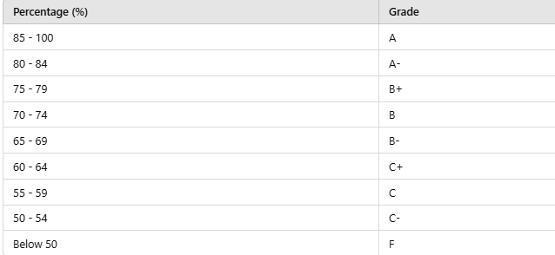
Expected Output
sample.txt
Ali Ahmad, L1F17MSCS0011, 14, 14, 24, 43
result.txt
Ali Ahmad, L1F17MSCS0011, 79.7%, A⁻
Question 2: [10-Points]
Write a C++ program in which, read a c-string word from “word_frequency.txt”. Your task is to store the word with its length separated by a coma into another file “word_lenght.txt”. Find the word which has max length on the console.
Example:

word_frequency.txt | Word_length.txt
This course will also enable the students to develop practical applications | This ,4  Course ,6  will ,4  also ,4  enable ,6  the ,3  students ,8  to ,2  develop ,7  practical ,9  applications, 12
Max word: applications, 12
Question 3: [10-Points]
Write a C++ program in which, read data from “Employee.txt”. Your program should have many driven solution and user should press ‘Y’ to continue and press ‘N’ for terminate. You have to do the following tasks:
Employee.txt
Employee Salary Department
Ahsan Khan, 50000, IT
Alia Shams, 60000, Management
Najam ul Saqib,30000, Sales
Ahmer Javed, 50000, HR

Expected Output:
*********Employee System******************
- Press ‘S’: Add more 5 records in the file with existing file format.
- Press ‘P’: Print all records on console.
- Press ‘E’: Find the employee which has max salary on the console.
- Press ‘D’: Department wise searching.
- Press ‘R’: Write all the record into another file except the one who is going to leave the department.
- Press ‘X’ : exit.

End of Assignment1

