Programming Fundamentals

Lab 13
Topic | 2D array basic
Objective | - 2D ARRAYS  - Concept of 2D array as array of arrays.  - Declaring and initializing 2D arrays.  - Memory model of 2D array.  - Accessing individual elements in 2D array.  - Discuss why column size of each row must be same.  - Traversing 2D array (row-wise, column-wise, diagonally)  - Handling 2D arrays using 1D array functions.  - Problem solving involving 2D arrays.

Lab Description:
This lab is basically designed for the basic understanding of 2D array and its use.
Two-dimensional Arrays:
The simplest form of multidimensional array is the two-dimensional array. A two-dimensional array is, in essence, a list of one-dimensional arrays. To declare a two-dimensional integer array of size [rowSize][ColumnSize], you would write something as follows –
SYNTAX:
dataType arrayName[rowSize][columnSize];
To declare a 2D array of type Integer with 2 rows and 4 columns:
int arr[3][4];
Initializing Two-Dimensional Arrays:
Multidimensional arrays may be initialized by specifying bracketed values for each row. Following is an array with 3 rows and each row has 4 columns.
int arr[3][4] = { { 0, 1, 2, 3 }, { 4, 5, 6, 7 }, { 8, 9, 10, 11 } };
The nested braces, which indicate the intended row, are optional. The following initialization is equivalent to the previous example
int arr[3][4] = { 0, 1, 2, 3, 4, 5, 6, 7, 8, 9, 10, 11 };
Memory model of Two-Dimensional Array:
Two-Dimensional array basically define as matrix form, but in actual it contains same memory map like one dimensional. Each index of a 2D array mapped on a 1D array.
Example:
2D array: | 1D array:
  arr | [0] | [1]
  [0] | 11 | 21
  [1] | 35 | 14
  [2] | 51 | 63
   | [0] | [1] | [2] | [3] | [4] | [5]
  arr | 11 | 21 | 35 | 14 | 51 | 63
Accessing Two-Dimensional Array Elements:
An element in a two-dimensional array is accessed by using the subscripts, i.e., row index and column index of the array.
Example:
int val = arr[2][3];
The above statement will take the 4th element from the 3rd row of the array. You can verify it in the above figure. Let us check the following program where we have used a nested loop to handle a two-dimensional array.
Example:
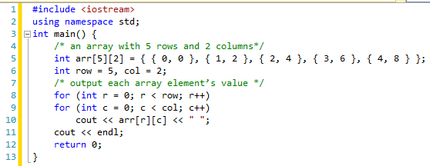

Handling 2D arrays using 1D array functions:
We can handle 2D array using 1D functions. Because each row of a 2D array can be used as 1D array. So we can use all function for each row of a 2D array which we define for 1D array.
Example:
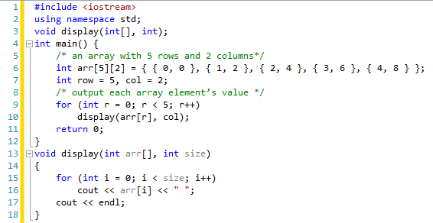

Lab Tasks
Quiz Score Problem:
In a course there are multiple quizzes in every semester. On average there are 6 quizzes in every course. Some of the students perform well in some quizzes and some are not. But we need to maintain the record of all quizzes which are conduct in semester for performing different analysis.
Some analysis which are performed on the above mention data are:
- Identify the student with maximum marks
- Identify the students who have below average marks in any quiz.
- Identify the student who missed 50% or above quizzes.
- Sort the marks of each student to identify the performance.

Quizzes have 15% weightage in total grade.
- Calculate the marks obtained out of 15 consider average of all quizzes.
- Calculate the marks obtained out of 15 consider top 4 quizzes.

Normalize the marks of each quiz and perform the all above operations and compare the results.

