Table of Contents
1. Background 1
2. Dataset & Pre-processing 2
3. Methods 2
3.1 Model Heads & Multi-Task Learning 2
3.2 Baseline CNNs (Transfer Learning) 2
3.3 Training Setup 3
4. Evaluation Metrics 3
4.1 Categorical (Expressions) 3
4.2 Continuous (Valence/Arousal) 3
5. Results 4
5.1 Classification Test Set 4
Training/validation curves (loss & accuracy): 4
Confusion matrices: 7
5.2 Continuous Valence & Arousal 7
6. Qualitative Analysis (Correct / Incorrect / Borderline) 8
7. Discussion 10
8. Reproducibility 10
9. Conclusion 11

1. Background

Affect refers to the outward expression of emotion. Affective computing aims to model and infer human effect from signals such as the face, voice, and physiology. Faces are a key non-verbal channel; therefore, we study both categorical emotion recognition (8 classes: Neutral, Happy, Sad, Surprise, Fear, Disgust, Anger, Contempt) and dimensional affect (continuous valence ∈ −1, +1 and arousal ∈ −1, +1).
The dataset provides cropped 224×224 RGB faces, 68 facial landmarks, categorical labels, and valence/arousal annotations. Valence reflects pleasantness; arousal reflects activation (calm→excited).

2. Dataset & Pre-processing
- Data: Images, annotations.
- Filtering: Samples with valence/arousal = −2 (Uncertain/No-face) removed.
- Split: Stratified train/validation (from the training set) and test split (80/20 overall).
- Transforms (train): RandomResizedCrop (224), HorizontalFlip, ColorJitter/RandAugment, normalize (ImageNet mean/std), RandomErasing.
- Transforms (Val/test): Resize → CenterCrop (224), Normalize.

3. Methods

3.1 Model Heads & Multi-Task Learning
All backbones feed a two-head multi-task head:
- Classification head → 8 logits (Cross-Entropy with label smoothing and class weights).
- Regression head → 2 outputs (valence, arousal) with Smooth L1 loss.

3.2 Baseline CNNs (Transfer Learning)
We used ImageNet-pretrained backbones (transfer learning), then:
- Phase A (warm-up): freeze backbone for first 3 epochs (train only heads).
- Phase B (fine-tune): unfreeze entire network with a lower LR.
Backbones compared
- ResNet18 (classic residual baseline; light & fast)
- ResNet50 (deeper residual network)
- DenseNet121 (dense connectivity for gradient/feature reuse)
- EfficientNet-B0 (parameter-efficient compound scaling)

3.3 Training Setup
- Optimizer: AdamW (lr=1e-3, weight decay=1e-4)
- Scheduler: ReduceLROnPlateau (on Val loss)
- Batch size: 32
- Epochs: 30
- Regularization: label smoothing (0.1), class-balanced sampler, MixUp (α=0.2), RandomErasing
- Device: Google Colab GPU.
- Reproducibility: fixed seeds, results saved.

4. Evaluation Metrics

4.1 Categorical (Expressions)
- Accuracy: overall correctness.
- F1-macro: balances precision/recall across classes (robust to imbalance).
- Cohen’s κ and Krippendorff’s α: inter-rater reliability style agreement between prediction and ground truth.
- ROC-AUC (OvR) and PR-AUC (macro) threshold-independent quality.

4.2 Continuous (Valence/Arousal)
- RMSE: magnitude of error (lower is better).
- Pearson’s r: correlation with ground truth (higher is better).
- SAGR: sign agreement (right side of valence/arousal axis).
- CCC (Concordance Correlation Coefficient): combines correlation with mean-level agreement

5. Results

5.1 Classification Test Set

Model | Accuracy | F1-macro | Cohen’s κ
DenseNet121 | 0.469 | 0.469 | 0.393
ResNet18 | 0.439 | 0.438 | 0.359
EfficientNet-B0 | 0.427 | 0.424 | 0.346
ResNet50 | 0.401 | 0.395 | 0.316
Observation. DenseNet121 performed best on accuracy, F1, and κ, indicating better feature reuse/regularization on this dataset. ResNet50 underperformed (likely overfitting on limited data and less forgiving without GPU-level tuning).

Training/validation curves (loss & accuracy):

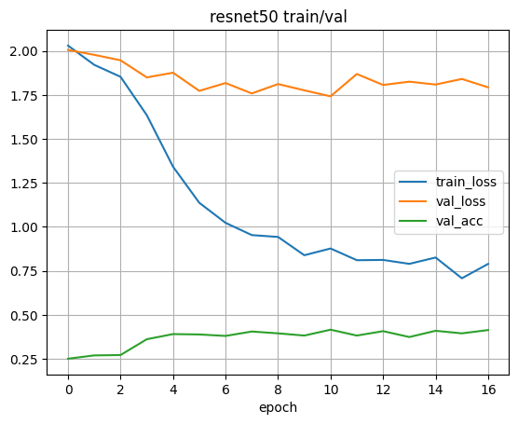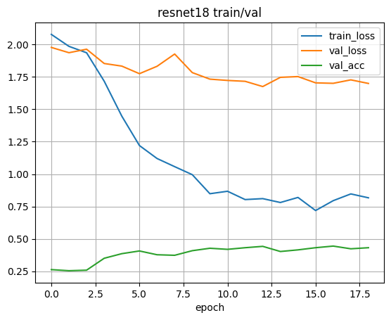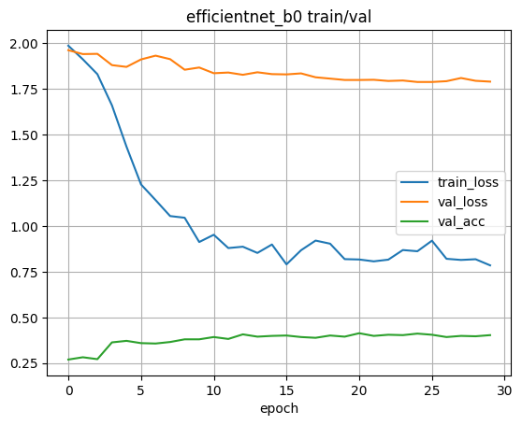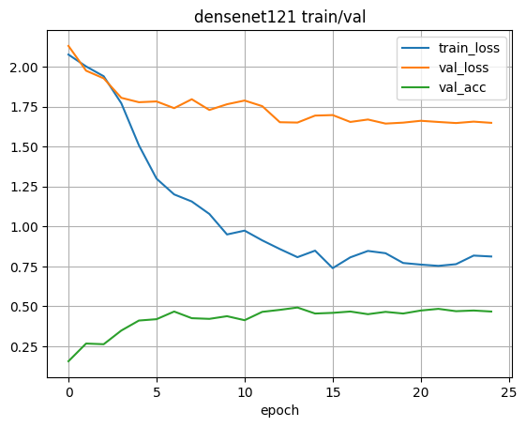

Confusion matrices:
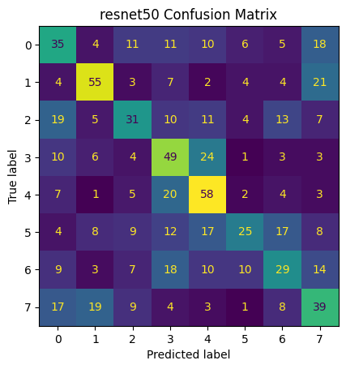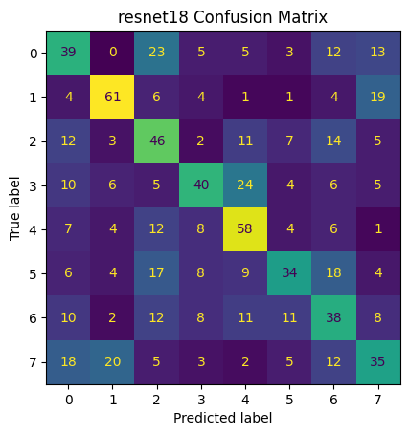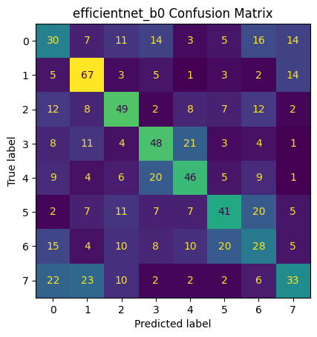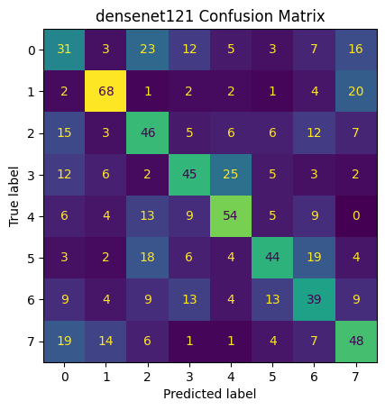

5.2 Continuous Valence & Arousal
We report RMSE, r, SAGR, and CCC per model in the JSON result files:
- results_densenet121.json
- results_resnet18.json
- results_efficientnet_b0. json
- results_resnet50.json
Takeaway. CCC is emphasized as the most indicative metric for deployment because it balances correlation with bias/scale alignment; models with higher CCC are preferred for real-world affect tracking.

6. Qualitative Analysis (Correct / Incorrect / Borderline)
To understand model behavior beyond metrics, we plotted top-K examples for DenseNet121:
- Correctly classified: confident predictions, clear visual cues
- Incorrectly classified: common confusions (e.g., Fear ↔ Surprise)
- Borderline: low-margin predictions and ambiguous faces
Insert Figure 3: Qualitative grids
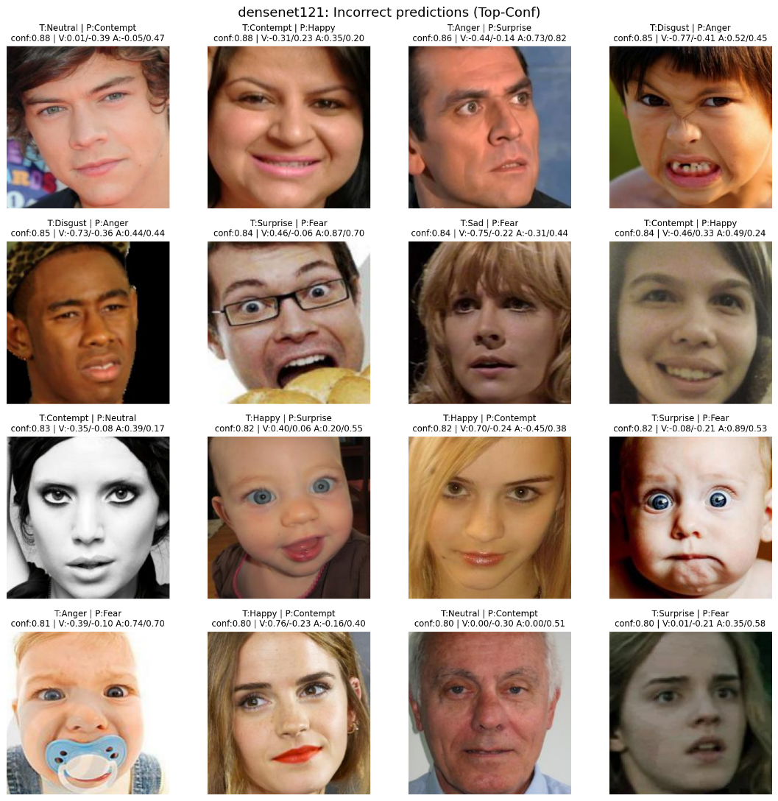
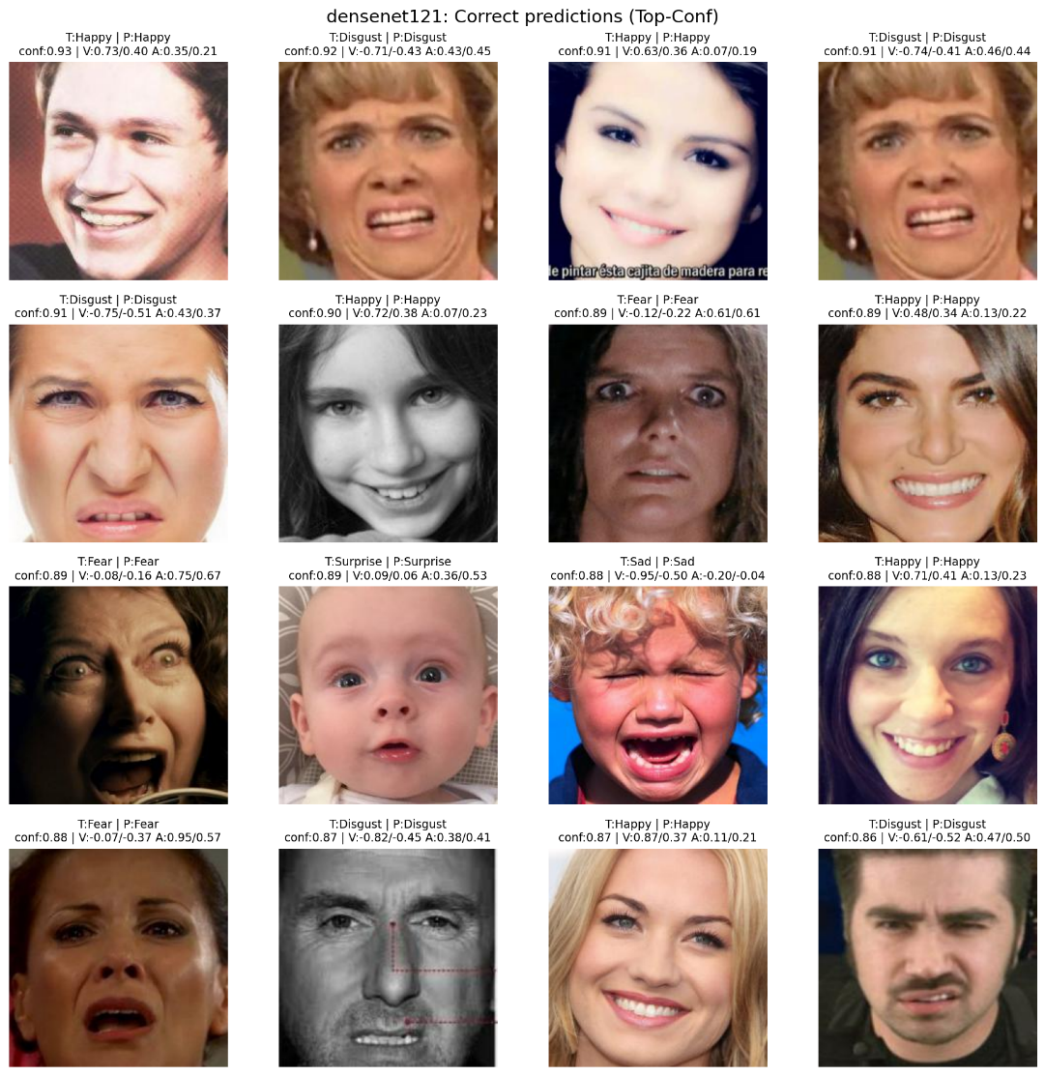
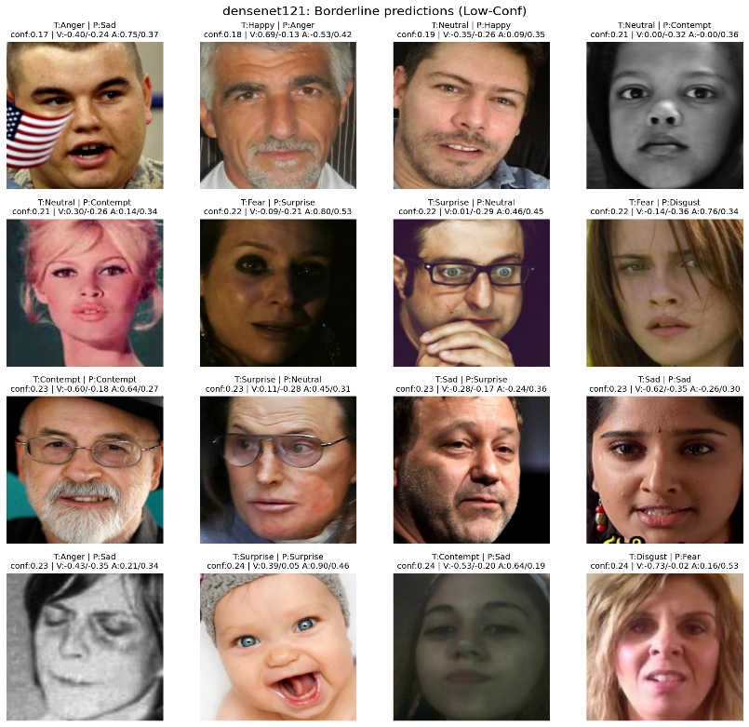
CSV of all test predictions: qualitative_predictions.csv (includes file paths, true/pred labels, probabilities, valence/arousal preds/targets)

7. Discussion
- Why DenseNet121 wins: Dense connections encourage feature reuse and stable gradients, which helped on our moderate-sized dataset with eight subtle classes.
- ResNet50 underperformance: deeper capacity without stronger regularization and limited compute led to slower convergence and possible overfit.
- Continuous metrics: CCC and SAGR are particularly relevant for “in the wild” systems since users care about correct direction (positive vs negative) and consistent scale.
If we aimed for 60–70% + accuracy, we would:
- Train longer with GPU (mixed precision, bigger batches).
- Stronger augmentations (CutMix, RandAugment tuned), curriculum or class-aware sampling.
- Use larger modern backbones (ConvNeXt-Tiny, EfficientNet-B2/B3) or Vision Transformers with regularization.
- Add facial landmarks/multi-modal features (landmark heatmaps as auxiliary input).
- Class-imbalance handling (focal loss, LDAM, or improved class weighting).
- Hyper-parameter search (LR, weight decay, λ for VA loss).

8. Reproducibility
- Notebook: i212699_MuhammadSharjeelNadir_A1_CS4045.ipynb
- Output (saved):
  - Checkpoints: best_*.pth
  - Curves: figures/curves_*.png
  - Confusion matrices: figures/cm_*.png
  - Test predictions CSV: qualitative_predictions.csv
  - Model-wise JSON metrics: results_*.json
  - Comparison table: comparison_multi.json

9. Conclusion
This assignment evaluated multiple CNN baselines for facial affect recognition in both categorical and dimensional domains using transfer learning. DenseNet121 achieved the best balance of accuracy and reliability metrics. For deployment, CCC should be prioritized alongside SAGR for valence/arousal. With GPU training, broader augmentation, and modern architectures, the system can be pushed further toward state-of-the-art results.

