Kagome Lattice – Open Science 2022

This is a solution for the quantum state preparation of the Kagome Lattice in a quantum computer for the open science challenge 2022. The solution is implemented as a python program (kagome_solution.py) which delegates its work to the Kagome lattice class (kagome_lattice.py). An auxiliary program (kagome_expected.py) is used to calculate the expected ground state of the lattice.

The goal of the program is to find the ground state of the lattice using the rules described in the open science challenge:

* It uses the VQE algorithm outlined in the Jupyter Notebook.
* It tries to find the ground state with a relative error less than 1%.
* It uses the quantum processor ibmq_guadalupe.

# Implementation

The solution is implemented by feeding all the parameters of the VQE algorithm outlined in the Notebook as command line arguments. Thus, the arguments can be classified as follows.

$ python kagome_solution.py -h

## Common Arguments

All arguments are optional.

|  |  |  |
| --- | --- | --- |
| Name | Description | Default Value |
| -h | Display a command line help. | None |
| -c CN, --cn CN | Connection String: Hub/Group/Project. | ibm-q-community/ibmquantumawards/open-science-22 |
| -b,--run_backend | Quantum processor. | Ibmq_guadalupe |
| -t, --transpile_backend | Transpilation backend. | Ibmq_guadalupe |
| -q, --num_qubits | Number of qubits of the QPU. | 16 |
| -v,--verbosity | Verbosity level (1-5). | 1 |

## Ansatz Options

Control the behavior of the VQE ansatz. All arguments are optional.

|  |  |  |
| --- | --- | --- |
| Name | Description | Default Value |
| -a, --ansatz_type | Ansatz type:   * ExcitationPreserving * EfficientSU2 * PauliTwoDesign * TwoLocal * RealAmplitudes | ExcitationPreserving |

## Optimizer Options

All arguments are optional.

|  |  |  |
| --- | --- | --- |
| Name | Description | Default Value |
| -o, --optimizer_type | Optimizer type:   * SPSA * SLSQP * COBYLA * UMDA * GSLS * GradientDescent * L_BFGS_B * NELDER_MEAD * POWELL * NFT | SPSA |
| -i, --max_iter | Maximum number of iterations or function evals used by the optimizer. | 100 |

## Run time options

Miscellaneous run time options.

|  |  |  |
| --- | --- | --- |
| Name | Description | Default Value |
| -ol, --opt_level | Circuit optimization level (1-3) | 1 |
| -ui, --uniform_interaction | Heisenberg Model uniform interaction value. | Edge weight. |
| -up, --uniform_potential | Heisenberg Model uniform potential | 0.0 |
| -w, --weight | Lattice edge weight. | 2.4 |
| -s,--shots | Number of execution shots. | 2048 |

## Error Correction Options

|  |  |  |
| --- | --- | --- |
| Name | Description | Default Value |
| -r, --resilience_type | Resilience type (1-3):   * T-Rex: 1 * ZNE: 2 * PEC: 3 | 2 |

# How It Works

The solution leverages Qiskit’s runtime VQE algorithm to find the ground state of the lattice (see figure 1).

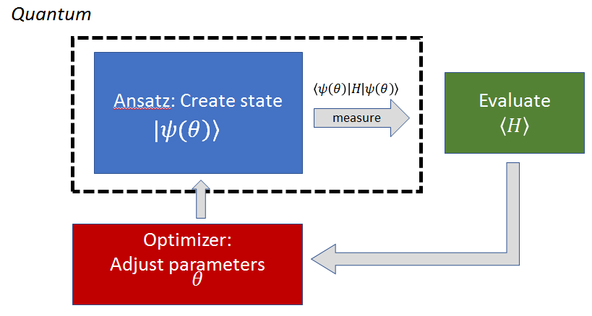

Implementation wise, this is a python program that can be executed from the command line of your laptop. The program requires will execute the VQE algorithm in IBMQ Guadalupe using the following default parameters:

* Ansatz: The heuristic excitation-preserving wave function ansatz.
  + ExcitationPreserving (reps=1, entanglement=’linear’)
* Optimizer: Simultaneous Perturbation Stochastic Approximation (SPSA) optimizer.
  + SPSA (maxiter=100)
* Resilience/Error mitigation: Zero noise extrapolation - ZNE (1).
* Shots: 2048
* Edge weight: 1.0
* Heisenberg Model Uniform Interaction: 1.0
* Heisenberg Model Uniform potential: 0.0

These arguments can be changed at run time using command line arguments which are displayed by running:

**$ python kagome_solution.py -h**

usage: kagome_solution.py [-h] [-c CN] [-b RUNBACKEND] [-t TRANSPILE_BACKEND] [-q NUM_QUBITS]

[-s SHOTS] [-a {ExcitationPreserving,EfficientSU2,PauliTwoDesign,TwoLocal,RealAmplitudes}]

[-o {SPSA,SLSQP,COBYLA,UMDA,GSLS,GradientDescent,L_BFGS_B,NELDER_MEAD,POWELL,NFT}]

[-i MAX_ITER] [-ol {1,2,3}] [-ui UNIFORM_INTERACTION] [-up UNIFORM_POTENTIAL]

[-r {T-REx,ZNE,PEC}] [-w WEIGHT] [-v {1,2,3,4}]

optional arguments:

-h, --help show this help message and exit

-c CN, --cn CN Connection String: Hub/Group/Project (default: ibm-q-community/ibmquantumawards/open-science-22)

-b RUNBACKEND, --runbackend RUNBACKEND

Run backend

-t TRANSPILE_BACKEND, --transpile_backend TRANSPILE_BACKEND

Transpile backend

-q NUM_QUBITS, --num_qubits NUM_QUBITS

Run backend # of qubits

-s SHOTS, --shots SHOTS

Shots

-a {ExcitationPreserving,EfficientSU2,PauliTwoDesign,TwoLocal,RealAmplitudes}, --ansatz_type {ExcitationPreserving,EfficientSU2,PauliTwoDe

sign,TwoLocal,RealAmplitudes}

Ansatz type

-o {SPSA,SLSQP,COBYLA,UMDA,GSLS,GradientDescent,L_BFGS_B,NELDER_MEAD,POWELL,NFT}, --optimizer_type {SPSA,SLSQP,COBYLA,UMDA,GSLS,GradientDe

scent,L_BFGS_B,NELDER_MEAD,POWELL,NFT}

Optimizer type

-i MAX_ITER, --max_iter MAX_ITER

Maximum number of iterations

-ol {1,2,3}, --opt_level {1,2,3}

Optimization level

-ui UNIFORM_INTERACTION, --uniform_interaction UNIFORM_INTERACTION

HeisenbergModel uniform interaction

-up UNIFORM_POTENTIAL, --uniform_potential UNIFORM_POTENTIAL

HeisenbergModel uniform potential

-r {T-REx,ZNE,PEC}, --resilience_type {T-REx,ZNE,PEC}

Resilience type

-w WEIGHT, --weight WEIGHT

Edge weight

-v {1,2,3,4}, --verbosity {1,2,3,4}

Verbosity level

# Scalability

The program is designed to run in any quantum processor with any number of qubits. For example to run in Geneva (27 qubits) with an NFT optimizer and uniform potential:

$ python3 kagome_solution.py -b ibm_geneva -t ibm_geneva -q 27 -a EfficientSU2 -w 1.0 -o NFT -up -1.0

# Results

Here is a list of multiple solutions obtained in ibmq_guadalupe:

## Solution 1

|  |  |
| --- | --- |
| Backend: ibmq_guadalupe  Ansatz: EfficientSU2 (reps=1, entanglement='reverse_linear')  Optimizer : NFT(maxiter=175)  Resilience : ZNE (2)  Shots: 2048  Edge weight: 1.34 | Execution time (s): 19224.63  Expected ground state energy: -18.00000000  Computed ground state energy: -17.93602214  Result eigen value: -17.93602214  **Relative error: 0.35543258 %%** |

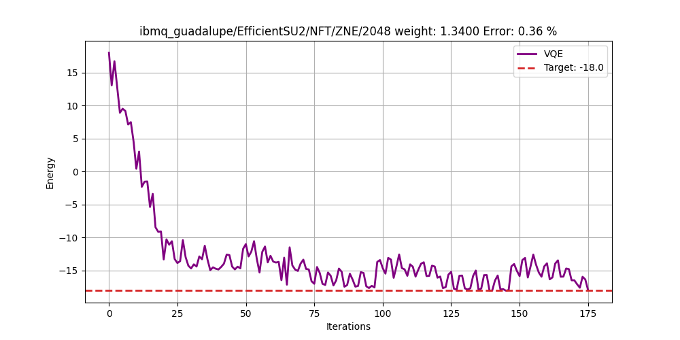

## Solution 2

|  |  |
| --- | --- |
| Backend: ibmq_guadalupe  Ansatz: ExcitationPreserving(reps=1, entanglement='linear')  Optimizer : SPSA(maxiter=100)  Resilience : ZNE (2)  Shots: 2048  Edge weight: -2.4000 | Execution time (s): 113953.17  Expected ground state energy: -18.00000000  Computed ground state energy: -18.15273438  Result eigen value: -18.15273438  **Relative error: 0.848%** |

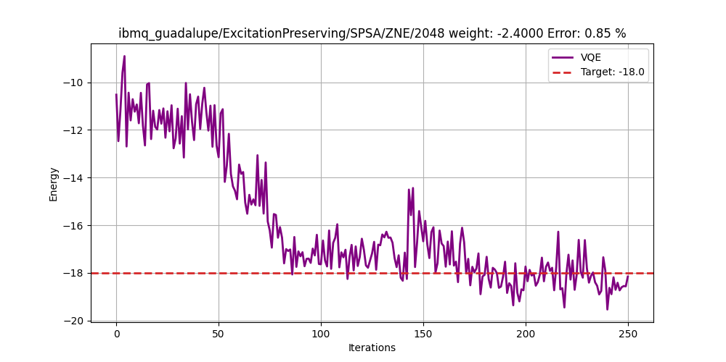

## Solution 3

|  |  |
| --- | --- |
| Backend: ibmq_guadalupe  Ansatz: EfficientSU2 (reps=1, entanglement='reverse_linear')  Optimizer : SPSA(maxiter=100)  Resilience : ZNE (2)  Shots: 2048  Edge weight: 1.9000 | Execution time (s): 102658.02  Expected ground state energy: -18.00000000  Computed ground state energy: -19.38377279  Result eigen value: -19.38377279  **Relative error: 7.687%** |

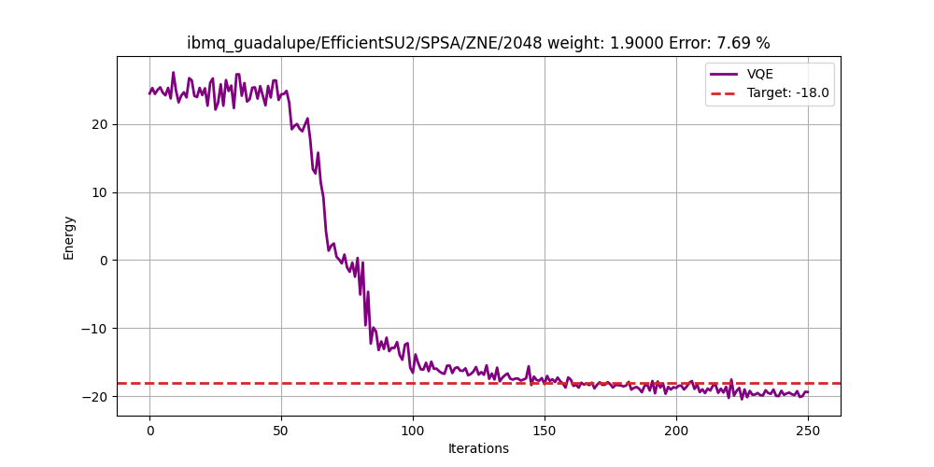

# Final Results and Metrics

The following section details the error mitigation techniques applied both at the quantum and classical levels.

## Quantum Error Mitigation

* Ansatz: ZNE (Zero Noise Extrapolation)
* Circuit optimization level = 1

Here is a chart of the success rate with Quantum mitigation only. It is pretty awful, runs failed 91% of the time. **Note: that success means the error threshold falls below 1%.**

## Classical Error Mitigation Techniques

The following classic mitigation techniques were applied after those awful error rates.

1. If at some stage of the optimization cycle the point falls below the error threshold (default 1%), the process is aborted and the optimization returns the collected data.
2. If a point falls below the target ground state by some delta = ||x| - |target||, then the uniform interaction (UI) is decreased on the fly (a new Hamiltonian is constructed with this UI and the process continues). This has the effect of moving the curve upwards towards the ground state.
3. If the optimization cycle completes and the final point is above the target ground state by delta. The VQE optimization recurses with a new Hamiltonian with an increased uniform interaction. This is to drive the curve downwards towards the target. As a failsafe to avoid infinite recursions, the maximum number of recursive calls allowed is 5. **Note that rule 1) acts as an exit condition for rules 2, 3** *(i.e. the optimization may abort in the middle of a recursive call if the error threshold falls below 1%)***.**

This changes things dramatically, with a final success rate of 100%. Not one experiment has failed!

|  |  |  |  |  |  |
| --- | --- | --- | --- | --- | --- |
| Total Runs | Success | Failed | Avg run time (h) | Maxiter | Total Jobs |
| 114 | 10 | 104 | 2 | 150 | 17100 |
| 29 | 29 | 0 | 1 | 100 | 2900 |

Here we can see rule 1 in action: at iteraction ~68 the x point happened to fall below 1% aborting the optimization process (which defaults at 100 iteractions).

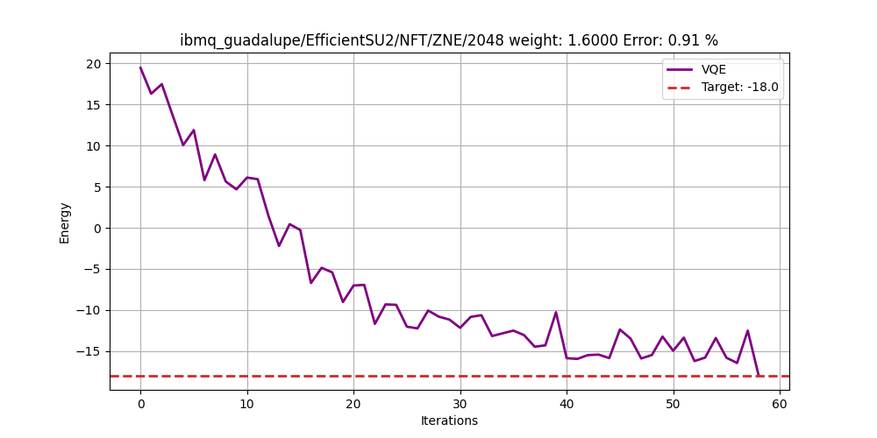

Here we can see rule 3 in action. The optimizer reached the end at 100 cycles below target, a recursive call kicks in with a lower uniform interaction, *however at loop ~130 rule 1 kicks in and the process completes.*

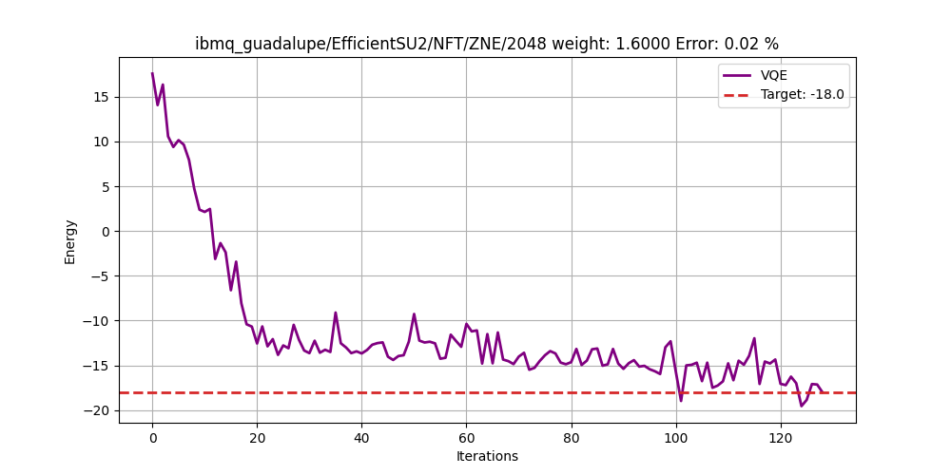

# References

IBM Quantum Awards: Open Science Prize 2022 <https://github.com/qiskit-community/open-science-prize-2022/blob/main/kagome-vqe.ipynb>

IBM Quantum Awards Event site: <https://ibmquantumawards.bemyapp.com/#/event>

Qiskit Error Mitigation: https://qiskit.org/documentation/partners/qiskit_ibm_runtime/tutorials/Error-Suppression-and-Error-Mitigation.html