Introduction to ThapCamTV: A Popular Destination for Football Fans and Sports Enthusiasts
Football has become more than just a sport; it is a global passion that connects millions of fans every day. With the increasing demand for online sports content, many viewers are looking for platforms that provide convenient access to matches, news, and football-related information. ThapCamTV has gained attention among sports followers by offering a comprehensive viewing experience and a variety of football content. Let's explore what ThapCamTV is, its key features, and why it continues to attract a large audience.

What Makes ThapCamTV a Preferred Choice for Football Lovers Around the World
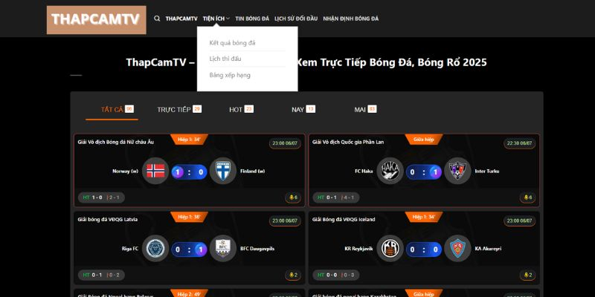
ThapCamTV is known as a platform that focuses on delivering football-related content to fans who want quick and easy access to their favorite matches. Instead of relying solely on traditional television broadcasts, many users turn to online platforms for greater flexibility and convenience.
One reason behind the popularity of ThapCamTV is its accessibility. Users can follow football events from different leagues and competitions through a simple online interface. This allows fans to stay connected with the sport regardless of their location or schedule.
Another important factor is the platform's focus on football communities. Sports enthusiasts often look for more than just live matches. They want updates, discussions, statistics, and insights that help them understand the game better. By offering a broader football experience, ThapCamTV appeals to a wide range of viewers.
The growing trend of digital sports consumption has also contributed to the platform's popularity. Modern audiences increasingly prefer online solutions that provide instant access to content whenever they need it.

Comprehensive Football Coverage That Keeps Fans Updated Every Day
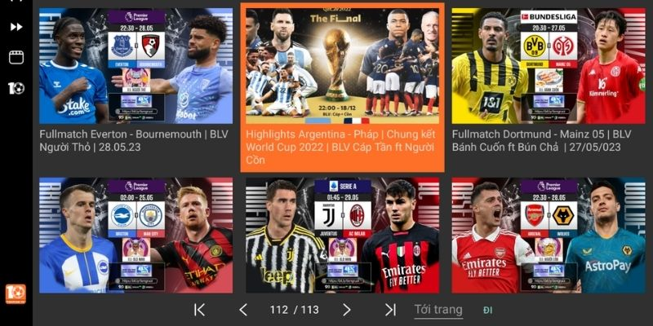
One of the biggest strengths of ThapCamTV is its ability to provide extensive football coverage. Fans are no longer interested in watching only major tournaments; they also want information about domestic leagues, international competitions, and emerging football events.
The platform helps viewers stay informed about match schedules, team performances, and important developments within the football world. This continuous flow of information creates a more engaging experience for users who follow multiple competitions throughout the year.
In addition to match-related content, football fans often seek rankings and statistical data. Many users pay close attention to the BXH of their favorite leagues to track team performance and analyze title races throughout the season. Access to such information enhances the overall value of the platform for dedicated supporters.
By combining live football content with useful updates and statistics, ThapCamTV positions itself as more than just a streaming destination. It becomes a hub for football enthusiasts seeking a deeper connection with the sport.

User-Friendly Features That Enhance the Overall Viewing Experience
Modern sports platforms must provide more than content alone. User experience plays a significant role in determining whether visitors return regularly. ThapCamTV places considerable emphasis on simplicity and ease of use, making it accessible to a broad audience.
The platform is designed to help users locate matches and information quickly. Navigation is generally straightforward, allowing viewers to spend less time searching and more time enjoying the content they are interested in. This convenience is especially important during major football events when audiences want immediate access to ongoing matches.
Compatibility across multiple devices is another valuable feature. Many football fans now consume content through smartphones, tablets, and laptops rather than traditional television. A platform that performs well across different screen sizes can significantly improve user satisfaction.
Fast access to content also contributes to a smoother experience. Football supporters often value speed because missing even a few minutes of a match can mean missing key moments. Efficient platform performance helps maintain viewer engagement and loyalty.

How ThapCamTV Reflects the Growing Shift Toward Digital Sports Consumption

The way people consume sports content has changed dramatically over the past decade. Traditional broadcasting remains important, but online platforms have become increasingly influential in shaping how audiences follow football.
ThapCamTV reflects this broader shift toward digital viewing habits. Modern users appreciate the flexibility of accessing sports content whenever and wherever they choose. This convenience aligns perfectly with the fast-paced lifestyle of many football fans today.
The growth of mobile internet and improved streaming technologies has further accelerated this trend. Viewers no longer need to be at home to follow a match. Whether traveling, working, or spending time outdoors, fans can stay connected to football through online platforms.
This evolution has also created new opportunities for sports communities. Digital platforms encourage interaction among supporters, allowing them to share opinions, discuss matches, and engage with football content in real time. Such interactions help strengthen fan engagement and create a more dynamic viewing environment.
As technology continues to advance, platforms like ThapCamTV are likely to play an even larger role in shaping the future of sports entertainment.

Why ThapCamTV Continues to Attract a Loyal Audience in a Competitive Market
The online sports industry is highly competitive, with numerous platforms competing for audience attention. Despite this environment, ThapCamTV has managed to maintain strong interest among football fans by focusing on the needs of its users.
Consistency is one factor that contributes to audience loyalty. Fans appreciate platforms that regularly provide access to football content and relevant updates. Reliable performance helps build trust and encourages repeat visits.
Another important aspect is content diversity. Football enthusiasts often have different interests, ranging from live matches and schedules to rankings and analysis. By addressing multiple areas of interest, the platform appeals to both casual viewers and dedicated supporters.
User convenience also remains a key competitive advantage. Platforms that prioritize accessibility and straightforward navigation often perform better because they reduce barriers between users and the content they want to consume.
As football continues to grow globally, platforms capable of delivering valuable, user-focused experiences are likely to remain relevant and popular among sports audiences.

Conclusion
ThapCamTV has established itself as a recognized destination for football fans seeking convenient access to sports-related content. Through comprehensive football coverage, user-friendly features, and a focus on accessibility, the platform continues to attract viewers who want to stay connected with the game they love. As digital sports consumption becomes increasingly important, thapcamtv represents the ongoing evolution of how football fans engage with matches, news, rankings, and the broader football community. Its ability to combine convenience with valuable information makes it an appealing choice for sports enthusiasts looking for a modern football experience.

