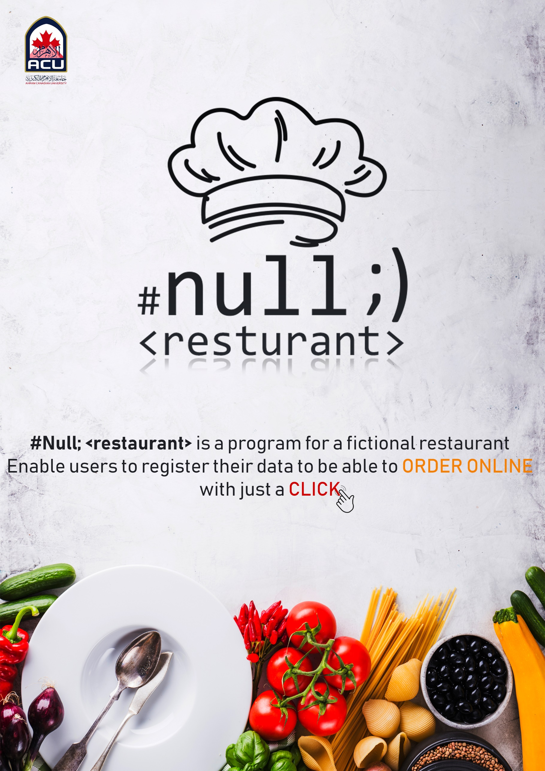

Fast food becomes very important in our live nowadays so we created this app to work on it after the course end also to improve it and make it suitable to be an important app like (Otlob , El-menus , Uber , …,…,...)

#Null; <restaurant> forms

Home:form as an interface of the program.

Offers**:** Shows daily offers with an exclusive price and special additions.

Menu**:** with just CHECK your orders and it`s number  
 then choose the payment method.  
 it`s automatically calculate the total charge after adding taxes.

Delivery: By entering phone number (if it was registered before, Go to **Menu**.  
 If it wasn`t registered before, Go to **Customers** to register first.)

Customers**:** To register and save your data in #Null; `s database.

MyInfo: Enables the admins to show the information of all users.  
 Enables the user to edit his data if he changes any of them.

AboutUS: Shows the programmers of #Null; members information.

Our project code in details: -

We use photo shop to design all back ground and small buttons in our app

Home: - We use one function in this button it is name is Exit button

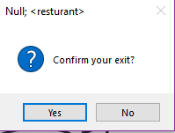

When we press this button there is a massage show it contain is

“if we want to confirm exit from the application?”

If we press Yes, we will exit from the application

If we press No the application still be run

This function is repeated in every user control to allow the user to exit from any user control of the app.

Offers: -

We use six buttons in this user control to move throw the offers

There is a function it is name is bringing front it benefits is to make everything in our form front anything by using this function we be able to move throw the small buttons which contain the offers

it shows the restaurant offers and best dishes.



Menu: -

In this user control we choose our order then we choose the way which we pay with finally we see our reset with tax

We do this with some functions: -

1: -Reset Text Boxes: -

This function enables us to reset the value of the text box into zero to allow us to add a new order.

2: -Enable Text Boxes: -

Without this function we cannot write on the text box of the food so we should mark on the text box of this function to open writing in the text box of food.

3: - Reset check Boxes: -

This function enable us to reset the value of the check box into zero to allow us to add a new check.

4:-Check box functions :-

There is 12 function under this name, these functions used to enable us to write on the text boxes by using if statement , in this statement the value of check box must be equal true to enable us to write in this text box then before we press true the value in the text box equal zero and cannot be handle until we press true .

5:-Total button click :-

In this function we calculate the check by multiple the number of orders by the value which we but to every text box then we but this value in the charge then we multiple charge by the value of tax (0.14) finally we but the value in the total ,

Then when we press total the value of the charge before the tax show in the charge

And the value of tax show in the text box of tax 0.14 ,

And the value of the check show in the text of total

We use six buttons in this user control to move throw the offers

There is a function it is name is bring front it benefit is to make everything in our form front anything by using this function we be able to move throw the small buttons which contain the offers

it shows the restaurant offers and best dishes .

If we don’t choose the way we pay within the compo box there is an exception handling and there a massage shown told you to choose the payment method

We but this functions in try and catch to avoid the error in input format .

Customer: -

We use data base in this user control

We take the information which we in put in user control and but in the table in data base

We have five text boxes in this user control

(user name, password, confirm password, phone number, address)

And two buttons (male, female)

And a compo box (city)

In this user control we create our account in the app by in put our name in the first text box

Then we in put our password in the second text box

In the third text box we must input the same number which we in put in the previous text box

We use six buttons in this user control to move throw the offers

There is a function it is name is bringing front it benefits is to make everything in our form front anything by using this function we be able to move throw the small buttons which contain the offers

it shows the restaurant offers and best dishes.

Then we choose our gender (male, female)

Then we choose our city from the compo box

The account can’t be create without press true in the last text box .

My info: -

In this user control we allow the customer to edit his or her information which it creates in the customer user control

The customer should login first by input the name and password correctly

If the user in put the name (‘’ admin ‘’) and password (“admin’’) that is mean the user is from the programmers of the app so it allow him to watch the all data of customers and delete the data .

References

Geeks for Geeks

Stack overflow

About US

Mahmoud El-Sharkawy 41710020

Mahmoud Fathy 41710032

Mokhtar Saeed 41710092

Yara Orabi 41710061

Amr Ewies 41710204

U N D E R T H E S U P E R V I S I O N O F

Dr. Ahmed Seif  
Eng. Mai Mohamed