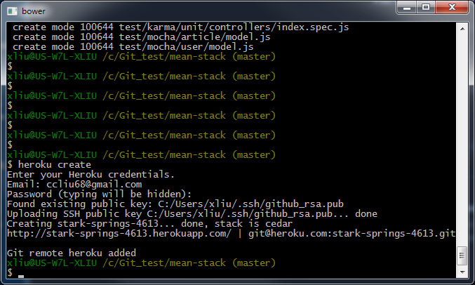

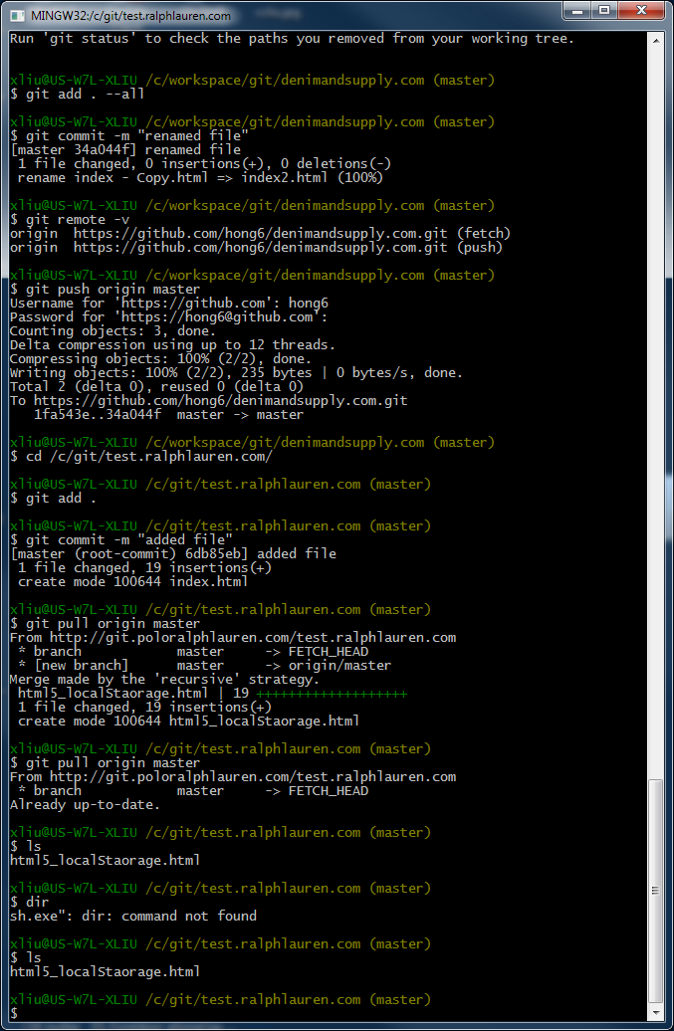

------------------

Copied libcurl.dll to here

C:\Program Files (x86)\Git\libexec\git-core

--------------------

C:\Windows\System32\drivers\etc\hosts --- Open hosts file in notepad

# Copyright (c) 1993-2009 Microsoft Corp.

#

# This is a sample HOSTS file used by Microsoft TCP/IP for Windows.

#

# This file contains the mappings of IP addresses to host names. Each

# entry should be kept on an individual line. The IP address should

# be placed in the first column followed by the corresponding host name.

# The IP address and the host name should be separated by at least one

# space.

#

# Additionally, comments (such as these) may be inserted on individual

# lines or following the machine name denoted by a '#' symbol.

#

# For example:

#

# 102.54.94.97 rhino.acme.com # source server

# 38.25.63.10 x.acme.com # x client host

# localhost name resolution is handled within DNS itself.

# 127.0.0.1 localhost

# ::1 localhost

10.98.43.132 git.poloralphlauren.com

10.98.43.132 gitweb.poloralphlauren.com

Then in command line run

Ip config /flushdns

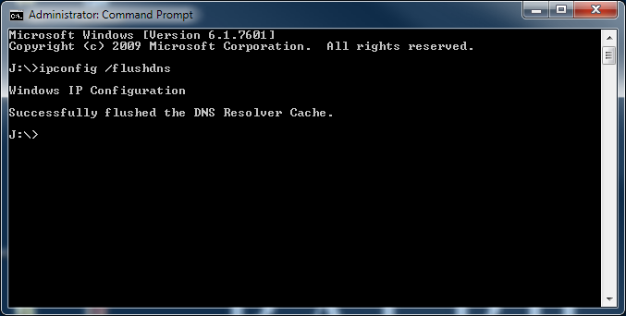

<http://gitweb.poloralphlauren.com/>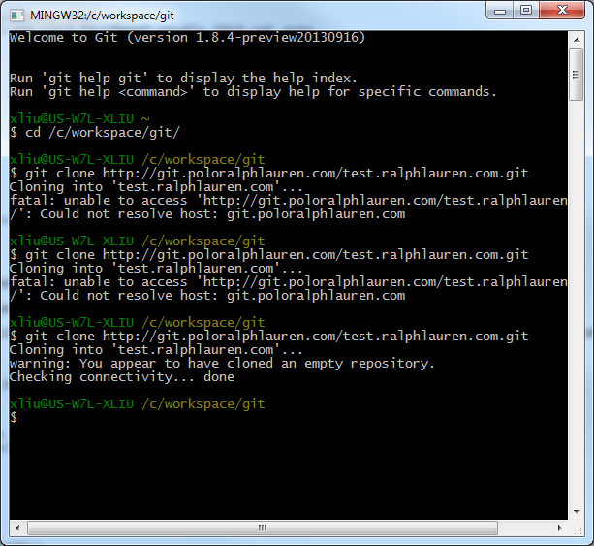

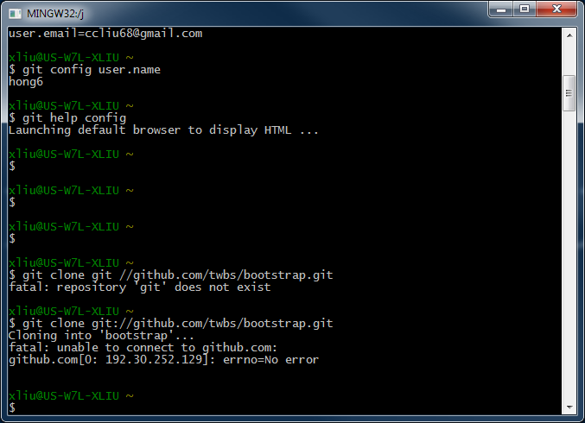

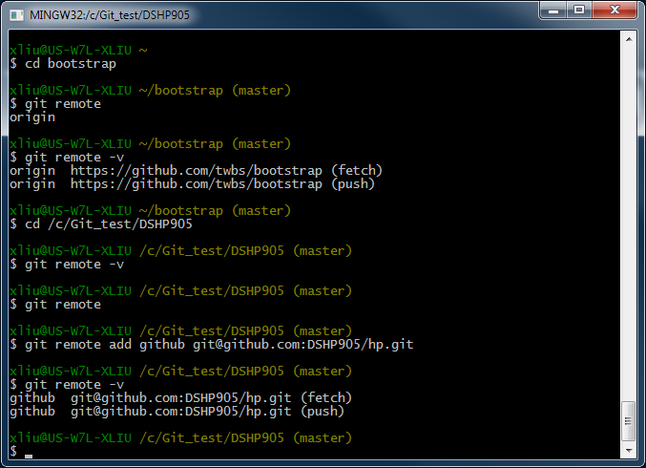

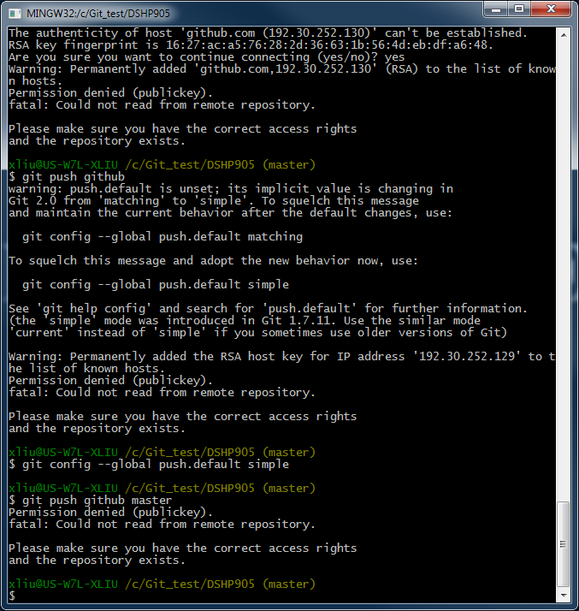

Only do once, already have the SSH key in account hong6

<https://help.github.com/articles/generating-ssh-keys>

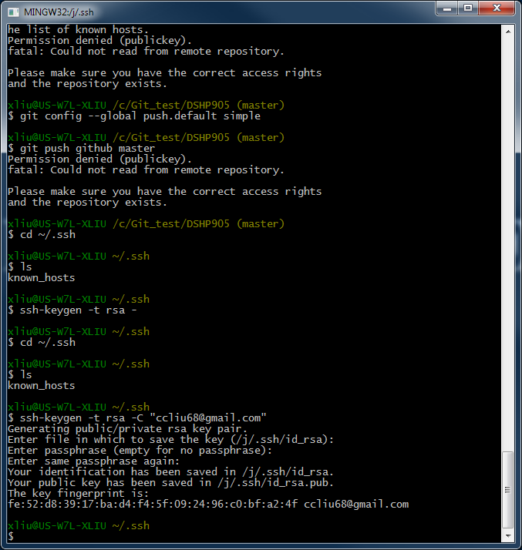

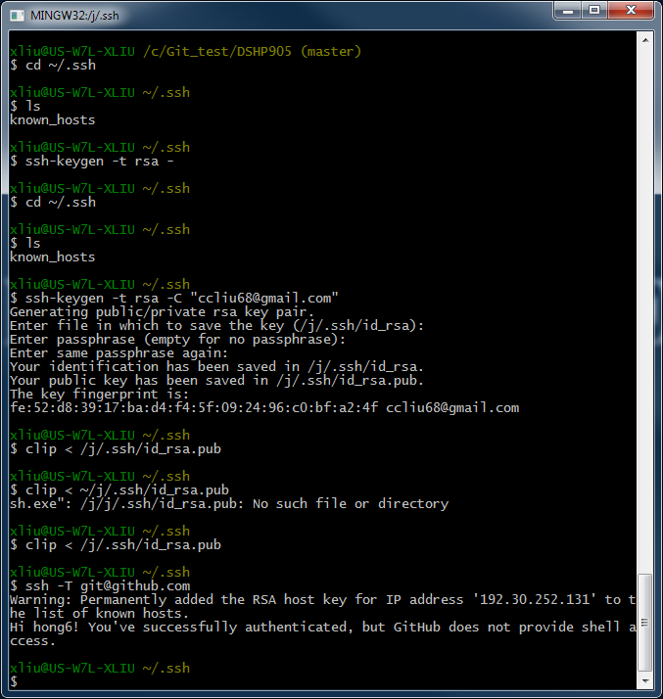

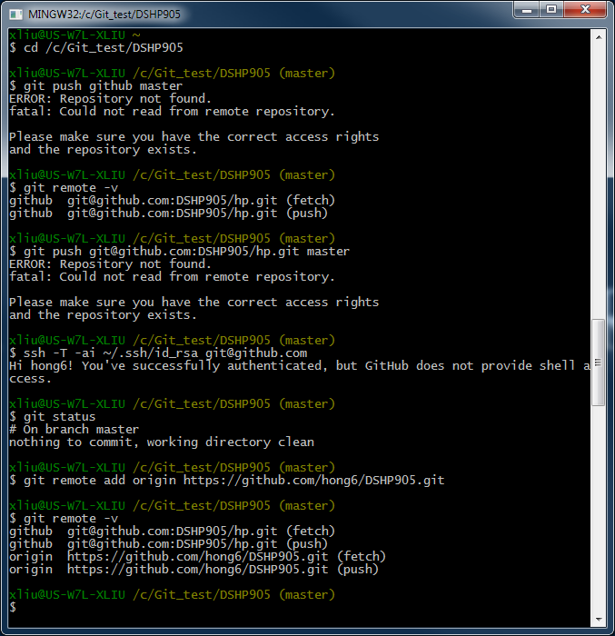

Have to go to <https://github.com/hong6>

Repositories tab 🡺+New Then

$git pull origin master ----here master is branch

$git push origin master

See following figure

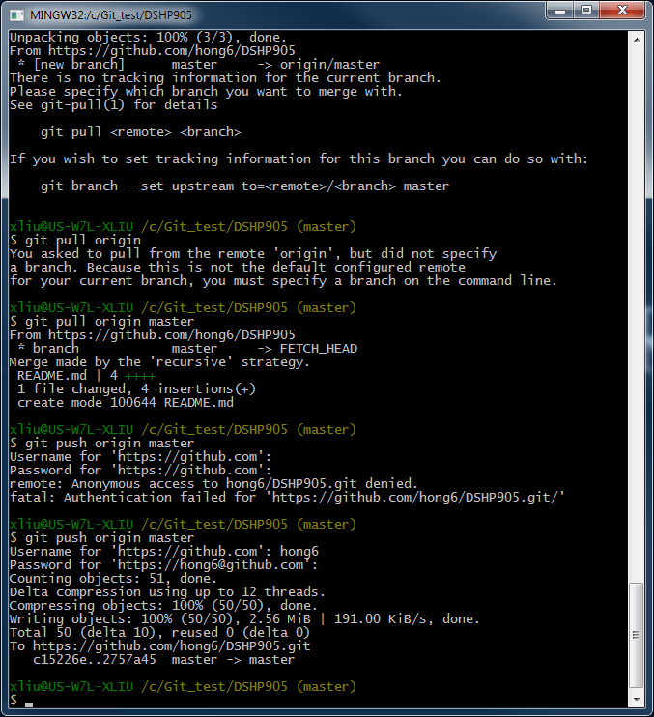

**Command line add new repository for local directory**

$cd /c/Git_test/jquery-animation/

$git init

$git add .

$git commit –m “initial v1”

$git remote add origin <https://github.com/hong6/jquery-animation.git>

$git remote –v

Have to go to <https://github.com/hong6>

Repositories tab 🡺+New to create, and get the URL(both https or SSH) you entered,

Ex: jquery-animation, it will be:

<https://github.com/hong6/jquery-animation>

Then (alternately use API or curl)

$git pull origin master ----here master is branch, if any changes made locally or else no need

$git push origin master

Done

If you changed some thing locally, you can do

$git add

$git commit –m “”

$git push origin master

Done again

**git clone from beginning with create github new account**

0 create new account at [github.com](http://github.com)

1 download git, install

2 git config --global [user.name](http://user.name) "hong6"

3 git config --global user.email [ccliu68@gmail.com](mailto:ccliu68@gmail.com)

4 git config --list

5 create new directory/folder ex: c:\fromGithub

6 cd /c/fromGithub/

**CLONE FROM GITHUB EXAMPLE**

7 git clone <https://github.com/hong6/jquery-animation>

Ex: clone jQuery to local directory C:\Git_test\

$ cd /c/Git_test/

$ git clone <https://github.com/jquery/jquery.git>

That’s it! It will create sub directory c:\Git_test\jquery

So, you can go there check and sync it or update it

$ cd jquery or cd /c/Git_test/jquery

$ git remote –v

*Origin https//github.com/jquery/jquery.git (fetch)*

*Origin https//github.com/jquery/jquery.git (push)*

$ git fetch origin master

This always changes FETCH_HEAD

*From* [*https://github.com/jquery/jquery*](https://github.com/jquery/jquery)

*\*branch master -> FETCH_HEAD*

$ git pull origin master

From <https://github.com/jquery/jquery>

*\*branch master -> FETCH_HEAD*

*Already up-todate.*

And you also can push from local to the repository (not try yet for jquery!!!)

$ git push origin master

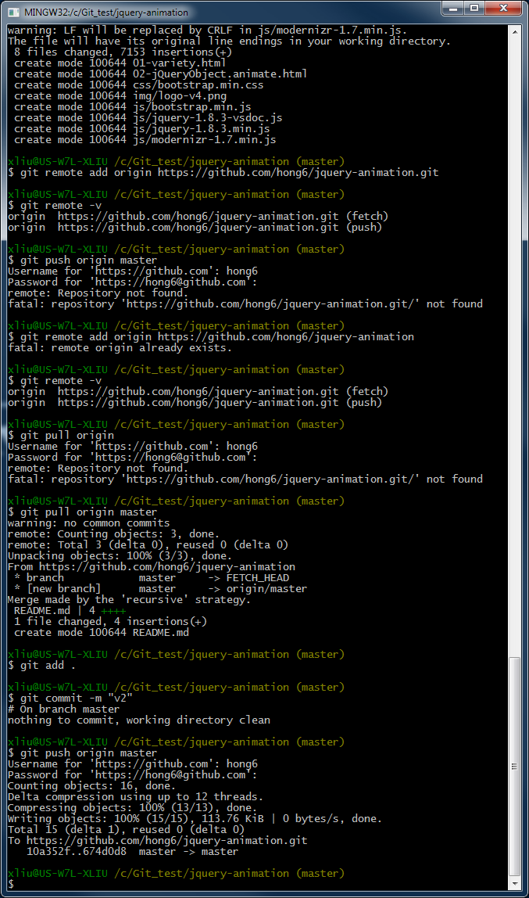

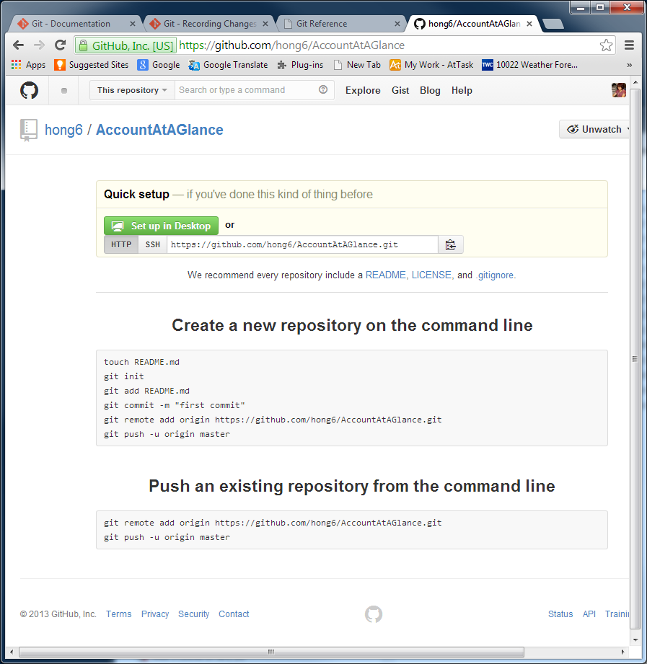

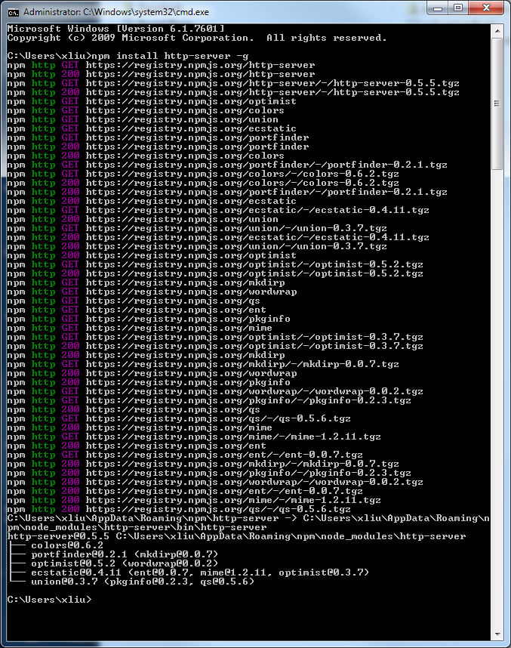

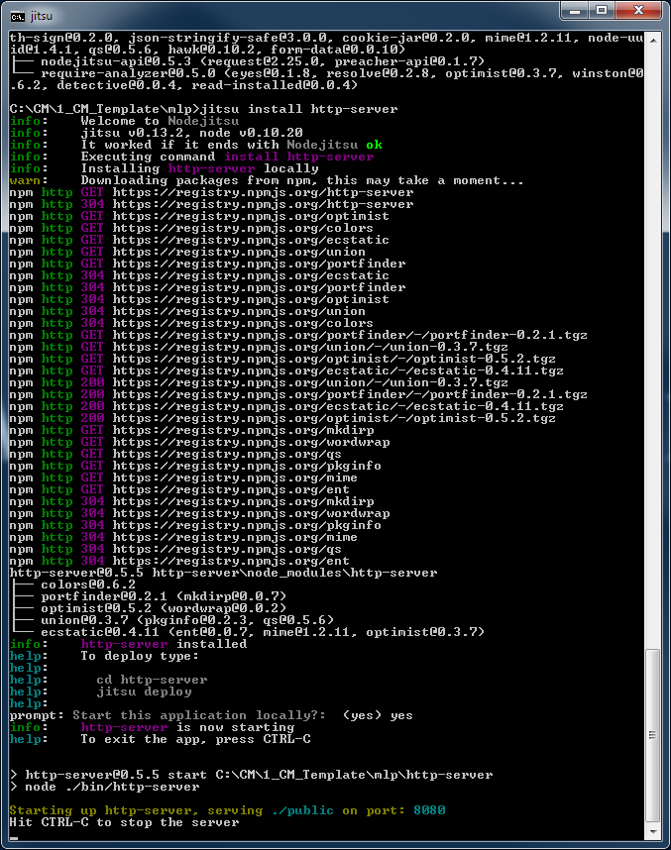

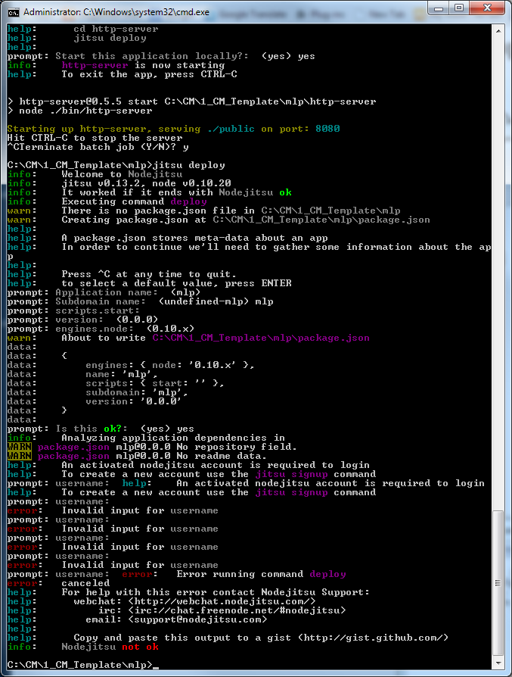

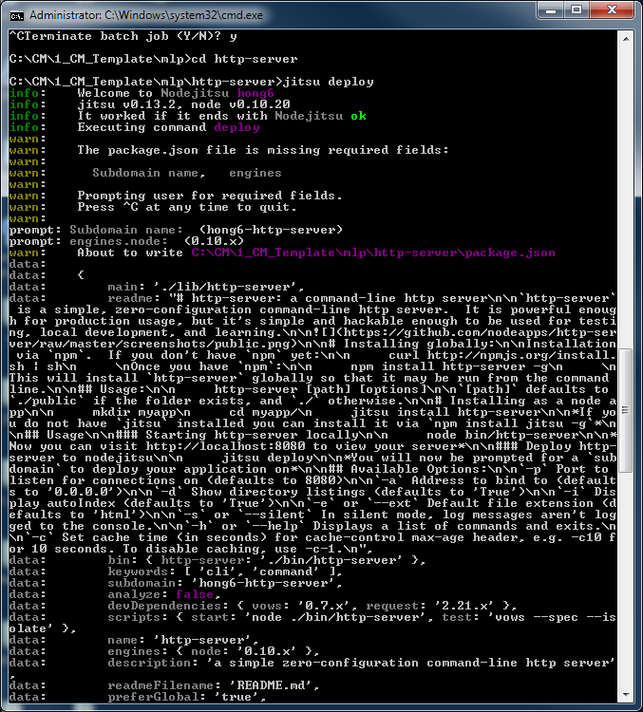

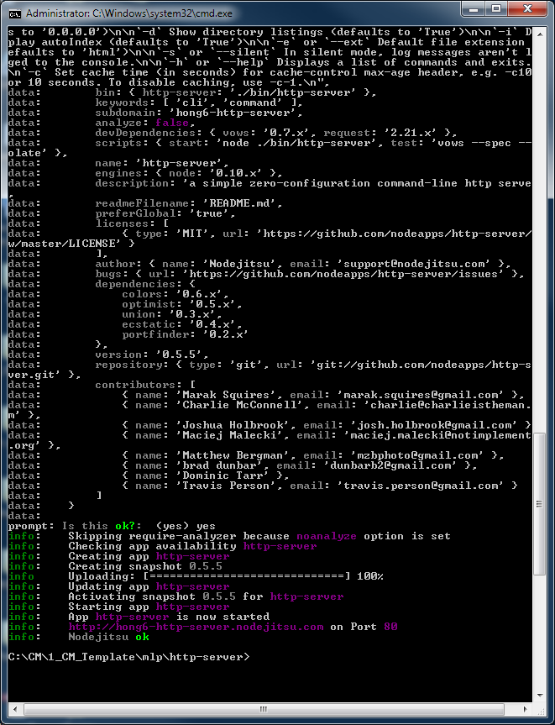

<http://localhost:8080>

<http://mlp.nodejitsu.com/>

<http://hong6-http-server.nodejitsu.com/>

<https://npmjs.org/package/http-server>

Installing globally:

Installation via npm. If you don't have npm yet:

curl http://npmjs.org/install.sh | sh

Once you have npm:

npm install http-server -g

This will install http-server globally so that it may be run from the command line.

Usage:

http-server [path] [options]

[path] defaults to ./public if the folder exists, and ./ otherwise.

Installing as a node app

mkdir myapp

cd myapp/

jitsu install http-server

If you do not have jitsu installed you can install it via npm install jitsu -g

Usage: Starting http-server locally

node bin/http-server

Now you can visit http://localhost:8080 to view your server

Deploy http-server to nodejitsu

jitsu deploy

You will now be prompted for a subdomain to deploy your application on

<http://curl.download.nextag.com/download/curl-7.21.7-win64-ssl-sspi.zip>

<https://support.gradesfirst.com/entries/20398251-How-to-Setup-cURL-on-Windows-7-64-bit>

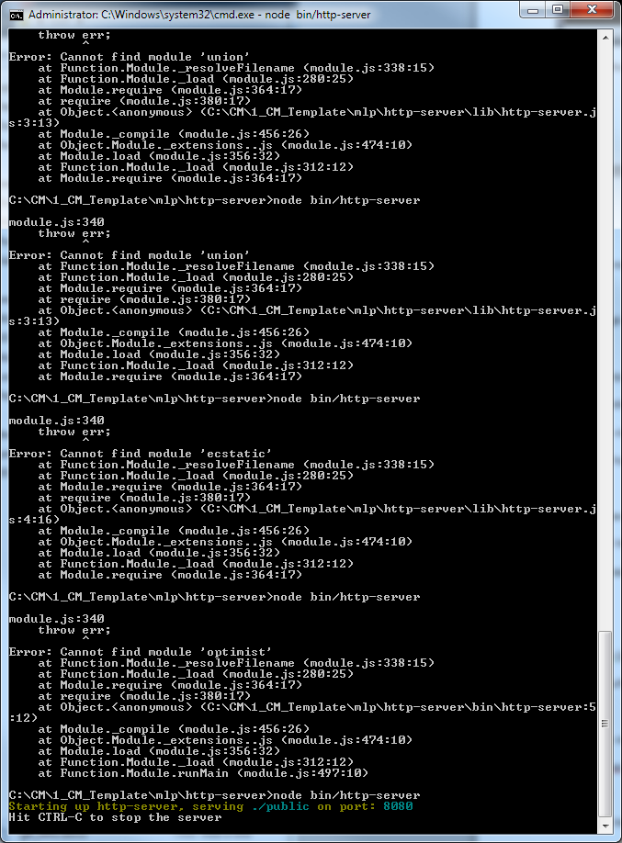

**Backbone Server set up**

#1Clone the repository:

Go to, <https://github.com/liammclennan/backbone-server> copy url

$ git clone <https://github.com/liammclennan/resourceserver.git>

#2 install node - did

#3 install the dependencies

$ npm install

#4 start the server

$ node resourceserver.js

($ npm start (or node rasterver.js))

http://localhost:3002/

#5 once server set ok, use curl to make request to backbone server

$ curl -v <http://localhost:3002/people>

GET request

$ curl <http://localhost:8080/people>

$ curl –vX POST <http://localhost:8080/people> -H “Content-Type: application/json” –d ‘{“name”:”Bob”,”age”:34}’

GET collection, []

$ curl <http://localhost:8080/people>

GET single resource, just an object,{}

$ curl <http://localhost:8080/people>

Ex:

C/CM/1_CM_Template/mlp/http-serve/

$node bin/http-server

<http://localhost:8080>

FROM Manu

Cmd.exe

>cd c:\2012\LBA

>node simpleserver.js

Express server listening on port 4713 in development mode

So you can go here bring site up <http://localhost:4713>

\\Usnypdmacodr1\CreativeShare\5_Flash\manu

http://lesbeauxarts.ralphlauren.com/?ab=int_101713_HP_CM_P4S3_M_LBA_EXPLORENOW

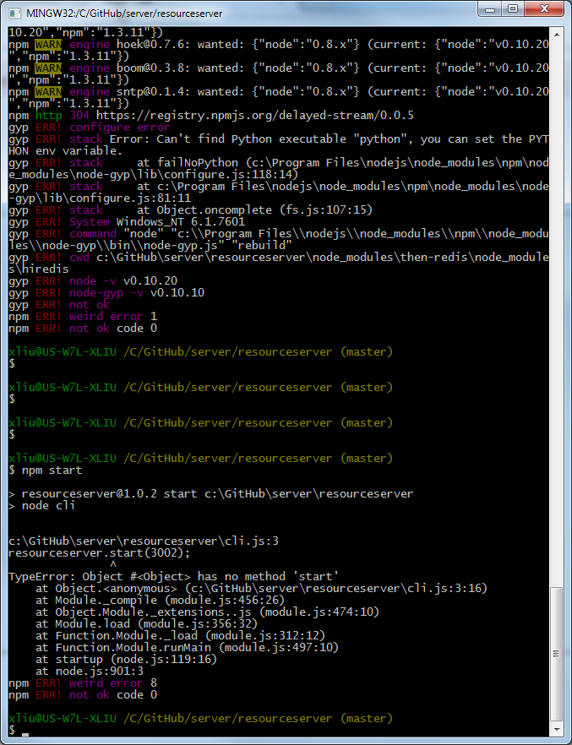

How to check which version of v8 is installed with nodeJS

node -e 'console.log(process.versions.v8);'