CAREERCLUSTER: AI-POWERED STUDENT RECRUITMENT SYSTEM

S. VIDULA (UGC0323021), A. JAYARATHNA (UGC0323002), S. HEMANTHA (UGC0323014)
Registration numbers: UGC0323021, UGC0323002, UGC0323014
Name of the supervisor: Mewan Jayathilake
February 2026

Declaration
I certify that this dissertation does not incorporate, without acknowledgement, any material previously submitted for a degree or diploma in any University/Institute and to the best of my knowledge and belief, it does not contain any material previously published or written by another person or myself except where due reference is made in the text.
Signature of Candidates: sharly Vidula , sudeera Hemantha , anashya jayarathne
Date: . 2026/02/13. . . . . . . . .

Countersigned by: Signature of Supervisor: Mewan Jayathilake
Date: . . . 2026/02/14. . . . . . .

Abstract
This project addresses the inefficiencies and security concerns inherent in traditional student recruitment platforms by introducing CareerCluster, an AI-powered, closed-loop recruitment system. The primary objective was to eliminate manual data entry for candidates and prevent unauthorized spam from recruiters. This was achieved by developing a web application using the MERN stack (MongoDB, Express.js, React, Node.js) integrated with a PDF parsing engine and simulated Large Language Model (LLM) logic. The system successfully automates candidate profiling by reading uploaded PDF resumes and assigning industry-specific tags, such as "Culinary Expert" or "UI Engineer". Furthermore, a three-tier role-based access control system (Student, Employer, Admin) was implemented, ensuring that all connection requests and job vacancy postings are manually vetted by an Administrator before reaching the student dashboard. Real-time communication was established using the EmailJS library to trigger instant email notifications upon administrative approval. The resulting platform provides a secure, streamlined, and intelligent bridge between university talent and prospective employers.

Acknowledgements
We would like to express our sincere gratitude to our supervisor, Lecturer Mewan, for providing invaluable technical guidance and continuous support throughout the development of CareerCluster. We also extend our thanks to our colleagues and evaluators whose feedback helped refine our system architecture and user interface.

Table of Contents
- Declaration
- Abstract
- Acknowledgements
- Table of Contents
- List of Figures
- List of Tables
- List of Acronyms
- Chapter 1: Introduction
- Chapter 2: Analysis
- Chapter 3: Design
- Chapter 4: Implementation
- Chapter 5: Evaluation
- Chapter 6: Conclusion
- References
- Appendices

List of Figures
- Figure 2.1: Top-Level Use Case Diagram of CareerCluster
- Figure 3.1: System Architecture Diagram
- Figure 3.2: User Interface Wireframe - Admin Dashboard
- Figure 3.3: User Interface Wireframe - Employer Search
- Figure 4.1: Module Interaction Diagram
- Figure A.1: Node.js Server Execution Screenshot
- Figure C.1: Student Resume Upload Interface
List of Tables
- Table 2.1: Functional Requirements Prioritization
- Table 5.1: System Test Cases and Results
- Table 5.2: User Acceptance Testing Summary
List of Acronyms
- API: Application Programming Interface
- DOM: Document Object Model
- JWT: JSON Web Token
- LLM: Large Language Model
- MERN: MongoDB, Express.js, React.js, Node.js
- UI/UX: User Interface / User Experience

Chapter 1 Introduction
1.1 Motivation
Traditional job hunting requires students to manually fill out extensive application forms and exposes their contact information to unverified third parties, leading to spam. CareerCluster was developed to automate the profiling process using Artificial Intelligence and introduce a secure, admin-moderated gateway between students and recruiters.
1.2 Aims and Objectives of the Project
- To develop a robust MERN stack web application with distinct dashboards for Students, Employers, and Admins.
- To integrate an AI Resume Parser capable of extracting text from PDFs and automatically assigning relevant industry tags.
- To implement a secure "Connection Request" and "Job Vacancy" workflow that mandates Admin approval.
- To establish real-time email notifications for students upon successful connection approvals using EmailJS.

1.3 Scope of the Project
The system encompasses user authentication, automated profile generation via PDF analysis, candidate filtering for employers, and an administrative moderation panel. Out-of-scope functionalities for this release include direct LinkedIn OAuth logins, payment gateways, and WebSocket real-time chat, which are planned for future iterations.

1.4 Structure of the Thesis
Chapter 2 covers the system analysis, including requirements and process models. Chapter 3 details the architectural and UI design. Chapter 4 explains the MERN stack implementation and code structure. Chapter 5 presents the evaluation and testing results. Finally, Chapter 6 concludes the project with a critical evaluation and future work.

Chapter 2 Analysis
2.1 Explaining the current system using Flow Charts

In the existing ecosystem, job boards operate on an open-communication model where recruiters can message students directly, often resulting in irrelevant inquiries. CareerCluster alters this flow:
- Student Flow: Uploads PDF -> AI assigns tags -> Profile is listed anonymously.
- Employer Flow: Searches tags -> Submits "Connection Request" or posts "Job Vacancy" -> Status set to PENDING_ADMIN.
- Admin Flow: Reviews request -> Clicks "Approve" -> Status updates and triggers Email Notification to Student.
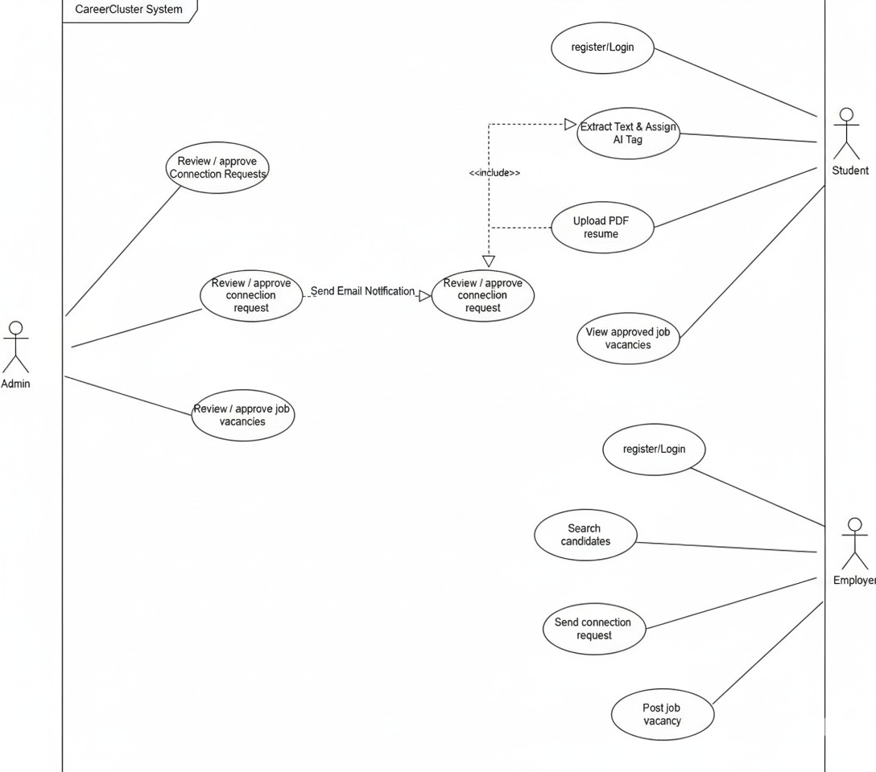

2.2 Review Similar Systems with References
Current market leaders like LinkedIn and Glassdoor provide extensive networking capabilities but lack a dedicated, moderated "sandbox" environment for university students. These platforms allow direct messaging, which bypasses university moderation. CareerCluster addresses this by introducing the Admin Gatekeeper role, drawing inspiration from closed university alumni networks but enhancing it with modern AI resume tagging.
2.3 Identifying/Prioritization the functional and non-functional requirements

Functional Requirements:
- FR1 (High): The system must parse uploaded .pdf resumes and extract text data.
- FR2 (High): The AI logic must categorize text into career tags (e.g., distinguishing a "Mobile App Developer" from a Chef).
- FR3 (High): Employers must be able to post job vacancies that default to a "pending" state.
- FR4 (Medium): The system must dispatch automated emails via EmailJS when an Admin approves a request.
Non-Functional Requirements:
- Security: Passwords and user sessions must be secured using JWT (JSON Web Tokens).
- Performance: The AI parsing and React DOM rendering must execute efficiently without severe lag.
- Usability: The UI must be responsive and follow a modern Glassmorphism aesthetic.
2.4 Identifying the suitable process model with a justification
An Agile software development methodology was utilized. This allowed the team to build the core Minimum Viable Product (User Auth and Dashboards) quickly and iteratively add complex features, such as the AI integration (pdf-parse) and the EmailJS notification system, during subsequent sprints based on testing feedback.

Chapter 3 Design
3.1 Relevant Design Diagrams
CareerCluster leverages a Client-Server architecture built on the MERN stack.
- Frontend: Developed with React.js. It manages state via useState and useEffect hooks and uses Axios for API communication.
- Backend: Node.js and Express REST API handling routing, file uploading (multer), and logic.
- Database: MongoDB Atlas (Cloud) utilizing specific collections for users, requests, and jobs.
3.2 User interface design with LIVE SCREEN SHOTS.
The user interface was designed to be intuitive and role-specific. A custom "Glassmorphism" theme was created using semi-transparent panels and gradients to provide a modern aesthetic. The Employer dashboard features a dynamic search bar for AI tags, while the Admin dashboard focuses on centralized lists of pending approvals with clear "Approve" and "Block" actions.
HERE ARE THE SCEEN-SHOTS OF EMPLOYEE_DASHBOARD.

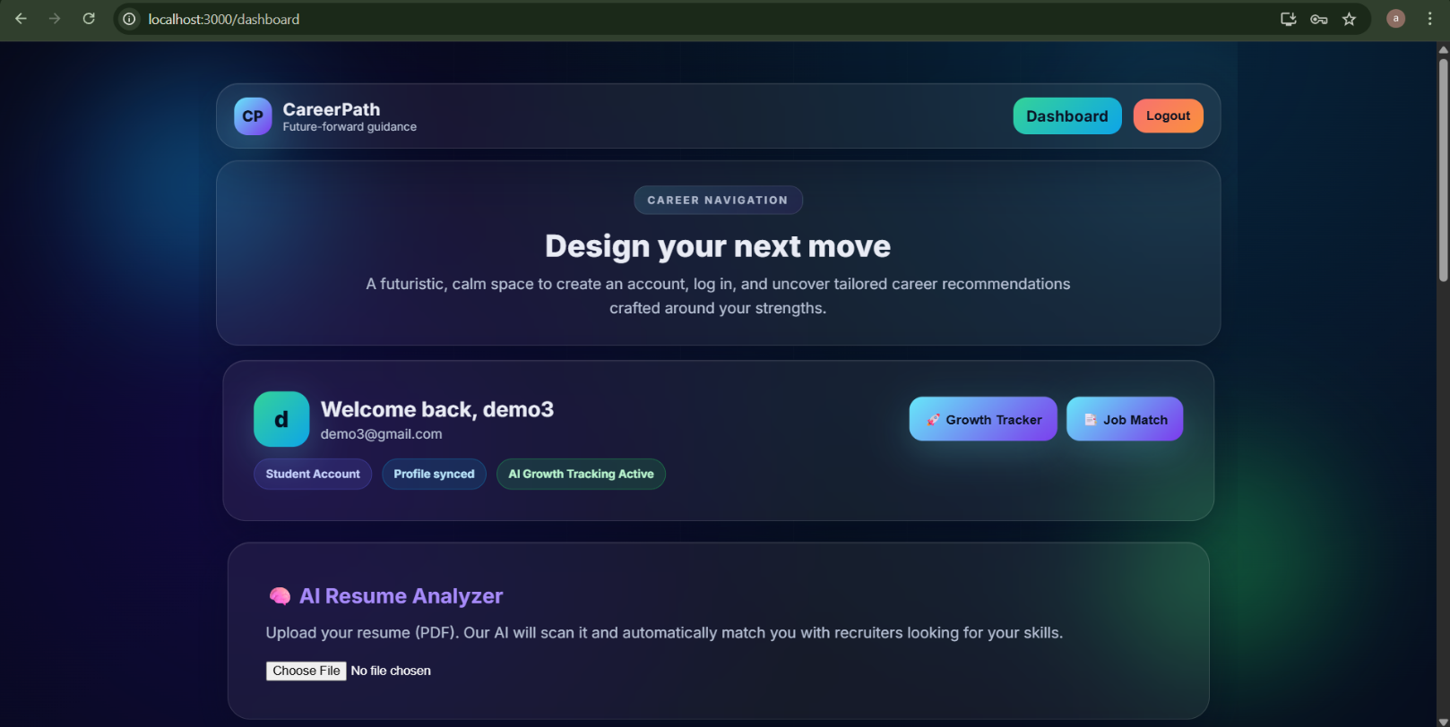
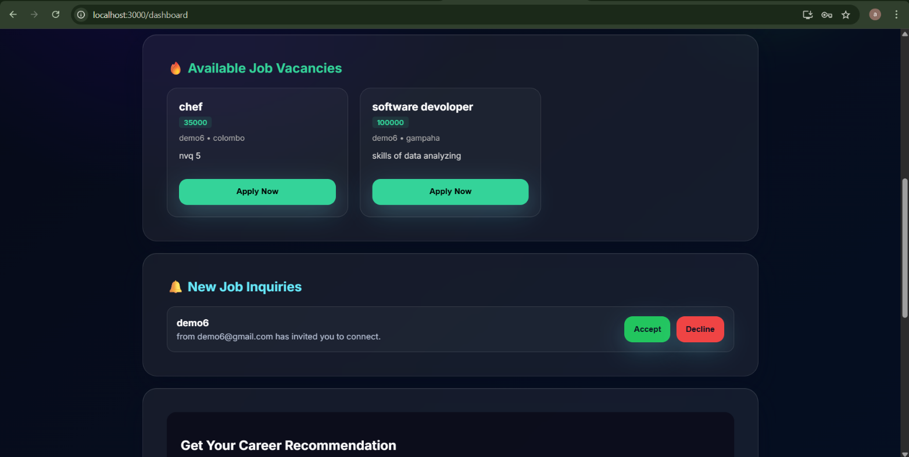
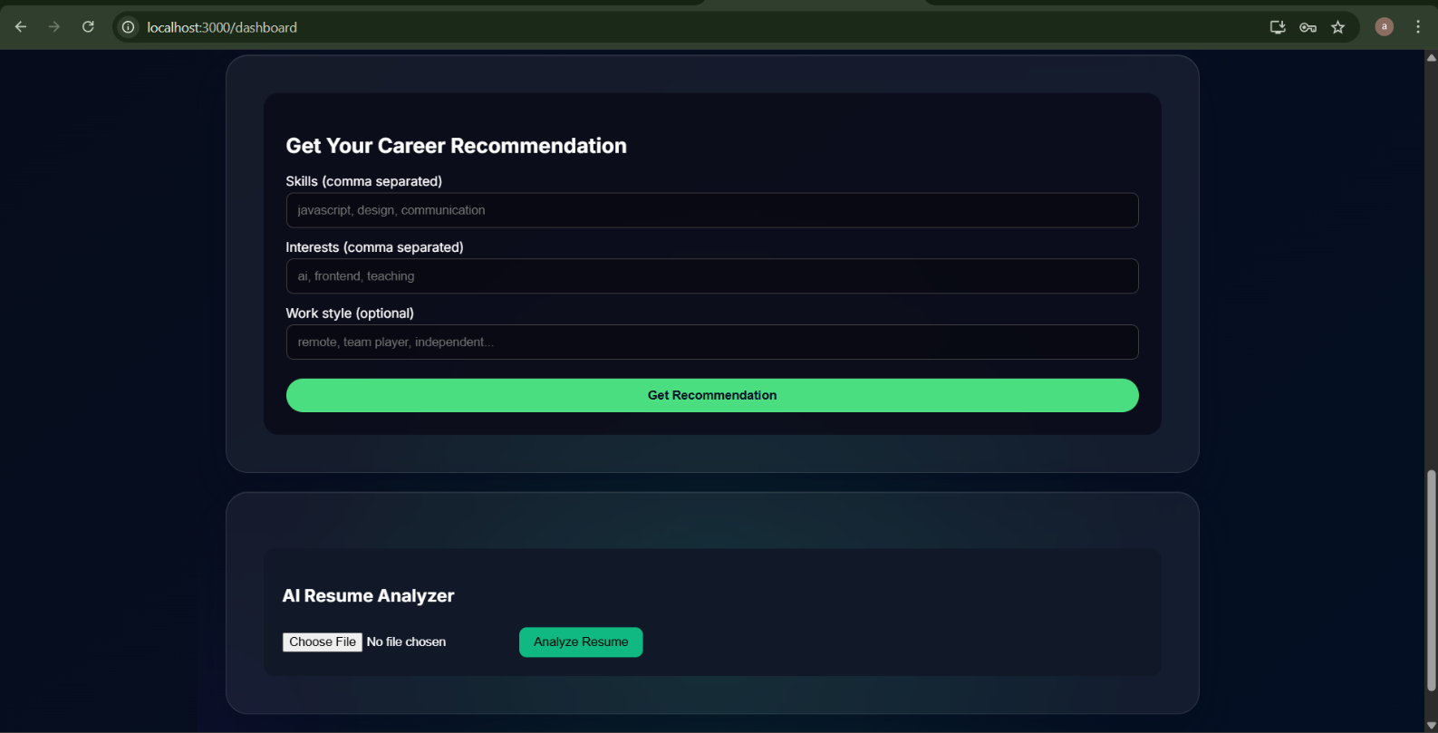

HERE ARE THE SCEEN-SHOTS OF EMPLOYER_DASHBOARD.
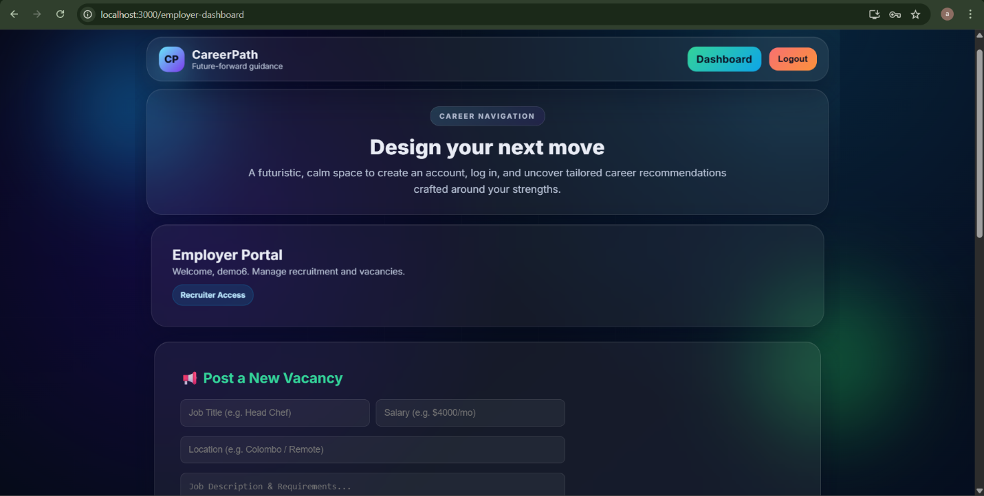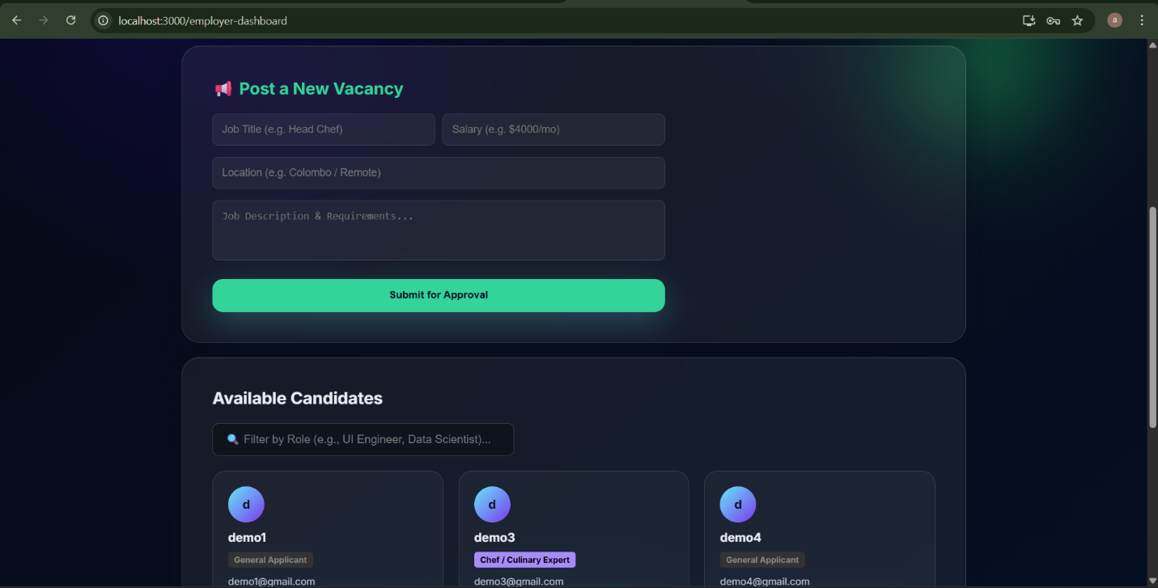
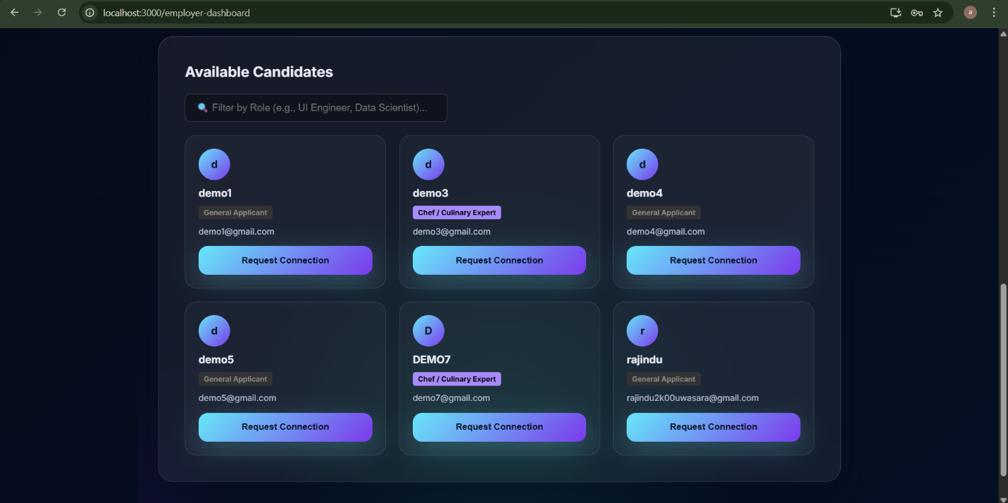

HERE ARE THE SCEEN-SHOTS OF ADMIN_DASHBOARD.
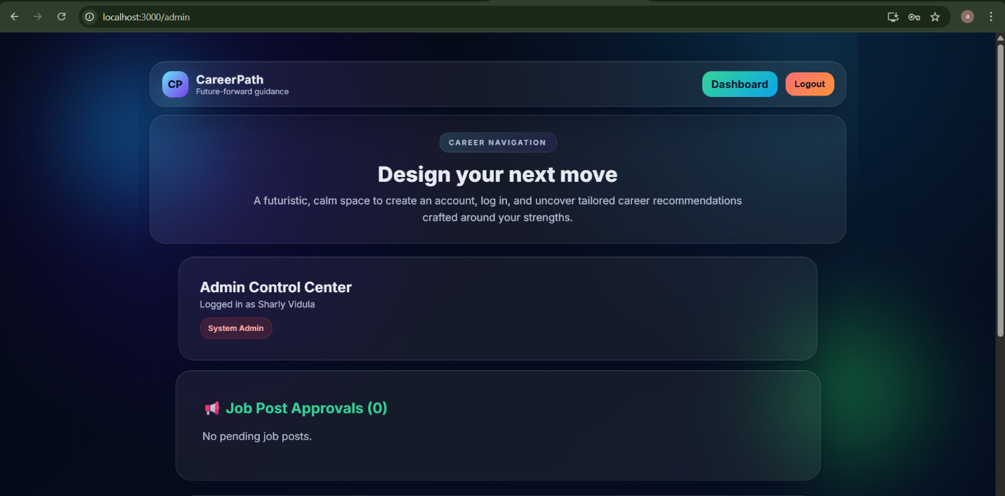

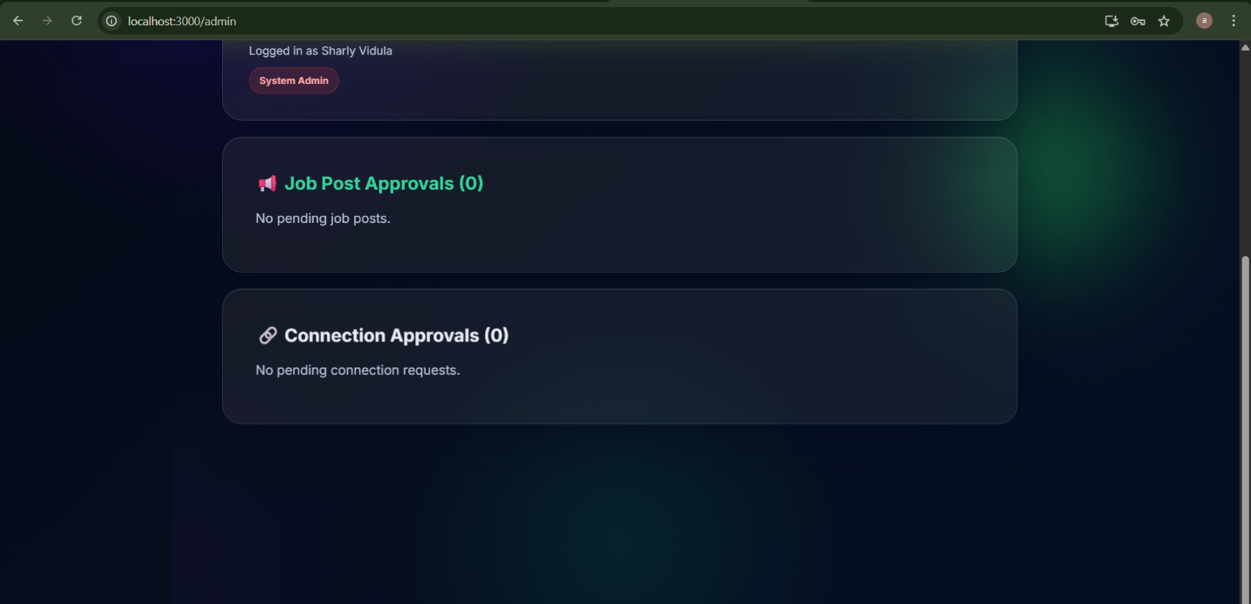

Chapter 4 Implementation
The system was implemented using Visual Studio Code, Node.js, and npm.
4.1 Core Module Structures
- userRoutes.js (Backend): Handles backend routing for Auth, Resume Uploads (multer and pdf-parse), Recruitment Requests, and Job Postings.
- emailService.js (Frontend): An independent module utilizing @emailjs/browser to handle API handshakes for real-time notifications without requiring SMTP backend setup.
4.2 AI Parsing Logic Implementation
To resolve misclassification issues (e.g., confusing a Chef's phone number with a "Mobile Developer"), custom fallback logic was implemented to parse resumes accurately.
JavaScript
// Resume Parsing Backend Logic
const pdfData = await pdfParse(req.file.buffer);
const text = pdfData.text.toLowerCase();
let aiRole = "General Applicant";

// Keyword classification matrix
if (text.includes("chef") || text.includes("culinary")) aiRole = "Chef / Culinary Expert";
else if (text.includes("react") || text.includes("frontend")) aiRole = "UI Engineer";
else if (text.includes("python") || text.includes("data")) aiRole = "Data Scientist";
4.3 EmailJS Integration
The notification system was implemented in the frontend to trigger immediately after the database updates the connection status to PENDING_EMPLOYEE.
JavaScript
// Admin Dashboard Approval Logic
const handleRequestDecision = async (req, decision) => {
const newStatus = decision === 'approve' ? 'PENDING_EMPLOYEE' : 'DENIED';
await axios.put(`/api/users/requests/${req._id}`, { status: newStatus });

if (decision === 'approve' && req.employeeId?.email) {
await sendNotification(req.employeeId.name, req.employeeId.email, req.employerId.name);
}
};

Chapter 5 Evaluation
5.1 System Testing
The system underwent rigorous testing to ensure reliability and security.
Table 5.1: System Test Cases and Results | Test ID | Module | Action | Expected Result | Actual Result | Status | | :--- | :--- | :--- | :--- | :--- | :--- | | TC01 | Auth | Employer attempts to access /admin route | Redirected to /dashboard with Access Denied alert | Redirected successfully | Pass | | TC02 | AI Parser | Upload a Culinary CV in PDF format | System assigns "Chef / Culinary Expert" tag | Assigned correctly | Pass | | TC03 | Requests | Employer sends duplicate connection request | Backend throws 400 Bad Request | Prevented duplication | Pass | | TC04 | Admin | Admin clicks 'Approve' on job vacancy | Job status updates to 'approved' and shows on Student dash | Displayed correctly | Pass | | TC05 | Email | Admin approves connection request | EmailJS triggers and sends real email to Student | Email received in 3s | Pass |
5.2 User Acceptance Testing
User testing was conducted with a small group representing the three roles. Employers found the dynamic search filter highly efficient for finding specific skill sets. Students appreciated the automated profile generation, noting it saved significant time compared to traditional form-filling.

Chapter 6 Conclusion
6.1 Critical Evaluation
The CareerCluster platform successfully met its primary objectives. The integration of the AI Resume Parser drastically reduces user onboarding friction, and the 3-stage connection cycle effectively secures student data. The addition of the Job Vacancy board provides a comprehensive ecosystem for recruitment.

6.2 Lessons Learnt
A significant lesson learned during development was managing API key security and resolving environment variable errors (e.g., AuthenticationError: 401) when integrating third-party SDKs like Groq. Furthermore, designing the complex relational queries in MongoDB ($nin filters and .populate()) provided deep insights into NoSQL database architecture.
6.3 Future Work
Future iterations of the software will prioritize:
- Migrating from the mocked AI logic to a full OpenAI/Grok API integration for dynamic skill extraction.
- Implementing bcrypt password hashing for production-level security.
- Adding WebSocket (Socket.io) for in-app, real-time messaging between connected employers and students.
- LinkedIn OAuth 2.0 integration to allow one-click profile generation.

References
[1] J.L. Whitten and L.D. Bentley, Systems Analysis and Design Methods, 7th ed. Tata McGraw-Hill, 2007. [2] EmailJS, "EmailJS Official Browser Documentation", 2026. [Online]. Available: https://www.emailjs.com/docs/browser/ [Accessed: 10-Feb-2026]. [3] MongoDB, "Mongoose v6.0.0 Documentation", 2026. [Online]. Available: https://mongoosejs.com/ [Accessed: 08-Feb-2026]. [4] React, "Hooks API Reference", 2026. [Online]. Available: https://reactjs.org/docs/hooks-reference.html [Accessed: 05-Feb-2026].

Appendices
Appendix A - System Manual

Installation & Execution:
- Install Node.js on the host machine.
- Navigate to the backend directory and run npm install to install dependencies (express, mongoose, pdf-parse, multer, cors, dotenv).
- Create a .env file in the backend directory with MONGO_URI and PORT=5000.
- Start the backend server using npm start or npm run dev
- Navigate to the frontend directory and run npm install (including @emailjs/browser, axios, react-router-dom, chart.js).
- Start the React application using npm start. The app will launch on localhost:3000.

Appendix B - Design Documentation
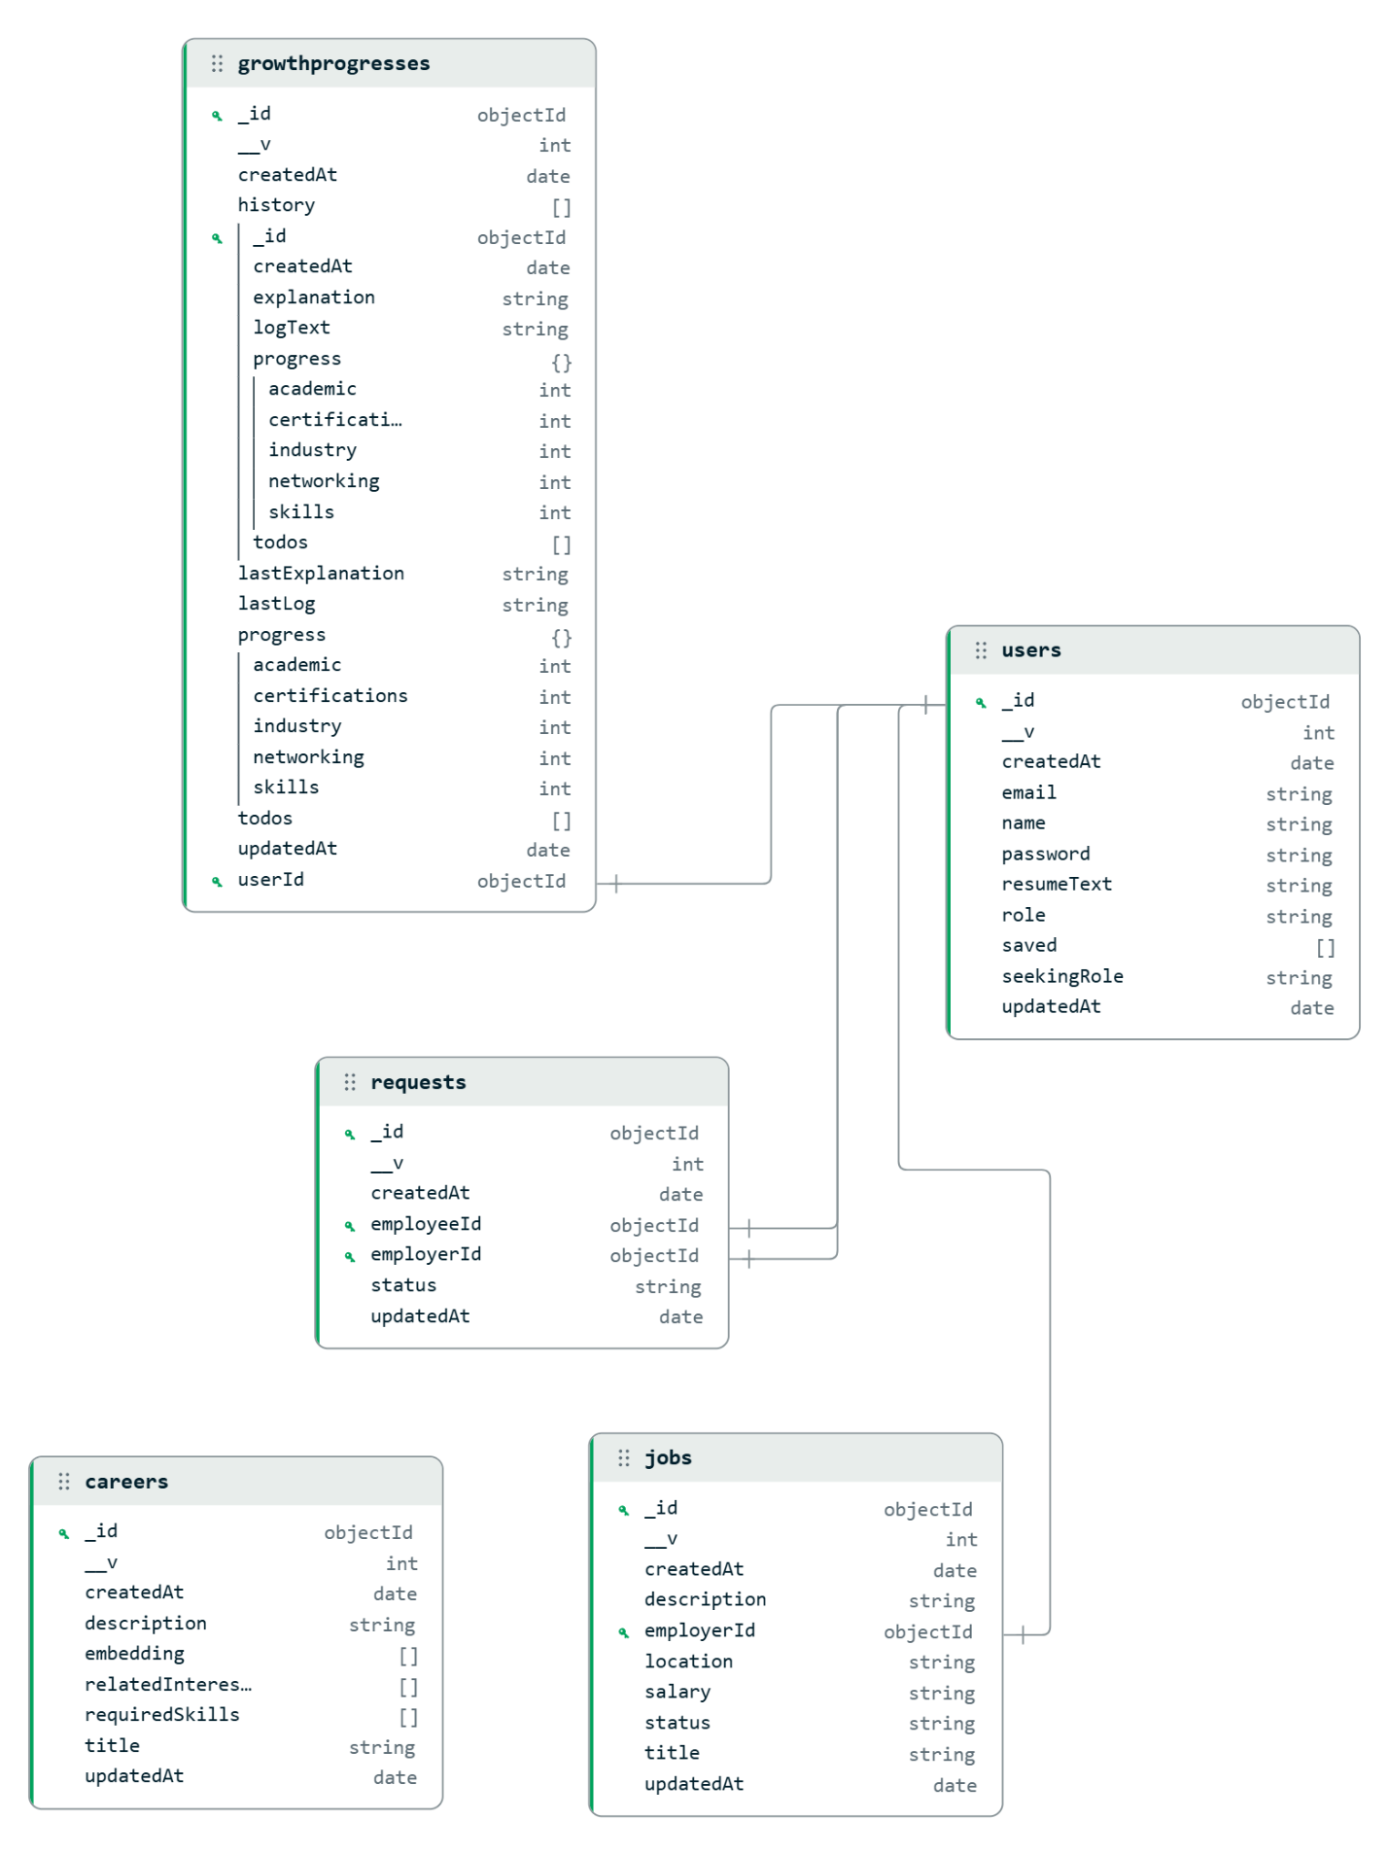

- User: _id, name, email, password, role (user/employer/admin), resumeText, seekingRole.
- Request: _id, employerId (ref: User), employeeId (ref: User), status (PENDING_ADMIN, PENDING_EMPLOYEE, ACCEPTED, DENIED).
- Job: _id, employerId (ref: User), title, description, salary, location, status (pending, approved, rejected).

Appendix C - User Manual
For Students:
- Register an account and navigate to the User Dashboard.
- Click "Choose File" under the AI Resume Analyzer section and upload a PDF.
- Wait for the success alert indicating your new AI-assigned role.
- View approved jobs under the "Available Job Vacancies" section.
- Accept or Decline incoming connection requests in the "New Job Inquiries" panel.

For Employers:
- Use the "Post a New Vacancy" form to submit a job. It will remain hidden until Admin approval.
- Use the Search bar to filter candidates by their AI-assigned roles (e.g., type "UI Engineer").
- Click "Request Connection" on a candidate card to send an inquiry to the Admin.
For Admins:
- Log in with Admin credentials.
- Review "Job Post Approvals". Click ✅ Publish to push the job to students.
- Review "Connection Approvals". Click Approve to authorize the connection and trigger an automated email to the student.
Appendix D - Management Reports
The Admin Dashboard serves as the primary management report generation tool. It aggregates data to show:
- Total volume of pending connection requests requiring moderation.
- Total volume of pending job vacancies submitted by employers.
- Visual breakdown of system traffic and role distributions (viewable in the Growth Tracker analytics charts).
Appendix E - Test Results
(Note for candidates: Include screenshots of your functional testing here, such as the successful EmailJS delivery, Postman API responses, or the browser console logs showing successful data retrieval)
Appendix F - Client Certificate

