**Angular – 10**

* What is Angular and Why Angular?
* Difference between React and Angular?
* What we can develop with Angular?
* Angular Versions: 8,9,10.
* TypeScript Language [HTML, JavaScript, CSS]
* Angular 10
* Components
* Services
* Pipes
* Routing
* Forms
* Security
* Material
* Animations
* End to End Integration

**2 Months**

* **SPA [**Single Page Application]
* **PWA [**Progressive Web Application]
* Web Started in early 1990’s “Tim Berners Lee”.
* We are building applications for web from early 1990’s.
* Why suddenly you need some technologies like Angular, React, which are available from 2010 – 2014.

**What are the challenges in modern web development?**

* Modern web >80% from smart devices like mobiles, tabs.
* **Unified UX** 
  + Unified Experience across devices.
  + Application must have same UX and Behaviour
  + Mobile to PC
* **Fluid UX**
  + User will stay on one page and get access to everything from the page.
* **Loosely Coupled and Extensible**
* **Simplified Deployment and Upgrade.**

**What is solution?**

* Better build SPA, PWA instead of Web Application.

**How to Build SPA & PWA? Can I use JavaScript, jQuery?**

1. Yes

**What are the problems with JavaScript and jQuery?**

* JavaScript is a Language.
* jQuery is a Library
* Lot of DOM [Document Object Model] manipulations
* Lot of references
* Lot of coding
* Heavy application
* Data Binding Issues
* Navigation Issues [location, history]
* Language and Library can’t control the application flow.

**What is solution?**

Better use a framework client side.

Knockouts JS, BackBone JS, Ember.js, Vue JS, Angular JS etc..

[JavaScript]

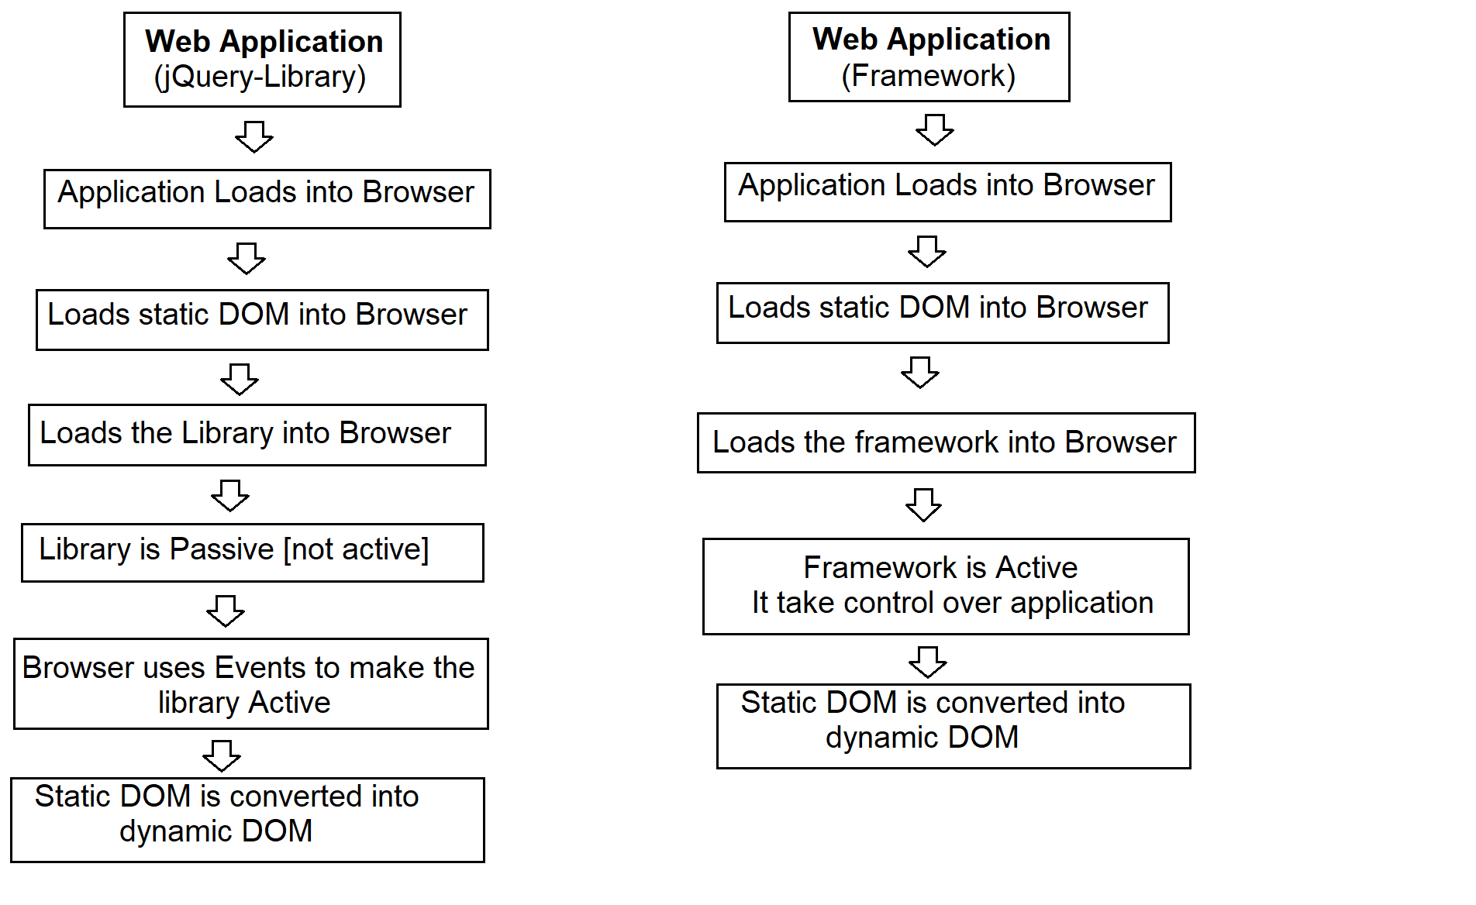

**What is Angular JS?**

* It is an open source and cross platform client-side framework developed by **Google**.
* For designing SPA developers started using Angular JS.
* Doesn’t require DOM manipulations.
* It uses MVC, MVVM frameworks.
* Less Code
* Fluid UX
* Unified UX
* Loosely couple Extensible

**What are the issues with Angular JS?**

* Google developed Angular JS as a framework for its internal purpose.
* We are using Angular JS for our application.
* Lot of GAPS.
* Angular JS uses JavaScript as Language.
* JavaScript is not strongly typed.
* Angular uses Legacy Library
* Applications a heavy
* Slow in rending
* Google designed an alternative technology for developer by name “Angular”
* 2014 Google Angular Team
* Google started a language called “atscript” trans compiles into “javascript”.
* Platform for developers called “Angular”.

**Angular**

* Angular is developer’s platform.
* Angular is an alternative for Angular JS.
* Angular JS – uses – JavaScript
* Angular started with “AtScript”
* Microsoft – TypeScript – Anders Hejlsberg for - .NET Language “C#” 2003.
* Angular – JavaScript
* Angular – TypeScript
* Angular – Google
* TypeScript – Microsoft

**Features of Angular**

* Open Source
* Cross Platform
  + Apache Cordova, Ionic, Native Script
* You can build application for
  + Web
  + Mobile Web
  + Mobile Native
  + Native Desktop
* Speed and Performance
  + 10x speed than Angular JS
  + Modular Library
  + Lazy Loading
  + Differential Loading
  + Asynchronous [JavaScript Library RxJS]
* End to End tools for developer
  + Language
  + Library
  + Framework [Building, Testing]
  + Deploying
* Angular uses frameworks like MVC, MVVM, Micro Services
* Supported Google and Large community

**Angular [Google] – React [FaceBook]**

**Angular – MVC [Model – View – Controller]**

**Model – Data - API – Server Side - Database**

**View – UI**

**Controller – Application Logic**

**Angular 7 – No Longer Supported**

**TypeScript**

**What is TypeScript**