**What is Angular? Why Angular?**

Basic Software Requirements for Building **Web Applications**

1. HTML
2. CSS
3. Client-Side Script
   1. JavaScript
   2. TypeScript etc.
4. Client-Side Library
   1. JQuery
   2. JQlite
   3. RxJS etc.
5. Server-Side Scripting
   1. JSP
   2. PHP
   3. ASP.NET
   4. Python etc.
6. Database
   1. Oracle
   2. MySql
   3. MongoDb etc.
7. Middleware
   1. Express
   2. Oracle Middleware
   3. CISCO Middleware
8. IDE [Integrated Development Environment]
   1. Eclipse
   2. Visual Studio
   3. Visual Studio Code
   4. Web Strom
   5. Sublime etc..
9. Desk Top Publishing Tools [DTP]
   1. Photoshop
   2. Flash
   3. Illustrator
   4. CorelDraw etc..

* **We are building application for web from early 1990’s** [Tim Berners Lee – Introduced – Web]
* Legacy type development
* **Suddenly why you need Angular, React like technologies, which are there from 2010, 2014**
* Modern

**What are the challenges in Modern Web Development?**

*Majority of users are using our application from smart-devices [80% of users]*

1. Application must have **Unified-UX  
   -** Application must provide same experience across all devices.  
   - Mobile user must get access to everything.  
   - Application should not optimize.
2. Application must have **Fluid-UX  
   -** User will stay on only one page.  
   - He can access everything from one page.  
   - He will not navigate to next or previous page.  
   - Entire browsing happens in one page.  
   - New details are added to page without reloading the complete page.
3. Loosely coupled and Extensible Architecture  
   - Application must able to update with new features without re-installing.

- New features that are added into application should not lead to Catastrophic Failures.  
- Easy Upgrade  
- Easy Deployment  
- Single Step Installation

- Application must be ready to use without re-starting the device.

**What is solution?**

***Better build SPA & Progressive Web Applications instead of Legacy type Web Applications***

**Is SPA [Single Page Application] is a New Type of Application?**

***No. [Twitter, Ebay]***

**How to Build SPA? Can I use JavaScript & JQuery?**

***Yes, but have issues.***

**What are the issues with JavaScript and JQuery?**

* They use lot of **DOM** manipulations.
* Lot of references.
* Lot of coding with references.
* Heavy on browser.
* Slow in rendering.
* JavaScript is a language, JQuery is a library, they don’t have the ability to control application flow.
* To control application flow explicitly we need frameworks like MVC, MVP, MVVM.
* JavaScript will not support complete OOP.
* Navigation issues [It requires lot of Ajax]

**What is solution?**

***Better use a Framework Client Side***

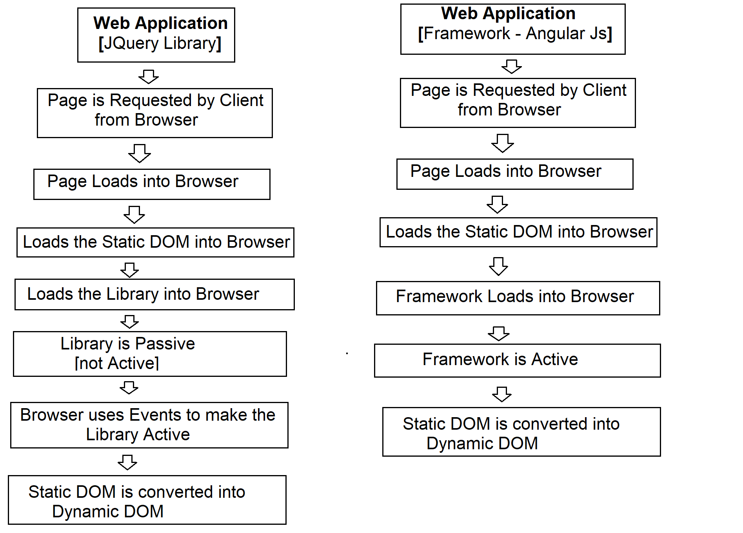

**What is Framework?**

* Framework is a Software Architectural Pattern.
* Architectural patterns are same like Design Patterns but have a broader scope.
* Framework have the ability to build and control the application flow.

**Server-Side Frameworks**

Java - Spring

Php - Cake PHP, Code Igniter

Perl - Catalyst, Dancer

Python - Django, Flask, Grok

Ruby - Ruby on Rails

.NET - ASP.NET MVC

**Client-Side Frameworks**

* Angular JS
* BackBone Js
* Ember JS
* Vue JS
* **Knockout JS**
* SPINE etc.

**Angular JS**

* It is an open source and cross platform, JavaScript Based framework developed by Google and maintained by a large community on organizations and developers in order to address the issues of **SPA**.
* Angular Open Source 2010
* Angular is Cross platform
* Frameworks like “Cordova, Ionic, NativeScript” [Mobile Application]
* MVC, MVP, MVVM

**Issues**

* It is JavaScript Based
* Not Strongly Type
* Not Implicitly strictly typed
* Not complete OOP supported
* Angular JS is not designed for what you are using hence lot of GAPS. [**MIT – License]**
* Legacy Library
* Slow in rendering
* Heavy applications

**Angular**

* Google Angular JS team started a new **platform for developers** called **Angular**. To over come the issues of Angular JS.
* A developer’s platform comprises of all tools required for developer from building application to deploying. [Language, Framework for flow, Framework for Testing, tools for deploying].
* Angular team wants to use a new language instead of JavaScript for their new platform.
* Google Angular team started a language called “**AtScript**” for their new platform called “Angular”.
* Browsers can’t understand “AtScript”, they transcompile “AtScript” into JavaScript.
* Microsoft already have a language called “TypeScript” developed by “Anders Hejlsbreg”.
* Microsoft is using TypeScript for their language called “C#” to handle client-side interactions.
* Microsoft started using TypeScript as alternative for “JavaScript”.
* Google decided to use Microsoft’s “TypeScript” in Angular.

**Angular Features:**

1. **Develop Across All Platforms  
   -** You can build application that can run on any OS and any Device.  
   - Develop application for web, mobile web, native mobile and native desktop.  
   - Angular uses cross platform frameworks like Cordova, Native Script, Ionic etc.
2. **Speed and Performance  
   -** It uses modular library. [Loads only what is required for a situation]  
   - It uses Asynchronous library [**RxJS**]  
   - It can also use “Immutable.js”  
   - Dynamic Loading [JIT – Just-In-Time and AOT- Ahead-Of-Time]  
   - Differential Loading [Library is classified for Legacy and Modern Browsers]  
   - Your application can run anywhere.
3. **Productive Tooling  
   -** Tools for Testing  
   - Tools for Deploying and Hosting  
   - Tools Debugging