**TypeScript**

* **Anders Hejslberg** designed for language called “C#” for Microsoft and later introduced “TypeScript” for “C#”.
* TypeScript is an open source, cross platform language developed by “Microsoft” and used in Angular (Google) for building SPA and Progressive web application.
* TypeScript is strict superset of JavaScript.
* TypeScript is strongly typed language.
* TypeScript follow “Duck Typing” mechanism.  
  **ex:**

**JavaScript**var x = 10; [x is number type]

x = “John”; [x transforms into string type]  
**TypeScript**

var x:number = 10;

x = “John”; [invalid]

* TypeScript is an Object-Oriented Programming Language  
  **[***JavaScript Supports some features OOP – but not OOP Language]*
* TypeScript can leverage the benefits of OOP and supports features like extensibility, reusability, dynamic polymorphism, etc.
* TypeScript is completely built with “**TypeScript**”.
* TypeScript supports **low level features** that can directly interact with hardware services.
* Browser can’t understand TypeScript.
* TypeScript programs are trans compiled into JavaScript.
* Developers will use TypeScript and Browser will use “JavaScript”.

**TypeScript Architecture**

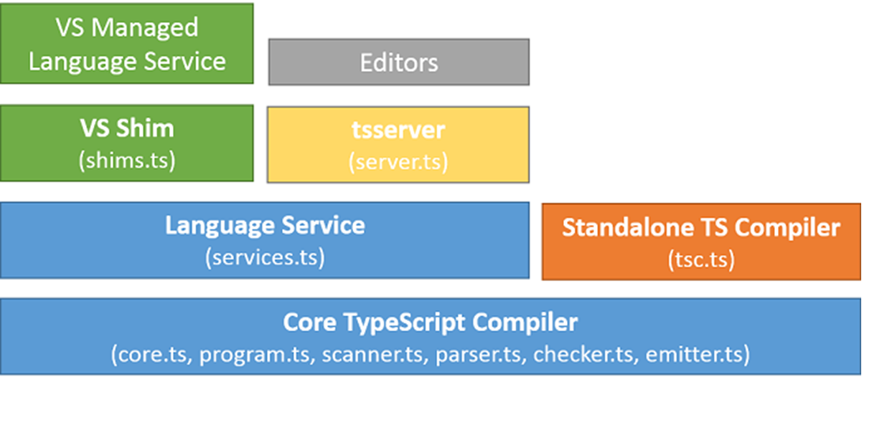

|  |  |
| --- | --- |
| **Component** | **Description** |
| Core TypeScript Compiler | It verifies the syntax, keywords, input and output activities, parsing methods and reports the errors.  ***core.ts, program.ts, scanner.ts, parser.ts, checker.ts, emitter.ts*** |
| Standalone TS Compiler | It trans compiles the TypeScript program into a JavaScript program.  ***tsc.ts***  Ex:  Hello.ts -> tsc -> Hello.js |
| Language Service | It is a pre-defined business logic. It provides a set of functions which you can inject into your application to handle specific functionality.  TypeScript language service comprises of functions, keywords, contracts etc.  ***services.ts*** |
| tsserver | It is the location where your TypeScript programs are hosted, compiled, processed etc. It manages the request and response in an application.  ***server.ts*** |
| VS Shim | Visual Studio Shim – It is used to make your TypeScript programs understandable to all OSx. [Cross Platform]  ***shims.ts*** |
| VS Managed Language Service | Library for cross platform.  Native to any OS is Un-Managed.  Managed is for every OS. |
| Editor | It provides support for various editors used to build, debug, test and deploy application.  **Ex:**  **Visual Studio Code, Sublime, WebStrom, Eclipse etc.** |