**TypeScript**

* **Anders Hejslberg** designed for language called “C#” for Microsoft and later introduced “TypeScript” for “C#”.
* TypeScript is an open source, cross platform language developed by “Microsoft” and used in Angular (Google) for building SPA and Progressive web application.
* TypeScript is strict superset of JavaScript.
* TypeScript is strongly typed language.
* TypeScript follow “Duck Typing” mechanism.  
  **ex:**

**JavaScript**var x = 10; [x is number type]

x = “John”; [x transforms into string type]  
**TypeScript**

var x:number = 10;

x = “John”; [invalid]

* TypeScript is an Object-Oriented Programming Language  
  **[***JavaScript Supports some features OOP – but not OOP Language]*
* TypeScript can leverage the benefits of OOP and supports features like extensibility, reusability, dynamic polymorphism, etc.
* TypeScript is completely built with “**TypeScript**”.
* TypeScript supports **low level features** that can directly interact with hardware services.
* Browser can’t understand TypeScript.
* TypeScript programs are trans compiled into JavaScript.
* Developers will use TypeScript and Browser will use “JavaScript”.

**TypeScript Architecture**

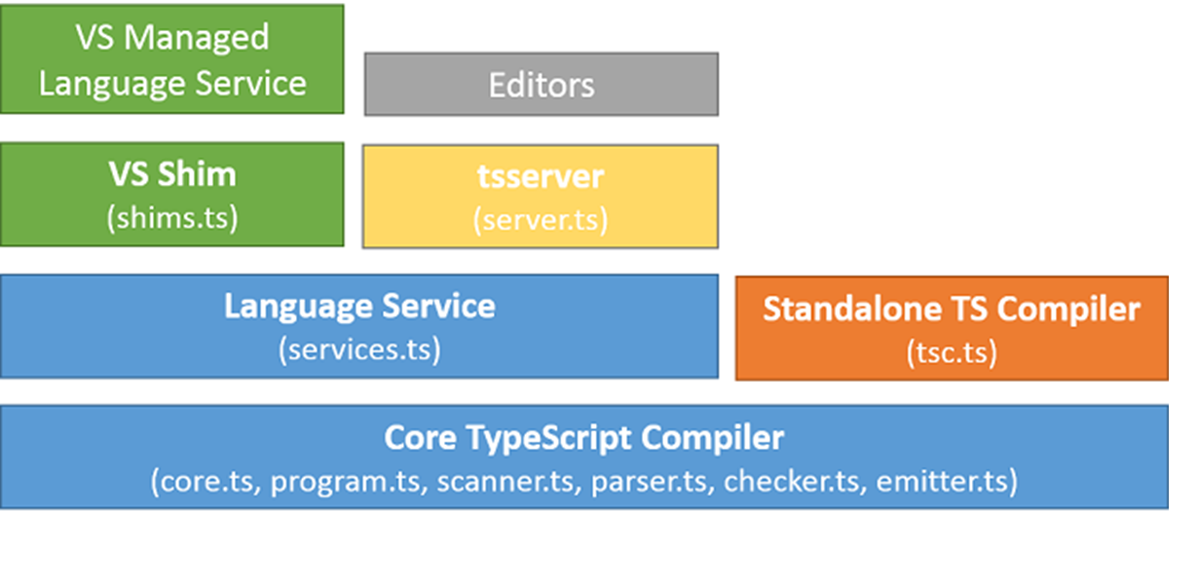

|  |  |
| --- | --- |
| **Component** | **Description** |
| Core TypeScript Compiler | It verifies the syntax, keywords, input and output activities, parsing methods and reports the errors.  ***core.ts, program.ts, scanner.ts, parser.ts, checker.ts, emitter.ts*** |
| Standalone TS Compiler | It trans compiles the TypeScript program into a JavaScript program.  ***tsc.ts***  Ex:  Hello.ts -> tsc -> Hello.js |
| Language Service | It is a pre-defined business logic. It provides a set of functions which you can inject into your application to handle specific functionality.  TypeScript language service comprises of functions, keywords, contracts etc.  ***services.ts*** |
| tsserver | It is the location where your TypeScript programs are hosted, compiled, processed etc. It manages the request and response in an application.  ***server.ts*** |
| VS Shim | Visual Studio Shim – It is used to make your TypeScript programs understandable to all OSx. [Cross Platform]  ***shims.ts*** |
| VS Managed Language Service | Library for cross platform.  Native to any OS is Un-Managed.  Managed is for every OS. |
| Editor | It provides support for various editors used to build, debug, test and deploy application.  **Ex:**  **Visual Studio Code, Sublime, WebStrom, Eclipse etc.** |

* TypeScript Version 0.8 in October 2012 First version that Microsoft made public.
* The latest stable version of TypeScript is **3.9.7 – July**
* TypeScript 4.0 is the next version, it is still in Beta

**Setup Environment for TypeScript**

1. You need a package manager to install any library for your development process.
2. Package Manger is a software that can connect with online repository and download library for your project.
3. There are several package managers
   1. NPM
   2. Yarn
   3. Bower
   4. RubyGems
   5. NuGet etc..
4. **We Will install NPM [Node Package Manager]**- Visit Official Node JS  
    <https://nodejs.org/en/download/>

* Download for your OS
* Install on your PC
* Go to Command Prompt and Test   
  > node -v  
  > npm -v

<https://www.npmjs.com/>

1. **Install TypeScript for your PC**

> npm install -g typescript

> tsc -v [to test installed TypeScript version]

**How to use TypeScript in a Web Application?**

1. You have to create a new Web Application or Web Site on local Web Server.

- You can use web server software like Apache Tomcat, IIS, etc.

2. Windows have local Web Server called IIS [Internet Information Services Manager]   
 - Go to Control Panel

- Go to Administrative Tools

- Look for “Internet Information Services Manager”

- If you are unable to find *IIS in Administrative Tools* then you have to manually add from

“Programs and Features” in control panel.

* Open any Browser and type the following URL to test your Web Server

<http://localhost>

(or)

<http://127.0.0.1>

3. Create a new Web Site on Local Web Server  
- Open IIS [Run 🡪 Inetmgr]

- Expand Local Computer [http://localhost]

- Expand “Sites” folder

- Right Click on “Default Web Site”

- Select “Add Virtual Directory” [creating a new website]

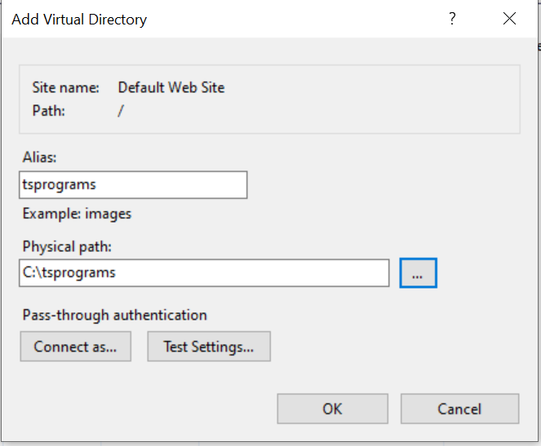

Virtual Path : <http://localhost/tsprograms>

Physical Path : C:\tsprograms

* Every Web Application starts with “index.html”
* Create a new HTML page by name “index.html” and save in your project physical path.

You can use “notepad”