* **Web started in early 1990’s**
* **Web was introduced by “Tim Berners Lee” [**HTML**]**
* **Web Applications are built by using**
  + HTML
  + CSS
  + JavaScript
  + jQuery

**What are the challenges in Modern Web Development?**

* Majority of Web Users are using web from smart devices [Mobiles].
* Unified-UX
  + Application must reach any device that is from a mobile to desktop.
  + Application must provide same experience across all devices.
  + Mobile users must get access to everything.
* Fluid-UX
  + User will stay on one page and can browse every thing from the page.
  + New details are added into page without reloading the complete page.
* Loosely coupled and Extensible Architecture
* Simplified Deployment

**What is solution?**

* Better build “Single Page Application” instead of traditional web application.
* SPA, are unified in UX.
* SPA, are fluid

**How to build SPA? Can we use JavaScript, jQuery for SPA?**

* Yes, you can use JavaScript, jQuery for building SPA

**What is problem with JavaScript and jQuery?**

* JavaScript is a language.
* jQuery is a library
* Language and Library can build application but can’t control application flow.
* JavaScript and jQuery use lot of DOM (Document Object Model) manipulations.
* Lot of references
* Lot of coding
* JavaScript and jQuery can provide access to Browser objects like window, history etc.
* Navigation Issues
* Lot of Ajax explicitly.

**What is Solution?**

* Better use any framework Client-Side.
* Framework have the ability to build application and control the application flow.
* Framework is de-coupled from DOM manipulations.
* It uses MVC, MVP, MVVM, Micro Services like framework for controlling the application flow.

Ex:

**Knockout JS**

**Backbone JS**

**Angular JS**

**Angular**

**What is a framework and Why we need Framework?**

* Framework is an software architectural pattern that have the ability to build application and control the application flow.

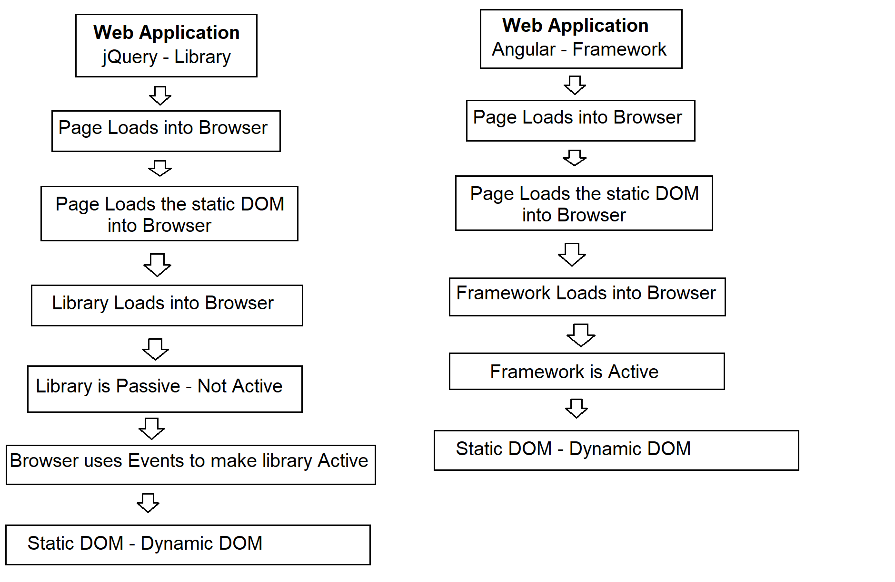

**Java Spring**

**.NET ASP.NET MVC**

**PHP Cake PHP, Code Igniter**

**Python Django, Flask**

**JavaScript SPINE, Angular JS**

Angular JS and Angular Framework

React JS is a library

Developer 4+ Years - Library and Framework

Project – Everything is built as application on server side, Client side they just need a good UI, better to use “React JS”.

Project – Client Side we need an application that communicates with server side application. Client need a good application on browser not just the UI. Then better to use “Angular”

React is “UI-View”

Angular is “Model-Controller-View”

**Angular JS and Angular**

**What is Angular JS?**

* Angular JS is JavaScript based Framework introduced by Google in 2010 and Maintained by a large community of developers and organizations.
* Angular JS is open source and cross platform.
* For Developing SPA.
* Angular JS is a Framework.
* It is de-coupled from DOM Manipulations.
* Less code and reference.
* Two-way data binding.
* Implicitly uses Ajax. [Asynchronous JavaScript And XML]

**Issues with Angular JS:**

* Angular JS is not designed for what it is being used for.
* Angular JS is not designed for your type of requirements but you are using it.
* Lot of GAPs. Need support for 3rd Party.
* Angular JS uses JavaScript as Language.
  + JavaScript is not a complete OOP.
  + It is not strongly typed.
  + Schema less.
  + Compatibility Issues
* Angular JS uses a Legacy Library
* Slow in rendering, in loading.
* Browser compatibility issues.

Angular JS version 1x [1.8 latest]

**Google Angular Team**

* New technology for building SPA.
* Started a language called “AtScript” to overcome the issues of JavaScript.
* Microsoft already have a language called “TypeScript”
* TypeScript is an OOP
* Strongly Typed
* Google Angular team started “Angular 2” 2016
* Angular is modular library.
* Only the library required for the situation is loaded.
* Faster [10x faster than Angular]
* Asynchronous library [Without loading complete page, it can add new details to page]
* Differential loading [Library will be loaded according to browser]
* Reduce the browser compatibility issues.

**Angular is an alternative for Angular JS not replacement.**

**Angular 11**

**TypeScript**