**­**

**Setup Environment for TypeScript**

* **Install Node JS on your PC**
  + Web Development requires a package manager software.
  + Package Manager is used to install various libraries that are required for project development.
  + There are various types of package managers like
    - **Yarn**
    - **NPM**
    - **NuGET**
    - **Bower**
    - **RubyGEMS** etc.
  + **Installing Node JS on your computer gets “NPM”** as Package Manager.
    - Visit <https://nodejs.org/en/download/current/>
    - Download and Install Node JS for your OS.

**Note: If you have Node JS already installed on your PC. Make sure that its version is 10x and higher.**

* + Test the version of Node JS and NPM from your command prompt.

**C:\> node -v  
C:\> npm -v**

* **Install TypeScript on your PC**
  + Open your windows command prompt
  + Run the following command  
    **C:\> npm install -g typescript**
  + You can check the version of TypeScript by using   
    **C:\> tsc -v**
* **Install Editor on your PC** 
  + It provides an Integrated Development Environment [IDE] from where you can build, debug, test and deploy application.
  + Developers can use various Editors like
    - Sublime
    - Visual Studio Code
    - Eclipse
    - Web Strom etc.
  + **Download and Install “Visual Studio Code” as Editor**

[**https://code.visualstudio.com/**](https://code.visualstudio.com/)

* **Install following plugins on your Visual Studio Code**
  + Open Visual Studio Code
  + Go to “Customize” category and install support for “JavaScript”
  + Go to “Extensions”
  + Search and Download the following extensions
    - **Live Server**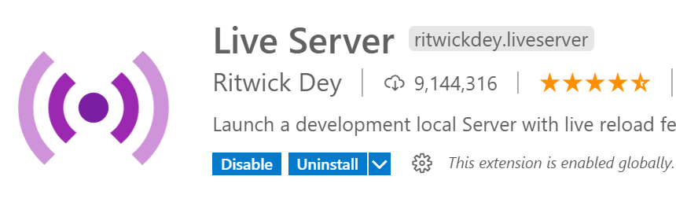
    - **Vscode-icons**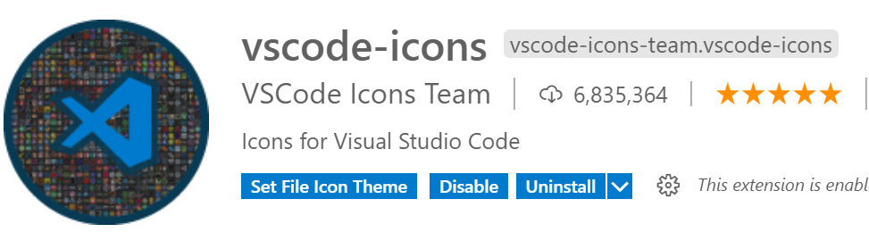
    - **TsLint**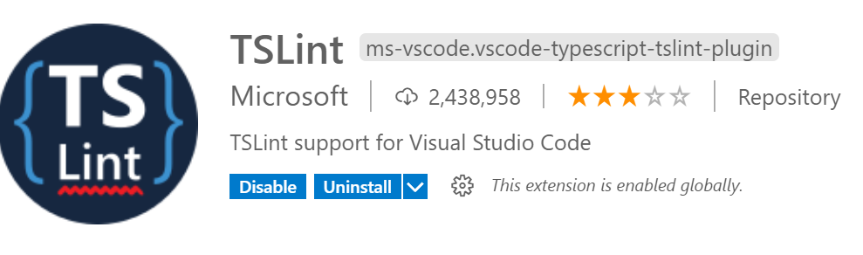
* **Create a new TypeScript Project** 
  + Open File Explorer on your PC
  + Create a new folder for project  
    **C:\TypeScript-Project**
  + Open the project folder in Visual Studio Code.
    - File Menu -> Open Folder -> C:\TypeScript-Project
  + Open Terminal [Ctrl + `]
  + Run the following command  
    > npx tsc --init
  + This will add “tsconfig.json”
  + Run the following command  
    > npm init
  + This will walk through Web application initialization and will generate “package.json”.
  + Add a new folder “public”
  + Add a new file into folder “index.html”
  + Add HTML code into “index.html”
  + Right Click in Index.html and select “Open With Live Server”