**Front End Web Development**

**What is Web?**

* A computer network comprises of group of computers connecting with each other for sharing of information and devices.
* Internet is a Wide Area Network that connects computers all over the world.
* In early 1990’s “**Tim Berners Lee”** introduced the concept of Web.
* Web is a portion of internet with restricted access.
* You are learning how to build applications for Web.

**Architecture of Web Application**

* Software Applications and Products
  + One Tier
  + Two Tier
  + 3 Tier
  + N Tier

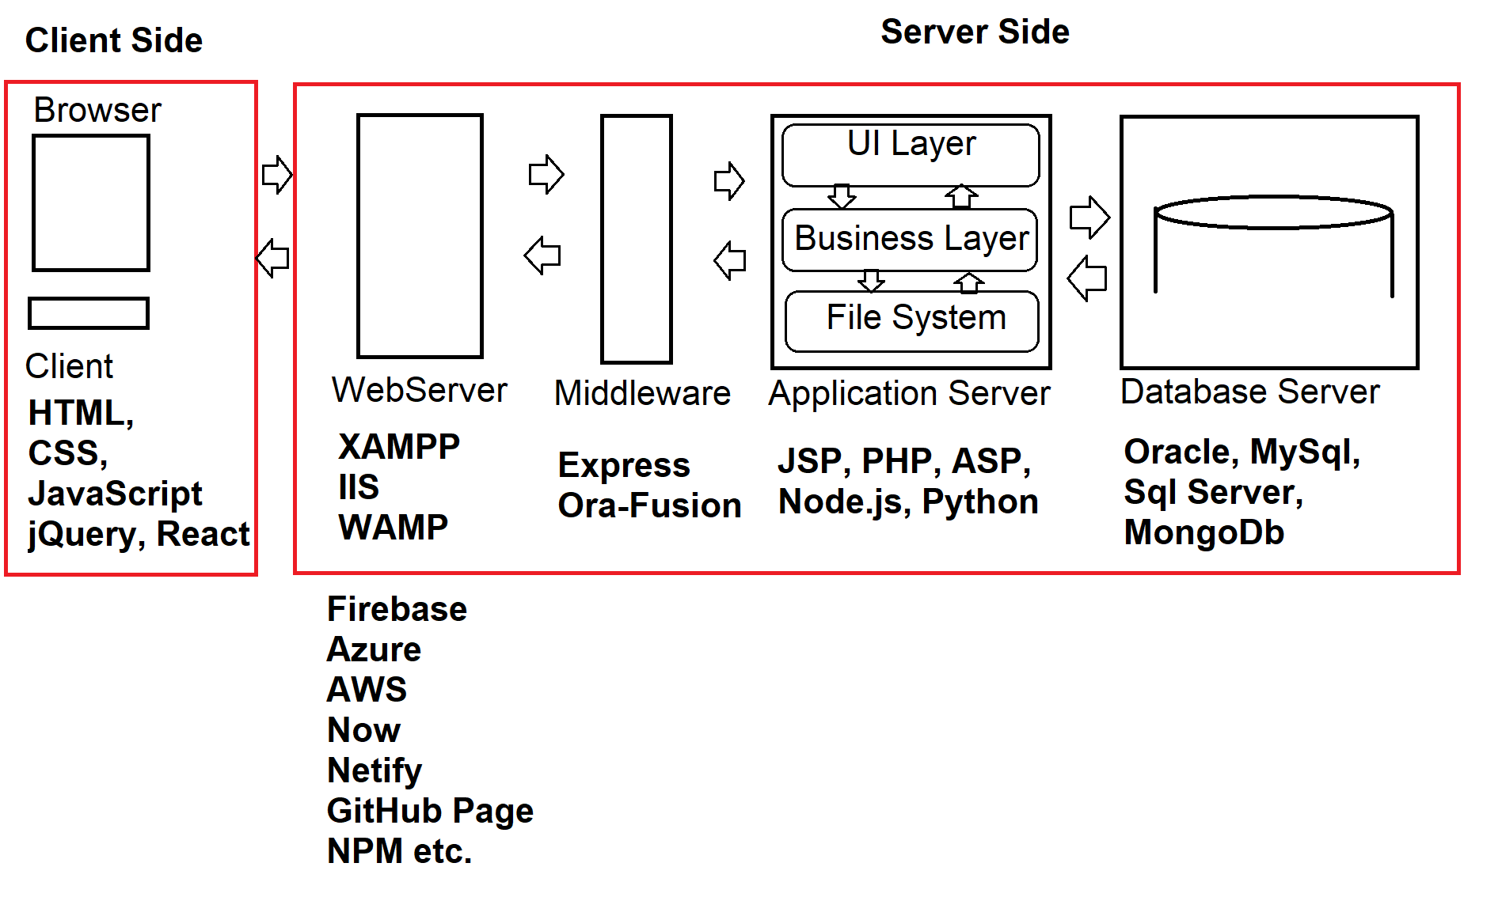

**Front End Web Development is all about Client Side**

**What are the basic requirements to Build and End to End Web Application?**

* HTML
* CSS
* JavaScript [Client-Side Language: TypeScript, VB Script, ECMA Script, Coffee Script..]
* jQuery [Client-Side Library: jQlite, RxJS, React.js]
* Angular JS, Backbone, Knockout, Angular etc. [Framework]
* Cross platform Frameworks: Ionic, Native Script, Cordova etc.
* Middleware: Express, Oracle Fusion
* Server-Side Scripting: JSP, PHP, ASP, Node.js etc.
* Database: Oracle, MySql, Sql Server, MongoDB
* DTP Tools: Illustrator, Photoshop, Flash etc.
* CMS: Content Management System: IDE [Build, Debug, Test, Deploy]  
  Eclipse, Sublime, Visual Studio Code etc.
* Version Controlling: GIT
* Testing: Jasmine, xUnit etc.