**What is Web Server?**

* Web Server resembles both hardware and software. It satisfies the client request by sending and receiving resources & requests.
* Server role is hosting your resources, processing requests and managing response etc.
* Web Server Software
  + IIS [Internet Information Services Manager]
  + Tomcat etc.
* Local Web Server
* Cloud Live Server

**Local Web Server on Windows**

**Look for Local Web Server on Windows:**

* Open Windows Control Panel
* “Switch to Icon View”
* Go to “Administrative Tools”
* Look for “Internet Information Service Manager”

**Turn ON local IIS if not available:**

* Go to Control Panel
* Go to “Program and Features”
* Click on “Turn Windows Features ON or OFF”
* Select “Internet Information Services”
* Add to your local windows.

**Test Your local Web Server:**

* Open any browser: Chrome, Edge, Fire Fox
* Type the following URL:   
  <http://127.0.0.1> or <http://localhost>

**Web Terminology**

**What is Web Site?**

* Web Site is a virtual directory on web server.
* Web Site will give access to resources on server.
* Site: location on server: It may be a drive or directory location

**Creating a new Website of Local Server [IIS]:**

* Open Local IIS [Run -> inetmgr]
* Expand “local computer”
* Expand “Sites” folder
* Right Click on “Default Website”
* Select “Add Virtual Directory”

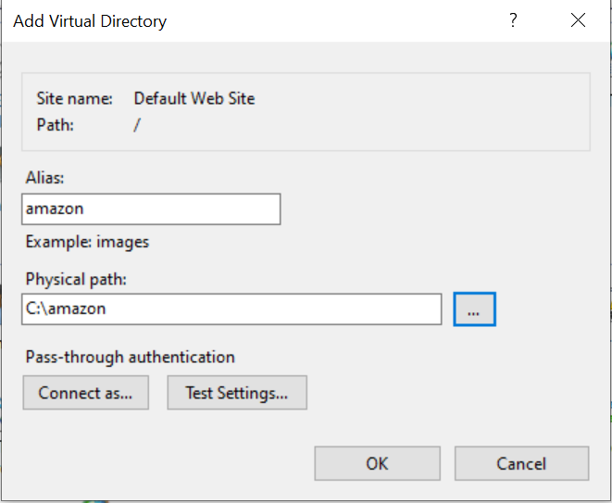

Virtual Path: <http://localhost/amazon> : URL – Uniform Resource Location

Physical Path: C:\amazon