**Software Application and Software Product**

* Software designed according to Client Requirements is known as “Software Application”.
  + Amazon Mobile App, Amazon Website
  + Java, .NET, PHP, Python, Node Js, Angular, React, HTML, CSS, JavaScript etc.
* Software designed according to Domain requirements is known as “Software Product”
  + ERP [SAP, Ariba, Oracle Applications]

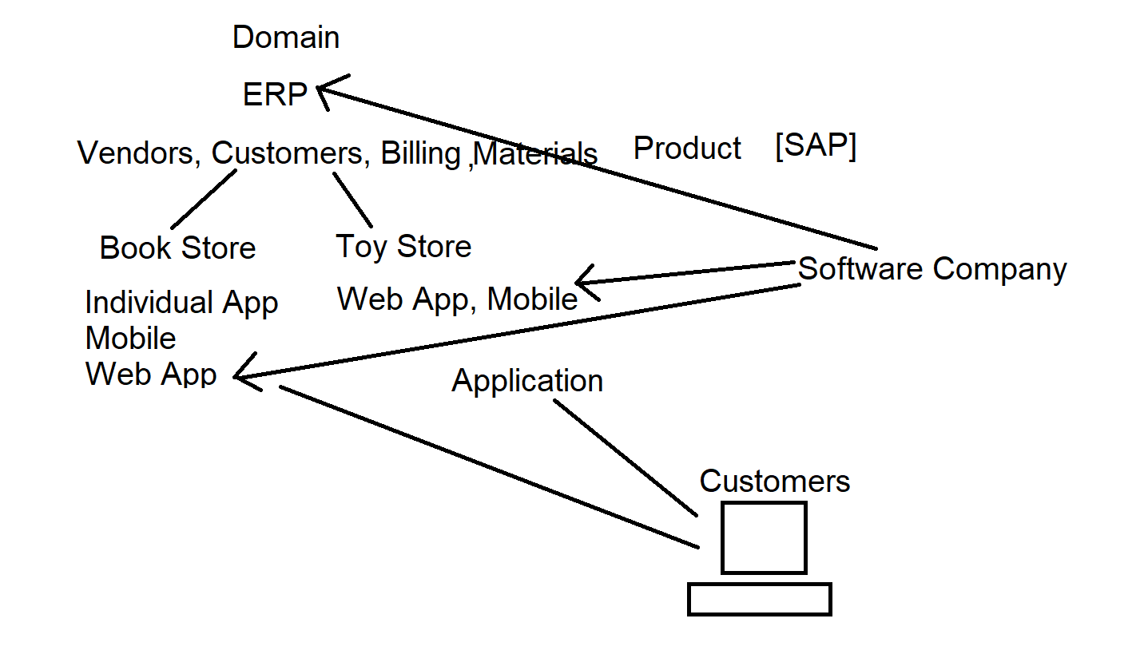

* To build any application for client requirements you need
  + Front End
  + Back End
  + Middleware
* **Front End:** It creates a proper UI. So that client can interact with the application.
* **Back End:** It handles interaction with the user and the data source. It accepts the request, process the request, pick up from the database and returns the response.
* **Middleware:** It handles the communication between front end & back end.
* **Full Stack Developer can handle all.**

**Types of Applications**

* **Desktop Application**

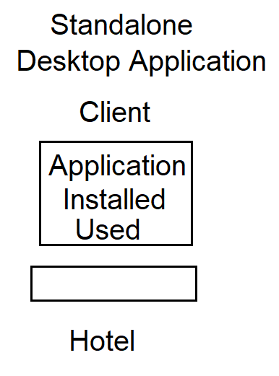

* **Web Application**

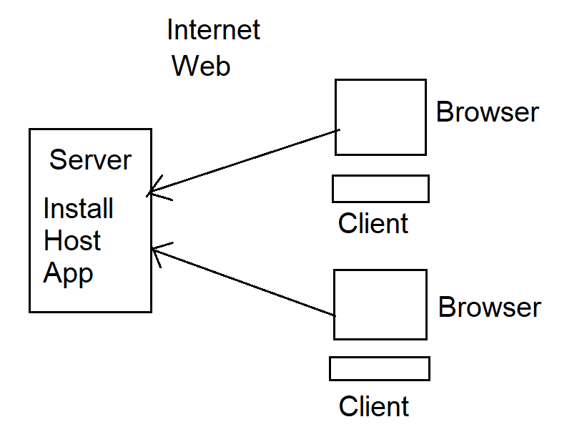

[www.amazon.in](http://www.amazon.in)

[www.netflix.com](http://www.netflix.com)

* **Distributed Application**

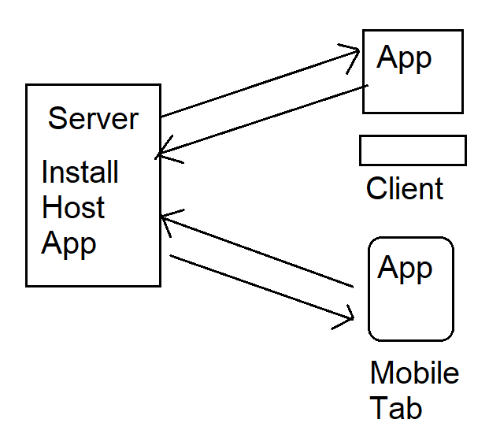

Amazon app on mobile

Netflix app on mobile, desktop, laptop

* **Mobile Application**

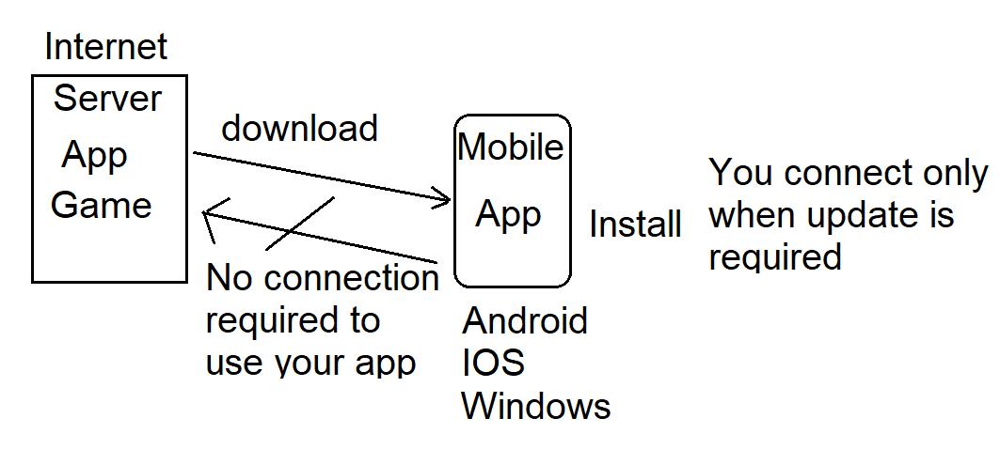

Game Apps, Tutorial Apps, Coding Apps

* AI Application
  + It is the simulation of human intelligence process by machines.
  + Speech Recognition [Siri, Alexa, Google Home etc]
  + Biometrics
* 2D and 3D Gaming Application
  + It is for game consoles. [X-Box]
* IoT Application
  + Internet of Things
  + Smart Home [bulb, fan]
  + Wearables
  + Temperature, rainfall, humidity, wind speed, etc.

**What you can develop by learning Full Stack Course?**

* Web Applications
  + HTML, CSS, Bootstrap, JavaScript, JQuery, Angular JS, Node JS, Express, MongoDB, MySql
* Distributed Applications
  + React, [SPA, Progressive App]
* Mobile Native Applications
  + Ionic Framework

**What are the primary areas of Applications we cover in Full Stack?**

* Front End [UI with UX]
* Back End [Server-Side Application & Database]
* Middleware [Communication between multi-tiers]
* Testing and Deploying [Live]

**Order**

* Front End Development [HTML, CSS, Bootstrap, JavaScript, JQuery, Angular JS, React, Ionic]
* Backend and Middleware [Node JS, Express]
* Testing & Deploying [Jasmine & Karma, Firebase]

MEAN - MongoDB, Express, Angular, Node JS

MERN - MongoDB, Express, React, Node JS

Full Stack – Front End and MERN, MEAN

Java, .NET, PHP, Python – Java Full Stack Developer, .NET Full Stack

**Web Applications**