**Workshop**

**What is HTML?**

* HTML is a presentation language.
* Hyper Text Markup Language.
* Term Hyper is derived from Greek Term, which means “Beyond”
* Hyper Text is the text that comprises of content beyond what you see.
* Markup means marking up our information for presentation.
* HTML comprises of elements arranged in a hierarchy called DOM.   
  (Document Object Model)

**What is the Document Object Model [DOM]?**

* The Document Object Model (DOM) is a programming API for HTML and XML documents.
* It defines the logical structure of documents.
* It specifies a way for accessing and manipulating HTML and XML document.
* HTML presents all its elements in a hierarchy called DOM.
* With DOM programmers can create and build documents, navigate their structure, and add, modify or delete elements and content.
* HTML presents DOM and JavaScript Manipulates DOM
* HTML DOM is static and JavaScript makes the static DOM into Dynamic DOM.

**What is the Browser Object Model [BOM]?**

* It represents the browser model.
* It defines a set of objects that are used to manipulate the browser.
* Programmer uses BOM to handle interaction with regard to browser.
* Programmer can know about browser and its capabilities by using BOM.
* BOM is programming API for Browser manipulations.

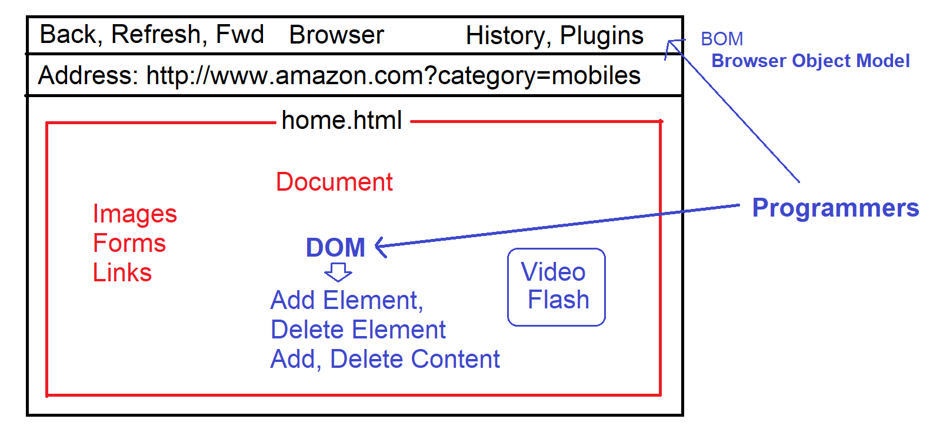

**Browser Object Model**

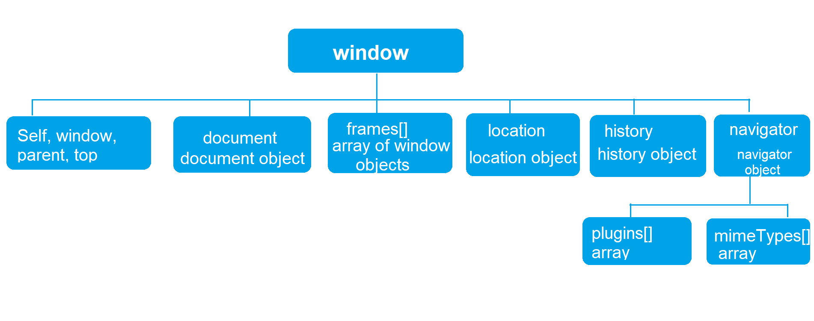

|  |  |
| --- | --- |
| **Browser Object** | **Description** |
| window | It provides a set of properties and methods which are used to manipulate the browser window, like open window, close, minimize window etc. |
| location | It provides a set of properties and methods which are used to know client location details, like URL, IP address, Path, Server Name, port number etc. |
| history | It provides a set of properties and method which are used to manipulate the browser history. |
| navigator | It provides a set of properties and methods which are used to know the client browser details, like browser family name, version, plugins, MIME types, cookies etc. |
| document | It provides access to the DOM model. It provides set of properties and methods that are used to manipulate the HTML document in browser. |

**Setup Environment**

* Downloading and Install any Editor
  + Visual Studio Code
  + Web Strom
  + Sublime
  + Eclipse etc.

<https://code.visualstudio.com/Download>

* Install any Live Server Plugin into your editor or you can also view in a browser.
* Visual Studio Code Editor
  + Install Extension by name “Live Server”
* **Create a new Folder for our workshop and Open in your editor**

**Browser Object Model**

* window
* location
* navigator
* history
* document

**window object**

* It provides a set of properties and methods that are used to manipulate the browser window.

|  |  |
| --- | --- |
| **Member** | **Description** |
| open() | It opens any document in a new window.  Syntax:  window.open(“path”, “title”, “options”) |
| close() | It closes the current window or any specific window in workspace. |
| print() | It opens printer properties to print the page. |

Ex:

<!DOCTYPE html>

<html>

<head>

<title>BOM</title>

<script>

function OpenImage(){

window.open("Images/speaker.jpg","JBL Speaker","width=600 height=400");

}

function CloseWindow(){

window.close();

}

function PrintWindow(){

window.print();

}

function OpenShoe(){

window.open("Images/shoe.jpg","Nike","width=500 height=400");

}

</script>

<style>

img:hover {

cursor:grab;

}

</style>

</head>

<body>

<h2>Window Object</h2>

<button onclick="OpenImage()" >Open</button>

<button onclick="CloseWindow()">Close</button>

<button onclick="PrintWindow()">Print</button>

<div onclick="OpenShoe()">

<img src="Images/shoe.jpg" width="100" height="100">

</div>

</body>

</html>

**location object**

* It provides a set of properties and methods that are used to get or set the client location.

|  |  |
| --- | --- |
| **Member** | **Description** |
| host | Gets the server name or IP address |
| port | Gets the port number |
| protocol | Gets the current protocol |
| href | Gets the current URL |
| pathname | Gets the current file path. |
| reload() | It reloads the current location [Refresh the page] |
| search | It gets the query string. |

Ex:

<!DOCTYPE html>

<html>

<head>

<script>

function GetDetails()

{

document.getElementById("host").innerText = location.host;

var msg;

if(location.protocol=="http:") {

msg = "You are using Live Web Server";

} else {

msg = "You are using File Server";

}

document.getElementById("protocol").innerHTML = location.protocol + "<br>" + msg;

document.getElementById("url").innerText = location.href;

}

function GotoPage() {

location.href = "home.html";

}

</script>

<style>

dt {

background-color:darkcyan;

color:white;

margin-top: 20px;

}

</style>

</head>

<body>

<h2>Location Details</h2>

<button onclick="GetDetails()">Get Details</button>

<button onclick="GotoPage()">View Window Example</button>

<dl>

<dt>Server Name / IP Address</dt>

<dd id="host"></dd>

<dt>Protocol</dt>

<dd id="protocol"></dd>

<dt>URL</dt>

<dd id="url"></dd>

</dl>

</body>

</html>

**Navigator Object**

* It provides a set of properties and methods that are used to know the browser details.

|  |  |
| --- | --- |
| appName | Returns the browser family name. [Netscape] |
| platform | Get the details of supported platforms. |
| cookieEnabled | Returns true if cookies are enabled. |
| plugins[] | Returns the list of plugins installed in browser. |
| mimeTypes[] | Returns the list supported file types in browser. |

Ex:

<!DOCTYPE html>

<html>

<head>

<title>Navigator</title>

<script>

function Verify(){

var msg;

if(navigator.cookieEnabled)

{

msg = "Cookies Enabled.. You can Continue - You are using " + navigator.language;

} else {

msg = "Your Browser Disabled Cookies - Please Enable";

}

document.getElementById("msg").innerHTML = msg;

}

</script>

</head>

<body>

<button onclick="Verify()">Verify Cookies</button>

<h3 id="msg">

</h3>

</body>

</html>

Ex: To Get All Plugins

<!DOCTYPE html>

<html>

<head>

<script>

function f1(){

for(var i=0; i<navigator.plugins.length; i++)

{

document.write(navigator.plugins[i].name + "<br>");

}

}

f1();

</script>

</head>

<body>

</body>

</html>

Ex: To Verify any specific plugin

<!DOCTYPE html>

<html>

<head>

<script>

function f1(){

if(navigator.plugins['Chrome PDF Viewer']==undefined)

{

alert("You don't have PDF Plugin Please Install");

location.href="http://www.adobe.com/download";

} else {

document.write("You can view PDF Documents");

}

}

f1();

</script>

</head>

<body>

</body>

</html>

**History Object**

* It provides set of properties and method that are used to access browser history and navigate to previous and next pages in history.

|  |  |
| --- | --- |
| **Member** | **Description** |
| length | Gets the total count of pages in browser history. |
| back() | Moves to previous page in browser history. |
| forward() | To next page in browser history. |
| goto() | To move to any specific page in browser history. |

Ex:

<!DOCTYPE html>

<html>

<head>

<script>

function f1(){

if(history.length>3) {

alert("You can view Max 3 Pages- Please Register for More");

location.href="register.html";

} else {

document.write("You can view max 3 page only..");

}

}

f1();

</script>

</head>

<body>

</body>

</html>

**Document Object**

* It provides the set of properties and method that are used to manipulate the HTML document.
* Adding elements / Data
* Removing elements / Data
* Modifying elements/ Data etc.
* This document exposes the DOM [Document Object Model]