**Workshop**

**What is HTML?**

* HTML is a presentation language.
* Hyper Text Markup Language.
* Term Hyper is derived from Greek Term, which means “Beyond”
* Hyper Text is the text that comprises of content beyond what you see.
* Markup means marking up our information for presentation.
* HTML comprises of elements arranged in a hierarchy called DOM.   
  (Document Object Model)

**What is the Document Object Model [DOM]?**

* The Document Object Model (DOM) is a programming API for HTML and XML documents.
* It defines the logical structure of documents.
* It specifies a way for accessing and manipulating HTML and XML document.
* HTML presents all its elements in a hierarchy called DOM.
* With DOM programmers can create and build documents, navigate their structure, and add, modify or delete elements and content.
* HTML presents DOM and JavaScript Manipulates DOM
* HTML DOM is static and JavaScript makes the static DOM into Dynamic DOM.

**What is the Browser Object Model [BOM]?**

* It represents the browser model.
* It defines a set of objects that are used to manipulate the browser.
* Programmer uses BOM to handle interaction with regard to browser.
* Programmer can know about browser and its capabilities by using BOM.
* BOM is programming API for Browser manipulations.

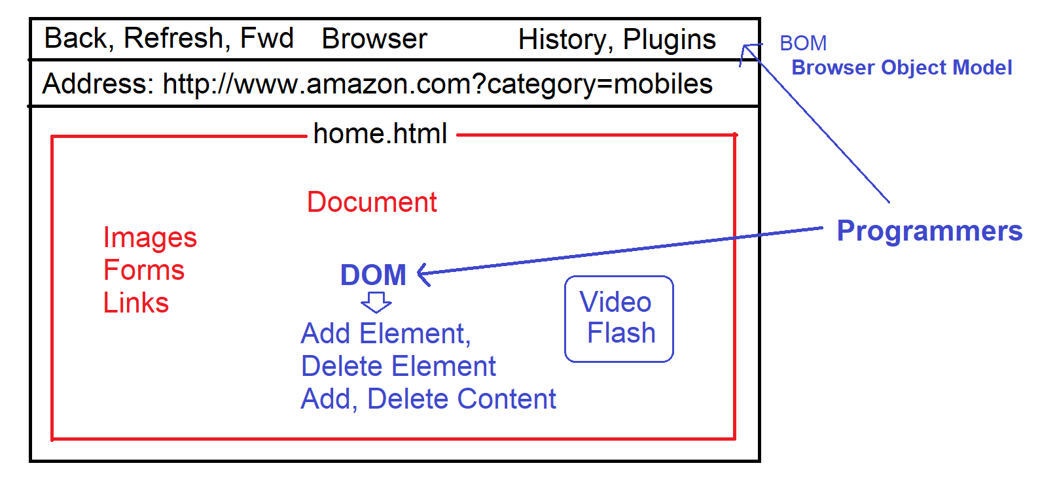

**Browser Object Model**

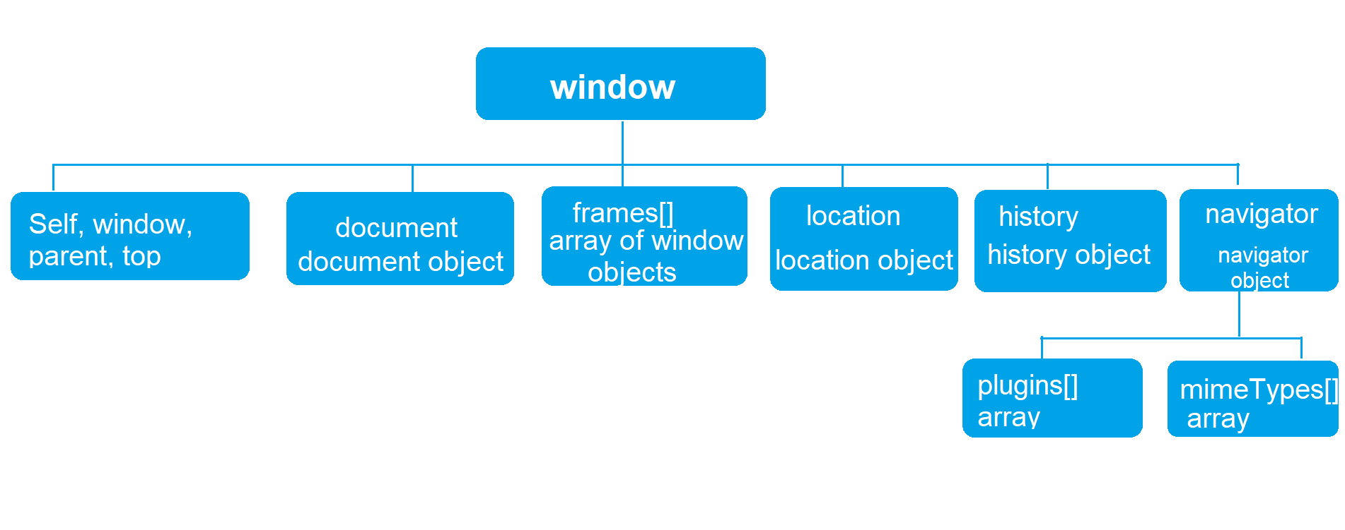

|  |  |
| --- | --- |
| **Browser Object** | **Description** |
| window | It provides a set of properties and methods which are used to manipulate the browser window, like open window, close, minimize window etc. |
| location | It provides a set of properties and methods which are used to know client location details, like URL, IP address, Path, Server Name, port number etc. |
| history | It provides a set of properties and method which are used to manipulate the browser history. |
| navigator | It provides a set of properties and methods which are used to know the client browser details, like browser family name, version, plugins, MIME types, cookies etc. |
| document | It provides access to the DOM model. It provides set of properties and methods that are used to manipulate the HTML document in browser. |