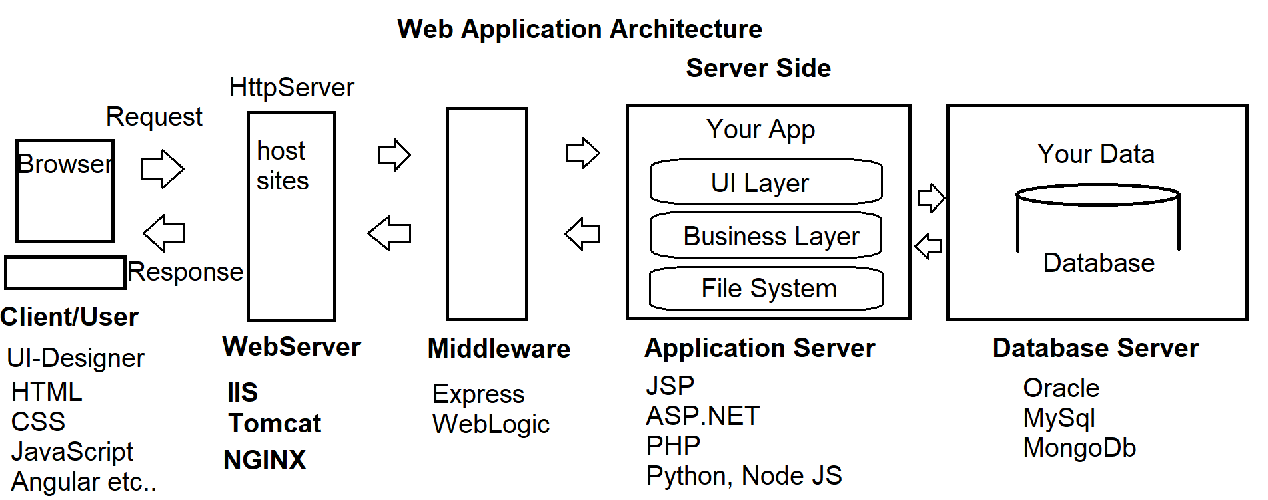

**What are the basic requirements to build an end-to-end Web Application?**

1. HTML
2. CSS
3. Client-Side Script

**JavaScript Language, JQuery Library, Angular Framework etc..**

1. Server-Side Script

**JSP, PHP, .NET, Python**

1. Middleware

**Express, Web Logic etc..**

1. Database

**Oracle, MySql, MongoDb etc..**

1. Desk Top Publishing Tools

**Photoshop, CorelDraw, Flash etc..**

1. IDE’s

**Visual Studio Code, WebStrom, Eclipse, Notepad++ etc..**

**Stack Developers**

* Java Stack
* .NET Stack
* PHP Stack
* Python Stack
* MEAN Stack

M - MongoDb Database

E - Express Middleware

A - Angular Client Side

N - Node JS Server Side

* MERN Stack

M - MongoDb Database

E - Express Middleware

R - React Client Side

N - Node JS Server Side

**What we learn in UI Technologies?**

1. HTML
2. CSS, Bootstrap
3. Client-Side Script

**JavaScript Language, JQuery Library, Angular Js, TypeScript**

1. Publishing Tools  
    **Photoshop, Flash**
2. IDE’s

**Visual Studio Code**

**We will learn how to publish live, integrate with server side and database**

What is Web?