**UI-Full Stack-Development**

* We are going to build
  + Traditional Web Application
  + SPA [Single Page Application]
  + Introduction to PWA [Progressive Web Application]

**Traditional Web Application**

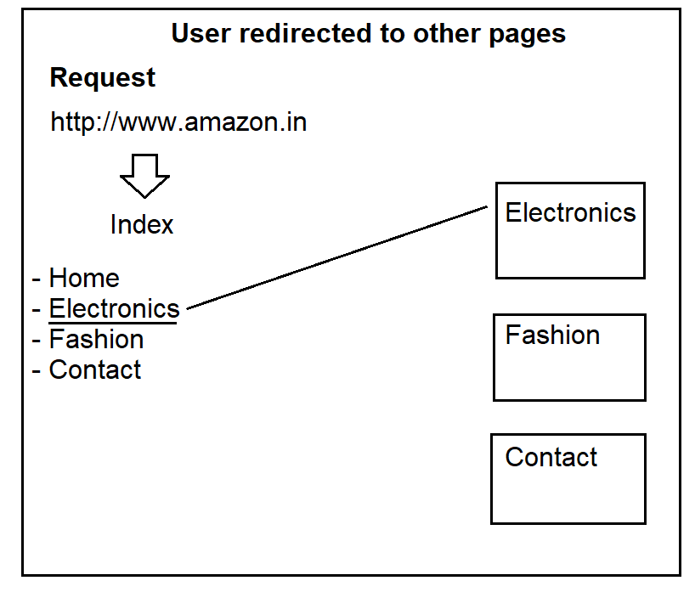

**SPA [Single Page Application]**

* User stays on one page and gets access to everything on the page.
* New details are added to page without reloading the page.



**PWA Progressive Web Application**

* App like experience in browser.
* Mobile Friendly
* Mobile Native
* Run on iOS, Android, Windows Phone

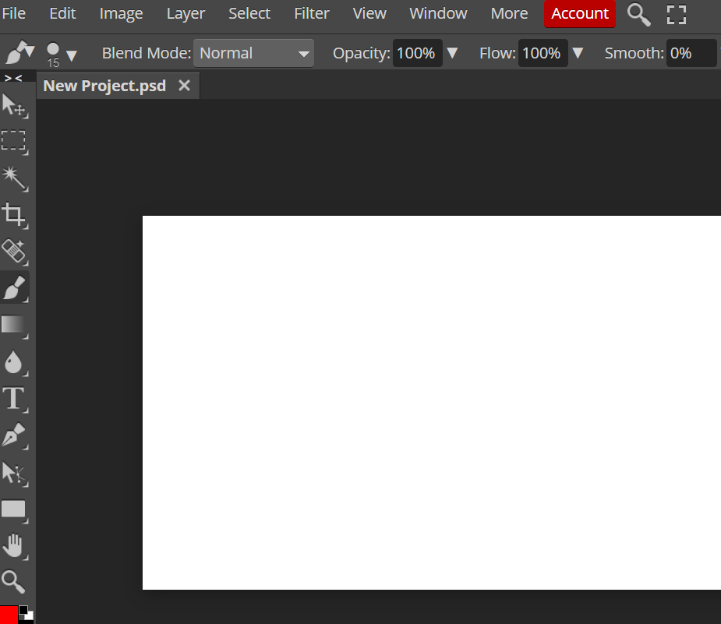

**Tool Chain Required for Traditional Web Application**

* HTML
* CSS
* JavaScript
* jQuery
* Bootstrap
* Database [MongoDB]
* Middleware [Express]
* Server-Side Technology [Node.js]

**Tool Chain Required for SPA Web Application**

* HTML
* CSS
* JavaScript
* jQuery
* Bootstrap
* TypeScript
* **Angular**
* Database [MongoDB]
* Middleware [Express]
* Server-Side Technology [Node.js]

**Tool Chain Required for Progressive Web Application**

* HTML
* CSS
* JavaScript
* jQuery
* Bootstrap
* TypeScript
* **Angular**
* **Android, iOS,**
* **Ionic, Native Script, Apache Cordova**
* Database [MongoDB]
* Middleware [Express]
* Server-Side Technology [Node.js]

**What is the role of Database?**

* To store the data required for business.
* Data is present in Database
* Database is handled by Database Server / Data Center