Friend book A Semantic Based Friend Recommendation System for Social Networks

Abstract:

Existing social networking services recommend friends to users based on their social graphs, which may not be the most appropriate to reﬂect a user’s preferences on friend selection in real life. In this paper, we present Friend-book, a novel semantic-based friend recommendation system for social networks, which recommends friends to users based on their life styles instead of social graphs. By taking advantage of sensor-rich smart-phones, Friend-book discovers life styles of users from user-centric sensor data, measures the similarity of life styles between users, and recommends friends to users if their life styles have high similarity. Inspired by text mining, we model a user’s daily life as life documents, from which his/her life styles are extracted by using the Latent Dirichlet Allocation algorithm. We further propose a similarity metric to measure the similarity of life styles between users, and calculate users’ impact in terms of life styles with a friend-matching graph. Upon receiving a request, Friend-book returns a list of people with highest recommendation scores to the query user. Finally, Friend-book integrates a feedback mechanism to further improve the recommendation accuracy. We have implemented Friend-book on the Android-based smart-phones, and evaluated its performance on both small-scale experiments and large-scale simulations. The results show that the recommendations accurately reﬂect the preferences of users in choosing friends.

Existing System:
Most of the friend suggestions mechanism relies on pre-existing user relationships to pick friend candidates. For example, Facebook relies on a social link analysis among those who already share common friends and recommends symmetrical users as potential friends. The rules to group people together include:
- Habits or life style
- Attitudes
- Tastes
- Moral standards
- Economic level; and
- People they already know.
Apparently, rule #3 and rule #6 are the mainstream factors considered by existing recommendation systems.
Disadvantages:
Existing social networking services recommend friends to users based on their social graphs, which may not be the most appropriate to reflect a user’s preferences on friend selection in real life

Proposed System:

- A novel semantic-based friend recommendation system for social networks, which recommends friends to users based on their life styles instead of social graphs.
- By taking advantage of sensor-rich smart-phones, Friend-book discovers life styles of users from user-centric sensor data, measures the similarity of life styles between users, and recommends friends to users if their life styles have high similarity.
- We model a user’s daily life as life documents, from which his/her life styles are extracted by using the Latent Dirichlet Allocation algorithm.
- Similarity metric to measure the similarity of life styles between users, and calculate users’
- Impact in terms of life styles with a friend-matching graph.
- We integrate a linear feedback mechanism that exploits the user’s feedback to improve recommendation accuracy.
Advantages:
- Recommendeds potential friends to users if they share similar life styles.
The feedback mechanism allows us to measure the satisfaction of users, by providing a user interface that allows the user to rate the friend list

Architecture Diagram:
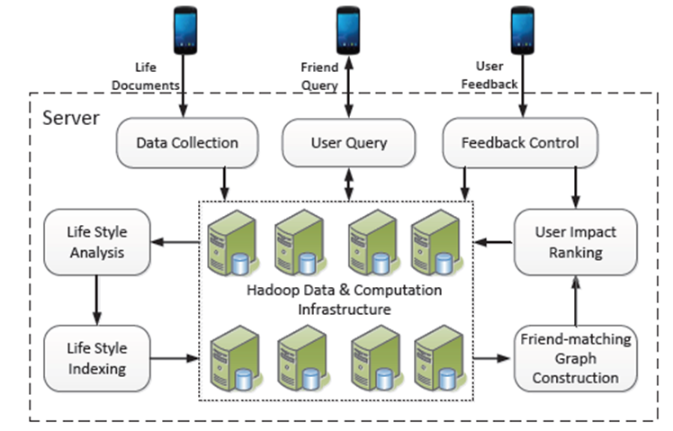

KEYWORDS:
Generic Technology Keywords: Database, User Interface, Programming
Specific Technology Keywords: C#.Net, ASP.Net, WCF, MS SqlServer-14
Project Keywords: Presentation, Business Object, Data Access Layer, Database
SDLC Keywords: Analysis, Design, Code, Testing, Implementation, Maintenance

SYSTEM CONFIGURATION
HARDWARE CONFIGURATION
S.NO | HARDWARE | CONFIGURATIONS
1 | Operating System | Windows 7 or above
2 | RAM | 2GB
3 | Processor (with Speed) | Intel Pentium IV (3.0 GHz) and Upwards
4 | Hard Disk Size | 40 GB and above
5 | Monitor | 15’ CRT
SOFTWARE CONFIGURATION
S.NO | SOFTWARE | CONFIGURATIONS
1 | Platform | Microsoft Visual Studio 2013
2 | Framework | .Net Framework 4.5
3 | Language | C#.Net
4 | Front End | Asp.net, html
5 | Back End | SQL Server 2014

FEASIBILITY STUDY:
Preliminary investigation examine project feasibility, the likelihood the system will be useful to the organization. The main objective of the feasibility study is to test the Technical, Operational and Economical feasibility for adding new modules and debugging old running system. All system is feasible if they are unlimited resources and infinite time. There are aspects in the feasibility study portion of the preliminary investigation:
- Technical Feasibility
- Economical Feasibility
- Operation Feasibility

Technical Feasibility:
In the feasibility study first step is that the organization or company has to decide that what technologies are suitable to develop by considering existing system.
Here in this application used the technologies like Visual Studio 2013 and SqlServer 2014. These are free software that would be downloaded from web.
Visual Studio 2013 –it is tool or technology.

Determining Economic Feasibility:

Assessing the economic feasibility of an implementation by performing a cost/benefit analysis, which as its name suggests compares the full/real costs of the application to its full/real financial benefits. The alternatives should be evaluated on the basis of their contribution to net cash flow, the amount by which the benefits exceed the costs, because the primary objective of all investments is to improve overall organizational performance.
Type | Potential Costs | Potential Benefits
Quantitative | - Hardware/software upgrades  - Fully-burdened cost of labor (salary + benefits)  - Support costs for the application  - Expected operational costs  - Training costs for users to learn the application  - Training costs to train developers in new/updated technologies | - Reduced operating costs  - Reduced personnel costs from a reduction in staff  - Increased revenue from additional sales of your organizations products/services
Qualitative | - Increased employee dissatisfaction from fear of change | - Improved decisions as the result of access to accurate and timely information  - Raising of existing, or introduction of a new, barrier to entry within your industry to keep competition out of your market  - Positive public perception that your organization is an innovator
The table includes both qualitative factors, costs or benefits that are subjective in nature, and quantitative factors, costs or benefits for which monetary values can easily be identified. I will discuss the need to take both kinds of factors into account when performing a cost/benefit analysis.

Operational Feasibility
Not only must an application make economic and technical sense, it must also make operational sense.
Operations Issues | Support Issues
- What tools are needed to support operations?  - What skills will operators need to be trained in?  - What processes need to be created and/or updated?  - What documentation does operations need? | - What documentation will users be given?  - What training will users be given?  - How will change requests be managed?
Very often you will need to improve the existing operations, maintenance, and support infrastructure to support the operation of the new application that you intend to develop. To determine what the impact will be you will need to understand both the current operations and support infrastructure of your organization and the operations and support characteristics of your new application. To operate this application END-TO-END VMS. The user no need to require any technical knowledge that we are used to develop this project is Asp.net ,C#.net. That the application providing rich user interface by user can do the operation in flexible manner.

N Tier Architecture:-
Simply stated, an n-tier application helps us distribute the overall functionality into various tiers or layers:
- Presentation Layer
- Business Rules Layer
- Data Access Layer
- Database/Data Store
Each layer can be developed independently of the other provided that it adheres to the standards and communicates with the other layers as per the specifications.
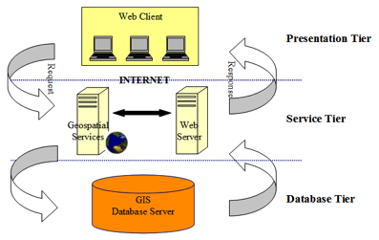

Fig 1.1-N-Tier Architecture
This is the one of the biggest advantages of the n-tier application. Each layer can potentially treat the other layer as a ‘Block-Box’.
In other words, each layer does not care how other layer processes the data as long as it sends the right data in a correct format.

- The Presentation Layer:
Also called as the client layer comprises of components that are dedicated to presenting the data to the user. For example: Windows/Web Forms and buttons, edit boxes, Text boxes, labels, grids, etc.
- The Business Rules Layer:
This layer encapsulates the Business rules or the business logic of the encapsulations. To have a separate layer for business logic is of a great advantage. This is because any changes in Business Rules can be easily handled in this layer. As long as the interface between the layers remains the same, any changes to the functionality/processing logic in this layer can be made without impacting the others. A lot of client-server apps failed to implement successfully as changing the business logic was a painful process.
- The Data Access Layer:
This layer comprises of components that help in accessing the Database. If used in the right way, this layer provides a level of abstraction for the database structures. Simply put changes made to the database, tables, etc do not affect the rest of the application because of the Data Access layer. The different application layers send the data requests to this layer and receive the response from this layer.

- The Database Layer:
This layer comprises of the Database Components such as DB Files, Tables, Views, etc. The Actual database could be created using SQL Server, Oracle, Flat files, etc.In an n-tier application, the entire application can be implemented in such a way that it is independent of the actual Database. For instance, you could change the Database Location with minimal changes to Data Access Layer. The rest of the Application should remain unaffected.

Software Development Life Cycle
The Systems Development Life Cycle (SDLC), or Software Development Life Cycle in systems engineering, information systems and software engineering, is the process of creating or altering systems, and the models and methodologies use to develop these systems.
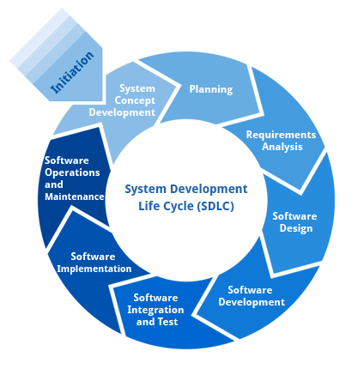
Requirement Analysis and Design
Analysis gathers the requirements for the system. This stage includes a detailed study of the business needs of the organization. Options for changing the business process may be considered. Design focuses on high level design like, what programs are needed and how are they going to interact, low-level design (how the individual programs are going to work), interface design (what are the interfaces going to look like) and data design (what data will be required). During these phases, the software's overall structure is defined. Analysis and Design are very crucial in the whole development cycle. Any glitch in the design phase could be very expensive to solve in the later stage of the software development. Much care is taken during this phase. The logical system of the product is developed in this phase.
Implementation
In this phase the designs are translated into code. Computer programs are written using a conventional programming language or an application generator. Programming tools like Compilers, Interpreters, and Debuggers are used to generate the code. Different high level programming languages like C, C++, Pascal, Java, .Net are used for coding. With respect to the type of application, the right programming language is chosen.
Testing
In this phase the system is tested. Normally programs are written as a series of individual modules, this subject to separate and detailed test. The system is then tested as a whole. The separate modules are brought together and tested as a complete system. The system is tested to ensure that interfaces between modules work (integration testing), the system works on the intended platform and with the expected volume of data (volume testing) and that the system does what the user requires (acceptance/beta testing).
Maintenance
Inevitably the system will need maintenance. Software will definitely undergo change once it is delivered to the customer. There are many reasons for the change. Change could happen because of some unexpected input values into the system. In addition, the changes in the system could directly affect the software operations. The software should be developed to accommodate changes that could happen during the post implementation period.
SDLC METHDOLOGIES
This document play a vital role in the development of life cycle (SDLC) as it describes the complete requirement of the system. It means for use by developers and will be the basic during testing phase. Any changes made to the requirements in the future will have to go through formal change approval process.
SPIRAL MODEL was defined by Barry Boehm in his 1988 article, “A spiral Model of Software Development and Enhancement. This model was not the first model to discuss iterative development, but it was the first model to explain why the iteration models.
As originally envisioned, the iterations were typically 6 months to 2 years long. Each phase starts with a design goal and ends with a client reviewing the progress thus far. Analysis and engineering efforts are applied at each phase of the project, with an eye toward the end goal of the project.
The following diagram shows how a spiral model acts like:
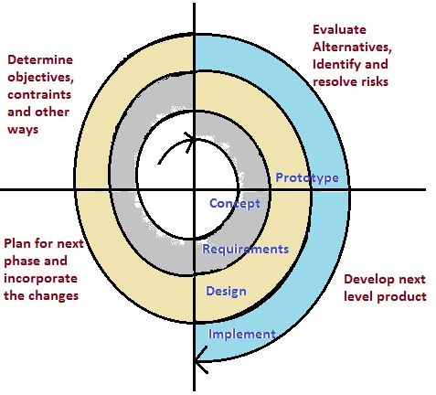
The steps for Spiral Model can be generalized as follows:
- The new system requirements are defined in as much details as possible. This usually involves interviewing a number of users representing all the external or internal users and other aspects of the existing system.
- A preliminary design is created for the new system.
- A first prototype of the new system is constructed from the preliminary design. This is usually a scaled-down system, and represents an approximation of the characteristics of the final product.
- A second prototype is evolved by a fourfold procedure:
- Evaluating the first prototype in terms of its strengths, weakness, and risks.
- Defining the requirements of the second prototype.
- Planning an designing the second prototype.
- Constructing and testing the second prototype.
- At the customer option, the entire project can be aborted if the risk is deemed too great. Risk factors might involved development cost overruns, operating-cost miscalculation, or any other factor that could, in the customer’s judgment, result in a less-than-satisfactory final product.
- The existing prototype is evaluated in the same manner as was the previous prototype, and if necessary, another prototype is developed from it according to the fourfold procedure outlined above.
- The preceding steps are iterated until the customer is satisfied that the refined prototype represents the final product desired.
- The final system is constructed, based on the refined prototype.
- The final system is thoroughly evaluated and tested. Routine maintenance is carried on a continuing basis to prevent large scale failures and to minimize down time.

