YASK-CIEM Study Material
A visual guide to cloud identity exposure management
Screenshots are illustrative interface captures. They may show demo data and an earlier application version; labels and values can differ from your installation.

A step-by-step guide to every screen, button and option in YASK-CIEM (Cloud Infrastructure Entitlement Management).

Part 1 - Concepts

1.1 What the application does
YASK-CIEM is a Windows desktop application that answers one question: who can do what in my cloud, and is that access safe?
It connects to Azure, AWS and Google Cloud through the cloud CLI you are already signed in with, collects identities, roles, permissions and resources, and then:
- shows the effective access each identity has,
- flags risky access (for example, a dormant administrator),
- proposes least-privilege improvements,
- supports access reviews, evidence exports and ticketing.
All scans are read-only. The application never grants, removes or changes cloud access. Remediation is a planning and approval workflow only; cloud changes are disabled in this build.

1.2 Key terms
Term | Meaning
Identity / principal | A user, group, service principal, managed identity or service account
Role | A named bundle of permissions (for example Owner, Global Administrator)
Permission | A single allowed action (for example Microsoft.Storage/*/read)
Entitlement | A grant that gives an identity a role or permission at a scope
Scope | Where a grant applies (subscription, resource group, account, project, directory)
Effective access | What an identity can really do after direct, inherited and group-based grants are combined
Access path | The chain that connects an identity to a resource (identity, group, role, scope, resource)
Blast radius | How much could be affected if one identity or path were abused
Privileged identity | An identity holding administrator-level access
Workload identity | A non-human identity (service principal, managed identity, service account)
PIM | Privileged Identity Management; roles can be Active or Eligible (not yet activated)
Access review (campaign) | A scheduled check where reviewers certify or reject access
Attestation | The recorded decision of a reviewer, with an evidence hash
Evidence bundle | A signed export of controls, evidence and gaps (not a compliance certification)

Part 2 - Installing and starting

2.1 Requirements
- Windows 10 or 11.
- At least one cloud CLI, signed in:
- Azure: Azure CLI (az)
- AWS: AWS CLI v2 (aws)
- Google Cloud: Google Cloud CLI (gcloud)
- A cloud account with read access (see Part 3).

2.2 Installing
Two installers are provided. Install only one on a machine.
- Native installer - run YASK-CIEM-Setup-<version>.exe (or the .msi). Accept the Windows administrator prompt. A box shows the version and build time; click Yes to install, then Yes to launch.
- MSIX installer - run YASK-CIEM-Setup-<version>.exe from the MSIX folder. It asks you to type TRUST to trust the publisher certificate (this is a development-signed package), then installs for your account.
Notes:
- The installer writes %TEMP%\YASK-CIEM-Setup.log (native). Send this file if an install fails.
- Re-running the native setup over an installed copy removes the old copy first, then installs.

2.3 First launch and the trial
- On first launch a 14-day trial starts. The header pill shows the days left.
- When the trial expires, cloud and workspace options are disabled; your local data is not deleted.
- The trial survives reinstalling under the same Windows account.

2.4 Window layout
Area | What it contains
Header, left | Logo, application name and tagline
Header, right | Trial pill, Connect Cloud, Disconnect Cloud, Settings, minimize, maximize, close
Left menu | Dashboard, Cloud Accounts, Identities, Resources, Entitlements, Effective Access, Access Paths, Risk Findings, Recommendations, Remediation, Organizations, Access Reviews, Scan History (and Feedback, Settings)
Security workspace card | Shows which provider is connected
Main area | The selected page
Status bar | Current page, database status, cloud status, version

You can drag the header to move the window.

Part 3 - Connecting a cloud
You connect with your existing CLI identity. Connect one provider at a time.

3.1 Step by step
- Click Connect Cloud in the header (or open Cloud Accounts).
- On the provider card (Azure, AWS or Google Cloud) click Connect. A separate terminal opens and runs the provider sign-in:
- Azure: az login
- AWS: aws configure sso (IAM Identity Center profile)
- Google Cloud: gcloud auth login
- Finish the sign-in in the browser.
- Return to the app. If the status does not change, click Refresh sign-in status.
- The left card shows, for example, "Azure connected".
To sign out, use Disconnect on the provider card, or Disconnect Cloud in the header (also cancels a pending sign-in).

3.2 Permissions needed
Provider | Recommended access
Azure | Reader on the subscription, plus Microsoft Graph read permissions for Entra (users, groups, service principals, directory roles)
AWS | Read-only IAM and Organizations access (for example SecurityAudit)
Google Cloud | Viewer and IAM viewer roles on the project or organization

For Azure PIM data, a tenant administrator must grant admin consent for RoleAssignmentSchedule.Read.Directory and RoleEligibilitySchedule.Read.Directory. If it is not granted, the app falls back to permanent directory role assignments and reports PIM as unavailable.

3.3 Cloud Accounts page
- Connect a cloud provider cards with Connect, Disconnect and Refresh sign-in status.
- Discovered accounts and permission sets table: provider, account, account ID, CLI profile, permission set, and scan access.

Part 4 - Running a scan (Dashboard)
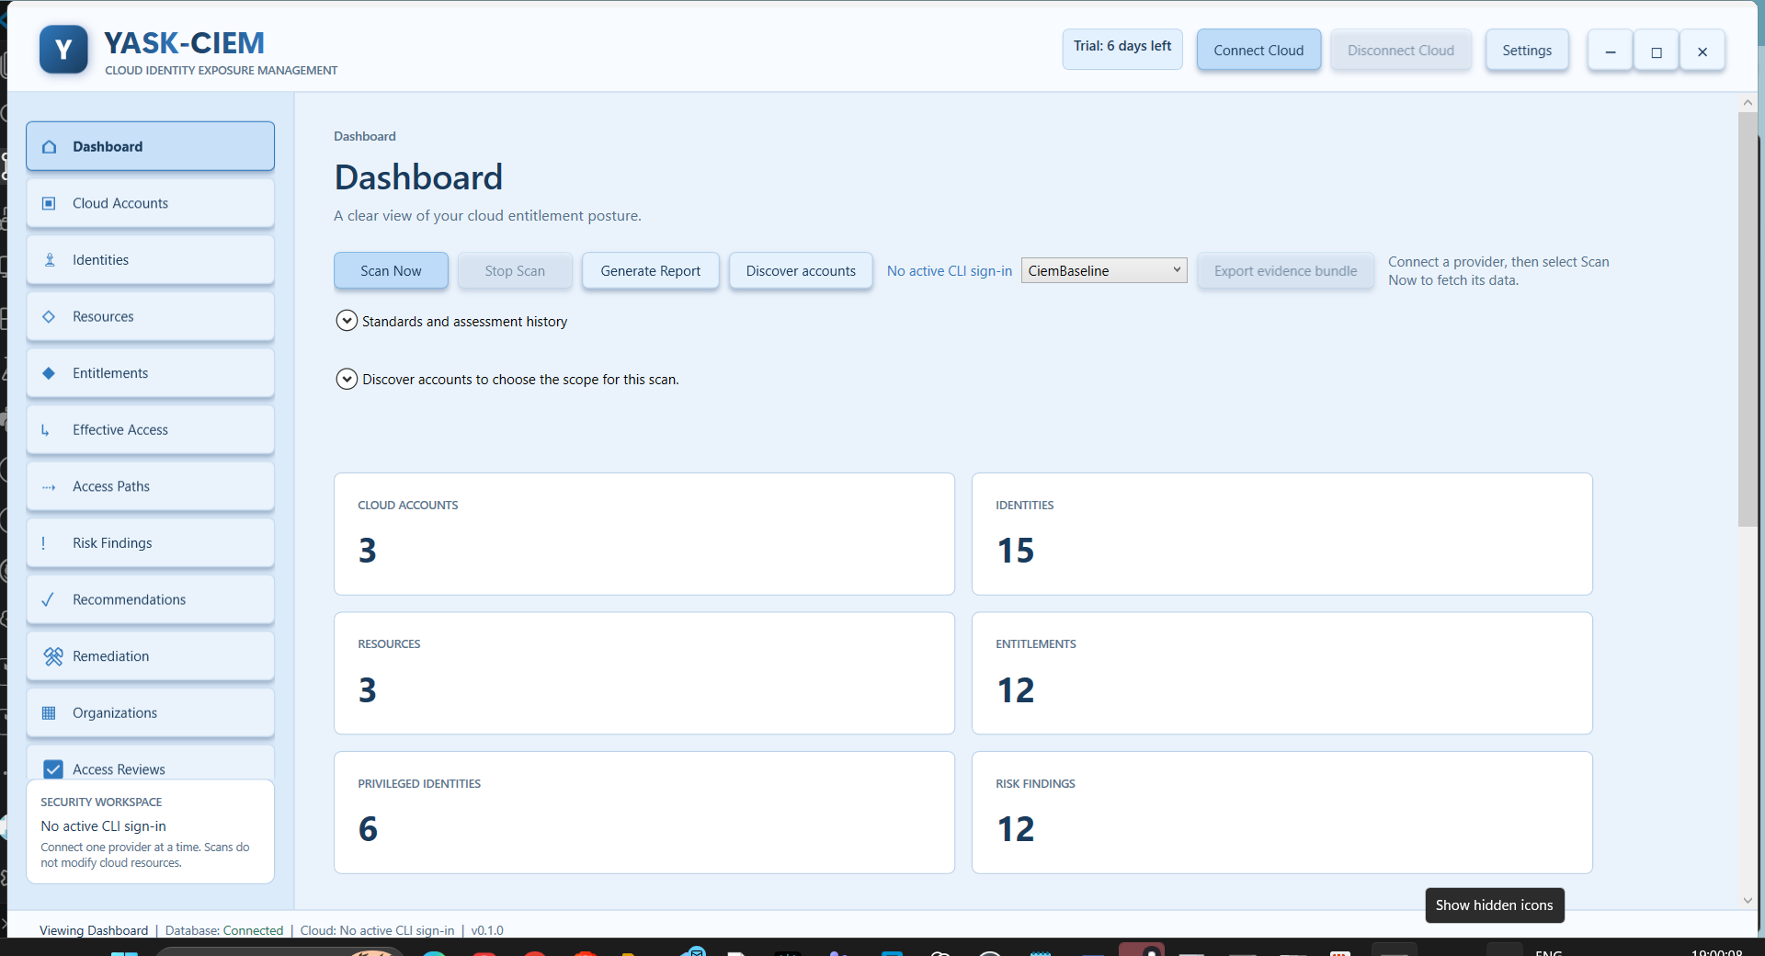
Dashboard overview

4.1 Buttons
Button | What it does
Scan Now | Scans the connected provider using read-only CLI calls
Stop Scan | Cancels the running scan
Generate Report | Saves findings as JSON or CSV to a folder you choose
Discover accounts | Lists the accounts the connected provider can see, so you can choose the scope
Export evidence bundle | Exports controls, evidence and gaps (needs an organization sign-in with report-export permission)

4.2 Step by step
- Connect a cloud (Part 3).
- Optional: click Discover accounts, open the account list, tick the accounts to scan (Select all / Select none). If you do not pick, all accounts are scanned.
- Click Scan Now. "Cloud scan in progress" appears with a moving bar.
- Wait for completion. A summary line shows accounts, identities, resources and effective-access assignments, and how many sources need attention.
- Review the cards below and open the other pages.
Typical duration is about a minute for a small tenant and longer for large tenants. Entra lookups are capped (directory discovery stops after 4 minutes and results are marked partial).

4.3 Dashboard cards
Card | Meaning
Cloud accounts / Identities / Resources / Entitlements | Counts from the latest scan
Privileged identities | Identities with administrator-level access
Risk findings / Critical findings | Total and critical risk findings
Last scan | Completion time of the newest scan
Evidence age | How old the evidence is
Source coverage | Which data sources were collected, partial, denied or unavailable
Unsupported permission sources | Permission types the app cannot evaluate yet
Attribution confidence | Share of assignments that show who changed them and when
Unknown / Unsupported evaluations | Access the engine could not decide
Risk by provider / by severity / Access decisions | Breakdown charts

Hover over a card to see details.

4.4 Standards and assessment history
Open the expander Standards and assessment history:
- Tick the standards for the assessment crosswalk: CIS Controls v8.1, NIST SP 800-53 Rev. 5, ISO/IEC 27001:2022, SOC 2 Trust Services Criteria.
- Control exceptions - record an accepted gap: fill Control, Reference, Recorded by, Expires (date) and Rationale, then Add exception. Select a row and Remove selected to delete one.
- Load assessment history shows saved assessments for the selected framework (requires report-export permission).
Exports are signed evidence snapshots, not a compliance certification or auditor attestation.

Part 5 - Exploring the results
All grid pages have a search box. Type to filter; sort by clicking column headers.

5.1 Identities
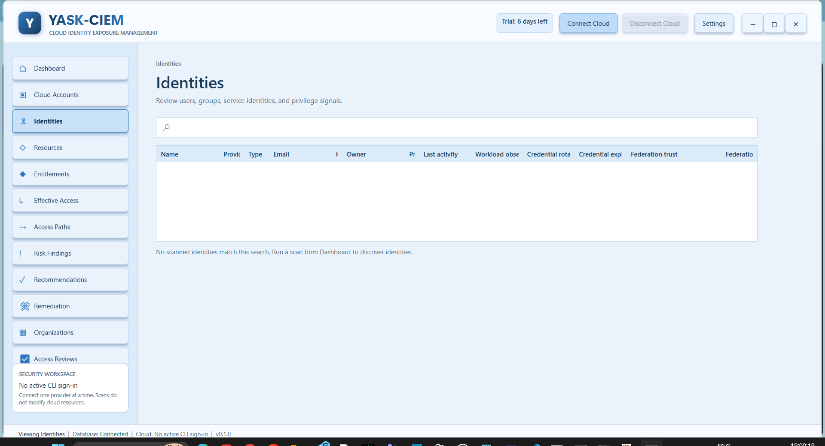
Identities page
Users, groups and service identities. Useful columns: Type, Email, Owner, Privileged, Last activity, Credential rotated / expires, Federation trust and whether it is verified.
Use it to find privileged users, ownerless workload identities and expiring credentials.

5.2 Resources
Normalized resources with name, type, resource ID, scope and location. Use it to see what the scan could enumerate.

5.3 Entitlements
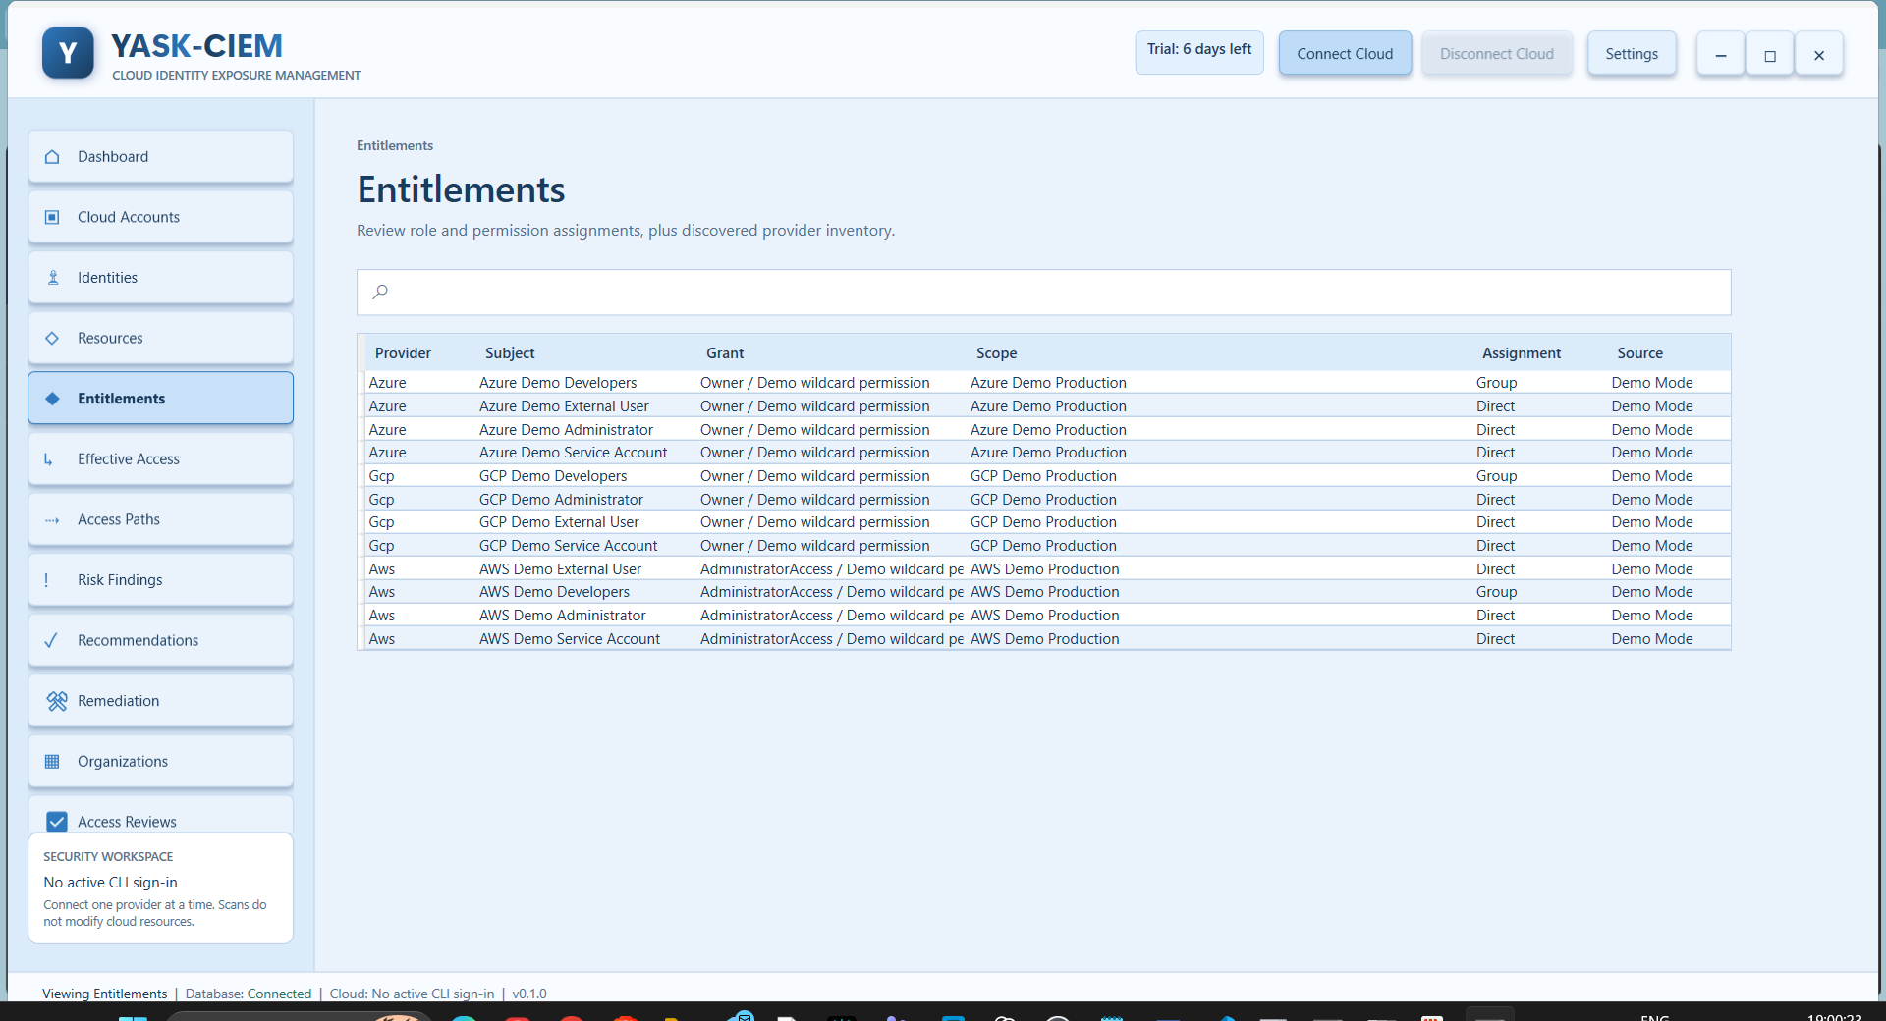
Entitlements page
Role and permission grants: provider, subject, grant, scope, assignment type and source. Also shows discovered roles and permissions.

5.4 Effective Access
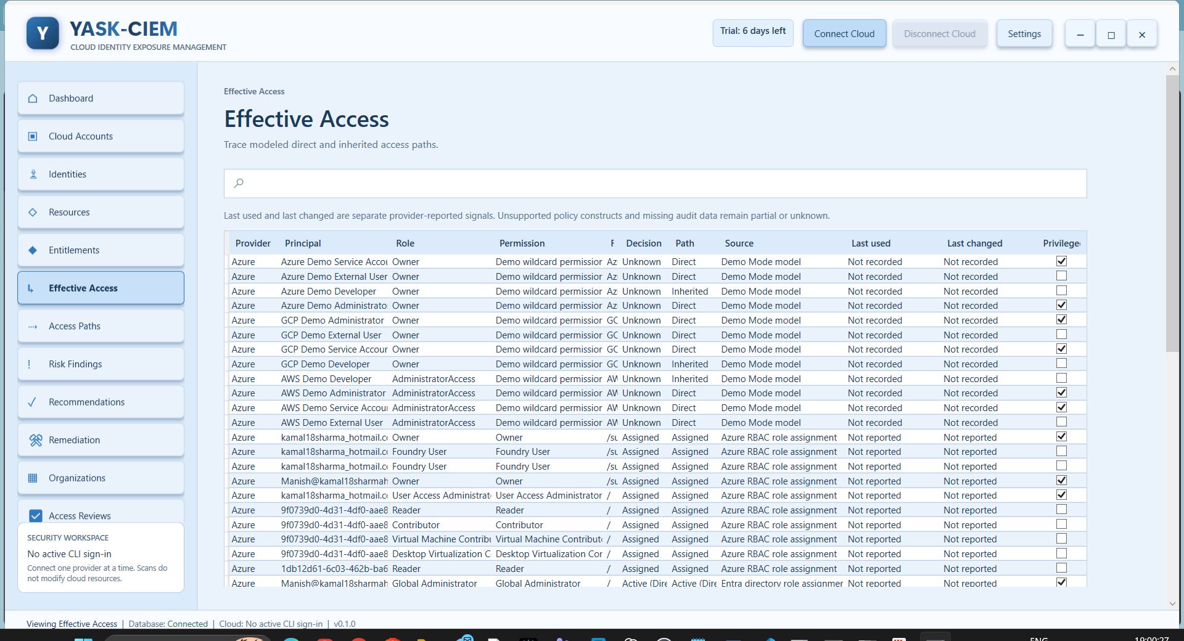
Effective Access page
Modeled access per principal, role, permission and resource, with decision (Allow, Conditional, Deny, Unknown), path, source, last used, last changed and privileged flag.
Permission simulator
- Choose a Principal, a Resource and a Permission.
- Click Evaluate.
- Read the result and the status line. It explains why access is allowed or not and what evidence was used.
Simulation uses scan data only; it does not call the cloud.

5.5 Access Paths
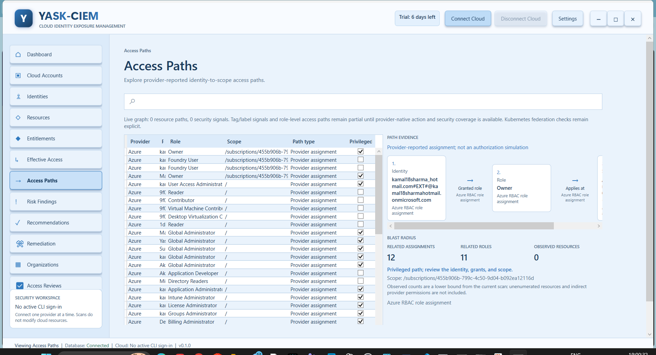
Access Paths page
Select a path to see its evidence (each hop from identity to resource) and its blast radius: related assignments, related roles and observed resources. A caveat reminds you counts are a lower bound.

5.6 Risk Findings
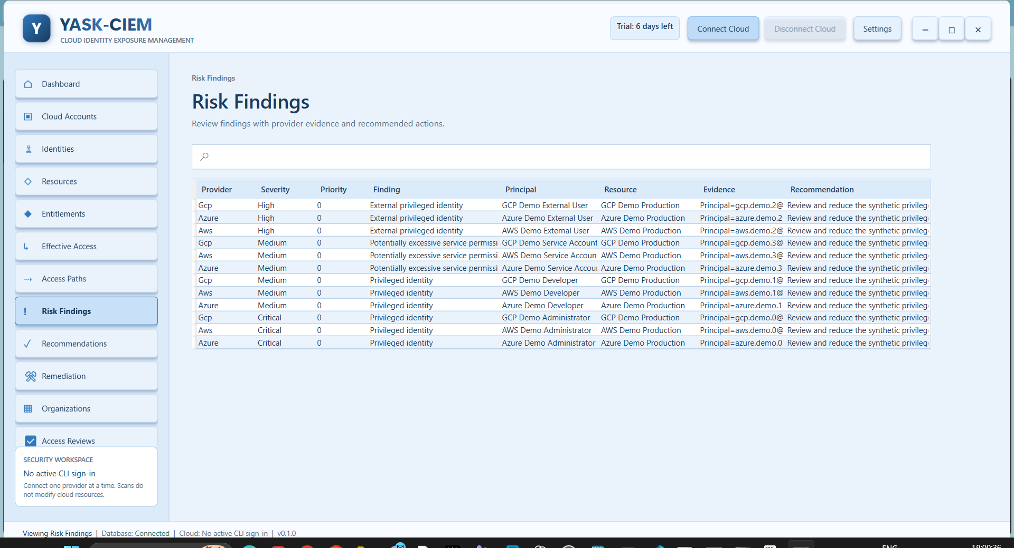
Risk Findings page
Findings with provider, severity, priority score, title, principal, resource, evidence and recommendation. Examples of what the rules detect:
- privileged identities, privileged service accounts and privileged group memberships,
- excessive or wildcard permissions and broad scope,
- dormant or external privileged identities,
- unowned, orphaned and overprivileged workload identities,
- unused entitlements and unused role assignments,
- exploitable identity-to-workload attack paths, redundant and long privilege chains.
Work through Critical and High first.

5.7 Scan History
Previous scans (retained for 7 days) with coverage details and access changes observed between scans. Use it to see what changed since the last scan and to read scan messages (for example, which data source was denied).

Part 6 - Acting on findings

6.1 Recommendations
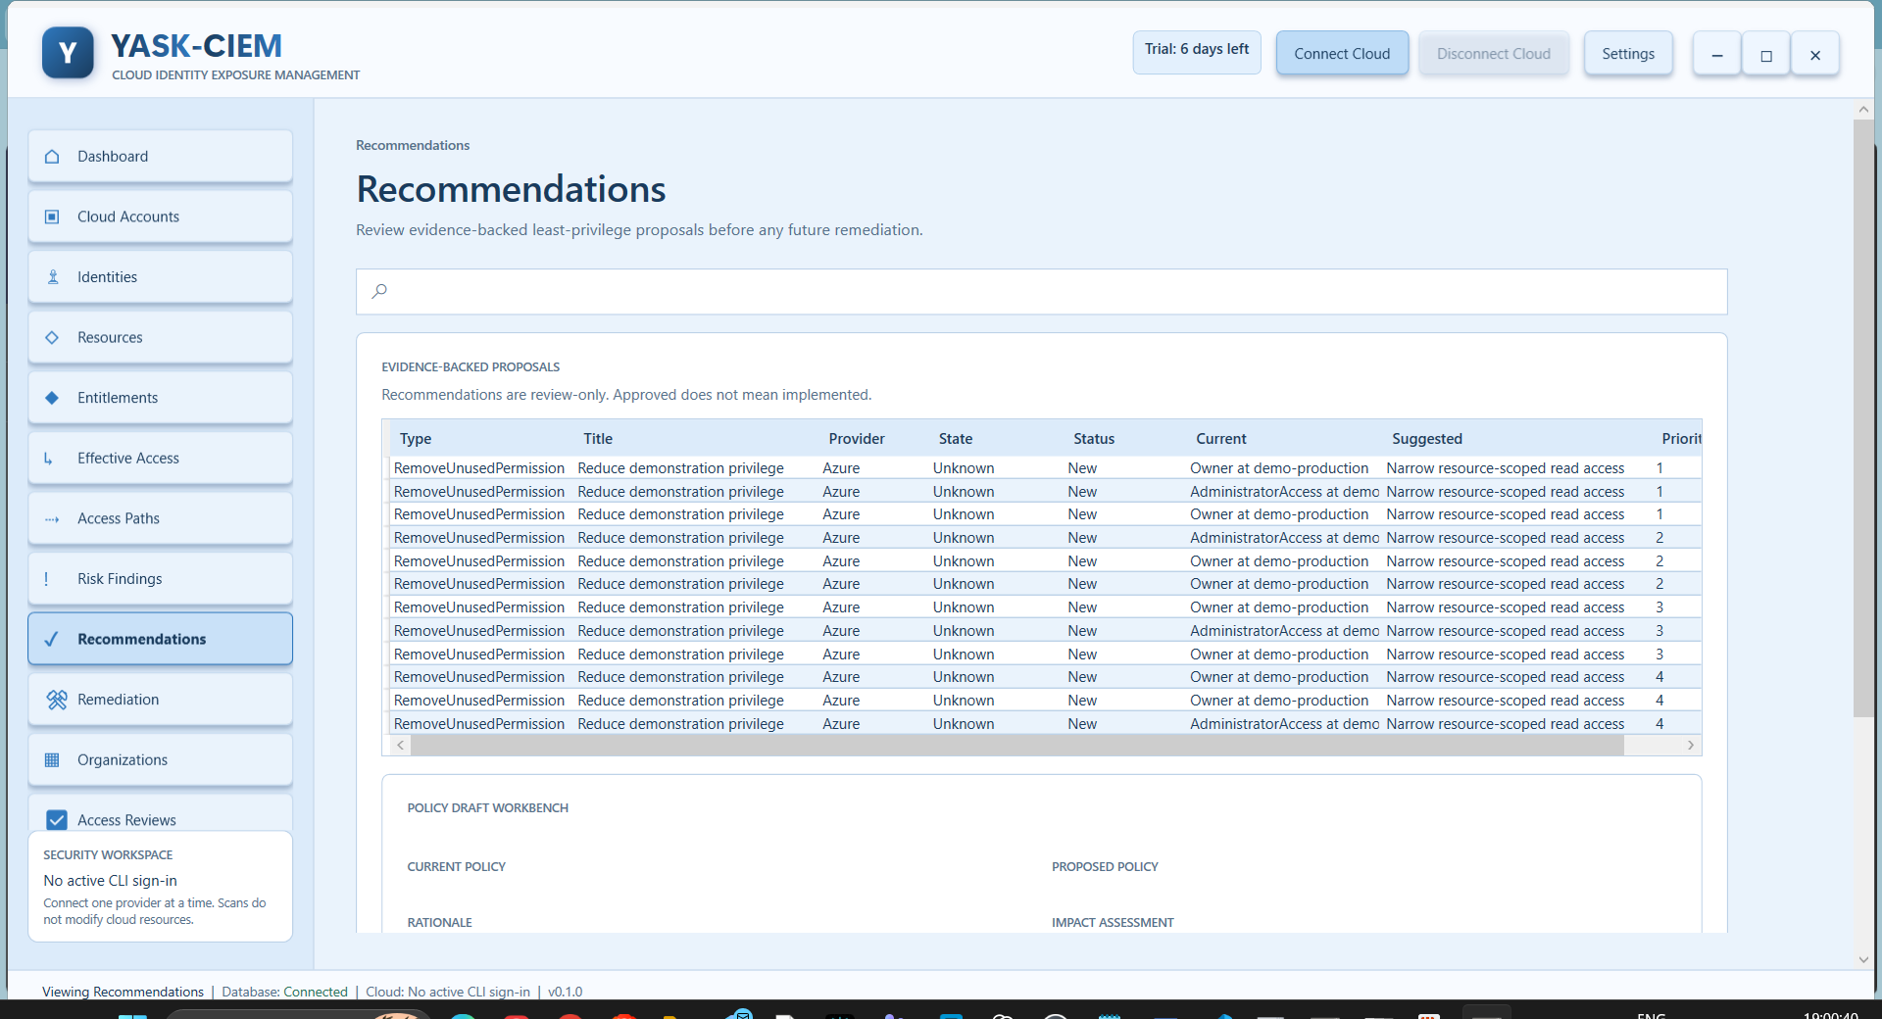
Recommendations page
Evidence-backed least-privilege proposals: type, title, provider, state, current and suggested values, and priority.
- Select a recommendation.
- Read Current policy, Rationale, Proposed policy and Impact assessment in the policy draft workbench.
- Export Review Draft saves a draft for your change process.
- Raise ticket creates one ticket for the recommendation (an existing link is reused). Refresh ticket status updates it.

6.2 Remediation (approval-gated)
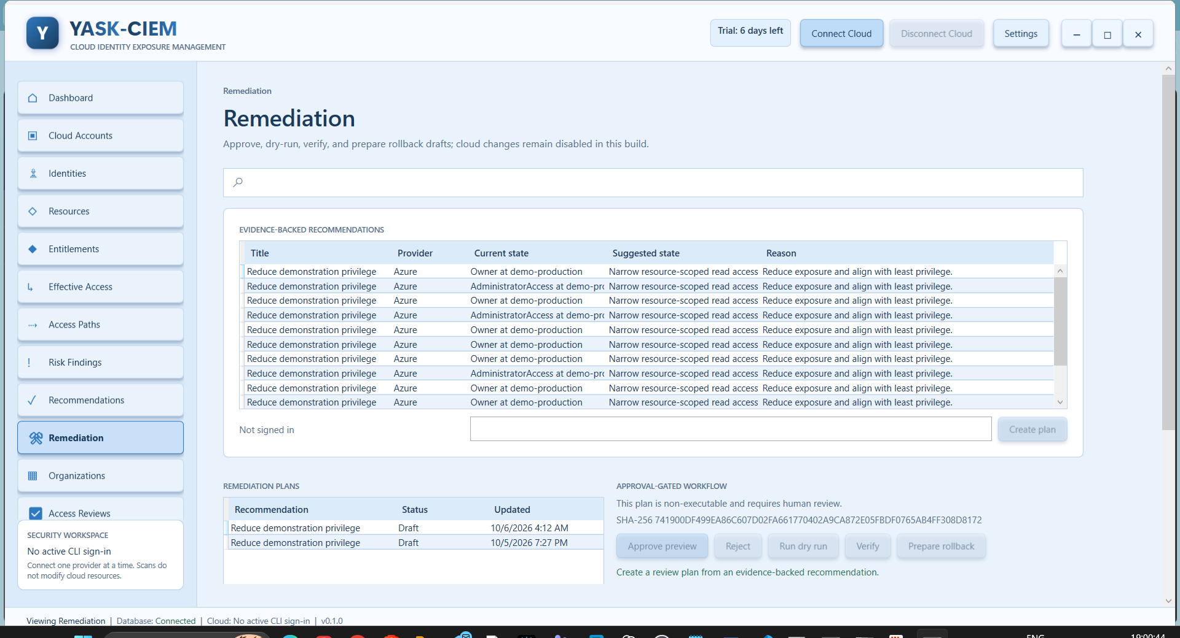
Remediation page
Cloud changes are disabled in this build; the workflow produces approvals and drafts only.
- Select a recommendation and click Create plan.
- Select the plan and review Proposed changes.
- Approve or Reject (the approver is recorded).
- Run dry run to simulate the change.
- Verify to check the result.
- Prepare rollback to create a rollback draft.
- Check the Audit trail at the bottom.

6.3 Access Reviews
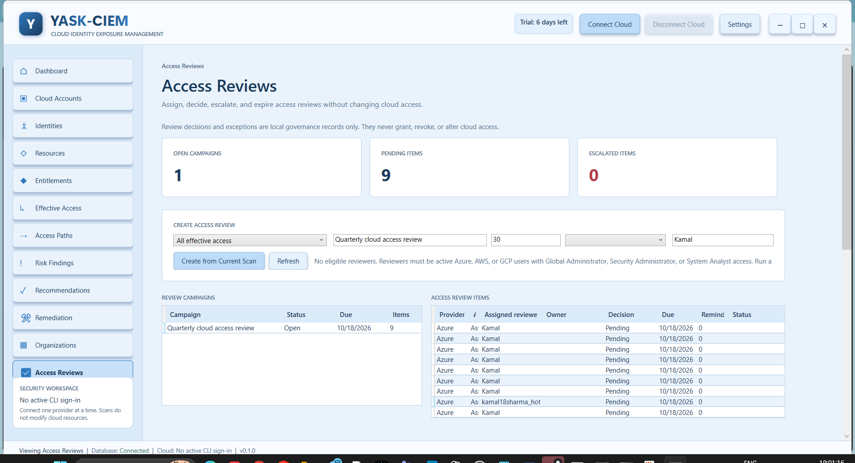
Access Reviews page
Create a campaign
- Choose a template:
- All effective access (30 days)
- Privileged workload identities (7 days)
- External identities (14 days)
- Enter a campaign name and duration (1-365 days).
- Choose a fallback reviewer. Only eligible reviewers are listed (see below).
- Confirm the actor name (recorded in the audit trail).
- Click Create from Current Scan. Each item is assigned to the identity owner when the owner is an eligible reviewer, otherwise to the fallback reviewer if eligible, otherwise left unassigned.
Who can be a reviewer
- An active user from Azure, AWS or Google Cloud (not a group, service account or disabled user).
- Holds an active grant of Global Administrator, Security Administrator or System Analyst.
- Equivalents recognised: Security Analyst; AWS AdministratorAccess and SecurityAudit; GCP roles/owner, roles/iam.securityAdmin and roles/iam.securityReviewer.
- Eligible-only PIM roles do not count. Users who are unavailable are never listed.
- The list is built from the latest scan, so scan first.
Review an item
- Select a campaign, then an item. Read Review evidence.
- To change the reviewer: pick an eligible reviewer, set the deadline, then Assign reviewer.
- To decide: choose Certified, NeedsInvestigation, Rejected or ExceptionGranted.
- Anything other than Certified needs a comment.
- ExceptionGranted also needs an expiry date.
- Click Record decision. An attestation with an evidence hash is stored.
- Review Attestations and the Audit history.
The top cards show open campaigns, pending items and escalated items. Overdue items receive reminders and are escalated automatically when the workspace refreshes. Decisions are local governance records and never change cloud access.

Part 7 - Teams and organizations

7.1 Organizations page
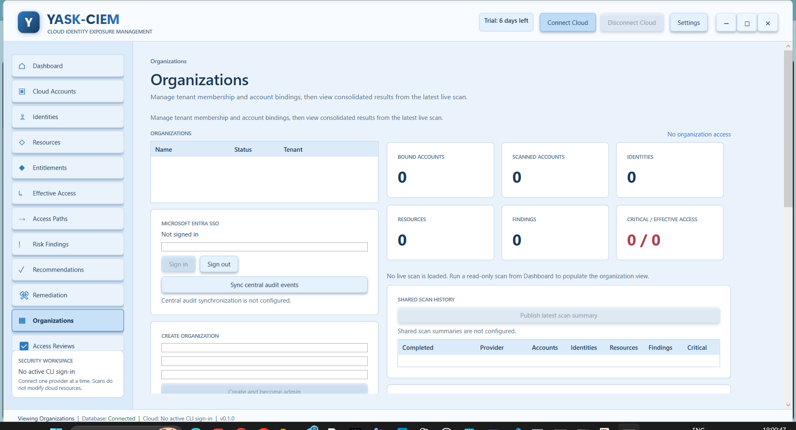
Organizations page
Used for multi-user workspaces and tenant membership.
- Sign in with Microsoft Entra SSO.
- Create and become admin to create an organization.
- Bind account to attach a cloud account to the organization.
- Add member and assign a role.
- View consolidated totals from the latest scan (accounts, identities, resources, findings, critical, effective access).
- Publish latest scan summary shares aggregate counts and coverage (no resource-level findings).
- Sync central audit events uploads local audit events to the tenant's central audit log.
Shared features need the central service URL (YASK_CIEM_API_BASE_URL, HTTPS) to be configured; without it the app works locally.

Part 8 - Settings
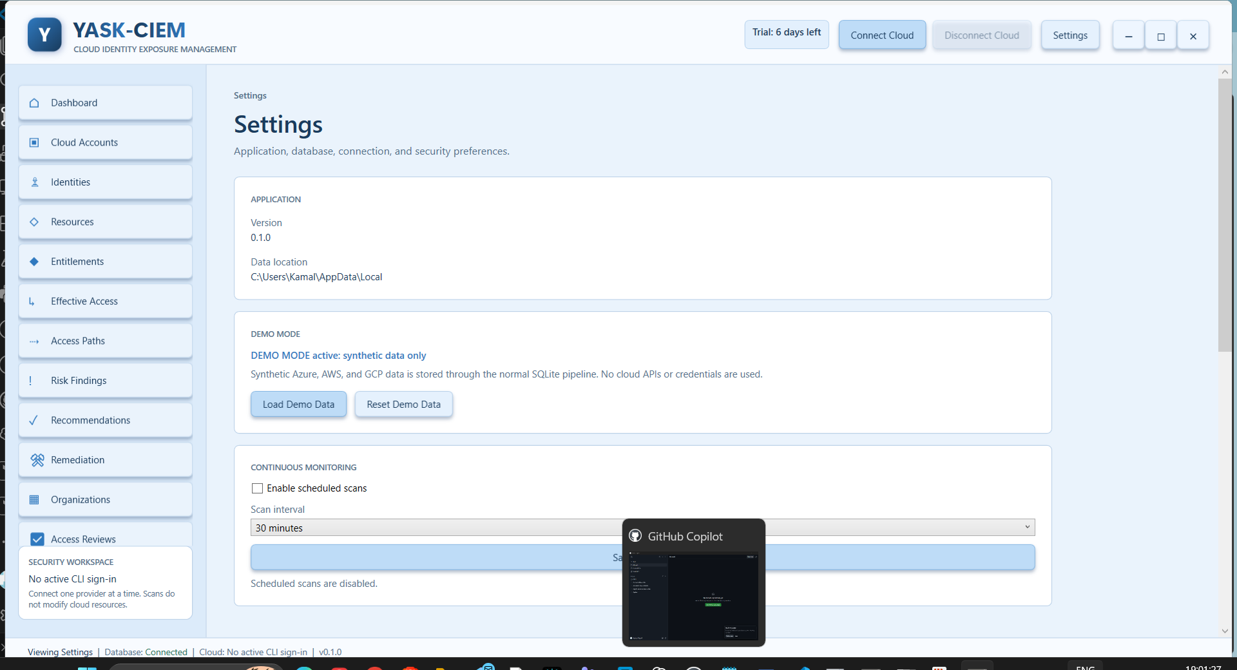
Settings page
Section | What to do
Application | Shows version and the data location
Demo mode | Load Demo Data fills the app with synthetic Azure, AWS and GCP data (no cloud access). Reset Demo Data clears it
Continuous monitoring | Tick Enable scheduled scans, choose an interval (5 minutes to 7 days), click Save schedule. Scans run while the app is open
Cloud connections | Use Connect Cloud in the header
Ticketing connection | Choose the system (native: Jira, Jira Service Management, ServiceNow; others use a signed webhook). Enter HTTPS site URL, project key or service desk ID, issue/request type, optional signed webhook URL, API user and token. Save URL, Save credential (stored in Windows Credential Manager) and then the request button

Part 9 - Feedback
Open Feedback, fill in Your feedback and Suggestions (both required), then Submit Feedback. It is stored locally.

Part 10 - Where data is stored
Item | Location
Application data, reports, scan history | %LOCALAPPDATA%\YASK-CIEM\
Database | %LOCALAPPDATA%\CloudEntitle\Data\cloudentitle.db
Application logs | %LOCALAPPDATA%\CloudEntitle\Logs\application-<date>.log
Installer log | %TEMP%\YASK-CIEM-Setup.log

The application log lists every cloud CLI command with its duration, which helps diagnose slow scans.

Part 11 - Recommended workflow
- Install and start the app.
- Connect one cloud and run Scan Now.
- Check the Dashboard cards, especially Source coverage.
- Open Risk Findings; handle Critical items first.
- Use Effective Access and Access Paths to understand each finding.
- Create Recommendations, raise tickets and create Remediation plans.
- Run an Access Review for privileged and external identities.
- Generate Report and, if signed in to an organization, Export evidence bundle.
- Enable scheduled scans and compare results in Scan History.

Part 12 - Troubleshooting
Symptom | Likely cause and action
"No active CLI sign-in" | Run az login (or the AWS/GCP command) and click Refresh sign-in status
Scan stays in progress | Large tenant. Wait, or Stop Scan; check the log for the slow CLI command
Dashboard shows zeros | No scan yet, or the scan found no data; read Scan History messages
PIM data unavailable | Tenant admin must grant Graph consent; permanent role assignments are still shown
Reviewer list is empty | Scan first; users must be active and hold a qualifying role
Export evidence bundle is disabled | Sign in to an organization with report-export permission
Install did nothing | Run the setup from PowerShell, read %TEMP%\YASK-CIEM-Setup.log
Trial expired | Cloud and workspace options are disabled; data is kept

Part 13 - Review questions
- Why is a YASK-CIEM scan safe to run in production?
- What is the difference between an entitlement and effective access?
- Which providers can you connect at the same time?
- What does blast radius tell you?
- Which decisions in an access review require a comment?
- Name three conditions a person must meet to be offered as a reviewer.
- What is the difference between an Active and an Eligible PIM role?
- Where would you look to find why a data source was missing from a scan?
Answers
1. All access is read-only through your existing CLI identity; no write operations exist.
2. An entitlement is one grant; effective access is the combined result after inheritance and groups.
3. One at a time.
4. How much could be affected if the identity or path were abused.
5. Everything except Certified; ExceptionGranted also needs an expiry date.
6. Active cloud user, available (not disabled), holds Global Administrator, Security Administrator or System Analyst (or equivalent).
7. Active is granted now; Eligible must be activated first and does not count for reviewer eligibility.
8. Scan History messages and the Dashboard Source coverage card.

