Name : Arun Sharma

Date : 06/01/2024

Assignment: Module 1.2 Assignment of (Module 1: Relational vs. Non-Relational Databases)

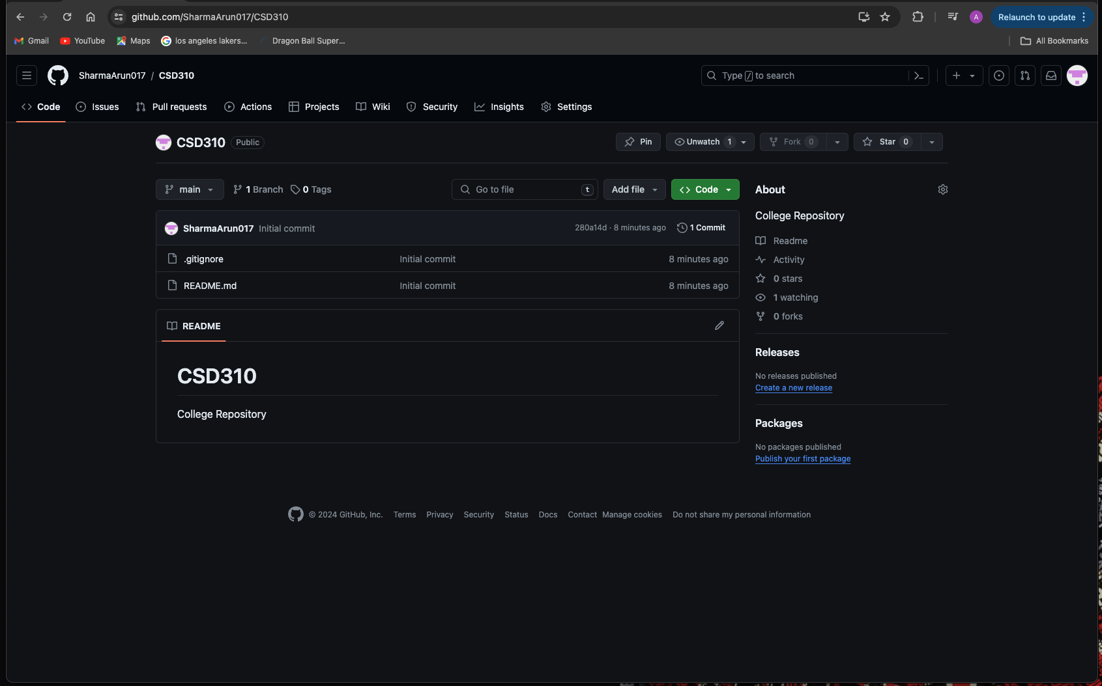

GitHub repository link: <https://github.com/SharmaArun017/CSD310>

Local repository image:

