**Module 5: Deployment Pipeline and Automated Testing**

**Assignment: 5.2 - Value Stream Mapping (VSM)**

**Name: Arun Sharma**

**Course: CSD380-H326 DevOps**

**GitHub Link:** [**https://github.com/SharmaArun017/csd-380**](https://github.com/SharmaArun017/csd-380)

**Date: 02/09/2025**

### **Introduction**

This is my **weekly routine**, which includes **work shifts, college studies, gym sessions, grocery shopping, and personal time**. Managing these responsibilities efficiently requires **structured planning and time optimization**. By using **Value Stream Mapping (VSM),** I have analyzed my weekly workflow to **identify inefficiencies, streamline task transitions, and improve time allocation**. This mapping helps ensure a **balanced approach to productivity, well-being, and effective time management throughout the week**.

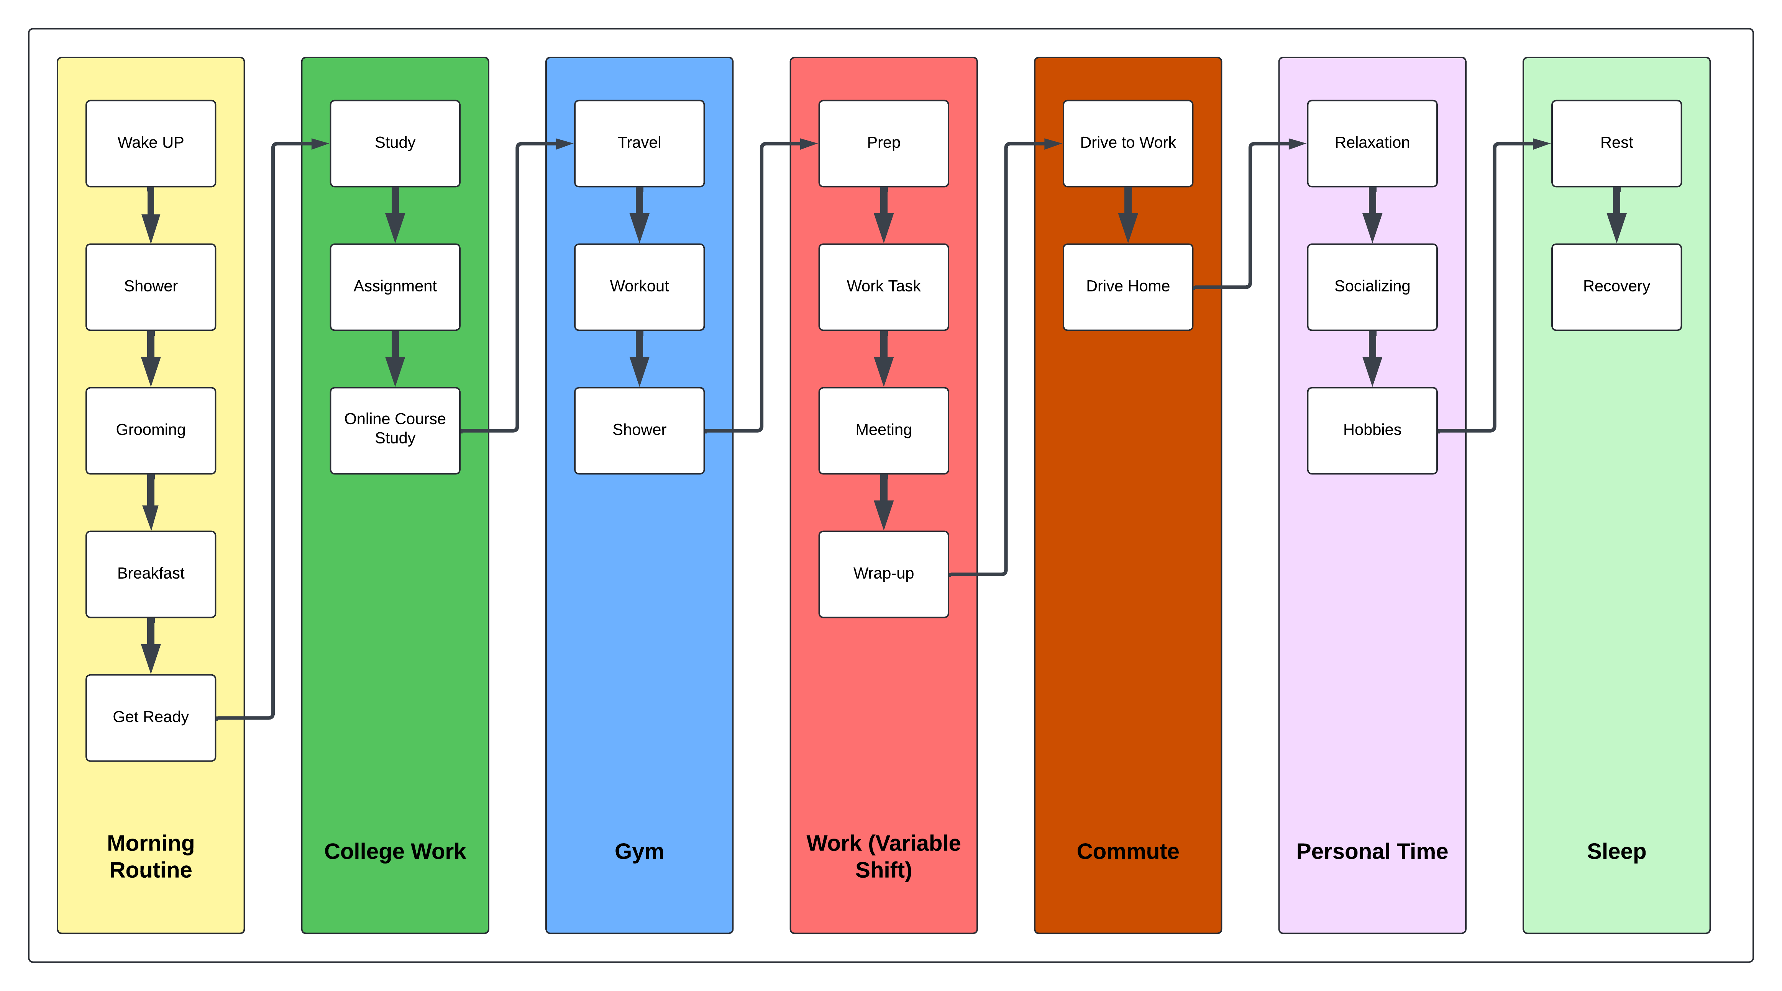

### **Estimated Average Flow Time**

|  |  |  |
| --- | --- | --- |
| **Category** | **Time Spent (Workdays)** | **Time Spent (Off-Days)** |
| **Morning Routine** | 1.5 hours | 1.5 hours |
| **Work (Variable Shift)** | 8 hours | Off |
| **Commute + Grocery Shopping** | 1.5 hours | 1.5 hours |
| **College Work & Study** | 6 hours | 10 hours |
| **Gym** | 1.5 hours | 1.5 hours |
| **Personal Time** | 1.5 hours | 1.5 hours |
| **Sleep** | 5.5 hours | 6.5 hours |

### Estimated Cycle Time

= Workdays Cycle Time: 20.5 hours

= Off-Days Cycle Time: 22.5 hours

### **Optimization of Weekly Routine Using Value Stream Mapping (VSM)**

#### **Introduction**

Optimizing a weekly routine is essential for maximizing efficiency and reducing unnecessary delays in daily activities. By applying **Value Stream Mapping (VSM)**, inefficiencies in **work, college studies, gym workouts, commute, and grocery shopping** can be identified and improved. The goal is to create a streamlined approach that enhances productivity while maintaining a balanced lifestyle.

#### **Reducing Transition Delays**

One of the key inefficiencies in the current routine is the **transition time between tasks**. Moving from **work to college assignments or from college work to gym workouts** consumes additional time. By strategically grouping similar tasks together, these transitions can be minimized. For example, instead of **taking long breaks between finishing work and starting college assignments**, an immediate switch to a **dedicated study block** can ensure that **more work is completed earlier, freeing up time later in the evening**.

#### **Streamlining Grocery Shopping and Commute**

Grocery shopping is currently **interspersed throughout the week**, leading to frequent, unplanned trips. This results in additional time spent on **traveling, parking, and shopping** multiple times rather than completing it efficiently in one go. The best approach is to **combine grocery shopping with work commutes** to minimize extra trips.

By **scheduling a dedicated grocery stop on specific workdays**, unnecessary travel can be eliminated, saving **15 to 30 minutes per day** that can be reallocated to personal time or additional college work.

#### **Enhancing Study Sessions for Maximum Efficiency**

The current study plan involves **long, unstructured study sessions** that can lead to burnout and reduced retention of material. Instead of studying in a continuous block, implementing **the Pomodoro Technique (25-minute focused work followed by a 5-minute break)** can improve focus and retention.

Additionally, prioritizing college work **on off-days with a structured 10-hour schedule** ensures that **study overload is avoided on workdays** while maintaining **consistent progress on assignments and coursework**.

#### **Improving Sleep Patterns for Better Productivity**

An inconsistent sleep schedule leads to **lower energy levels and decreased focus** throughout the day. Currently, **sleep duration varies between 5.5 to 6.5 hours**, which is lower than the recommended **7-8 hours for optimal cognitive function**.

To improve this, a **fixed sleep schedule should be established, even on off-days**, ensuring that wake-up and bedtime routines remain **consistent throughout the week**. This will lead to **better overall performance in both work and college assignments**.

#### **Structured Gym Scheduling for Health and Well-Being**

Gym sessions are essential for maintaining physical health but can sometimes be skipped due to **work overload or study demands**. A structured **workout schedule based on work shifts** can prevent this from happening.

* **On early work shifts (7 AM - 3:30 PM)** → Gym sessions should be scheduled **after work** to avoid morning rush.
* **On late work shifts (2 PM - 10:30 PM)** → Gym should be completed **before work**, ensuring that fitness remains a priority.
* **On off-days** → Longer, more intensive workouts can be planned to make up for missed sessions.