Belarc Advisor guide.

Step 1: Need to install the . exe advisor installer.

Step 2 :

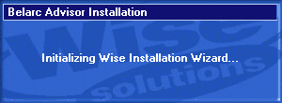

Step 3: Press “**Ok**”

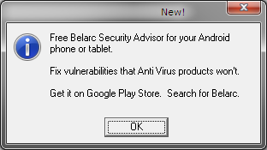

Step 4: Click on **“I Agree”** Button which I on the left end.

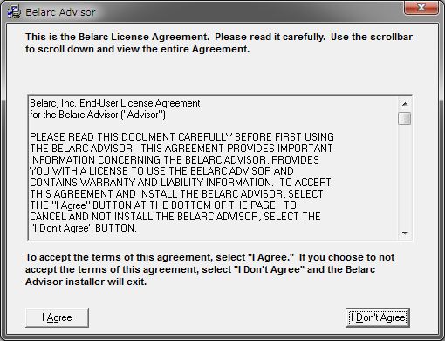

Step 5: Click on “**Install**” button.

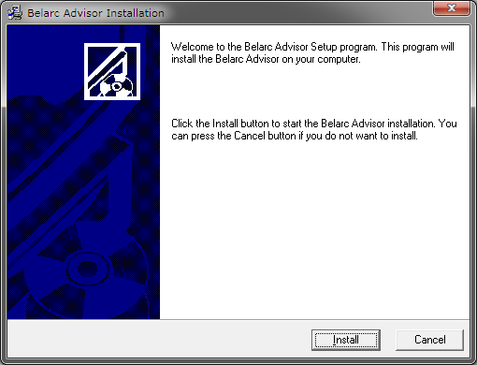

Step 6: Click on “**Yes**” button.

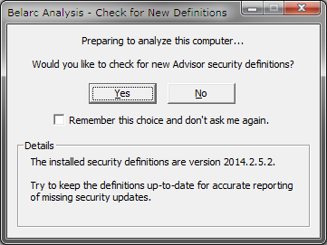

Step 7:

1. It will show the below message.

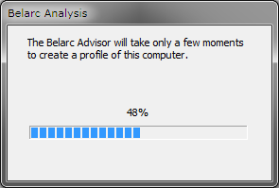

1. Click on remember the action check box and click on “**Allow**” button

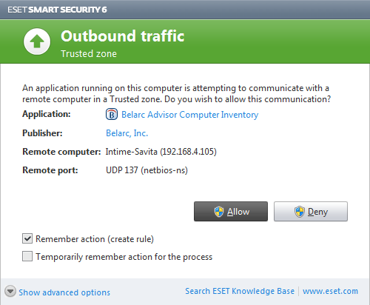

1. Will check the local network of this computer.

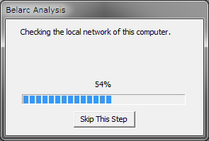

Step 8: Test will completes once the above checking completes the 100%.

It automatically opens the Result sheet as HTML.

**Result location.**

C:\Program Files (x86)\Belarc\BelarcAdvisor\System\tmp