**Sprint 1 Report**

Sprint duration: February 8, 2021 – March 7, 2021

Number of working days in a sprint: 1 month

Team members: Sapan Sharma(6352819), Alanna McNulty(6275168), Alexander Bowles(6089957), Arooj Fateh(6246185), Alex Orvitz (5517693), Samantha Laffin(5017538), Brian Jenkins (6063481)

## Sprint Backlog

|  |  |  |  |
| --- | --- | --- | --- |
| **Item Description** | **Sub-Task Description** | **Team Member(s)** | **Progress** |
| Home Page | Show a list of posts | Alex Orvitz | In Progress |
| Interact with posts | Alex Orvitz | In Progress |
| Test implemented functionality | Alex Orvitz | In Progress |
|  |  |  |
| Login Functionality | Login UI | Brian Jenkins | Complete |
| Login backend | Sapan Sharma | Complete |
| Login Security | Sapan Sharma | In Progress |
| JUnit Test Implemented | Brian Jenkins | In Progress |
|  |  |  |
| Profile Page | User profile UI | Arooj Fateh | In Progress |
| User profile mapping from database | Arooj Fateh | In Progress |
| User updating profile information | Arooj Fateh | In Progress |
| Other profile options | Arooj Fateh | Not started |
| Test implemented functionality | Arooj Fateh | Not started |
|  |  |  |
| Navigation Component |  | Alex Orvitz | Complete |
|  |  |  |
| Sign Up | Sign up UI | Brian Jenkins | Complete |
| Sign up Backend | Sapan Sharma | Complete |
| Sign up Methods | Brian Jenkins | Complete |
| Sign up Security | Brian Jenkins | Complete |
|  |  |  |
| Location Map Integration | Map UI | Brian Jenkins | Moved to next sprint |
| Map placement | Brian Jenkins | Moved to next sprint |
| Location permissions | Sapan Sharma | Moved to next sprint |
| Test implemented functionality | Sapan Sharma | Moved to next sprint |
|  |  |  |
| NPO Information Page | NPO UI | Alanna McNulty | In progress |
| NPO profile mapping from database | Alanna McNulty | Complete |
| NPO updating profile information | Alanna McNulty | Not started |
| Other profile options | Alanna McNulty | In Progress |
| Test implemented functionality | Alanna McNulty | In Progress |
|  |  |  |
| Firebase Setup and Management | Firebase Console management | Sapan Sharma | Complete |
| Firebase dependency management | Sapan Sharma | Complete |
| Firebase consistency across project | Sapan Sharma | In Progress |
| Test implemented functionality | Sapan Sharma | In Progress |
|  |  |  |
| Past Donation/Favourites Page | Page UI | Alexander Bowles | In Progress |
| Show list of past donations | Alexander Bowles | In Progress |
| Show list of favourites page | Alexander Bowles | In Progress |
| Map according to logged in user | Alexander Bowles | Complete |
| Test implemented functionality | Alexander Bowles | Not Started |
| ‘Add to favourites’ button added | Alexander Bowles | Not Started |
|  |  |  |
| Create Post Page | Create post UI | Arooj Fateh | Moved to next sprint |
| Create fields rules to upload post | Arooj Fateh | Moved to next sprint |
| Update firebase database | Arooj Fateh | Moved to next sprint |
| Test implemented functionality | Arooj Fateh | Moved to next sprint |
|  |  |  |
| Multiple User Permission Settings and Rules | Separating user classes and access | Sapan Sharma | Complete |
| Create admin level access | Sapan Sharma | Complete |
| Create donor level access | Sapan Sharma | In Progress |
| Create NPO level access | Sapan Sharma | In Progress |
| Create receiver level access | Sapan Sharma | In Progress |
| Test implemented functionality | Sapan Sharma | In Progress |
|  |  |  |
| Notifications | Create notifications on triggers | Sam Laffin | Moved to next sprint |
| Signup to notifications | Sam Laffin | Moved to next sprint |
| Create other methods to send/receive notifications | Sam Laffin | Moved to next sprint |
| Test implemented functionality | Sam Laffin | Moved to next sprint |

## Product Backlog

|  |  |  |  |
| --- | --- | --- | --- |
| Item ID | Item Description | Team Member(s) | Progress |
| DON-18 | Home Page | Alex Orvitz | In Progress |
| DON-16 | Login Functionality | Brian Jenkins | Complete |
| DON-19 | Profile Page | Arooj Fateh | In Progress |
| DON-29 | Navigation Component | Alex Orvitz | Complete |
| DON-15 | Sign Up | Brian Jenkins | Complete |
| DON-20 | NPO Information Page | Alanna McNulty | In progress |
| DON-23 | Firebase Setup and Management | Sapan Sharma | In progress |
| DON-28 | Past Donation/Favourites Page | Alexander Bowles | In Progress |
| DON-25 | Create Post Page | Arooj Fateh | To-do |
| DON-17 | Multiple User Permission Settings and Rules | Sapan Sharma | In progress |
| DON-26 | Notifications | Sam Laffin | To-do |
| DON-21 | Chat Interface | Brian Jenkins | To-do |
| DON-22 | Search Engine & Filters | Alex Orvitz | To-do |
| DON-24 | UI improvements and Design | Alanna McNulty | To-do |
| DON-27 | Location map integration | Brian Jenkins, Sapan Sharma | To-do |

## Issues and Risks to Overall Program

|  |  |
| --- | --- |
| Item ID | Issue Description |
| DON-18 | Search Bar and list showing updates and announcements still to be implemented; both will require using the database. |
| DON-20 | There are still two buttons remaining to be implemented, one of these buttons should open a map and directions to the non-profit from the current location, and the other should start a phone call with the organization. |
| DON-28 | The database is currently being built based on individual functionalities. This may warrant a review of architecture and naming conventions for better cohesion between all functions. |

## Monitoring Progress Toward Goals

|  |  |
| --- | --- |
| Item ID | Progress Description |
| DON-29 | Navigation between current pages is complete (See Current Navigation Diagram), but is incrementally updated if needed. |
| DON-23 | Firebase setup is complete and all functionality available in the free tier is available to use. Firebase build functionality dependencies to use in the project are added. ‘In progress’ task is to use release and monitor functionality of Firebase to manage distribution, performance insights and testing of the app. ‘To do’ task left is to see consistent rules of firebase tools are being implemented across the system. |
| DON-17 | Separation of user roles are designed but still need to be implemented, which will be done in the next sprint. |
| DON-28 | Favourites page has been set up and display for favourited past donation items is in progress. Retrieval of favourited items from the database based on the currently logged in user is complete and functional. Completion of item display, and the addition of an ‘Add to favourites’ button on existing pages will be the focus for next sprint. |
| DON-20 | The non-profit profile page gets all the necessary information from the database. The button leading to the organization’s website has been implemented, and the remaining buttons are in progress. The image on the “Visit website” button needs to be updated, and the remaining buttons should also have images added. |
| DON-26 | Notifications through Firebase Cloud Messaging have been explored. Implementation of user-based personalized notifications will be extended during the next sprint. |
| DON-19 | The user profile is in progress. Buttons for the home page, favourites page and going back are designed and in the process of implementation. Past donations button alongside the user’s name being displayed on the top (with the possibility of including profile pictures) are still in progress and the layout for that is still in the process of being finalized. |
| DON-15 | Sign-up functionality has been completed to specification. A user can sign up using a Google account or by registering with and E-mail and password. Alternate logins such as Facebook, iCloud or phone numbers could be considered in later sprints. |
| DON-16 | Log-in functionality has been implemented using the aforementioned techniques: Google sign up and Email/Password sign up. Each new user will be authenticated using the Firebase Authentication API as well as have a Firestore entry assigned to their UID. |
| DON-21 | The chat interface has been moved to the next sprint. This will require the use of Firebases’ real-time chat API which will interact with the Firebase Authentication API. |
| DON-27 | Location map integration has been moved to the next sprint. By making use of Google’s in-house ‘Maps’ API, this feature will allow users to easy see pick up, drop off and office locations of various NPOs. |
| DON-25 | The create post page has been moved to the next sprint. It will allow users with the flexibility of posting the items they want to donate in a way that the app is reliable and helps with the message getting across to various parties. |

## Metrics

We have 15 Main tasks, and each main task has subtasks. Create Post Page, Notifications, Chat Interface, Search Engine & Filters, UI improvements and Design, Location map integration main tasks will be completed in the next sprint. In progress tasks are partially shippable and have limited functionality which will be completed in the next sprint as well. Detailed tasks and subtasks can also be found on our Jira page: https://software4p02.atlassian.net/secure/RapidBoard.jspa?rapidView=2&projectKey=DON

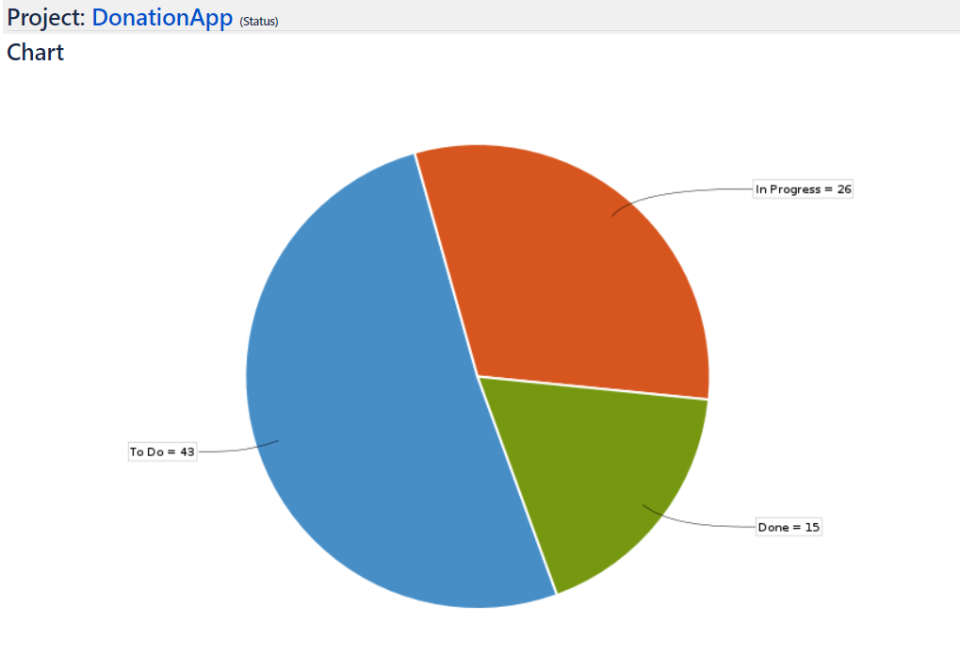

Current Navigation Diagram  
