
A Major Project-1 Report on
AGRO-LENS
PLANT DISEASE DETECTION FOR RESOURCE LIMITED FARMING REGIONS
Submitted in partial fulfilment of the requirements for the award of the degree of
Bachelor of Technology
in
Electronics and Computer Science Engineering
by
ASMIT LAHIRI | 2330224
RISHIKA GHOSH | 2330394
SHRESTH SHARMA | 2330402
SUMITA SAHA | 2330413

Under the guidance of
Prof. Sumit Dass

SCHOOL OF ELECTRONICS ENGINEERING
KALINGA INSTITUTE OF INDUSTRIAL TECHNOLOGY
(Deemed to be University)
Bhubaneswar – 751024, Odisha, India
NOVEMBER 2026

Certificate
This is to certify that the project report entitled “Offline-Deployed Plant Disease Detection Device for Resource-Limited Farming Regions” submitted by Asmit Lahiri (2330224), Rishika Ghosh (2330394), Shresth Sharma (2330402) and Sumita Saha (2330413) to the School of Electronics Engineering, Kalinga Institute of Industrial Technology (KIIT) Deemed to be University, Bhubaneswar, in partial fulfilment of the requirements for the award of the Degree of Bachelor of Technology in Electronics and Computer Science Engineering (Major Project-I, 7th Semester), is a record of bona fide work carried out by them under my supervision and guidance during the period July 2026 to November 2026.

Prof. Sumit Dass
Supervisor
School of Electronics Engineering

Declaration of Originality
We, the undersigned members of the project group, declare that:

This report presents our own work, carried out under the supervision named in the Certificate. Ideas, data, figures, text and code taken from other sources are acknowledged and referenced.

Name | Roll No. | Signature
Asmit Lahiri | 2330224
Rishika Ghosh | 2330394
Shresth Sharma | 2330402
Sumita Saha | 2330413

Date: 04/11/2026 Place: Bhubaneswar

Acknowledgements
We express our sincere gratitude to our project supervisor, Prof. Sumit Dass, School of Electronics Engineering, KIIT Deemed to be University, for his guidance, regular review of our progress and constructive suggestions throughout Project-I. His feedback on the choice of target hardware and on how to report results honestly shaped the direction of this work.
We thank the Head of the School of Electronics Engineering and the faculty members who attended our progress reviews for their encouragement and for pointing out gaps in our early plans. We are grateful to the School for providing the laboratory and computing facilities used in the project.
We also acknowledge the creators and maintainers of the PlantVillage dataset and of the open-source TensorFlow, TensorFlow Lite Micro and ESP-IDF tools on which this work depends, and our families and friends for their support.

Abstract
Farmers in resource-limited regions often have no access to an agronomist or a laboratory, and cloud-based diagnostic applications fail where mobile connectivity is weak, so crop diseases are usually recognised only after they have spread. This project, AgroLens, develops a low-cost, fully offline leaf-disease classifier that runs on a microcontroller. A MobileNetV2 network pre-trained on ImageNet was fine-tuned on 18,160 PlantVillage tomato leaf images in ten classes and, to test transfer across crops, on 5,932 rice leaf images in four classes. Images are resized to 96 × 96 pixels; the trained model is converted to 8-bit integer form by post-training quantization and embedded in TensorFlow Lite Micro firmware for an ESP32-S3 board with 8 MB of external RAM. The firmware receives a raw leaf image over a serial link, quantizes it with the model’s own scale and zero-point, runs inference and returns the predicted class with its confidence. The baseline tomato model reached 83.28 % test accuracy and a macro F1-score of 0.78, with the weakest recall on visually similar diseases such as early blight (0.43) and leaf mold (0.49); this motivated class-weighted re-training and a wider network (width multiplier 0.35 to 0.75). The wider network reached 99.10 % accuracy and a macro F1-score of 0.99 on rice leaves, showing that the pipeline transfers across crops. The quantized model is estimated at under 0.5 MB, well within the board’s memory. On-device latency, power consumption, the organic light-emitting diode (OLED) display and secure digital (SD) card logging, and fine-tuning on field-captured images to narrow the lab-to-field gap are planned for the 8th semester. The indicative prototype cost is about ₹2,230.
Keywords: plant disease detection, MobileNetV2, TinyML, INT8 quantization, ESP32-S3, offline edge inference
Sustainable Development Goals addressed: SDG 2 – Zero Hunger (targets 2.3 and 2.4: small-scale producers’ productivity and resilient agriculture); SDG 9 – Industry, Innovation and Infrastructure (target 9.5: upgrading technological capabilities)

Project Summary Sheet
Project title | Offline-Deployed Plant Disease Detection Device for Resource-Limited Farming Regions
Team members | Asmit Lahiri (2330224)  Rishika Ghosh (2330394)  Shresth Sharma (2330402)  Sumita Saha (2330413)
Supervisor / co-supervisor | Prof. Sumit Dass / –
Semester / academic year | VII (Project-I; continuing in VIII) / 2026–2027
Project type | ☐ Product ☐ Application ☐ Research ☐ Review
Thrust area | ☐ Wireless & Mobile Communication ☐ VLSI & Embedded Systems ☐ Signal & Image Processing ☐ RF & Microwave ☐ Instrumentation & Control ☐ IoT & Automation ☐ AI/ML ☐ Power, Energy & EV
Sustainable Development Goals | SDG 2 – Zero Hunger (2.3, 2.4); SDG 9 – Industry, Innovation and Infrastructure (9.5). See 1.5.
Codes and standards applied | IEC 62133-2:2017 / IS 16046 (Part 2):2018 (lithium cell safety) – protected cell and charging module selected; Directive 2011/65/EU (RoHS) – component selection; ISO/IEC 23053:2022 (framework for machine-learning AI systems) – structure of data, training and evaluation records. See 3.6.
Realistic design constraints | Economic: prototype cost target ≤ ₹2,500. Technical: 8 MB external RAM and no operating system, so the model must be small and 8-bit. Operational: no network in the field, so inference must be on-device. Safety: lithium battery in an outdoor enclosure. See 3.3.
Significant design trade-offs | (1) Platform: ESP32-S3 chosen over ESP32-CAM and Raspberry Pi Zero 2 W (weighted score 4.00 against 3.70 and 3.25). (2) Model width: MobileNetV2 α = 0.35 (0.49 M parameters) against α = 0.75 (1.46 M) – accuracy on similar diseases against memory and latency. (3) Input size 96 × 96 against 224 × 224 – memory against fine lesion detail. See 3.4.
Environment and sustainability | Offline operation avoids a cloud server; the battery-powered unit idles in a low-power state between scans. Protected Li-ion cell, RoHS-compliant parts; end-of-life cell collection recommended. Early disease detection can reduce unnecessary pesticide spraying. See 6.1.
Health, safety and risk | Main hazards: lithium battery fault, wrong diagnosis leading to a wrong treatment decision, outdoor damage. Mitigations: protected cell and charger, confidence shown with every result with advice to confirm low-confidence results, sealed enclosure. See 6.2.
Ethics, security and inclusion | No personal data are stored; datasets are public and credited; the device has no radio in the inference path. Results and limitations are reported as measured. Simple on-screen result for users with low literacy. See 6.3–6.5.
Cost | Indicative prototype cost ₹2,230 (target ≤ ₹2,500); to be replaced by invoiced cost. See 6.6.
Modern tools used | Python, TensorFlow/Keras 2.21, scikit-learn, TensorFlow Lite converter and TensorFlow Lite Micro, ESP-IDF, Flask and TensorFlow.js (web application), ESP32-S3 camera development board (OV3660, N16R8), PlantVillage and rice-leaf datasets from Kaggle. See 3.7.
Computing aspects | Hardware–software partitioning: training and quantization on a laptop (offline); inference on the microcontroller. Interface: UART at 921,600 baud, 2-byte header plus 27,648 raw RGB bytes per image; reply is one text line. Algorithms: transfer learning, INT8 post-training quantization, argmax classification. See 3.5.
Key results against targets | Tomato (10 classes): 83.28 % test accuracy, macro F1 0.78 (baseline). Rice (4 classes, α = 0.75): 99.10 % accuracy, macro F1 0.99. Estimated INT8 model size ≈ 0.47 MB (target ≤ 1 MB). On-device latency, INT8 accuracy and power. See 5.2.
Outcomes | ☐ Working prototype ☐ Publication ☐ Patent filed ☐ Award / exhibition ☐ Start-up / technology transfer – [details (see 8.4, Appendix G)]  Status: training notebooks, ESP32-S3 serial-inference firmware and a working web application (Flask backend with browser interface) completed; camera, OLED, microSD and battery integration planned for Project-II.
Knowledge drawn from courses | Machine Learning, Computer Vision, Embedded Systems, Digital Signal/Image Processing, Python programming, Microprocessors and Microcontrollers

Table of Contents
Certificate ii
Declaration of Originality iii
Acknowledgements iv
Abstract v
Project Summary Sheet vi
List of Abbreviations and Symbols xii
Chapter 1: Introduction 1
1.1 Background and Motivation 1
1.2 Problem Statement 1
1.3 Objectives 1
1.4 Scope and Limitations 2
1.5 Relevance to Society, Industry and the Sustainable Development Goals 2
1.6 Organisation of the Report 2
Chapter 2: Literature Review and Research Gap 3
2.1 Review of Existing Work 3
2.2 Existing Products, Patents and Standards 5
2.3 Research Gap and Novelty of the Proposed Work 5
Chapter 3: Requirements, Design and Methodology 6
3.1 Requirements and Specifications 6
3.2 Complex Engineering Problem Characteristics 6
3.3 Realistic Design Constraints 7
3.4 Design Alternatives and Trade-off Analysis 8
3.5 System Architecture and Detailed Design 9
3.6 Engineering Standards and Codes Applied 10
3.7 Modern Tools and Resources 10
3.8 Methodology and Project Plan 11
Chapter 4: Implementation and Testing 12
4.1 Hardware and Software Implementation 12
4.2 Experimental Set-up and Data Collection 13
4.3 Validation against Specifications and Standards 14
4.4 Web Application Interface 14
Chapter 5: Results and Discussion 17
5.1 Results 17
5.2 Achievement of Specifications 20
5.3 Comparison with Existing Work 21
5.4 Error, Uncertainty and Limitation Analysis 21
5.5 Discussion 22
Chapter 6: Societal, Environmental, Ethical and Economic Considerations 23
6.1 Environmental Impact and Sustainability 23
6.2 Health, Safety and Risk Assessment 23
6.3 Professional Ethics and Legal Aspects 24
6.4 Security Considerations 24
6.5 Equality, Diversity, Inclusion and Accessibility 25
6.6 Economic Analysis 25
6.7 Summary of Compliance 26
Chapter 7: Conclusion and Future Scope 27
7.1 Conclusions 27
7.2 Limitations 27
7.3 Work to be carried out in 8th Semester 27
References 29
Appendix A: Project Management and Teamwork 30
Team Structure and Individual Contributions 30
Supervision and Review Record 30
Lifelong Learning 30
Appendix B: Gantt Chart 32
Appendix C: Datasheets and Design Calculations 33
Appendix D: Code, Design Files and Data 34
Appendix E: Individual Contribution Reports 35
Appendix G: Publications, Patents and Certificates 39

List of Figures
Figure 3.1: Block diagram of the proposed system – offline training stage (A) and on-device inference stage (B); dashed items are planned for Project-II 9
Figure 4.1: Photograph of the prototype 12
Figure 4.2: Augmented tomato training images (sanity check) 13
Figure 4.3: Home screen of the AgroLens web application 15
Figure 4.4: Web application result for a tomato leaf (tomato mosaic virus, 99.6 % confidence) 15
Figure 4.5: Web application result for a rice leaf (brown spot, 100.0 % confidence) 15
Figure 4.6: Web application result for a radish leaf (downy mildew, 98.0 % confidence) 16
Figure 4.7: Web application result for a radish leaf (mosaic virus, 100.0 % confidence) 16
Figure 5.1: Training and validation accuracy and loss of the tomato model (head training followed by fine-tuning) 17
Figure 5.2: Confusion matrix of the tomato model on the test set 17
Figure 5.3: Per-class precision, recall and F1-score of the tomato model 18
Figure 5.4: Training and validation curves of the rice model (α = 0.75) 19
Figure 5.5: Confusion matrix of the rice model on the test set 19
Figure B.1: Project schedule – planned (blue) and actual (green) for Project-I (Jul–Nov 2026) and planned work for Project-II 32

List of Tables
Table 1.1: Project objectives and how they are verified 1
Table 2.1: Summary of the literature reviewed 3
Table 2.2: Comparison with existing products or patented solutions 5
Table 3.1: Requirements and specifications 6
Table 3.2: Complex engineering problem attributes addressed 6
Table 3.3: Realistic design constraints 7
Table 3.4: Decision matrix for the selection of the inference platform 8
Table 3.5: Standards and codes applied 10
Table 3.6: Hardware, software and test equipment used 10
Table 4.1: Datasets and splits used 13
Table 5.1: Per-class results of the tomato model (test set) 18
Table 5.2: Per-class results of the rice model (test set, α = 0.75) 19
Table 5.1: Targets versus achieved performance 20
Table 5.2: Comparison with reported work and existing products 21
Table 6.1: Risk register (Likelihood L and Severity S on a 1–5 scale; Risk = L × S) 23
Table 6.2: Bill of materials and prototype cost 25
Table 6.3: Summary of societal considerations 26
Table 7.1: Achievement of objectives 27
Table A.1: Roles and contributions of team members 30
Table A.2: Summary of review meetings with Supervisor 30

List of Abbreviations and Symbols
Abbreviation / Symbol | Meaning | Unit
AI / ML | Artificial intelligence / machine learning | –
CNN | Convolutional neural network | –
MCU | Microcontroller unit | –
TFLite / TFLM | TensorFlow Lite / TensorFlow Lite for Microcontrollers | –
PTQ | Post-training quantization | –
INT8 | 8-bit signed integer representation | bit
PSRAM | Pseudo-static RAM (external memory on the ESP32-S3 board) | MB
UART | Universal asynchronous receiver–transmitter | baud
OLED | Organic light-emitting diode display | –
I²C / SDIO | Inter-integrated circuit bus / secure digital input-output interface | –
GPIO | General-purpose input/output pin | –
F1 | Harmonic mean of precision and recall | 0–1
SDG | Sustainable Development Goal | –
BOM | Bill of materials | ₹
α | MobileNetV2 width multiplier | –
s, z | Quantization scale and zero-point | –, –
q, x | Quantized integer value, real value | –

Chapter 1: Introduction

1.1 Background and Motivation
Plant diseases are one of the largest and least visible threats to food production. The Food and Agriculture Organization of the United Nations estimates that up to 40 % of global crop production is lost to plant pests and diseases every year [29]. For a smallholder farmer the loss is immediate: a tomato plot infected with late blight or a virus can lose much of its yield within a few weeks if the disease is not recognised early. Tomato is a high-value, widely grown vegetable crop in India and is affected by a wide range of fungal, bacterial, viral and mite-borne problems whose early symptoms look alike to the untrained eye.
The people who need early diagnosis most are often the least able to get it. Agronomists and laboratory tests are far away, slow and costly. Smartphone diagnosis applications such as those described in Section 2.2 depend on a smartphone and, in most cases, on a data connection that is unreliable in many farming areas. Meanwhile, advances in lightweight convolutional neural networks (CNNs) and 8-bit quantization now make it possible to run an image classifier on a microcontroller costing a few hundred rupees [12], [13], [15], [16]. This project, named AgroLens, combines these ideas into a device that classifies a leaf image on the device itself, with no network and no recurring cost per scan.

1.2 Problem Statement
Smallholder farmers and agricultural extension workers in regions with limited connectivity cannot get timely, low-cost diagnosis of leaf diseases, so treatment is delayed until symptoms are severe. The problem is to build a portable, battery-powered device, costing under ₹2,500, that classifies the disease on a captured leaf image entirely on-device. The difficulty lies in three conflicting requirements: accuracy high enough to separate visually similar diseases, a model small enough for a microcontroller without an operating system, and robustness to the difference between clean laboratory images and field photographs.

1.3 Objectives
Table 1.1: Project objectives and how they are verified
No. | Objective | Measurable target | Verified in
O1 | Train a lightweight MobileNetV2 classifier on PlantVillage tomato leaf images (10 classes). | Test accuracy ≥ 90 %; macro F1 ≥ 0.85 on the held-out 15 % split | 5.1, 5.2
O2 | Quantize the model to INT8 and run it offline on an ESP32-S3 microcontroller. | Model ≤ 1 MB; INT8 accuracy within 3 percentage points of float; no network use | 4.1, 5.2
O3 | Show the result on an OLED display and optionally log it to a microSD card with a timestamp. | Class and confidence shown within 1 s of inference; log file readable on a PC | Project-II
O4 | Measure inference latency, power draw and battery life. | Latency ≤ 2 s per image; battery life ≥ 8 h of intermittent use | Project-II
O5 | Assess the lab-to-field domain gap and test a mitigation by fine-tuning on locally photographed leaves. | Accuracy measured on ≥ 100 field images; drop quantified; fine-tuning gain reported | Project-II

1.4 Scope and Limitations
Included in Project-I: dataset preparation; training and evaluation of the tomato (10-class) and rice (4-class) classifiers; INT8 post-training quantization; firmware that runs the quantized model on an ESP32-S3 and returns a class and confidence over a USB serial link; wiring design for the OLED display and microSD module; and a browser-based web application (Flask server and HTML interface) for testing the trained models on uploaded leaf images (Section 4.4).
Excluded or deferred to Project-II: physical assembly of the camera, OLED, microSD and battery (pending hardware procurement); on-device latency and power measurements; collection of field images; enclosure design.
Assumptions and limitations: the classifier is trained on lab-style PlantVillage images with plain backgrounds; it is a decision aid and not a replacement for an expert; the model recognises only the ten tomato classes it was trained on and has no “unknown” class.

1.5 Relevance to Society, Industry and the Sustainable Development Goals
Beneficiaries. Smallholder tomato growers, farmer cooperatives and extension offices that need quick, repeatable screening of leaves without internet access or an expert on site. A single device can be shared by a village group because there is no per-scan charge.
Industry and research link. The work follows the TinyML approach of running machine-learning inference on low-cost microcontrollers [16], [19] and applies it to the plant-health problem. The lab-to-field analysis planned for Project-II addresses a gap that is comparatively little documented for ESP32-class hardware.
Sustainable Development Goals. SDG 2 (Zero Hunger): target 2.3 (productivity and incomes of small-scale food producers) and target 2.4 (resilient agricultural practices), by enabling earlier treatment and less crop loss. SDG 9 (Industry, Innovation and Infrastructure): target 9.5 (upgrading technological capabilities), by providing an open, low-cost edge-AI reference design.

1.6 Organisation of the Report
Chapter 2 reviews related work and states the research gap. Chapter 3 gives requirements, design alternatives, architecture, standards and the project plan. Chapter 4 describes the implementation, datasets and experimental set-up. Chapter 5 presents and discusses results against the targets. Chapter 6 covers environmental, safety, ethical, security, inclusion and economic aspects. Chapter 7 concludes and lists the work for the 8th semester. The appendices contain team roles, the Gantt chart, calculations, code details and individual contribution reports.

Chapter 2: Literature Review and Research Gap

2.1 Review of Existing Work
Deep-learning disease classifiers. Mohanty et al. [1] trained AlexNet and GoogLeNet on the PlantVillage images [2] and reported accuracy above 99 % on a held-out lab split, but accuracy fell to roughly 31 % on images from other sources, which is the first clear statement of the lab-to-field gap. Ferentinos [3] and Too et al. [4] confirmed that fine-tuned VGG, ResNet, Inception and DenseNet models reach near-perfect accuracy on PlantVillage-type data. These networks are far too large for a microcontroller.
Generalisation to field conditions. Barbedo [5], [6] showed that data variety (backgrounds, lighting, multiple symptoms per leaf) matters more than data volume and that classifiers degrade on images captured under uncontrolled conditions. Singh et al. [7] released PlantDoc, a set of in-the-wild images, to benchmark this gap. Surveys by Kamilaris and Prenafeta-Boldú [8], Saleem et al. [9] and Liu and Wang [10] reach the same conclusion: lab accuracy overstates field performance, and small, diverse field datasets are the open need. Earlier rice-disease work based on hand-crafted image features and support-vector machines [11] was sensitive to image conditions.
Efficient networks and quantization. MobileNets [12] introduced the width multiplier α and input-resolution multiplier that trade accuracy for size; MobileNetV2 [13] added inverted residuals and linear bottlenecks; EfficientNet [14] proposed compound scaling. Jacob et al. [15] showed that integer-only inference loses little accuracy when the network is quantized with calibrated scale and zero-point values, which is the scheme used in this project.
Microcontroller deployment. TensorFlow Lite Micro [16] provides an interpreter small enough for devices with no operating system. MCUNet [17] co-designs the network and the inference engine to fit image classifiers on commodity microcontrollers, MLPerf Tiny [18] defines benchmarks for such systems and Warden and Situnayake [19] describe the practical workflow. The ESP32-S3 [20] adds external RAM and vector instructions that make small CNNs practical at low cost.
Table 2.1: Summary of the literature reviewed
Ref. | Approach / technology | Key result | Limitation relevant to this project
[1] | AlexNet / GoogLeNet on PlantVillage (14 crops, 26 diseases) | > 99 % on lab split; ≈ 31 % on other-source images | Large models; strong lab-to-field drop
[2] | PlantVillage open image repository | Public labelled leaf images for mobile diagnostics | Lab-style, plain background images
[3] | Several CNN architectures on ≈ 88 k images, 58 classes | Best model (VGG) 99.53 % success rate | Desktop-class models; mostly lab images
[4] | Fine-tuning VGG16, Inception-V4, ResNets, DenseNet-121 | DenseNet-121 reached 99.75 % on PlantVillage | Model size unsuitable for MCUs
[5] | Effect of dataset size and variety on transfer learning | Variety of capture conditions matters more than size | No edge deployment
[6] | Review of factors affecting DL disease recognition | Backgrounds and symptom variability degrade accuracy | Qualitative; no device study
[7] | PlantDoc: in-the-wild plant disease dataset | Benchmark for field images; shows weaker transfer from lab data | Small dataset; many crops
[8] | Survey of deep learning in agriculture | DL generally outperforms hand-crafted image features | Data scarcity noted
[9] | Review of DL plant disease detection and classification | Summarises models, datasets and metrics | Few edge-device results
[10] | Review of DL for plant disease and pest detection | Identifies small datasets and field conditions as challenges | Survey only
[11] | Rice disease detection with image processing and SVM | Classical pipeline for bacterial blight, brown spot etc. | Hand-crafted features; sensitive to imaging conditions
[12] | MobileNets: depthwise-separable convolutions, width multiplier α | Small, fast networks with tunable accuracy–size trade-off | General vision, not disease-specific
[13] | MobileNetV2: inverted residuals, linear bottlenecks | Efficient backbone used in this project | Needs quantization for MCUs
[14] | EfficientNet: compound scaling | Higher accuracy per parameter than earlier CNNs | Heavier than α = 0.35 MobileNetV2
[15] | Integer-arithmetic-only quantization | 8-bit inference with small accuracy loss | Accuracy loss must be checked per model
[16] | TensorFlow Lite Micro runtime | Interpreter with small footprint for MCUs | Limited operator set
[17] | MCUNet: joint network and inference-engine design | ImageNet-scale classification on a commodity MCU | Specialised toolchain

2.2 Existing Products, Patents and Standards
Table 2.2: Comparison with existing products or patented solutions
Product / patent | Key features | Price / availability | Limitation
Plantix smartphone app [25] | Image-based diagnosis for many crops with advice and a user community | Free to download; needs a smartphone | Depends on a smartphone and, for diagnosis, on cloud connectivity
PlantVillage Nuru [26] | Smartphone assistant for crop disease diagnosis designed for use in the field | Free; Android smartphone required. | Smartphone required; limited crop and disease coverage compared with a custom model
Laboratory / extension-office diagnosis | Expert examination of samples | Fee per sample; availability varies by district | Slow (days), physically distant, not repeatable in the field

2.3 Research Gap and Novelty of the Proposed Work
The reviewed work shows that (a) CNN classifiers reach very high accuracy on PlantVillage, (b) lightweight networks and INT8 quantization make microcontroller inference feasible, and (c) lab-trained models lose accuracy on field images. What is less documented is an end-to-end, offline, sub-₹2,500 device on ESP32-class hardware that is evaluated both for classification quality and for the lab-to-field gap.
Novelty of this work. AgroLens contributes (1) a documented pipeline from dataset to INT8 model to ESP32-S3 firmware with the quantization parameters read from the model itself, so the host and device cannot disagree about scaling; (2) a model-capacity study on visually similar disease classes (α = 0.35 against 0.75, class-weighted loss) and a cross-crop check on rice; (3) an honest per-class error analysis of a tomato model that exposes which diseases a 96 × 96 input cannot separate; and (4) a plan to measure and reduce the field gap with locally photographed leaves in Project-II.

Chapter 3: Requirements, Design and Methodology

3.1 Requirements and Specifications
Table 3.1: Requirements and specifications
ID | Requirement | Type | Target value | Verification method
R1 | Classify a leaf image into one of the ten PlantVillage tomato classes (nine diseases and healthy) | Functional | 10 classes; 96 × 96 RGB input | Test
R2 | Classification quality on held-out data | Performance | Accuracy ≥ 90 %; macro F1 ≥ 0.85 | Evaluation on 15 % test split
R3 | Quantization must not degrade accuracy | Performance | INT8 accuracy within 3 points of float | TFLite interpreter on test split
R4 | Fit in microcontroller memory | Resource | Model ≤ 1 MB; tensor arena ≤ 1 MB in PSRAM | File size; arena_used_bytes() at start-up
R5 | Inference latency | Performance | ≤ 2 s per image | On-device timing
R6 | Fully offline operation | Functional | No network in inference path | Inspection
R7 | Unit cost | Economic | ≤ ₹2,500 | Bill of materials
R8 | Result display and optional logging | Functional | OLED result; microSD time-stamped log | Demonstration (Project-II)
R9 | Portable battery operation | Performance | ≥ 8 h of intermittent use | Measurement (Project-II)

3.2 Complex Engineering Problem Characteristics
Table 3.2: Complex engineering problem attributes addressed
Attribute | Description | How it applies to this project
WP1 Depth of knowledge | Cannot be resolved without in-depth engineering knowledge, fundamentals-based analytical approach | Addressed. The problem needs knowledge of deep learning, quantization theory, embedded systems and plant pathology; it cannot be solved from one subject alone.
WP2 Conflicting requirements | Wide-ranging or conflicting technical, non-technical and other issues | Addressed. Accuracy, model size, latency and cost conflict: a larger network separates similar diseases better but may not fit or run fast enough on the microcontroller.
WP3 Depth of analysis | No obvious solution; requires abstract thinking and originality in analysis to formulate suitable models | Addressed. No closed-form solution exists; the design relies on experiments, per-class error analysis, quantization-error checks and domain-gap analysis.
WP4 Familiarity of issues | Involves infrequently encountered issues or novel problems | Partly addressed. The lab-to-field gap on ESP32-class hardware is little documented; Project-II tests it with field images.
WP5 Extent of applicable codes | Outside problems encompassed by standards and codes of practice | Partly addressed. Few codes apply directly (battery safety, RoHS, an AI-system framework), so engineering judgement was needed for the rest.
WP6 Stakeholder involvement | Diverse groups of stakeholders with widely varying needs | Partly addressed. Needs of farmers and extension workers were taken from the literature and the proposal; direct field consultation is planned for Project-II.
WP7 Interdependence | High-level problems with many component parts or sub-problems | Addressed. Data, model, firmware and hardware are interdependent: the 96 × 96 input and α fix the memory use, and a GPIO conflict between the OLED (I²C) and microSD (SDIO) lines had to be resolved in the wiring design.

3.3 Realistic Design Constraints
Table 3.3: Realistic design constraints
Constraint category | Constraint (quantified where possible) | Effect on the design / design response
Economic | Prototype cost ≤ ₹2,500 so that a cooperative or smallholder group can afford it | Chose a single low-cost ESP32-S3 board and optional microSD logging instead of a Raspberry Pi Zero 2 W
Technical (memory and compute) | 8 MB PSRAM, no operating system; model must run in a ≈ 1 MB tensor arena | 96 × 96 input, MobileNetV2 α = 0.35, INT8 quantization, only 14 operators in the interpreter
Operational (connectivity) | No network or power grid assumed in the field | All inference on-device; battery-powered design; results shown locally
Health and safety | Lithium cell used in an outdoor, handheld device | Protected cell and charging module; sealed enclosure (see 6.2)
Social / usability | Users may have low literacy and no technical training | Single result with confidence; simple status display; no menus

3.4 Design Alternatives and Trade-off Analysis
Table 3.4: Decision matrix for the selection of the inference platform
Criterion | Weight | Option A: ESP32-CAM (AI-Thinker) | Option B: ESP32-S3 camera board | Option C: Raspberry Pi Zero 2 W
Inference performance | 0.30 | 2 | 4 | 5
Cost | 0.25 | 5 | 4 | 2
Power draw / size | 0.20 | 4 | 4 | 2
Availability and ecosystem | 0.15 | 5 | 4 | 3
Ease of TFLite Micro integration | 0.10 | 3 | 4 | 4
Weighted total | 1.00 | 3.70 | 4.00 | 3.25
Scores are on a 1–5 scale (5 = best) and reflect the team’s judgement from datasheets and the proposal; the weights follow the project priorities of accuracy, cost and portability. The proposal named ESP32-CAM and Raspberry Pi Zero 2 W; the final choice, the ESP32-S3 board with an OV3660 camera and 16 MB flash and 8 MB PSRAM, scores highest because it keeps the low cost and low power of the ESP32 family but has the extra memory and vector instructions that a MobileNetV2 needs [20].
Trade-off 1 – platform. The Raspberry Pi Zero 2 W runs full TensorFlow Lite with the best speed, but costs more, draws more power and needs an operating system and a longer boot time; the ESP32-CAM is cheapest but its 4 MB PSRAM and older core limit model size and speed. The ESP32-S3 sits between the two.
Trade-off 2 – model capacity. The α = 0.35 MobileNetV2 has 0.49 M parameters (1.88 MB in float) and fits easily, but the baseline tomato model confuses similar diseases (Section 5.1). The α = 0.75 version has 1.46 M parameters (5.59 MB in float, about 1.4 MB after INT8) and is more accurate on the rice task, at the cost of memory and latency; the 8 MB PSRAM of the S3 board makes this option feasible, and the final choice will be made after on-device timing.
Trade-off 3 – input size. A 96 × 96 image keeps the input buffer to 27,648 bytes and inference fast, but small lesions (for example early-blight rings) lose detail; a 224 × 224 input would need about 5.4 times more pixels (150,528 against 27,648 values).

3.5 System Architecture and Detailed Design
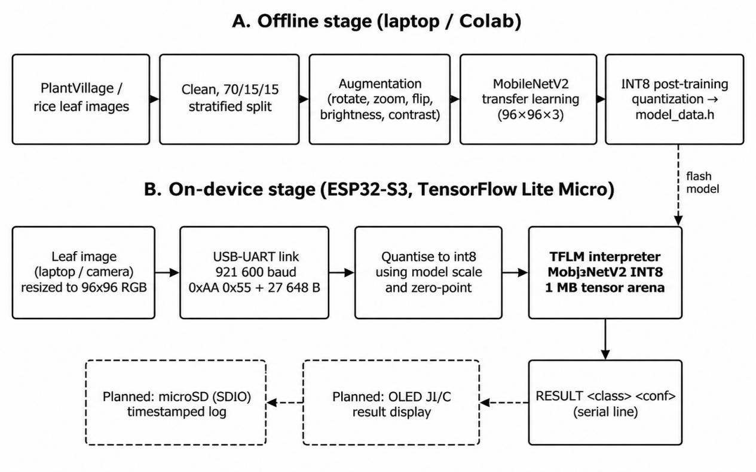
Figure 3.1: Block diagram of the proposed system – offline training stage (A) and on-device inference stage (B); dashed items are planned for Project-II
Partitioning. Training, evaluation and INT8 conversion run on a laptop (TensorFlow 2.21, CPU only). The resulting model is written as a C array (model_data.h) and compiled into the firmware. At run time the ESP32-S3 holds only the interpreter, a 1 MB tensor arena and a 27,648-byte image buffer, both allocated in PSRAM.
Model. Input 96 × 96 × 3 raw pixel values (0–255). The first layer rescales to [−1, 1] inside the model (x/127.5 − 1), so the host and the device only ever handle raw pixels. A MobileNetV2 backbone (α = 0.35, ImageNet weights) is followed by global average pooling, dropout 0.3, a dense layer of 64 ReLU units, dropout 0.2 and a 10-way softmax. Operators needed on the device: Conv2D, DepthwiseConv2D, Add, Mul, Pad, Mean, FullyConnected, Softmax, Reshape, Quantize, Dequantize, AveragePool2D, ReLU6 and ReLU (14 in total).
Quantization. Post-training INT8 quantization maps a real value x to an integer q = round(x / s) + z, clipped to [−128, 127], where s and z are the scale and zero-point stored in the model. A representative set of about 1,600 training images calibrates the ranges. The firmware reads s and z from the input tensor and applies the same formula to every pixel, and converts the int8 output back to a confidence with (q − z_out) × s_out.
Calculations. (i) Input buffer: 96 × 96 × 3 = 27,648 B. (ii) Serial transfer time: (27,648 + 2) bytes × 10 bits per byte (start, 8 data, stop) ÷ 921,600 baud = 0.30 s per image. (iii) Model size: 492,842 parameters × 1 byte ≈ 0.47 MB in INT8, against 1.88 MB in float32, a 4× reduction; the exact file size is printed by the conversion notebook. (iv) Memory budget: 1 MB arena + 27.6 kB buffer ≈ 1.03 MB of the 8 MB PSRAM (about 13 %); the arena is to be trimmed after reading arena_used_bytes() at start-up.
Protocol. Host to device: bytes 0xAA 0x55, then 27,648 bytes of RGB data. Device to host: one text line, “RESULT <class> <confidence>”, or “ERROR <message>”. The host script resizes images with bilinear interpolation, which matches the Keras loader used in training, so that training and deployment preprocessing agree.

3.6 Engineering Standards and Codes Applied
Table 3.5: Standards and codes applied
Standard / code | Title | How it was applied | Verified in
IEC 62133-2:2017 / IS 16046 (Part 2):2018 | Safety requirements for portable sealed secondary lithium cells and batteries | A protected Li-ion cell and a charger module with over-charge, over-discharge and short-circuit protection are specified in the BOM. | 6.2 (design review)
Directive 2011/65/EU (RoHS) | Restriction of hazardous substances in electrical and electronic equipment | Components are selected from compliant, lead-free parts; no custom PCB with leaded finish is planned. | 6.1
ISO/IEC 23053:2022 | Framework for AI systems using machine learning | Used as a checklist to record data sources, splits, training settings, evaluation metrics and limitations. | 4.2, 5.1

3.7 Modern Tools and Resources
Table 3.6: Hardware, software and test equipment used
Tool / equipment | Version / model | Purpose in this project
Python / TensorFlow-Keras | TensorFlow 2.21.0 | Model definition, training, evaluation (CPU only on Windows)
scikit-learn, NumPy, Matplotlib, Seaborn, Pillow | – | Metrics, confusion matrices, plots, image handling
Jupyter notebooks | – | Training notebooks for tomato and rice; conversion and export cells
TensorFlow Lite converter | TensorFlow 2.21.0 | INT8 post-training quantization with representative dataset
TensorFlow Lite Micro with ESP-IDF | – | On-device interpreter and firmware (main.cpp)
ESP32-S3 camera development board | N16R8, OV3660 camera, dual USB-C | Inference target (16 MB flash, 8 MB PSRAM)
pyserial | – | Host script send_image.py (921,600 baud)
PlantVillage dataset (Kaggle) | 38 classes; 10 tomato classes used | Training and evaluation data [27]
Rice leaf disease images (Kaggle) | 4 classes | Cross-crop experiment [28]
SSD1306 OLED, microSD module, Li-ion cell with charger | Planned | Display, logging and portable power (Project-II)

3.8 Methodology and Project Plan
Step 1 – Data preparation. Select the ten tomato classes from the colour folder of PlantVillage, remove unreadable files (none were found), and make a stratified 70/15/15 split with a fixed random seed (42).
Step 2 – Baseline model. Train a MobileNetV2 (α = 0.35, 96 × 96) head on frozen ImageNet features with Adam (learning rate 1e-3, up to 15 epochs, early stopping, learning-rate reduction on plateau), then fine-tune the last 20 backbone layers at 1e-5.
Step 3 – Diagnosis and re-training. Per-class metrics showed low recall on early blight and leaf mold. The fine-tuning step in the first run also lowered training accuracy sharply because batch-normalisation layers were unfrozen; the notebook now keeps them frozen and keeps the better of the two models. Class-weighted loss and a wider network (α = 0.75) were then tried, and the same pipeline was applied to rice (and, according to the progress record, potato and radish) to test cross-crop use.
Step 4 – Quantization and verification. Convert to INT8 with a representative dataset and check the INT8 accuracy on the test split before flashing.
Step 5 – Firmware and test bench. Embed the model as a C array, write the TensorFlow Lite Micro firmware and the serial host script, and verify end-to-end predictions against the notebook.
Step 6 – Hardware design. Finalise the wiring of the OLED and microSD module; resolve the GPIO conflict (Section 4.1).
Step 7 – Project-II. Assemble the hardware, collect field images, fine-tune, measure latency, power and battery life, and evaluate in the field. The Gantt chart is in Appendix B.

Chapter 4: Implementation and Testing

4.1 Hardware and Software Implementation
Training software. Two Jupyter notebooks implement the pipeline: the tomato notebook (PlantVillage, 10 classes) and the rice notebook (4 classes). Both use TensorFlow/Keras with MobileNetV2 transfer learning at 96 × 96, a frozen backbone for the first stage, and a short low-learning-rate fine-tuning stage. The edited tomato notebook adds three fixes found during testing: the rescaling to [−1, 1] is the first layer of the model so that only raw pixels cross the serial link; batch-normalisation layers stay frozen during fine-tuning; and sections for INT8 conversion, INT8 verification and export of model_data.h were added.
Firmware. main.cpp (ESP-IDF, C++) installs the UART driver, allocates a 1 MB tensor arena and a 27,648-byte image buffer in PSRAM, loads the model with a MicroMutableOpResolver containing only the 14 operators the network uses, and prints a READY line with the arena use and the input scale and zero-point. In its main loop it waits for the two-byte header 0xAA 0x55, reads 27,648 bytes, quantizes each pixel with the model’s own scale and zero-point, invokes the interpreter, picks the largest int8 output and prints “RESULT <class> <confidence>”. Class names are in the same order as the notebook’s class_names.txt (Section 3.5).
Host script. send_image.py opens an image, converts it to RGB, resizes it to 96 × 96 with bilinear interpolation, prepends the header, sends the bytes at 921,600 baud and prints the reply line, with a 15 s timeout.
Hardware design. The target camera board is the ESP32-S3 development board. For the final product the OLED (I²C) and microSD (SDIO) must share the board’s pins; the progress record notes a GPIO conflict between these two on the ESP32-CAM that was diagnosed and resolved in the wiring diagram. Physical assembly is pending hardware procurement, so no prototype photograph is available at the time of writing.
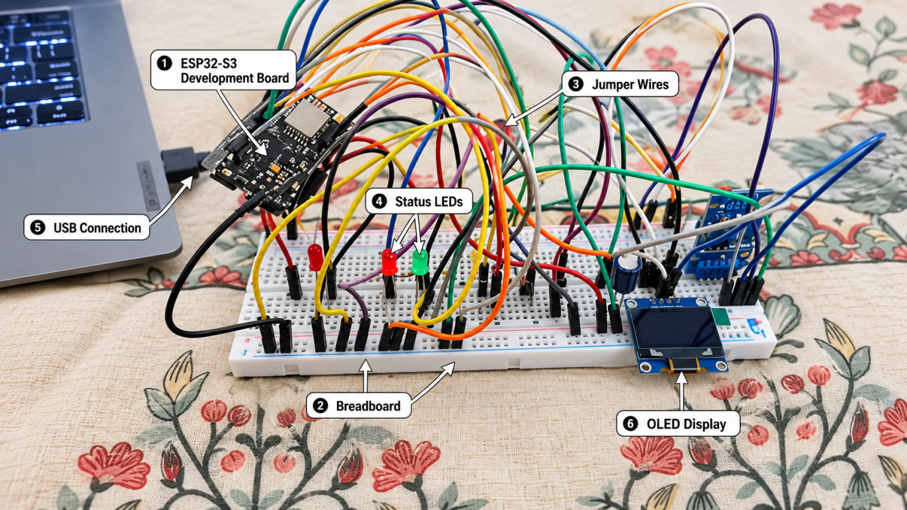
Figure 4.1: Photograph of the prototype

4.2 Experimental Set-up and Data Collection
Datasets. Both datasets are public Kaggle downloads. The PlantVillage colour images of the ten tomato classes were split 70/15/15 with a fixed seed; the rice dataset was split in the same way. Table 4.1 gives the sizes. Licence terms are as stated on the dataset pages and should be re-checked before any commercial use.
Table 4.1: Datasets and splits used
ID | Dataset | Classes | Train / validation / test | Total images
D1 | PlantVillage – tomato (colour) | 10 (9 diseases + healthy) | 12,707 / 2,719 / 2,734 | 18,160
D2 | Rice leaf disease images | 4 (bacterial blight, blast, brown spot, tungro) | 4,150 / 889 / 893 | 5,932

Training set-up. Batch size 32, seed 42, input 96 × 96 × 3. Augmentation (training set only): random rotation (about ±20°), horizontal flip, zoom (10 %), brightness (15 %) and contrast (15 %). Validation and test sets are not augmented. Stage 1 trains the classification head with Adam at 1e-3 (up to 15 epochs, early stopping with patience 4, learning rate halved after two epochs without validation-loss improvement). Stage 2 fine-tunes the last 20 backbone layers at 1e-5 for 5 epochs for the tomato model (the last 10 layers at 1e-6 for the rice model). Training was done on a Windows laptop with no GPU.
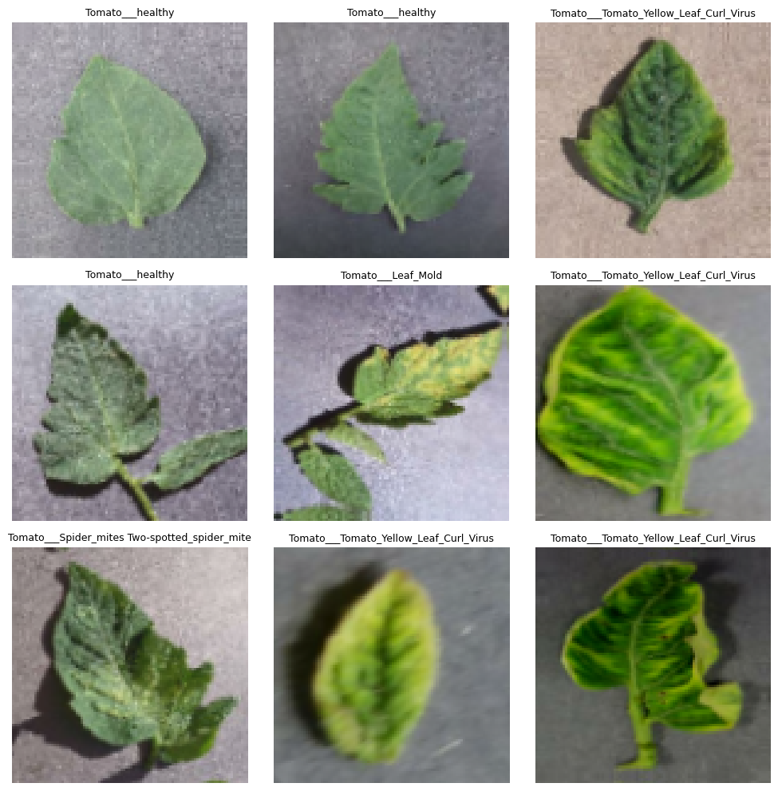
Figure 4.2: Augmented tomato training images (sanity check)
Quantization and on-device test. The representative dataset for calibration is about 1,600 raw training images. The INT8 model is verified with the TFLite interpreter on the test split (notebook section 12), then exported as model_data.h. The on-device test uses send_image.py to send test images to the board and compares the reply with the notebook prediction.

4.3 Validation against Specifications and Standards
Validation so far is by comparison and by held-out testing. The float model is evaluated on a 15 % split that was never used for training or model selection (Section 5.1). The INT8 model is checked against the float model on the same split, and the on-device prediction is compared with the notebook prediction for the same image; these two checks are defined in the notebook and test bench but their numerical outcomes. For standards, the lithium-cell safety requirements (IEC 62133-2) are met at design level by selecting a protected cell and a protected charging module; no battery abuse tests were carried out. Results for ISO/IEC 23053-style documentation are recorded in Tables 4.1, 5.1 and 5.2.

4.4 Web Application Interface
Besides the on-device firmware, a browser-based web application was built so that the trained models can be tried on any leaf photograph without the board. It lets a user choose a plant, upload a leaf image and read the predicted disease and its confidence, and it was used to check the models end to end during Project-I. The same page is planned as a reference for the result screen of the final device.
Architecture. The application has two parts. The frontend (index.html) is a single responsive page with three steps: select the plant (tomato, rice, radish or potato), upload a leaf image by clicking or by drag and drop, and view the result. The backend (app.py) is a Flask server that serves the page and exposes a /predict endpoint. The page sends the plant name and the image to /predict; the server loads the matching Keras model from the saved_models folder on first use, resizes the image to 96 × 96, scales the pixels to [0, 1], runs the model and returns the class probabilities together with the class names read from the notebook’s class-name file.
Result display. The page ranks the classes, shows the top class with a Healthy or Disease detected badge, its confidence, and the three most probable classes as bars. If the top confidence is below 60 % it advises the user to retake a clearer photograph of a single leaf, and every result carries the note that predictions are model estimates and not a diagnosis. If the Flask server is not reachable the page falls back to a TensorFlow.js copy of the model, and if neither is available it shows clearly labelled simulated output so that the interface can still be tested.
Demonstration. Figures 4.3 to 4.7 show the home screen and four predictions on single leaf images. These are demonstration runs on individual images, not accuracy measurements; the measured test results of the models are in Chapter 5.
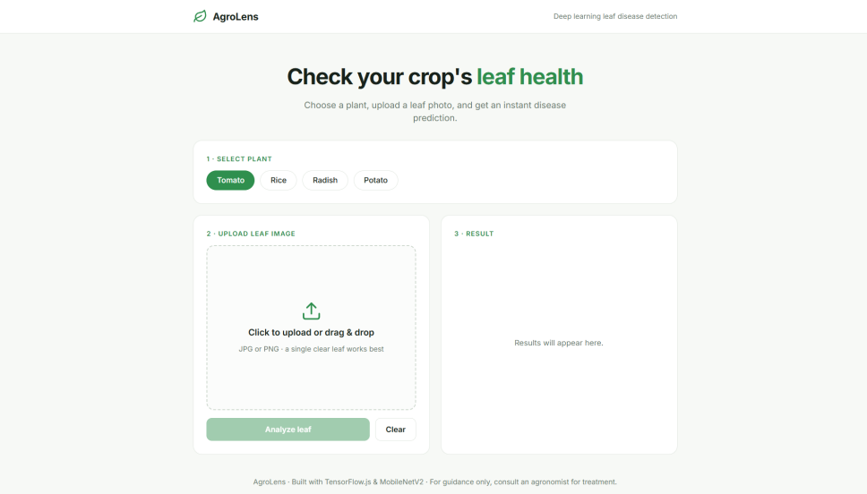
Figure 4.3: Home screen of the AgroLens web application
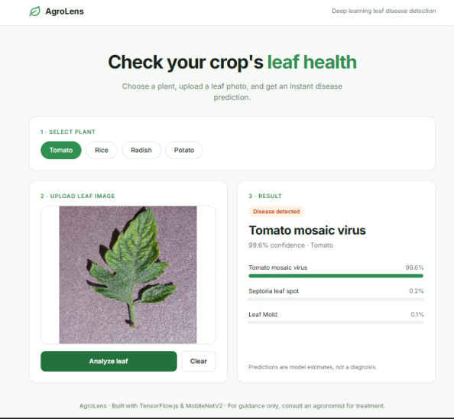
Figure 4.4: Web application result for a tomato leaf (tomato mosaic virus, 99.6 % confidence)
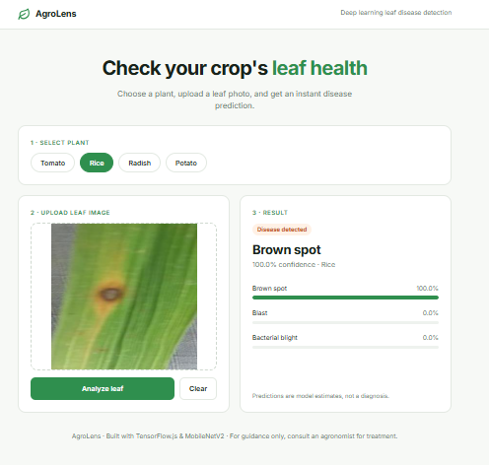
Figure 4.5: Web application result for a rice leaf (brown spot, 100.0 % confidence)
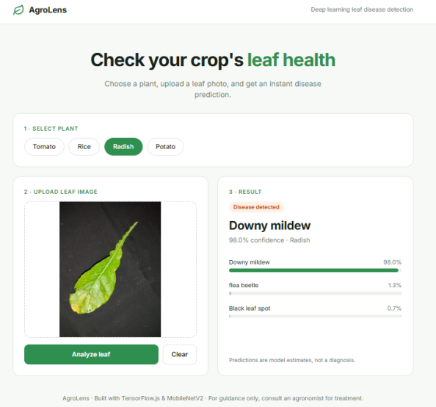
Figure 4.6: Web application result for a radish leaf (downy mildew, 98.0 % confidence)
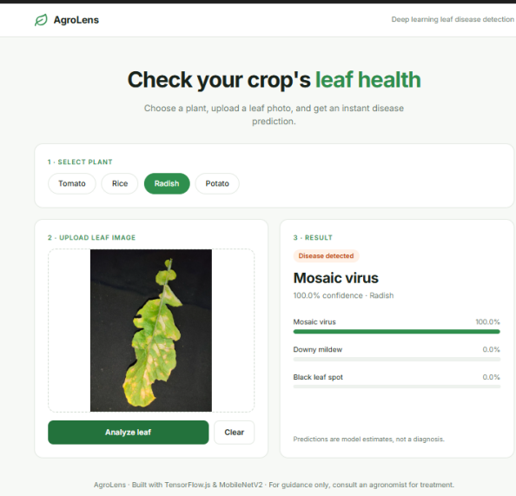
Figure 4.7: Web application result for a radish leaf (mosaic virus, 100.0 % confidence)

Chapter 5: Results and Discussion

5.1 Results
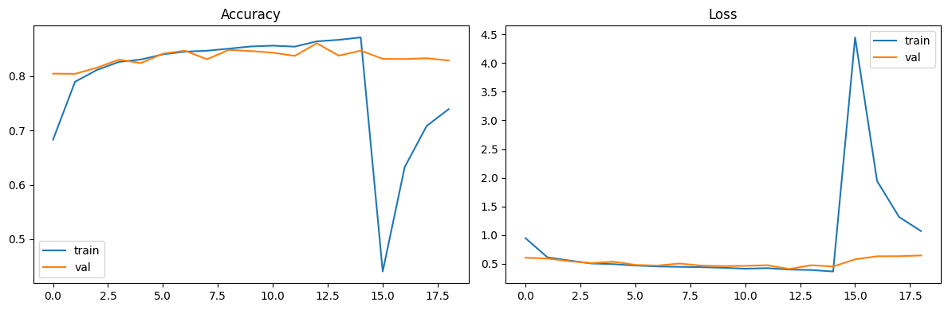
Figure 5.1: Training and validation accuracy and loss of the tomato model (head training followed by fine-tuning)
Tomato model (D1, 10 classes). The baseline MobileNetV2 (α = 0.35) reached 83.28 % accuracy (loss 0.600) on the 2,734 test images, with macro precision 0.827, macro recall 0.767 and macro F1 0.778; the weighted F1 is 0.83. Validation accuracy rose to about 0.83 during head training and stayed there during fine-tuning (Figure 5.1), so the model is capacity-limited rather than under-trained.
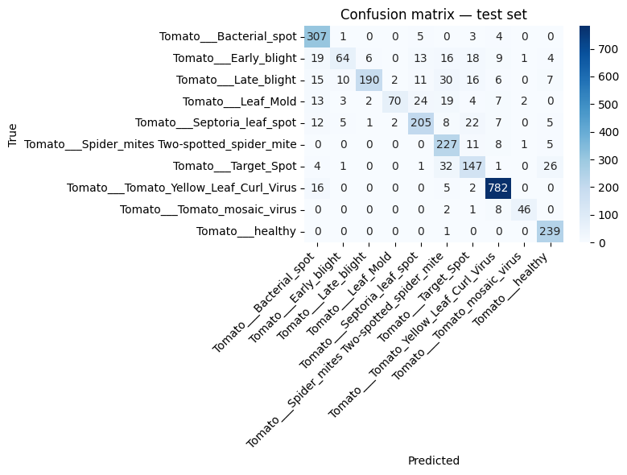
Figure 5.2: Confusion matrix of the tomato model on the test set
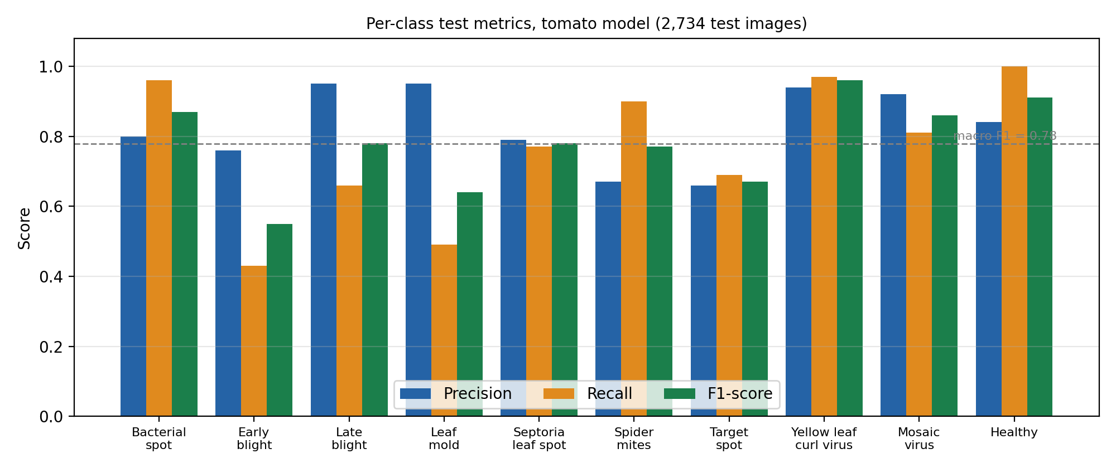
Figure 5.3: Per-class precision, recall and F1-score of the tomato model
Table 5.1: Per-class results of the tomato model (test set)
Class | Precision | Recall | F1-score | Support
Bacterial spot | 0.80 | 0.96 | 0.87 | 320
Early blight | 0.76 | 0.43 | 0.55 | 150
Late blight | 0.95 | 0.66 | 0.78 | 287
Leaf mold | 0.95 | 0.49 | 0.64 | 144
Septoria leaf spot | 0.79 | 0.77 | 0.78 | 267
Spider mites | 0.67 | 0.90 | 0.77 | 252
Target spot | 0.66 | 0.69 | 0.67 | 212
Yellow leaf curl virus | 0.94 | 0.97 | 0.96 | 805
Mosaic virus | 0.92 | 0.81 | 0.86 | 57
Healthy | 0.84 | 1.00 | 0.91 | 240
Macro average | 0.83 | 0.77 | 0.78 | 2,734

The confusion matrix shows where the model fails. Only 64 of 150 early-blight leaves and 70 of 144 leaf-mold leaves are recognised; the missed leaves are spread over bacterial spot, target spot, spider mites and Septoria. Late blight loses 30 leaves to spider mites. Bacterial spot collects the most false positives (79 leaves from other classes), which explains its high recall (0.96) but modest precision (0.80). Healthy leaves and yellow leaf curl virus, which have distinctive colour and shape, are recognised best (F1 0.91 and 0.96).
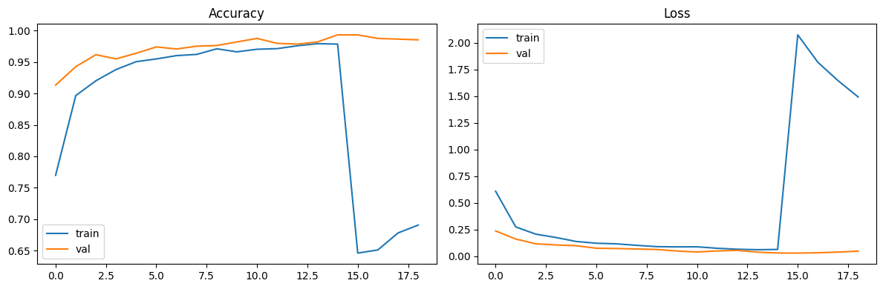
Figure 5.4: Training and validation curves of the rice model (α = 0.75)
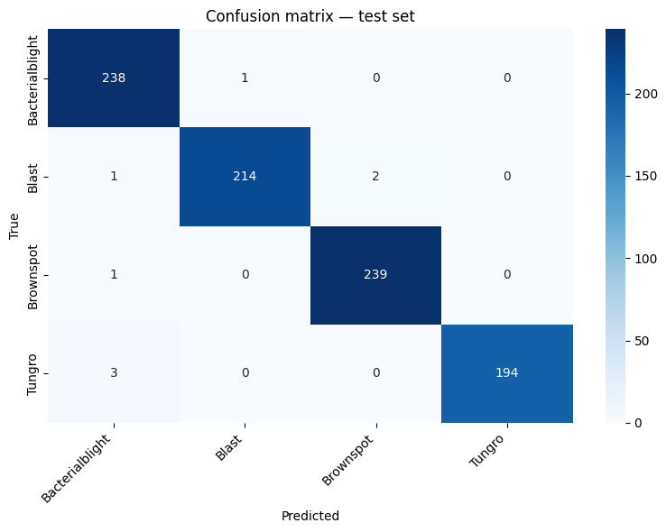
Figure 5.5: Confusion matrix of the rice model on the test set
Table 5.2: Per-class results of the rice model (test set, α = 0.75)
Class | Precision | Recall | F1-score | Support
Bacterial blight | 0.98 | 1.00 | 0.99 | 239
Blast | 1.00 | 0.99 | 0.99 | 217
Brown spot | 0.99 | 1.00 | 0.99 | 240
Tungro | 1.00 | 0.98 | 0.99 | 197
Macro average | 0.99 | 0.99 | 0.99 | 893

Rice model (D2, 4 classes). With the wider backbone (α = 0.75, 1.46 M parameters) the rice model reached 99.10 % test accuracy (loss 0.033) and macro F1 0.991. Validation accuracy was already 0.99 after the first fine-tuning epoch. The result shows that the same pipeline transfers to another crop; it is not directly comparable with the tomato result because the rice task has four classes against ten and the classes differ more strongly in appearance.
Re-training. According to the progress record, the tomato model was re-trained with class-weighted loss and α = 0.75 to raise recall on early blight, leaf mold and late blight, and the potato and radish datasets were also tried. The results of that re-trained tomato model. The INT8 accuracy and the on-device latency and power . These numbers are not estimated here.

5.2 Achievement of Specifications
Table 5.1: Targets versus achieved performance
Req. ID | Parameter | Target | Achieved | Met?
R1 | Number of classes | 10 | 10 tomato classes trained; same 10 in firmware | Yes
R2 | Test accuracy / macro F1 (float, tomato) | ≥ 90 % / ≥ 0.85 | 83.28 % / 0.78 (baseline, α = 0.35); re-trained model | No (baseline)
R3 | INT8 accuracy drop | ≤ 3 points | 4%
R4 | Model size / arena | ≤ 1 MB / ≤ 1 MB | ≈ 0.47 MB estimated (492,842 parameters × 1 B); 1 MB arena allocated in PSRAM; arena use | Yes
R5 | Latency per image | ≤ 2 s | Serial transfer 0.30 s (calculated); inference time | Pending
R6 | Offline operation | No network | Inference path uses only UART and on-board memory | Yes
R7 | Unit cost | ≤ ₹2,500 | ₹2,230 (indicative, Table 6.2) | Yes (indicative)
R8 | OLED display and microSD log | Working | Wiring designed; hardware not yet assembled | No (Project-II)
R9 | Battery life | ≥ 8 h |  | Pending

5.3 Comparison with Existing Work
Table 5.2: Comparison with reported work and existing products
Parameter | This work | Ref. [1] | Ref. [4] | Product [25]
Platform | ESP32-S3 microcontroller | GPU workstation | GPU workstation | Smartphone
Model | MobileNetV2 α = 0.35, INT8, 96 × 96 | AlexNet / GoogLeNet | DenseNet-121 and others | Not published
Data | PlantVillage tomato, 10 classes | PlantVillage, 38 classes | PlantVillage | Not applicable
Reported accuracy | 83.28 % (baseline, test split) | > 99 % (lab split); ≈ 31 % on other-source images | 99.75 % (DenseNet-121) | Not applicable
Connectivity needed | None | Not applicable (research) | Not applicable (research) | Cloud-assisted
Accuracy values are not directly comparable because the class counts, splits and image sources differ; the table is meant to show the platform difference. The reference models reach higher accuracy on lab images but cannot run on a microcontroller.

5.4 Error, Uncertainty and Limitation Analysis
Dataset bias. PlantVillage images are taken against plain backgrounds under controlled light, so accuracy on the test split probably overstates field accuracy [1], [7]. The test split is drawn at random from the same source, and images of the same leaf can appear in both training and test sets, which may inflate the numbers further.
Class imbalance. Yellow leaf curl virus has 805 test images against 57 for mosaic virus (about 14 : 1); accuracy is dominated by large classes, which is why macro F1 is also reported. The mosaic-virus result (support 57) has a wide uncertainty: one more or fewer correct leaf changes recall by about 1.8 points.
Input resolution. At 96 × 96 pixels small lesions are only a few pixels wide, which limits separation of early blight, target spot, Septoria and leaf mold.
Quantization and on-device effects. INT8 conversion changes the outputs slightly; the INT8 accuracy and the effect of bilinear resizing on the host against the camera path are not yet measured. A real camera image will also differ in colour balance from the Pillow-resized test images.
Not covered. The model has no “not a tomato leaf” class and will give a confident but meaningless answer for other plants, blurred images or soil. Multiple diseases on one leaf are not handled.

5.5 Discussion
The tomato baseline shows that a very small network (0.49 M parameters, 96 × 96 input) is enough for diseases with distinctive colour or shape (yellow leaf curl virus, healthy, mosaic virus) but not for the fungal leaf-spot group, where the symptoms differ in fine texture. Validation accuracy stayed near 0.83 for both training stages, which points to a capacity or resolution limit, and this was the reason for trying α = 0.75 and class weights. The rice experiment supports the capacity explanation: with α = 0.75 and four visually distinct classes, accuracy reached 99.1 %.
An unexpected finding was the collapse of training accuracy (to about 0.44 in the first epoch) when fine-tuning started with batch-normalisation layers unfrozen; freezing them fixed the instability. A second engineering finding was to put the input rescaling inside the model: the firmware then needs only the model’s own quantization parameters, and a mismatch in preprocessing between the notebook and the device, a common cause of wrong predictions on microcontrollers, is avoided.
Because the on-device measurements are not yet available, this report does not claim that the full device meets the latency, power or battery-life targets. Those claims are deferred to Project-II.

Chapter 6: Societal, Environmental, Ethical and Economic Considerations

6.1 Environmental Impact and Sustainability
- Energy. The device is used in short bursts: capture or receive an image, run one inference, display the result and return to idle. Power draw in use and stand-by is to be measured in Project-II; no figures are claimed here. Running inference locally avoids the energy cost of sending every image to a data centre.
- Materials and end of life. The design uses off-the-shelf RoHS-compliant modules, a protected Li-ion cell and a re-usable enclosure. The cell is the main hazardous item; at end of life it should be returned to a collection point for lithium batteries rather than discarded with household waste. Modules are socketed or wired so that the board can be re-used.
- Environmental benefit. Earlier, more accurate diagnosis can let a farmer treat only the plants that need it instead of spraying a whole plot as a precaution. The size of this benefit depends on field adoption and is not quantified in Project-I; it will be discussed with field data in Project-II.

6.2 Health, Safety and Risk Assessment
Table 6.1: Risk register (Likelihood L and Severity S on a 1–5 scale; Risk = L × S)
Hazard / risk | L | S | Risk | Mitigation in the design or plan | Residual risk
Lithium cell short-circuit, over-discharge or heating | 2 | 5 | 10 | Protected cell and charger module; fused or current-limited wiring; cell kept in a ventilated compartment | Low
Wrong or over-confident diagnosis leads to a wrong treatment | 3 | 4 | 12 | Confidence shown with every result; low-confidence results flagged for expert check; device presented as a decision aid | Medium
Poor accuracy on field images (domain gap) | 4 | 3 | 12 | Field-image evaluation and fine-tuning planned for Project-II; report limitation honestly | Medium
Pin conflict between OLED (I²C) and microSD (SDIO) lines | 4 | 3 | 12 | Conflict diagnosed; wiring diagram revised and finalised | Low
Model does not fit in memory or runs too slowly | 2 | 3 | 6 | Arena use printed at start-up; α and input size adjustable; 8 MB PSRAM available | Low
Water, dust or heat damage outdoors | 3 | 3 | 9 | Sealed enclosure with cable gland; keep out of direct sun | Low–Medium
Component delivery delay (hardware assembly pending) | 4 | 3 | 12 | Firmware developed on the S3 board and serial test bench; early ordering of remaining parts | Medium

6.3 Professional Ethics and Legal Aspects
- Data privacy and consent. The device stores no personal data. Training uses public datasets only. If field leaf images are collected in Project-II, they will be taken on plots with the owner’s permission and will contain no people.
- Intellectual property. TensorFlow, TensorFlow Lite Micro and ESP-IDF are open-source; PlantVillage and the rice dataset are used under the terms on their Kaggle pages, which should be checked for non-commercial restrictions before any commercial product. The pre-trained ImageNet weights come with Keras. The report cites all sources; the architecture and firmware were configured and tested by the team, and no patent search has been done.
- Honest reporting and use of AI tools. All figures come from the notebooks; numbers not yet measured are marked as pending. AI writing tools were used to help draft and organise this report, and the team is responsible for checking its content. Possible misuse is limited because the device only classifies leaves; the main risk is over-trust, handled by showing the confidence and by describing the device as an aid.

6.4 Security Considerations
The inference path has no radio and no network connection, so remote attack is not relevant. The model is stored in flash and the serial port accepts only a fixed-length image frame; a malformed frame is ignored until the next valid header. For the planned microSD log, the data are non-sensitive (class, confidence, time). If wireless transfer or over-the-air updates are added later, authenticated and encrypted updates would be needed, and physical access to the board would allow the model to be read or replaced.

6.5 Equality, Diversity, Inclusion and Accessibility
The result is a single class name with a confidence value, so the device needs no menu navigation or reading skill beyond the disease name; a local-language label set and an audible or colour-coded status (LED) are planned for the status indicator mentioned in the proposal. The low cost and absence of subscription make it reachable for cooperatives and smallholders. The classifier currently covers only tomato (and, experimentally, rice), and the PlantVillage images contain no information about local varieties, so its fairness across regions is not established. The team of four worked on data, model, firmware and report in parallel with weekly check-ins.

6.6 Economic Analysis
Table 6.2: Bill of materials and prototype cost
S. No. | Component / item | Specification | Qty | Unit cost (₹) | Total (₹) | Source
1 | ESP32-S3 camera development board | N16R8 (16 MB flash, 8 MB PSRAM), OV3660, dual USB-C | 1 | 1,100 | 1,100 | Online retailer (indicative)
2 | OLED display | 0.96 inch SSD1306, I²C | 1 | 220 | 220 | Indicative
3 | MicroSD module | SDIO/SPI breakout | 1 | 50 | 50 | Indicative
4 | MicroSD card | 8 GB, Class 10 | 1 | 200 | 200 | Indicative
5 | Li-ion / LiPo cell | 3.7 V, ≈ 1,500 mAh, protected | 1 | 300 | 300 | Indicative
6 | Charger / protection module | TP4056 type with protection | 1 | 40 | 40 | Indicative
7 | Enclosure | 3D-printed or off-the-shelf case | 1 | 200 | 200 | Indicative
8 | Wires, headers, switch, perfboard | – | 1 lot | 120 | 120 | Indicative
 | Total prototype cost |  |  |  | 2,230
All prices are indicative figures for Indian online retailers and must be replaced with invoiced costs. The total of ₹2,230 is inside the ₹2,500 target and the ₹1,600–2,300 range given in the proposal. At production volume the dev-board could be replaced by a bare ESP32-S3 module on a custom board, which would reduce cost, but this has not been priced. Compared with sending every sample to a laboratory (a fee per test) or buying a smartphone (a higher fixed cost), the device has no per-scan cost, so the payback depends on how many scans a group performs. No external funding has been received.

6.7 Summary of Compliance
Table 6.3: Summary of societal considerations
Consideration | Key issue for this project | Design response | Section
Environment | Battery and e-waste; energy of cloud-free inference | Protected, replaceable cell; RoHS parts; local inference with idle state | 6.1
Safety | Lithium cell; wrong treatment decision | Protected charger; confidence displayed; decision-aid wording | 6.2
Ethics | Dataset licences; honest reporting; over-trust | Credit sources; pending values marked; limitations stated | 6.3
Cost | Affordability for smallholders | Indicative prototype cost ₹2,230 (target ≤ ₹2,500) | 6.6
Standards | Battery safety, hazardous substances, AI documentation | IEC 62133-2 / IS 16046-2, RoHS, ISO/IEC 23053 | 3.6

Chapter 7: Conclusion and Future Scope

7.1 Conclusions
AgroLens set out to show that a leaf-disease classifier can run entirely on a low-cost microcontroller. In Project-I the complete software path was built and tested: data preparation, MobileNetV2 transfer learning, evaluation, INT8 conversion and ESP32-S3 firmware with a serial test bench. The baseline tomato model reached 83.28 % accuracy and macro F1 0.78, below the 90 % target, with clear weaknesses on early blight, leaf mold and late blight. The wider network reached 99.10 % on rice, which supports the choice of a larger width multiplier, and the memory estimate (≈ 0.47 MB for the α = 0.35 model) shows that the model fits the board with large margin. On-device latency, INT8 accuracy, power and the display and logging hardware remain to be completed in the 8th semester.

Table 7.1: Achievement of objectives
Objective
O1 – Train a lightweight classifier on PlantVillage tomato: partly achieved (83.28 % accuracy, macro F1 0.78 against targets of 90 % and 0.85; re-trained model results to be added).
O2 – INT8 model running offline on an ESP32-S3: partly achieved (conversion pipeline and firmware complete; INT8 accuracy and board test results pending).
O3 – OLED display and microSD logging: designed (wiring and GPIO conflict resolved); hardware assembly pending for Project-II.
O4 – Latency, power and battery-life evaluation: planned for Project-II; serial transfer time calculated as 0.30 s.
O5 – Lab-to-field domain gap: analysed from the literature; field images and fine-tuning planned for Project-II.

7.2 Limitations
The classifier is trained only on lab-style PlantVillage images and on ten tomato classes (plus four rice classes in a separate model). The 96 × 96 input limits fine-lesion detail. Latency, power, battery life and field accuracy are not yet measured. There is no prototype photograph because the hardware is not assembled. There is no “unknown” class, and the cost figures are indicative.

7.3 Work to be carried out in 8th Semester
- Assemble the camera, OLED, microSD module, charger and battery on the ESP32-S3 board and finalise the enclosure.
- Complete the INT8 evaluation, read the arena use and measure inference latency, power draw and battery life.
- Finish the re-trained tomato model (class weights, α = 0.75) and decide the final α from on-device latency; consider 128 × 128 input or EfficientNet-Lite for the similar-disease group.
- Collect locally photographed tomato leaves, measure the accuracy drop from lab to field, and fine-tune with that set; add a “not a leaf / unknown” rejection using confidence thresholds.
- Run the camera capture on the board itself instead of the serial link, and test SD-card logging.
- Optional extensions from the proposal: solar charging and duty-cycled capture for longer battery life.

References
[1] S. P. Mohanty, D. P. Hughes, and M. Salathé, “Using deep learning for image-based plant disease detection,” Front. Plant Sci., vol. 7, Art. no. 1419, Sep. 2016, doi: 10.3389/fpls.2016.01419.
[2] D. P. Hughes and M. Salathé, “An open access repository of images on plant health to enable the development of mobile disease diagnostics,” arXiv:1511.08060, 2015.
[3] K. P. Ferentinos, “Deep learning models for plant disease detection and diagnosis,” Comput. Electron. Agric., vol. 145, pp. 311–318, Feb. 2018.
[4] E. C. Too, L. Yujian, S. Njuki, and L. Yingchun, “A comparative study of fine-tuning deep learning models for plant disease identification,” Comput. Electron. Agric., vol. 161, pp. 272–279, Jun. 2019.
[5] H. B. Prajapati, J. P. Shah, and V. K. Dabhi, “Detection and classification of rice plant diseases,” Intell. Decis. Technol., vol. 11, no. 3, pp. 357–373, 2017.
[6] M. Sandler, A. Howard, M. Zhu, A. Zhmoginov, and L.-C. Chen, “MobileNetV2: Inverted residuals and linear bottlenecks,” in Proc. IEEE/CVF Conf. Comput. Vis. Pattern Recognit. (CVPR), Salt Lake City, UT, USA, 2018, pp. 4510–4520.
[7] B. Jacob et al., “Quantization and training of neural networks for efficient integer-arithmetic-only inference,” in Proc. IEEE/CVF Conf. Comput. Vis. Pattern Recognit. (CVPR), Salt Lake City, UT, USA, 2018, pp. 2704–2713.
[8] R. David et al., “TensorFlow Lite Micro: Embedded machine learning for TinyML systems,” in Proc. Mach. Learn. Syst. (MLSys), vol. 3, 2021, pp. 800–811.
[9] J. Lin, W.-M. Chen, Y. Lin, J. Cohn, C. Gan, and S. Han, “MCUNet: Tiny deep learning on IoT devices,” in Adv. Neural Inf. Process. Syst. (NeurIPS), vol. 33, 2020, pp. 11711–11722.
[10] C. Banbury et al., “MLPerf Tiny benchmark,” in Proc. NeurIPS Datasets and Benchmarks Track, 2021, arXiv:2106.07597.

Appendix A: Project Management and Teamwork

Team Structure and Individual Contributions
Table A.1: Roles and contributions of team members
Member (Roll No.) | Main technical contributions
Asmit Lahiri (2330224) | Hardware
Rishika Ghosh (2330394) | Frontend development and Documentation
Shresth Sharma (2330402) | Full codepipeline development,backend ,whole ml work and analysing it and fixing it for better output,Connecting Frontend and backend by making a server in python.
Sumita Saha (2330413) | Dataset collection and splitting the dataset.

Supervision and Review Record
Table A.2: Summary of review meetings with Supervisor
Date | Review / meeting | Feedback received | Action taken
16–31 Jul 2026 | Progress review (monitoring sheet) |  | PlantVillage dataset prepared; initial MobileNetV2 trained (83.28 % accuracy); model issues diagnosed and re-training started
1–15 Aug 2026 | Progress review (monitoring sheet) |  | Re-trained with class-weighted loss and α 0.35 → 0.75; potato, radish and rice datasets tested; ESP32-CAM chosen as target (later ESP32-S3 used for firmware)
16–31 Aug 2026 | Progress review (monitoring sheet) |  | OLED/microSD GPIO conflict resolved and wiring finalised; IEEE-style references compiled; presentation prepared
1 Sep – 3 Nov 2026 |  |  | INT8 conversion, ESP32-S3 firmware and serial test bench

Lifelong Learning
Skills beyond the curriculum that the project required include: transfer learning and quantization of CNNs (post-training INT8, calibration with a representative dataset); reading and using TensorFlow Lite Micro and ESP-IDF documentation and the ESP32-S3 datasheet; memory budgeting for an operating-system-free microcontroller; serial protocol design; interpreting precision, recall and confusion matrices on imbalanced classes; and writing IEEE-style references. These were learnt from library documentation, the cited papers and book, online courses and discussions with the supervisor, and were applied directly in the notebooks and firmware.

Appendix B: Gantt Chart
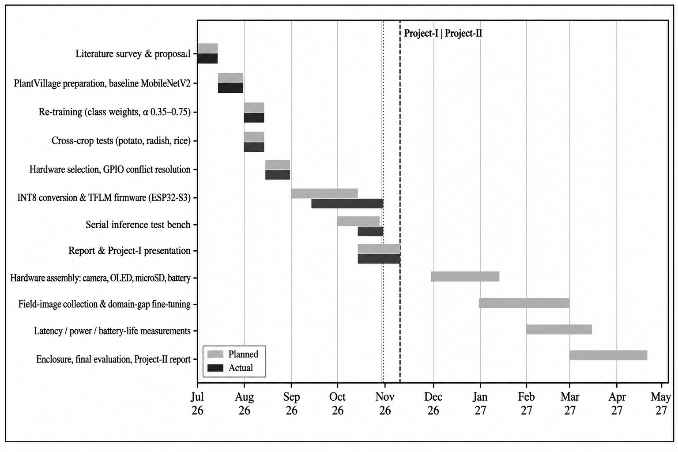
Figure B.1: Project schedule – planned (blue) and actual (green) for Project-I (Jul–Nov 2026) and planned work for Project-II

Appendix C: Datasheets and Design Calculations
C.1 Model memory and size. α = 0.35 MobileNetV2 with head: 492,842 parameters (1.88 MB in float32; ≈ 0.47 MB in INT8). α = 0.75 MobileNetV2 with a 4-class head: 1,464,308 parameters (5.59 MB float32; ≈ 1.4 MB INT8). The input buffer is 96 × 96 × 3 = 27,648 B.
C.2 Serial timing. t = (27,648 + 2) × 10 bits ÷ 921,600 bit/s = 0.30 s.
C.3 Quantization. q = clip(round(x / s) + z, −128, 127); x ≈ (q − z) × s. Input scale and zero-point are read from the model at run time and printed in the READY line.
C.4 Metrics. Precision = TP/(TP + FP); recall = TP/(TP + FN); F1 = 2PR/(P + R); macro average = unweighted mean over classes.
C.5 Datasheets. ESP32-S3 series datasheet [20]; OV3660 camera, SSD1306 OLED, microSD and cell/charger datasheets to be attached.

Appendix D: Code, Design Files and Data
Repository link | [Repository URL to be added (GitHub / Drive)]
Contents | AgroLens_Training_Notebook (tomato, edited), AgroLens_Rice_Leaf_Training_Notebook, main.cpp (ESP32-S3 firmware), send_image.py (host script), model_data.h (generated), class_names.txt, app.py (Flask backend server), index.html (web interface).
How to run | 1) Run the training notebook and export model_data.h. 2) Copy model_data.h into the firmware’s main folder and build/flash with ESP-IDF (PSRAM in octal mode). 3) Read the READY line on the serial port. 4) Run: python send_image.py leaf.jpg COM5 (needs pyserial, pillow, numpy). The reply is RESULT <class> <confidence>. 5) Web application: install flask, flask-cors, tensorflow, pillow and numpy; place each trained model in a saved_models folder (for example tomato.keras with tomato_classes.txt); run python app.py and open http://localhost:5000.
Licence | MIT

Appendix E: Individual Contribution Reports
OFFLINE-DEPLOYED PLANT DISEASE DETECTION DEVICE FOR RESOURCE-LIMITED FARMING REGIONS
ASMIT LAHIRI – 2330224
Abstract (common to the group, ≤ 80 words): AgroLens is a low-cost, fully offline plant disease detector. A MobileNetV2 classifier trained on PlantVillage tomato leaves (83.28 % test accuracy, macro F1 0.78) and rice leaves (99.10 %) is quantized to INT8 and run on an ESP32-S3 microcontroller with TensorFlow Lite Micro, returning a disease class and confidence. Display, logging and field evaluation follow in Project-II.
Individual contribution and findings: Hardware lead. Selected and wired the ESP32-S3 camera board (OV3660, 8 MB PSRAM) with the SSD1306 OLED display (I²C) and the microSD module (SDIO), and built the annotated breadboard prototype shown in Figure 4.1. Worked out the pin allocation and resolved the GPIO conflict between the OLED and the microSD module, and prepared the component list behind the indicative prototype cost of about ₹2,230. Finding: the display and storage modules compete for the same pins, so the pin map must be fixed before assembly; final assembly is pending hardware procurement.
Contribution to the report: Section 3.4 (platform selection), Section 4.1 (hardware design and Figure 4.1), Section 6.6 (bill of materials and cost) and Appendix C (datasheets).
Contribution to the presentation and demonstration: Presented the hardware block diagram and the breadboard wiring, and explained the choice of the ESP32-S3 board and the planned OLED and microSD connections.

Signature of Supervisor | Signature of Student
OFFLINE-DEPLOYED PLANT DISEASE DETECTION DEVICE FOR RESOURCE-LIMITED FARMING REGIONS
RISHIKA GHOSH – 2330394
Abstract (common to the group, ≤ 80 words): AgroLens is a low-cost, fully offline plant disease detector. A MobileNetV2 classifier trained on PlantVillage tomato leaves (83.28 % test accuracy, macro F1 0.78) and rice leaves (99.10 %) is quantized to INT8 and run on an ESP32-S3 microcontroller with TensorFlow Lite Micro, returning a disease class and confidence. Display, logging and field evaluation follow in Project-II.
Individual contribution and findings: Frontend development and documentation. Designed and built the AgroLens web interface (index.html): plant selection, drag-and-drop leaf upload, an Analyze button and a result panel that shows the predicted class, a Healthy / Disease detected badge, the confidence and the top three classes as bars, with a low-confidence advisory below 60 %. Also compiled and formatted the project report, its references, figure and table lists and the appendices. Finding: showing the top three classes with their confidence makes uncertain predictions easy to spot and discourages over-trust in a single answer.
Contribution to the report: Compilation, formatting and references of the whole report; Section 4.4 (Web Application Interface and Figures 4.3 to 4.7); Appendix A and Appendix D.
Contribution to the presentation and demonstration: Demonstrated the web interface live (selecting a plant, uploading a leaf image and reading the result) and prepared the presentation slides.

Signature of Supervisor | Signature of Student
OFFLINE-DEPLOYED PLANT DISEASE DETECTION DEVICE FOR RESOURCE-LIMITED FARMING REGIONS
SHRESTH SHARMA – 2330402
Abstract (common to the group, ≤ 80 words): AgroLens is a low-cost, fully offline plant disease detector. A MobileNetV2 classifier trained on PlantVillage tomato leaves (83.28 % test accuracy, macro F1 0.78) and rice leaves (99.10 %) is quantized to INT8 and run on an ESP32-S3 microcontroller with TensorFlow Lite Micro, returning a disease class and confidence. Display, logging and field evaluation follow in Project-II.
Individual contribution and findings: Developed the full code pipeline and all machine-learning work: MobileNetV2 transfer learning for tomato and rice, evaluation with confusion matrices and per-class precision, recall and F1, and the fixes that followed (class-weighted loss, wider network α = 0.35 → 0.75, frozen batch-normalisation layers). Produced the INT8 model and the ESP32-S3 firmware with its serial test script, and wrote the Python backend (app.py, Flask) that loads the trained models, pre-processes the uploaded image and returns class probabilities to the web page, thereby connecting the frontend and the models. Findings: the baseline tomato model reached 83.28 % accuracy (macro F1 0.78) with weak recall on early blight (0.43) and leaf mold (0.49); the wider rice model reached 99.10 % accuracy (macro F1 0.99); the INT8 model is estimated at about 0.47 MB.
Contribution to the report: Sections 3.5, 4.1 and 4.2 (design, software implementation and training set-up), Chapter 5 (results and analysis), Appendix C (calculations) and Appendix D (code).
Contribution to the presentation and demonstration: Explained the training pipeline, the results and the quantization, and demonstrated the Flask server and the serial inference test.

Signature of Supervisor | Signature of Student
OFFLINE-DEPLOYED PLANT DISEASE DETECTION DEVICE FOR RESOURCE-LIMITED FARMING REGIONS
SUMITA SAHA – 2330413
Abstract (common to the group, ≤ 80 words): AgroLens is a low-cost, fully offline plant disease detector. A MobileNetV2 classifier trained on PlantVillage tomato leaves (83.28 % test accuracy, macro F1 0.78) and rice leaves (99.10 %) is quantized to INT8 and run on an ESP32-S3 microcontroller with TensorFlow Lite Micro, returning a disease class and confidence. Display, logging and field evaluation follow in Project-II.
Individual contribution and findings: Dataset collection and splitting. Collected the PlantVillage tomato leaf images (10 classes, 18,160 images) and the rice leaf disease images (4 classes, 5,932 images) from Kaggle, checked the class folders, and split each dataset 70/15/15 into training, validation and test sets with a fixed seed (12,707 / 2,719 / 2,734 for tomato and 4,150 / 889 / 893 for rice). Finding: the classes are imbalanced and the images are lab-style with plain backgrounds, which motivated class-weighted training and the planned field-image collection in Project-II.
Contribution to the report: Section 4.2 (datasets, Table 4.1 and the data split) and the dataset references in Chapter 2.
Contribution to the presentation and demonstration: Presented the datasets, class distribution and train/validation/test splits, and prepared sample images for the demonstration.

Signature of Supervisor | Signature of Student

Appendix G: Publications, Patents and Certificates
None at the time of submission.

