CPEG – 597A – AM Adv Prob – CPEG – 2021SP

CPEG – 597B – AM Adv Prob – CPEG – 2021SP

**Final Graduate Project**

**Shreyash-Cafe**

Submitted by:

Shreyash Sharma – ID: 1019742

Advisor:

Dr. Ausif Mahmood



Department of Computer Science & Engineering

University of Bridgeport

Bridgeport, CT-06604

USA

Table of Contents

**Revision History** 3

**1. Introduction** 4

**1.1 Purpose of this document** 4

**1.2 Intended Audience** 4

**1.3 Definitions and acronyms** 4

**1.3.1** **Definitions** 4

**1.3.2** **Acronyms and abbreviations** 5

**2. Café Website** 5

**3. The Features of an online restaurant Website** 6

**3.1 Future Planning** 6

**3.2 Type of Users** 7

**4. Admin Roles** 7

**4.1 Admin Activity Diagram** 8

**4.2 Admin Login Action/View** 8

**5. Customer’s / Visitor’s Role** 11

**5.1 Customer Activity Diagram** 12

**5.2 Customers Login Action/View** 12

**6. Data Base** 13

**7. Conclusion** 15

# **Revision History**

|  |  |  |  |
| --- | --- | --- | --- |
| **Date** | **Version** | **Description** | **Author** |
| 03-08-2021 | 0.1 | Initial Draft | Shreyash Sharma |
| 03-25-2021 | 1.01 | Front end completed (using HTML, CSS) | Shreyash Sharma |
| 04-11-2021 | 1.02 | Back end Implemented ( using PHP) | Shreyash Sharma |
| 05-09-2021 | 1.1 | Connect Front and Back End and tested the functionality also test database is updated | Shreyash Sharma |
|  |  |  |  |

# **1. Introduction**

## **1.1 Purpose of this document**

The purpose of this document is to give the intended readers a view of how the project was conducted, which requirements where fulfilled or not and the reason for not fulfilling the requirement.

The second purpose of the document is that it is a receipt of what project will deliver to the reader/customer, which means by reading the requirements which have or have not been fulfilled reader may understand how the final product will be.

## **1.2 Intended Audience**

Intended audience is:

* Project Advisor : Dr. Ausif Mahmood.

## **1.3 Definitions and acronyms**

### **1.3.1 Definitions**

|  |  |
| --- | --- |
| **Keyword** | **Definitions** |
| VS Code – IDE | VS Code is a free open source text editor by Microsoft. It is available for Windows, Linux, and macOS. It comes with built-in support for JavaScript, TypeScript, and Node.js and has a rich ecosystem of extensions for other languages (such as C++, C#, Java, Python, PHP, and Go) and runtimes (such as .Net and Unity). |
| XAMPP | XAMPP software package contains Apache distributions for Apache server, MariaDB, PHP, and Perl. And it is basically localhost or a local server. It gives the suitable environment for testing MYSQL, PHP, Apache, and Perl projects on the local computer. |
| Apache Server | a web server application that delivers content such as HTML pages, multimedia, and CSS Style sheets over the internet. |
| MySQL | A database engine which can be used freely. |

### **1.3.2 Acronyms and abbreviations**

|  |  |
| --- | --- |
| **Acronym or**  **abbreviation** | **Definitions** |
| IDE | Integrated Development Environment |
| SQL | Structured Query Language |
| HTML | Hyper Text Markup Language |
| CSS | Cascading Style Sheet |
| VS Code | Visual Studio Code |

# **2. Café Website**

Cafe Website is a process of ordering snacks and beverage from a local Cafe through a web page or app. Much like ordering consumer goods online, many of these allow customers to keep accounts with them in order to make frequent ordering convenient. A customer will search for a favorite food, usually filtered via type of cuisine and choose from available items and choose delivery or pick-up. Payment can be amongst others either by credit card or cash, with the restaurant returning a percentage to the online food company.

# **3. The Features of an online restaurant Website**

* **Optimized for mobile:** According research shows that over 70% of visitors to a restaurant website are from a mobile or a tablet. If site isn’t mobile optimized, we are ignoring a large part of food market.
* **Easily updated:** We don’t want to be waiting for a website developer to update our website, and we don’t want to have to pay for it. We should be able to increase prices, add specials and content when we need to – quickly and easily.
* **Integrate with Facebook and Twitter:** Social media is an important part of most restaurants marketing plans, but if it isn’t integrated, social media is reaching its full potential.

## **3.1 Future Planning**

* **Take online bookings:** FREE Online Restaurant Booking System enables us to take bookings online, saving time on the phone and it captures customer details. We can manage the number of bookings and ensure we don’t get too many bookings at one time. Best of all, unlike other booking systems, the customer contacts are yours, they never get shared with others.
* **Manage your reputation:** We should seek feedback whenever we can – both on the website and after a booking. Our website should collect the feedback and if it is not great, we can manage that, if it is great, we can share it for everyone to see. This is great reputation management.
* **Payment Option :** At the time of payment, customers always want to do safe and secure transaction. So, future plan is to create a safe and secure platform using service like PAYPAL.
* **Customer Login:** To enhance security level, additional feature is added which is customer can create their account and keep record of their ordered history.

## **3.2 Type of Users**

* Customer’s / Visitor’s
* Admin / Owner

# **4. Admin Roles**

**Admin Role (Cafe Website owner):** Admin can manage whole site from admin Dashboard. They can manage below things,

* Add Admin
* Edit Admin
* Delete Admin
* Add Product
* Edit Product
* Delete Product
* Add Categories
* Edit Categories
* Delete Categories
* Check Orders
* Update Orders

## **4.1 Admin Activity Diagram**

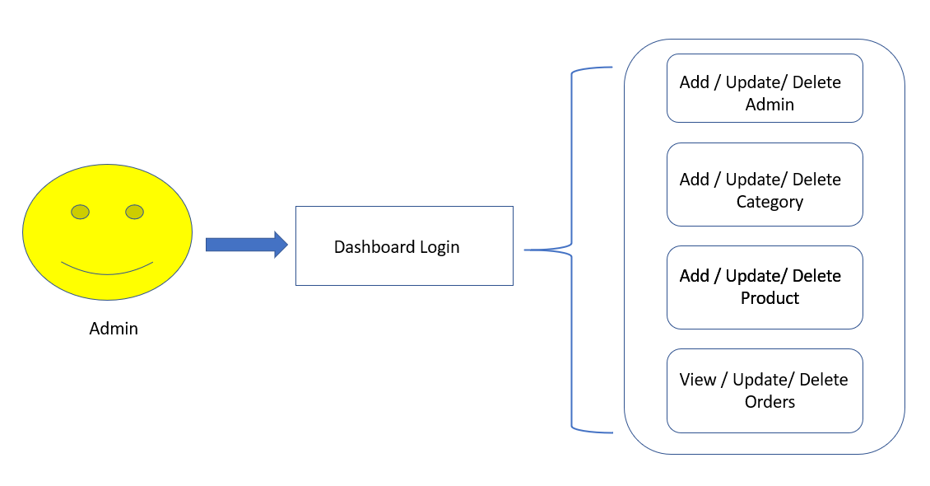

## **4.2 Admin Login Action/View**

**Admin Login Form**

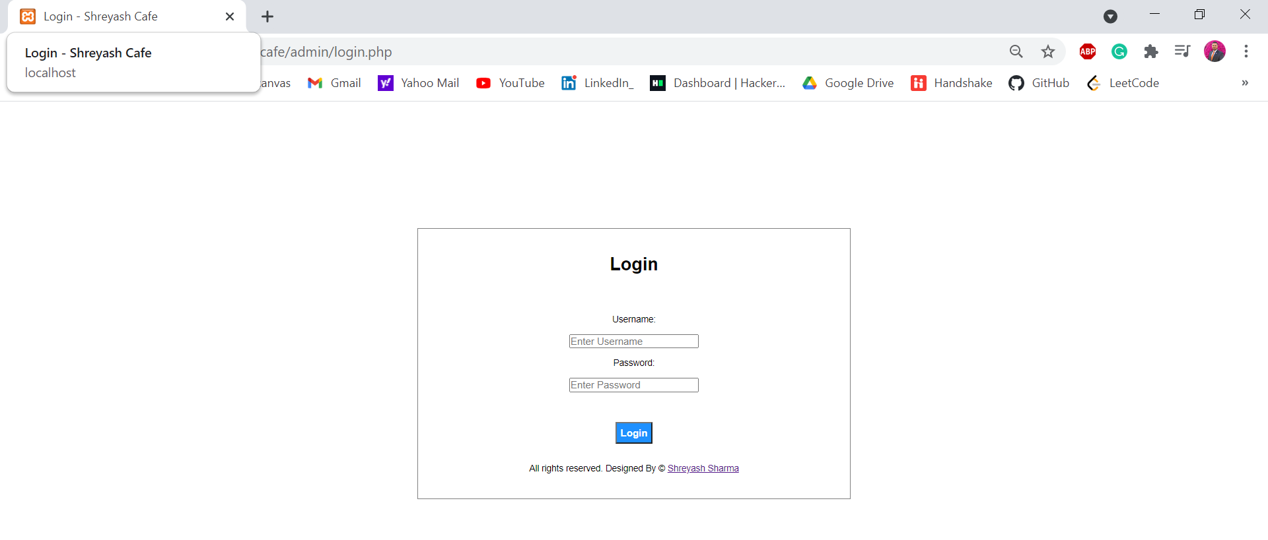

**Admin Dashboard**

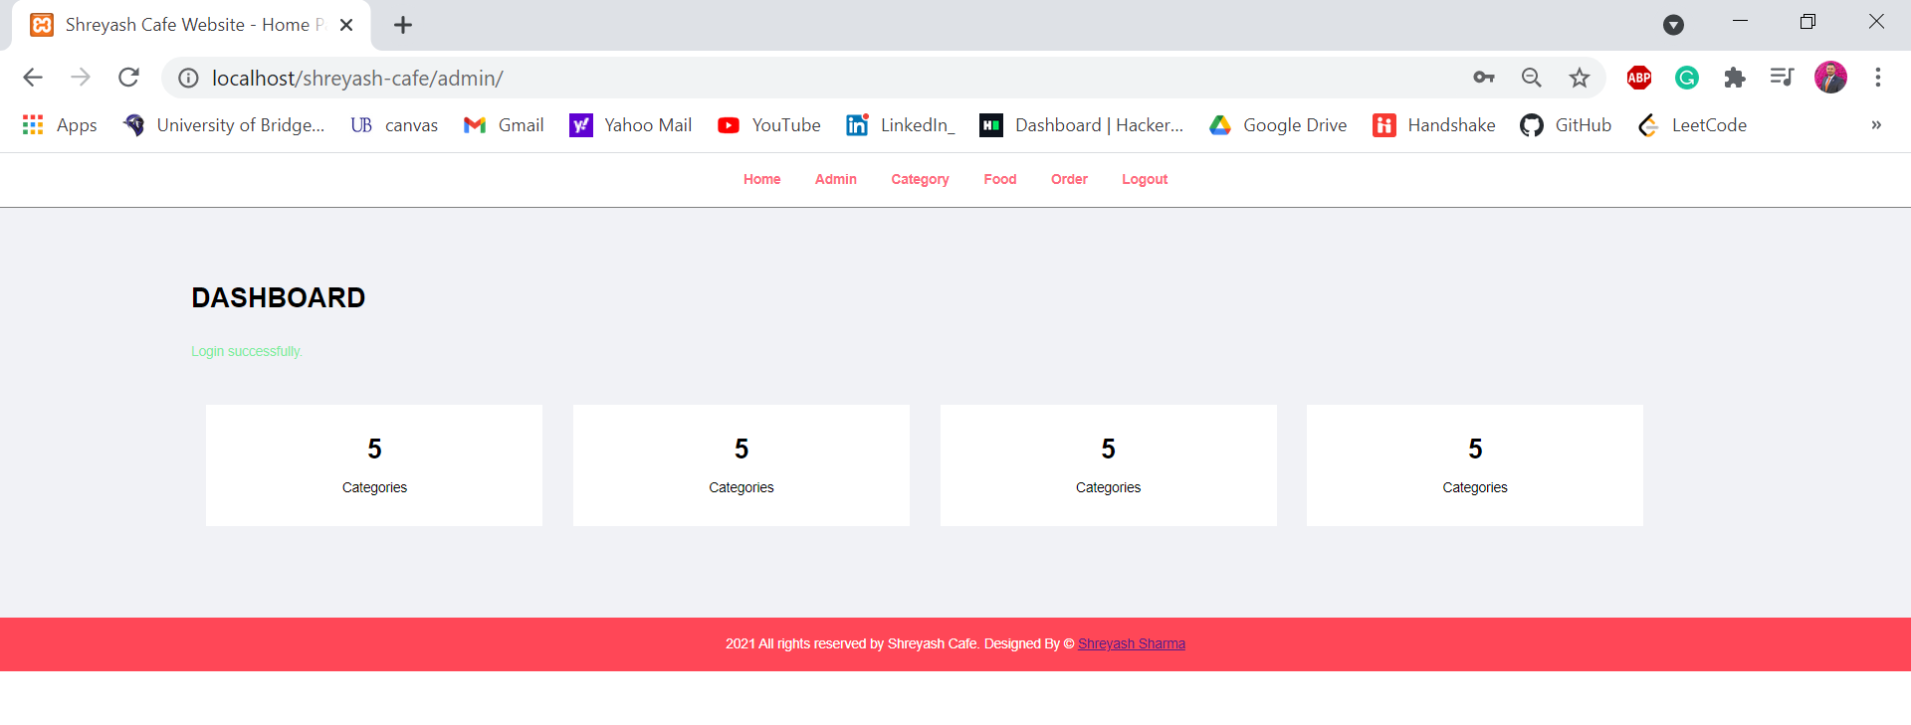

**Manage Admin**

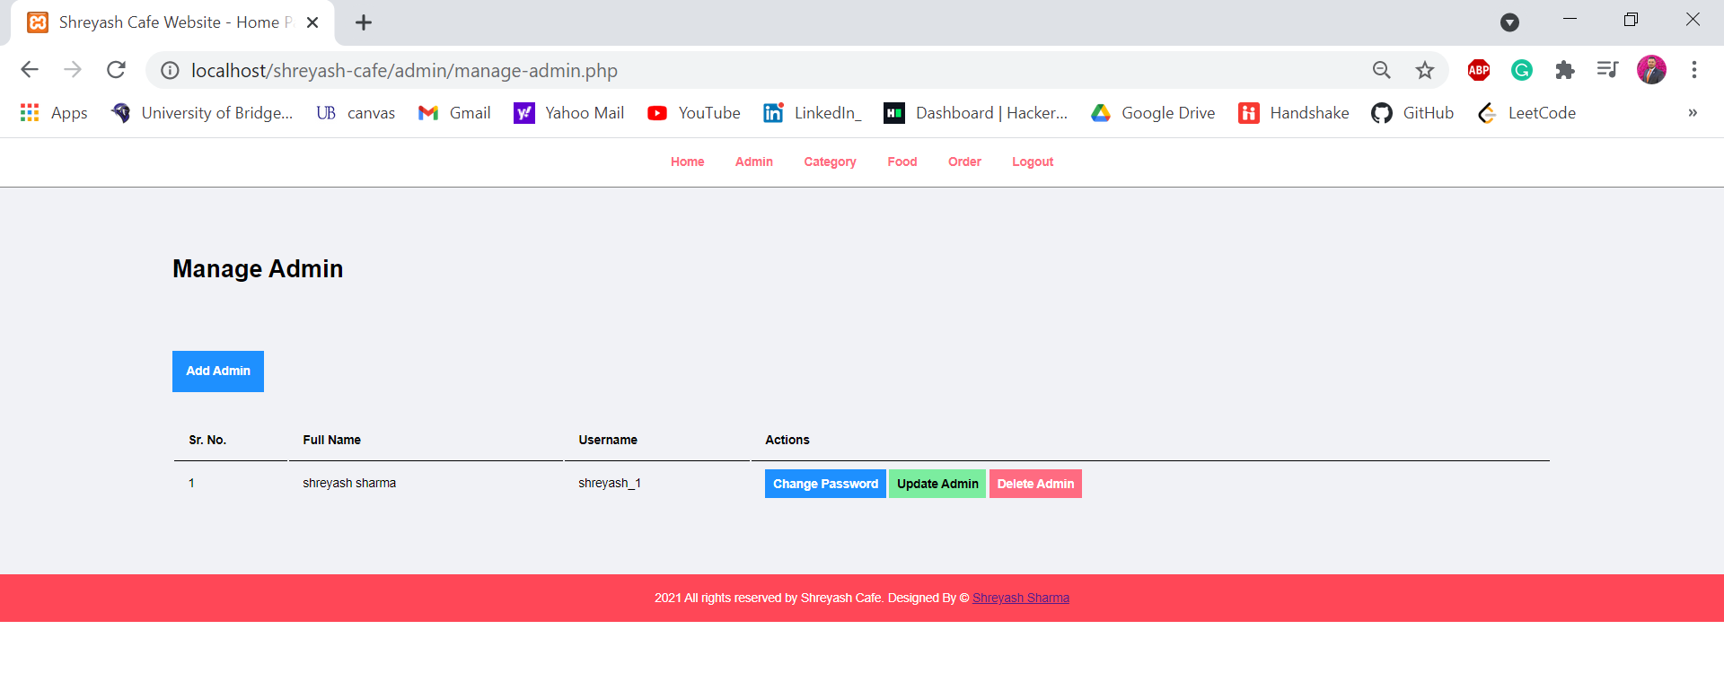

**Manage Categories**

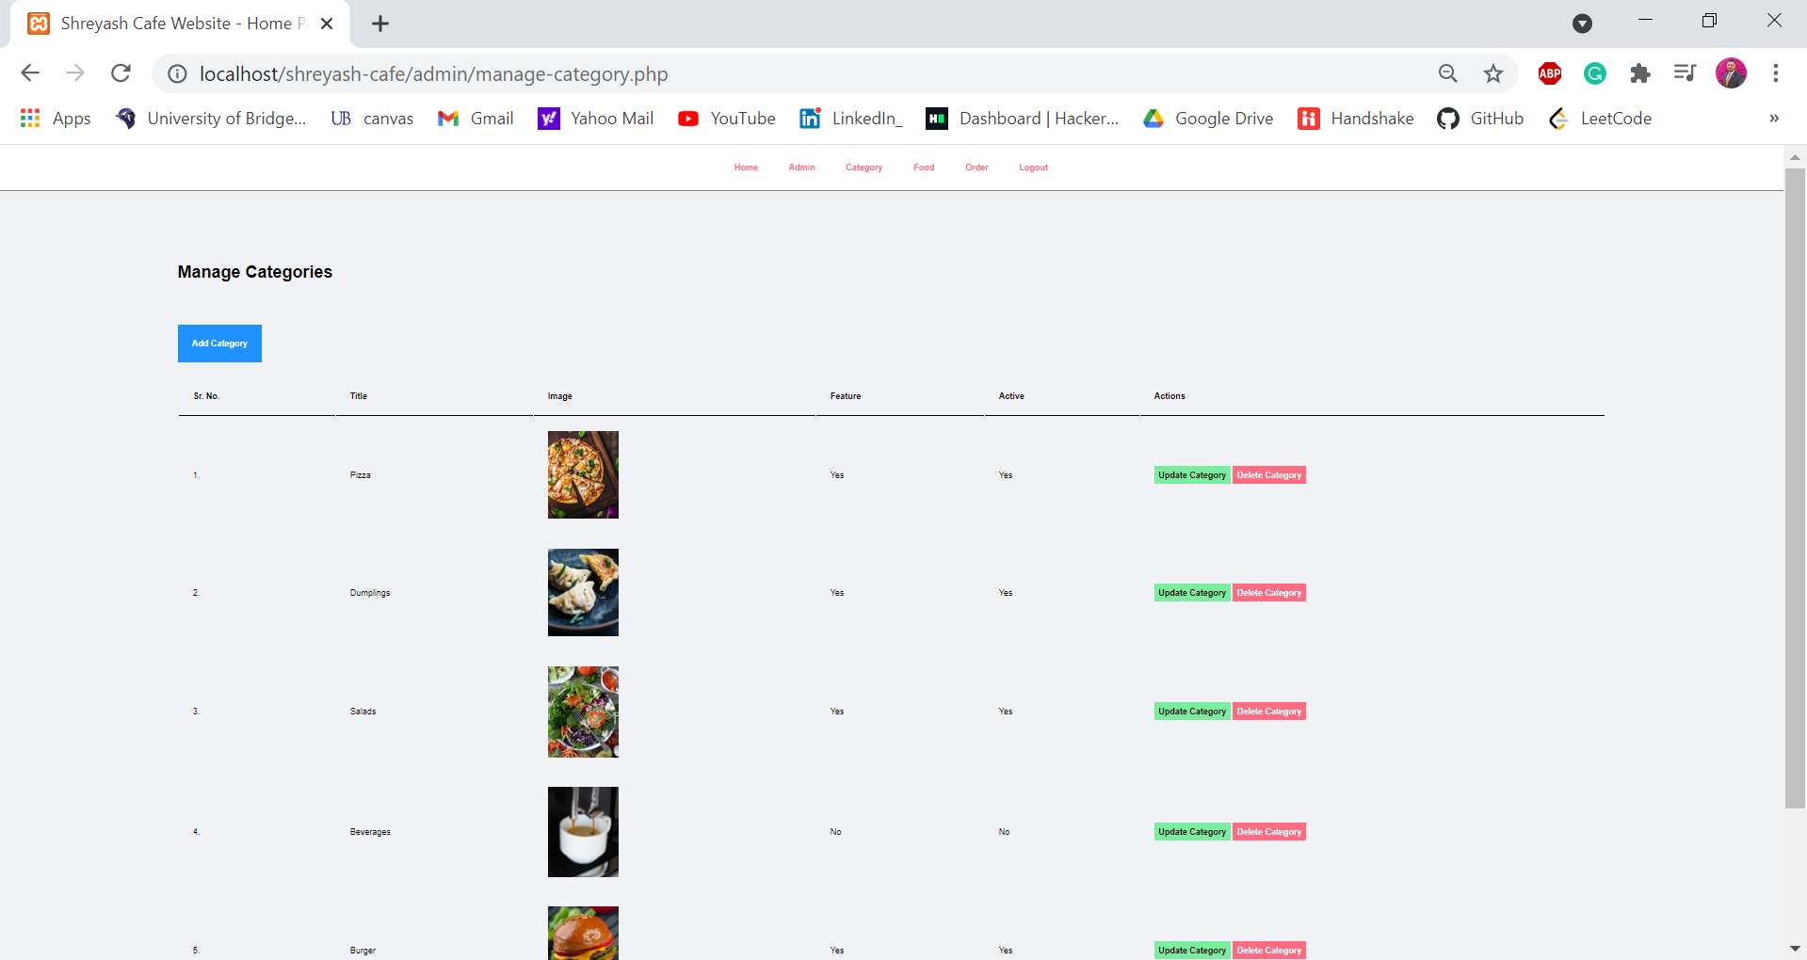

**Manage Food**

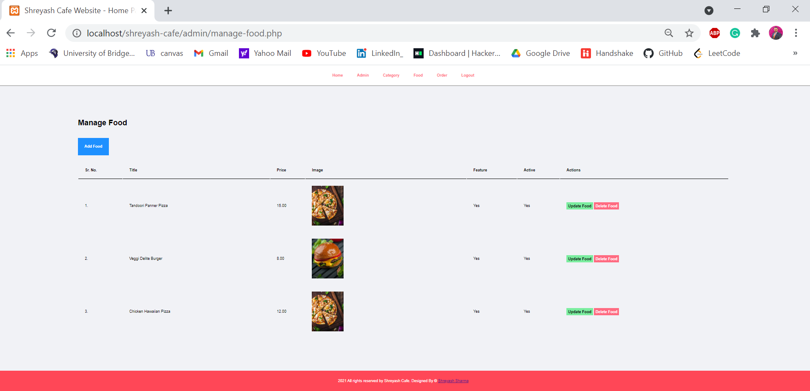

# **5. Customer’s / Visitor’s Role**

**Customer’s / Visitor’s Role:** Customers can visit cafe website. They can do below things,

* Login to website
* Visit restaurant
* Search Product (food)
* Place Order
* Process to Checkout
* Manage his Account
* Logout

## **5.1 Customer Activity Diagram**

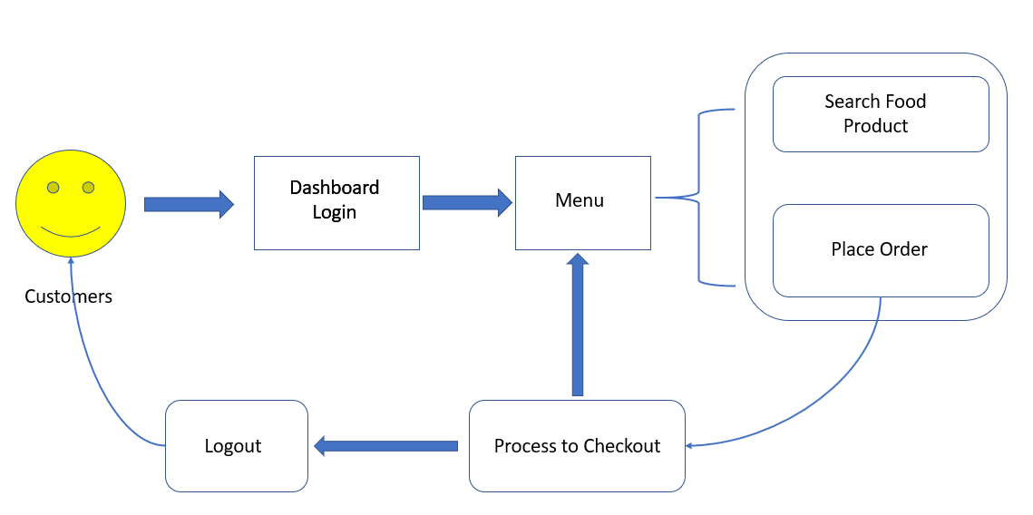

## **5.2 Customers Login Action/View**

**Café Webpage**

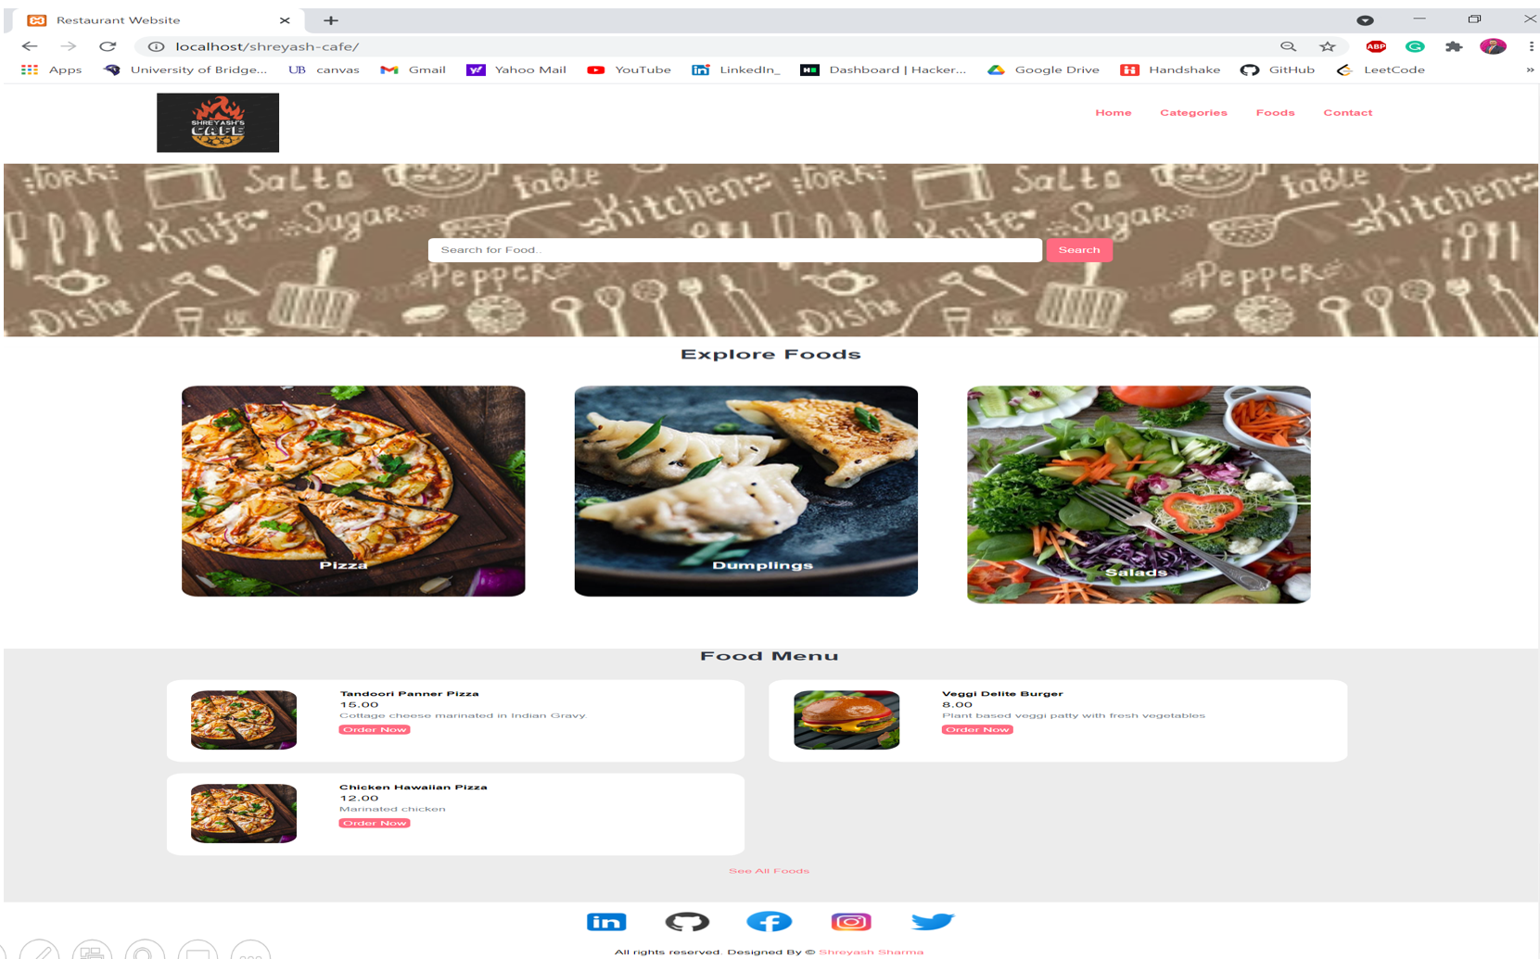

**Customer and Order Details Form**

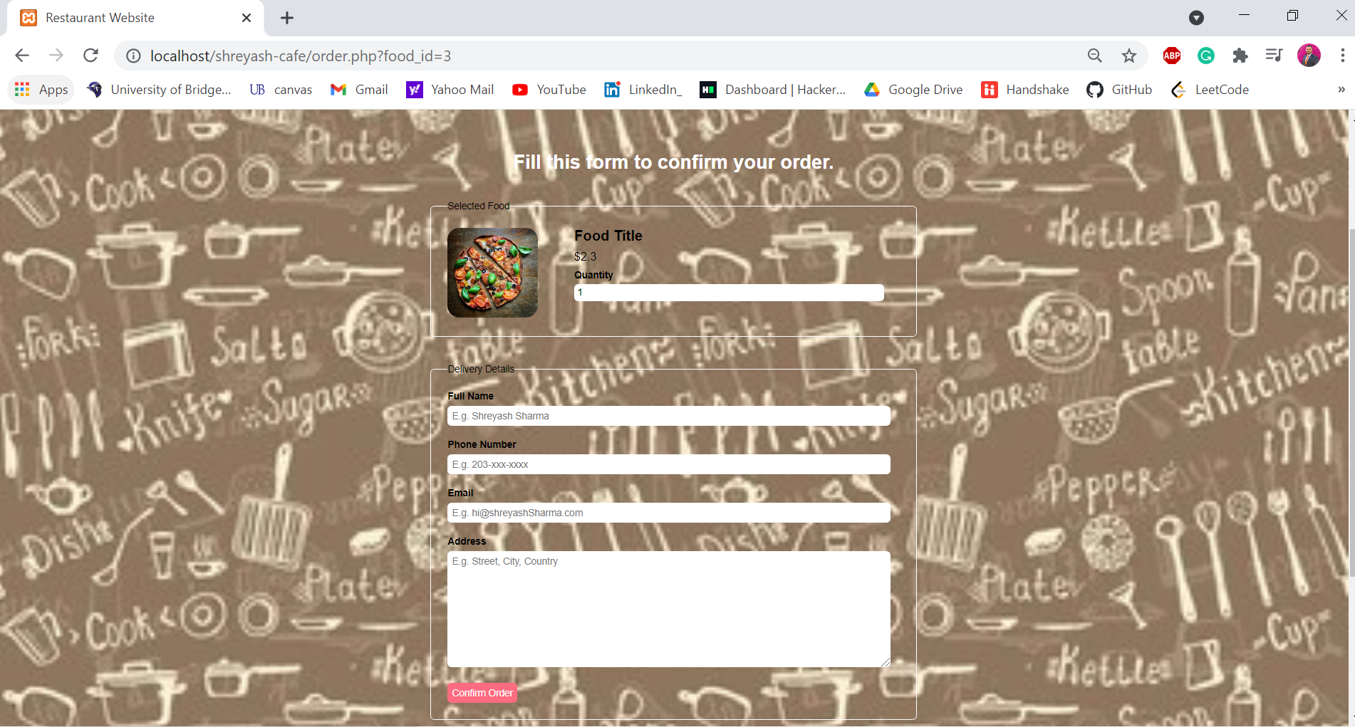

# **6. Data Base**

**ER Diagram**

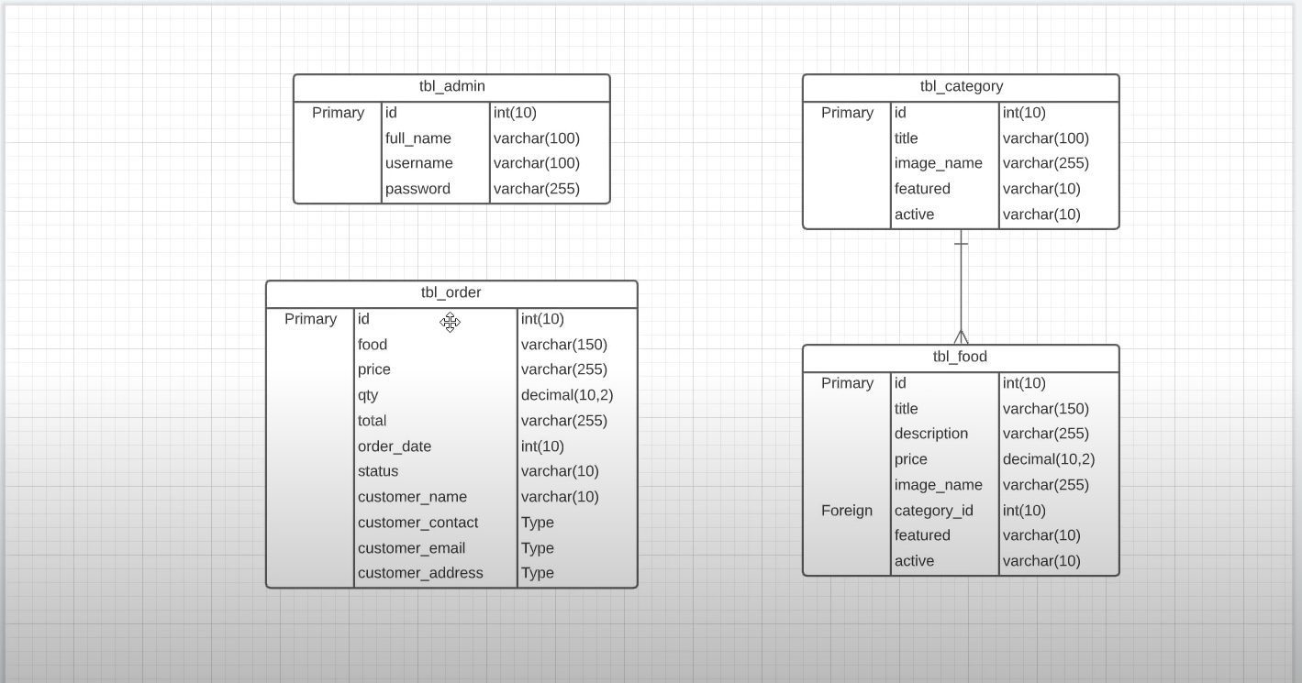

**Create Database using phpMyAdmin**

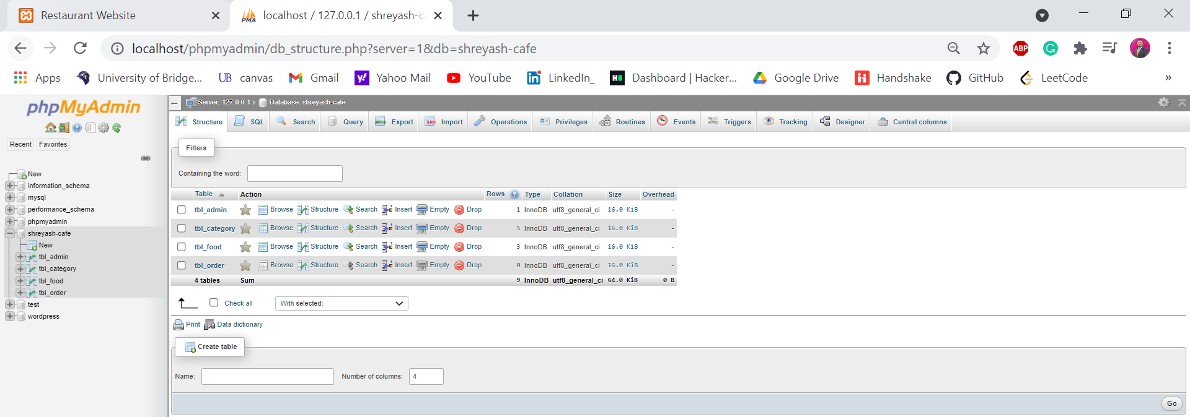

**Admin Table (Query - SELECT * FROM `tbl_admin`)**

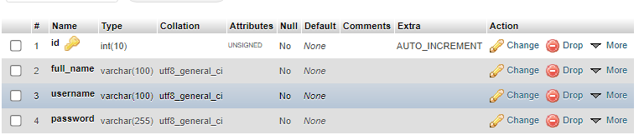

**Category Table (Query - SELECT * FROM `tbl_category` )**

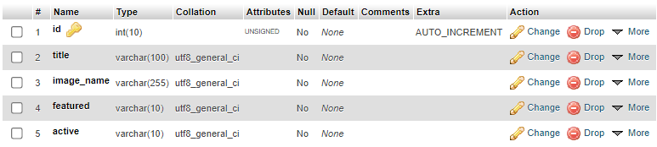

**Food Table (Query -SELECT * FROM `tbl_food` )**

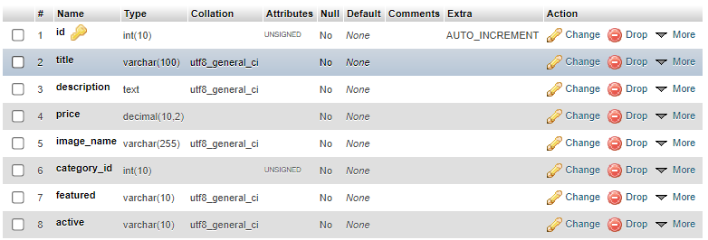

**Order Table (Query - SELECT * FROM `tbl_order`)**

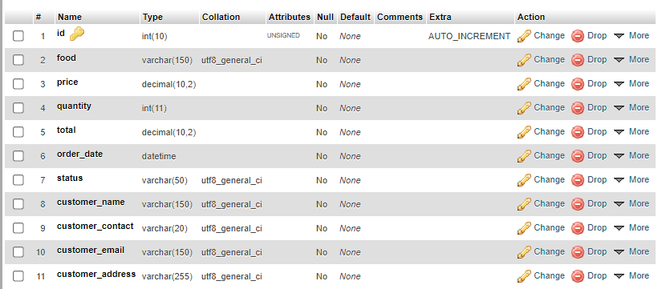

# **7. Conclusion**

Successfully able to complete a responsive café website which taken as a Graduate project. During the Project, I have learned Front end coding using basics HTML + CSS, Back end coding with PHP and, MySQL for Database. Almost all requirements are fulfilled except the order page working and payment setup, work is still in progress.