1. **WRITE UP OF PERTINENT RESULTS**

The underlying question regarding this project is whether college students prefer to watch movies or watch their favorite TV shows in a regular week. The collected data can be analyzed as measures of two different quantities. The first variable is MOVIES, which gives the number of time a person in the collected data watched movies in a week as compared to their favorite TV shows, given by the second variable TV.

For the first variable, the mean was 1.9 with a minimum of 0, a maximum of 5, and a standard deviation of 1.4227220. The lower and upper two-sided 95% confidence interval (CI) for the mean is (1.3687469 < mean < 2.4312531) which means that we can be 95% confident that the actual population mean, µ, is between 1.3687469 and 2.4312531. It seems to have normal distribution based on the histogram of the data collected. However, since a normal distribution has its mean, mode, and median all equal, this is not exactly the case with the first variable. Therefore, we could also say that although the shape of the histogram resembles that of a normal distribution curve, it is, in fact, random. The boxplot of the first variable is tall, which indicates that students hold quite different opinions about watching movies in a regular week. Compared with the second variable, the boxplot of which is not very tall, however, it is quite narrow indicating that maximum values revolve around the median.

For the second variable the mean was 2.9 with a minimum of 0, a maximum of 7, and a standard deviation of 1.8634414. The lower and upper two-sided 95% confidence interval (CI) for the mean is (2.2041796 < mean < 3.5958204) which means that we can be 95% confident that the actual population mean, µ, is between 2.2041796 and 3.5958204. The second variable again seems to have a random distribution based on the data collected and it shows no apparent pattern. The boxplot isn’t as tall as that of the first variable.

An interesting point about both boxplots is that both their interquartile ranges are 2.0 which means that most of the observations fall in that range. All the data collected and analysis conducted shows that college students prefer watching their favorite TV shows more than watching movies.

1. **COPY OF THE SURVEY**



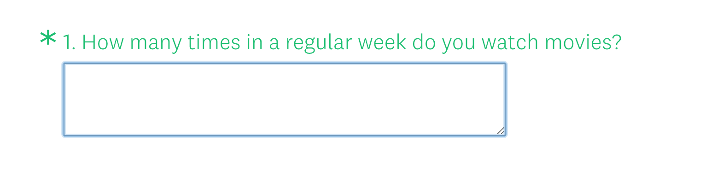

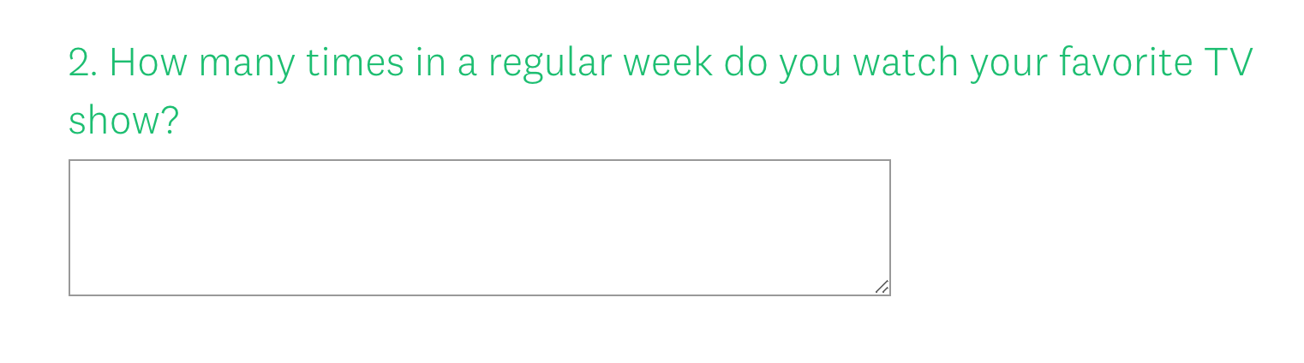

Here is a link to my survey: <https://www.surveymonkey.com/r/3T5W6K8>

1. **SAS CODE**

DATA SURVEY;

INPUT MOVIES TV;

DATALINES;

2 5

2 1

1 0

0 3

0 0

4 4

1 1

1 3

2 0

1 4

1 2

2 3

2 2

3 2

3 1

3 5

0 3

4 7

2 4

1 3

0 2

1 3

2 2

5 7

2 3

5 4

3 5

0 5

1 1

3 2

;

PROC PRINT DATA=SURVEY;

RUN;

PROC MEANS DATA=SURVEY MEAN MODE MEDIAN STD MIN MAX CLM;

RUN;

PROC UNIVARIATE DATA=SURVEY PLOT;

RUN;

PROC FREQ DATA=SURVEY;

RUN;

**OUTPUT/RESULTS**

