# AUTOMATION – AMAZON

This project aims at developing a test automation framework for automating certain functionalities of the web application – Amazon. The test scripts are written in Selenium since it serves as an automated testing suite for web applications across different browsers and platforms. The target is to automate the test cases where an item(book) is searched and the maximum possible attributes of the item is obtained.

**BUILT WITH:**

1. Eclipse IDE
2. Chrome/Mozilla browser
3. Selenium WebDriver 3.14
4. JDK 11
5. TestNG framework
6. Apache maven

Language used: java

**Why Java?**

Though Selenium supports other languages like ruby, python, C#, etc, we opt for java for the reasons that we have good support for selenium in java (help documentations and implementations), is platform independent and profoundly used by Testers in today’s market.

**Why TestNG?**

When we are using Java programming language in Selenium Automation tests, we have to choose either JUnit or TestNG as our Unit Testing Frameworks. Here, TestNG is preferred over JUnit, as TestNG is more powerful and suitable for Selenium. TestNG ranks up because it allows us to,

* Execute the test cases easily
* Prioritize the test cases
* Group the test cases
* Generate logs for the test cases (pass/fail)
* Generate reports

**Why MAVEN?**

Maven is used to define project structure, dependencies, build, and test management. Using pom.xml we can configure dependencies needed for testing and running code. Page Object Model (POM) helps makes the code more readable, maintainable, and reusable. Here is how POM is used in this project.

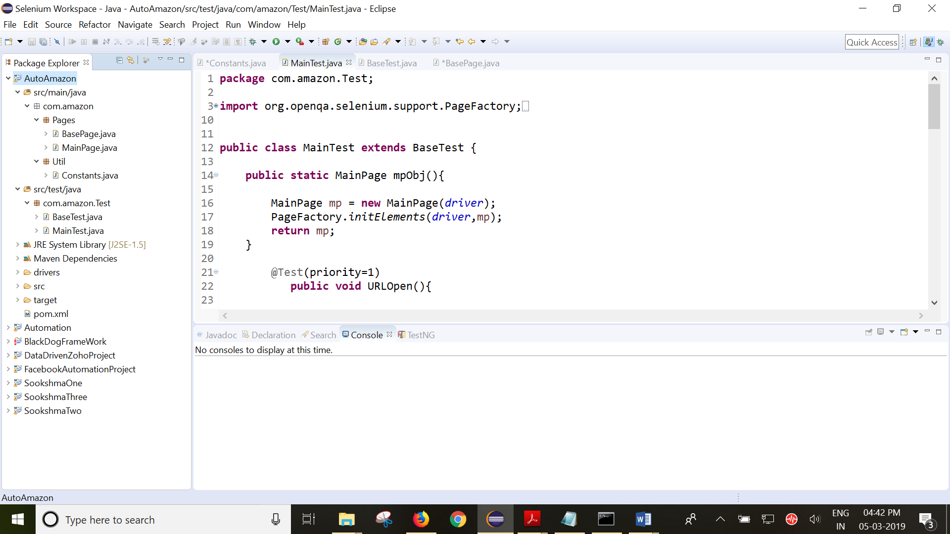

Test classes

Simple POM classes

**Running the tests:**

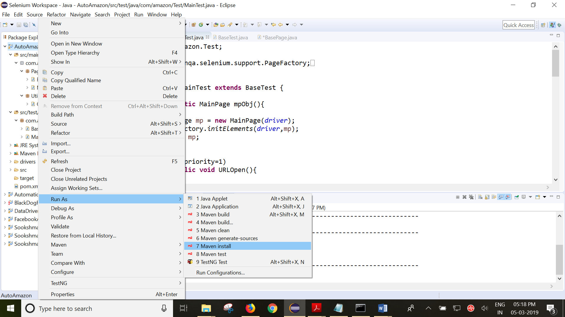

**Results:**

