Control Flow Structure
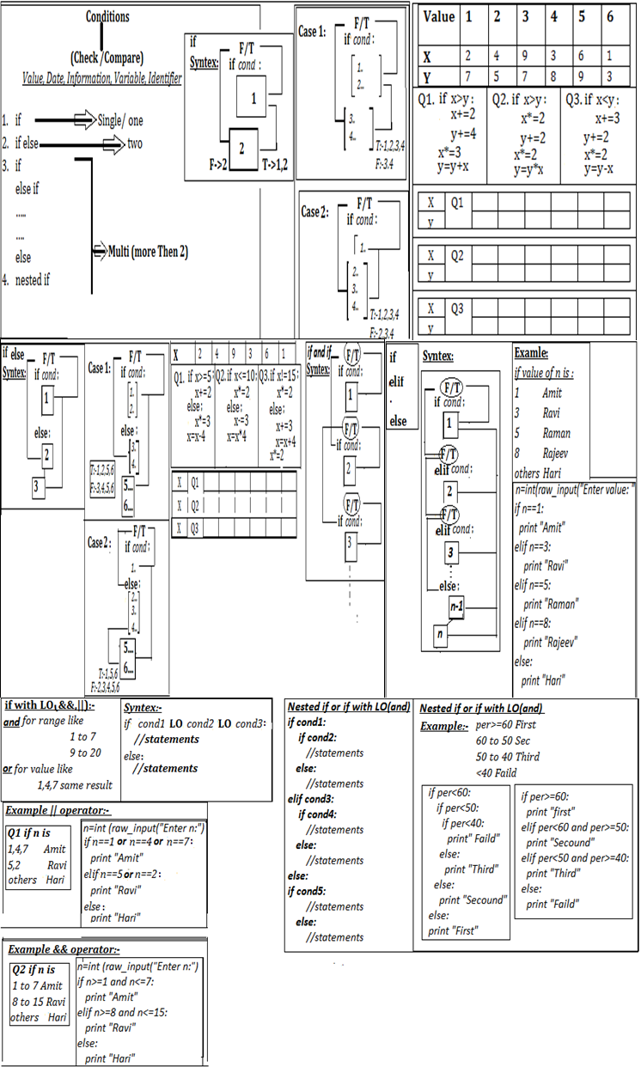
• The reserved word if begins aif statement.
• The condition is a Boolean expression that determines whether or not the body will be executed. A colon (:) must follow the condition.
• The block is a block of one or more statements to be executed if the condition is true. Recall that the statements within a block must all be indented the same number of spaces from the left. The block within an if must be indented more spaces than the line that begins the if statement. The block technically is part of the if statement. This part of the if statement is sometimes called the body of the if.

Syntax:
if condition:
block
Ex.
if x < 10:
y = x
could be written
if x < 10: y = x
but may not be written as
if x < 10:
y = x
if x == 10:
print('ten')
if 1:
print('one')
always prints one, while the statement
if 0:
print('zero')
Syntax:
if condition :
if block
else:
else block
Ex:d1 = 1.11 - 1.10
d2 = 2.11 - 2.10
print('d1 =', d1, ' d2 =', d2)
if d1 == d2:
print('Same')
else:
print('Different')
IF with OR and AND
x <= y and x <= z
x < y or x > y
if x == 1 or 2 or 3:
print("OK")

Condition (If, Switch and Nested)
- WAP to find no is –ve or +ve
- WAP to find no is even and odd
- WAP to find elder person in 2 persons
- WAP to find given year is leap year or not
- WAP to display age is greater than 18 or not
- WAP to find Person is senior citizen or not, input age
- WAP to find which no is greater no in 2 numbers
- WAP to find which no is lowest no in 2 numbers
- WAP to find which no is greater no in 3 numbers
- WAP to find which no is greater no in 4 numbers
- WAP to find which no is lowest no in 3 numbers
- WAP to find which no is lowest no in 4 numbers
- WAP to check whether a number is divisible by 5 and 11 or not.
- WAP to display Digit in text (0 to 9)
- WAP to Check given character is vowel or not.
- Write a menu driven program to calculate:
  - Area of circle[A=πr²]
  - Area of squire [A=a*a]
  - Area of rectangle[A=l*b]
- WAP to Assign a stream to student according:
Marks obtained in diff. subject | Stream
Eng., Maths and Science >=80% | Pure Science
Eng., and Science >=80%, Maths>=60% | Bio. Science
Eng., Maths and Science >=60% | Commerce
- WAP to print the Discount in Rupees for a salesman. The Discount is based on the following conditions
Sales Dis %
<Rs. 5000 5%
Rs. 5000 to Rs. 10000 8%
Above Rs. 10000 10%
[Dis=Sales*<Dis_percentage>)/100] ,[Total Amount=Sales-Dis]
- WAP to print the Income, Tax & Surcharge of Employ. The Tax and Surcharge based on the following conditions
Income Tax % Surcharge
<Rs. 15000 15% 7%
Rs. 15001 to Rs. 20000 18% 11%
Above Rs. 21000 20% 13%
[Total Income =Income- Tax-Surcharge][Tax=Income<Tax_percentage>)/100]display all information like Income, Tax & Surcharge .
- WAP to print the Division :
Per Division
< 40 Failed
40 to 50 Third
50 to 60 Second
>=60 First
- WAP to get input distance and print fare for the passenger according to:
DISTANCE FARE (in Rs.)
Upto 20km 10 P/K
Next 20km 7 P/K
Above 6 P/K
- WAP to for library charges a fine for books returned late. Following are the fines :
First five days : 40 paisa per day.
Six to ten day : 65 paisa per day.
Above ten days : 80 paisa per day
- WAP to for Electric Bill charges according to charges. Following are the fines :
First 100 Units : 1 Rs per day.
Next200 Units : 2 Rs per day.
Above300 Units : 4 Rs per day.
Q1. Given the following definitions: b1, b2, b3, b4 = true, false, x == 3, y < 3 evaluate the following Boolean expressions:
- b3  - b4  - not b1  - not b2  - not b3  - not b4  - b1 and b2  - b1 or b2  - b1 and b3  - b1 or b3  - b1 and b4  - b1 or b4  - b2 and b3  - b2 or b3  - b1 and b2 or b3  - b1 or b2 and b3  - b1 and b2 and b3  - b1 or b2 or b3  - not b1 and b2 and b3  - not b1 or b2 or b3  - not (b1 and b2 and b3)  - not (b1 or b2 or b3)  - not b1 and not b2 and not b3  - not b1 or not b2 or not b3  - not (not b1 and not b2 and not b3)  - not (not b1 or not b2 or not b3) | - True  - False  - False  - True  - False  - True  - 0  - 1  - True  - 1  - False  - 1  - 0  - True  - True  - 1  - 0  - 1  - False  - True  - True  - False  - False  - True  - True  - False

Q2. The following section of code assigns the indicated values to a bool:
x = 10y = 20
b = (x == 10) # assigns True to b
b = (x != 10) # assigns False to b
b = (x == 10 and y == 20) # assigns True to b
b = (x != 10 and y == 20) # assigns False to b
b = (x == 10 and y != 20) # assigns False to b
b = (x != 10 and y != 20) # assigns False to b
b = (x == 10 or y == 20) # assigns True to b
b = (x != 10 or y == 20) # assigns True to b
b = (x == 10 or y != 20) # assigns True to b
b = (x != 10 or y != 20) # assigns False to b
Q3. Given the following definitions: x, y, z = 3, 5, 7 evaluate the following Boolean expressions:
- x == 3
- x < y
- x >= y
- x <= y
- x != y - 2
- x < 10
- x >= 0 and x < 10
- x < 0 and x < 10
- x >= 0 and x < 2
- x < 0 or x < 10
- x > 0 or x < 10
x < 0 or x > 10
Q4. Express the following Boolean expressions in simpler form; that is, use fewer operators. x is an integer.
- not (x == 2)
- x < 2 or x == 2
- not (x < y)
- not (x <= y)
- x < 10 and x > 20
- x > 10 or x < 20
- x != 0
- x == 0
Q5.Consider the following Python code fragment:
What will the code print if the variables i, j, and k have the following values?
(a) i is 3, j is 5, and k is 7
(b) i is 3, j is 7, and k is 5
(c) i is 5, j is 3, and k is 7
(d) i is 5, j is 7, and k is 3
(e) i is 7, j is 3, and k is 5
(f) i is 7, j is 5, and k is 3
Q7. Consider the following Python program that prints one line of text:
What will the program print if the user provides the following input?
    - 3 (b) 21 (c) 5 (d) 17 (e) -5

Assignment 2:
- Convert the given statement into if statement

- ans =res>365?500/10:300/10
- comm=amount>=200?amount*.40:amount*.20
- k=x<=100?101:11;
- y=res>=500?12*2:22+3;
- res=x>=110?20*2:30+2;
- k=x<y?x+=10:y+=13;
- Rewrite the following code using ternary operator.

- age =20
if age>=18: res=1
else: res=0
- if x>5: y=x+2
else: y=x-2
- if sales>25000:
amt=sales*20.0/100.0
else: amt=sales*10.0/100.0
- if marks>200: res= ‘p’
else: char res= ‘f’
- if c>100: c+=2
else: c*=3
- if c== ‘a’: res= ‘v’
else: res= ‘n’

Find Output:
  - ch=input(“Enter Your Choice: “)
if x==’a’ : m*=2
elif x==’c’ : m/=2
elif x==’d’: m+=3
else: m*=3
print (“The Value of M is ”,m)
Result after execution if:
x | ‘a’ | ‘c’ | ‘g’ | ‘d’
m | 6 | 3 | 7 | 9
  - ch=input(“Enter Your Choice: “)
if ch= = ‘a’ : print(“Grade I”););
elif ch= = ‘b’ or ch== ‘d’:
print (“Grade II”););
else: print( “Invalid for Grade I & II”);
Result after execution if:
x | ‘d’ | ‘h’ | ‘g’ | ‘a’
  - in=int(input(“Enter Value of in: “))
col=int(input(“Enter Value of col: “))
if in==5:
col=col+1;
print (“The Col is ”,col)
elif in==10:
col=col*2;
print (“The col is “,col);
else:
col=col+4
print(“The Col is ”,col);
Result after execution if:
in | 6 | 5 | 10 | 9
col | 16 | 4 | 7 | 2
  - a=int(input(“Enter Value of a: ”))
if a==1:
a=a*a
print(“The Value of a: ”,a)
elif a==3 or a==4 or a==5:
a=a*3
printf(“The Value of a:”,a)
elif a==6 or a==7 or a==8:
a=a*4
printf(“The Value of a:”,a)
else:
a=a+a
print(“The Value of a:”,a)
Result after execution if:
a | 2 | 7 | 9 | 7 | 13
  - a=int(input(“Enter Value of a: “))
b=int(input(“Enter Value of b: “))
if (a<b or a>5)>10: print(“The Value of a is : ”,a)
else: print(“The Value of b is :”,b)
Result after execution if:
a | 4 | 12 | 10 | 5
b | 6 | 3 | 7 | 9
  - x=int(input(“Enter Value of x : “))
y=int(input(“Enter Value of y : “))
if x>5:
if y>5:
print(“The Value of y is :”,y)
else:
print (“The Value of x is :”,x)
x | 4 | 12 | 10 | 5
y | 6 | 3 | 7 | 9
  - p=int(input(“Enter Value of a: ”))
if p>0:
print(p,“is -VE”)
else:
print(p,“ is +VE ”)
Result after execution if:
p | 2 | -7 | 9 | 7 | -13
  - i=int(input(“Enter Value of a: ”))
if i==2:
print(“The I is ”,i)
i+=2
if i<51: print(“\n Thanks”)
Result after execution if:
i | 2 | 67 | 19 | 7 | 24
  - if a>=150:
b=b+100
c+=200
else:
b=b-40
c-=100
print(“ a is “,a,” ,b is ”,b, “ and c is ”,c)
a | 200 | 600 | 100 | 200 | 240
b | 300 | 400 | 200 | 200 | 340
c | 200 | 300 | 100 | 200 | 330

