|  |  |
| --- | --- |
| **Name** | Sharmaine R. Panayas |
| **Section** | IT41S3 |

**Instructions**:

1. This is an individual work.
2. Submit your work with the following filename format: **Week2_Activity1_Lastname_Firstname.pdf**
3. Make sure to have **references in APA format**.
4. Do not change the format.

**Activity**

1. Explain in detail the function of the Arithmetic Logic Unit. You must have at least two paragraphs (4 – 5 sentences per paragraph). Provide an example of computation.

Arithmetic Logic Unit (ALU) is one of the three (3) basic components of a Central Processing Unit (CPU). The Arithmetic Logic Unit is responsible for performing and carrying out arithmetic and logic. The majority of a CPU's procedures are performed by one or more Arithmetic Logic Units, which read data from input registers. The control unit is responsible for telling the Arithmetic Logic Unit on what operation is needed to perform on that data and the result will be stored in an output register.

Arithmetic Logic Unit performs basic arithmetic and logic operations. The basic arithmetic operation it performs are addition, subtraction, multiplication, and division. For logical operations, NOT, AND, and OR. Basic arithmetic and logic operations basic arithmetic and logic operations.

All data that is stored in a computer is manipulated in the form of binary numbers, 0 and 1. To transform data into binary numbers, transistor switches are used. There are two states of a switch which represent a binary number. An open transistor switch represents a 0, it means that there is no current. While a closed transistor switch represents 1, it means there is a current.

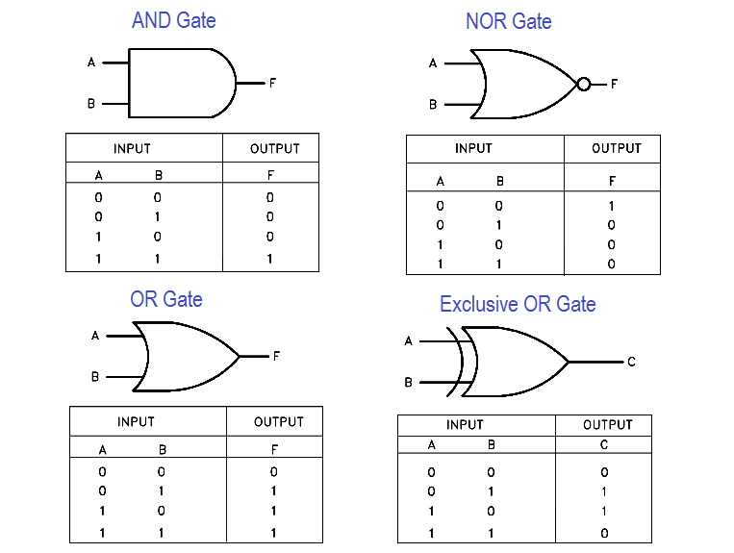Here is an example of Arithmetic Logic Unit computation, I will be based on the image below.

|  |  |  |
| --- | --- | --- |
| **A** | **B** | **Output** |
| 0 | 0 | 0 |
| 1 | 0 | 1 |
| 0 | 1 | 0 |
| 1 | 1 | 1 |

Logic Operation follows a simple process, if input A is 0 and input B is 1, the output is 0. Same output vice versa. If both A and B input is 0, the output is 0. If both A and B input is 1, the output is 1.

2. How the CU works?

Control Unit (CU) is also one of the basic components on how the Central Processing Unit (CPU) works. The function of the Control Unit is to let the peripherals of the computer to know on how to respond to instructions received from a program. The said peripherals are the computer’s logic unit, memory, and both input and output devices. The Control Unit transmits direct operations in a CPUs and GPUs.

It works by receiving data from input devices that it transforms into control signal. It decodes the instruction into commands and those commands will be sent to the CPU. The processor of the computer then instructs the associated hardware on what operations to perform. The functions of a control unit are determined by the type of CPU.

3. How the I/O works?

I/O (Input/Output) devices are type of devices that transfers data on a device and displays it. It is categorized by two types, the Input devices and Output devices. Input devices is any hardware device that is used to send data to a computer, for example a keyboard. On the other hand, Output Devices is any hardware that receives data from the input device, for example a monitor. A single device can also be an input/output device such as Headsets.

I/O (Input/Output) devices works by transmitting data to a computer using an input device and receiving the data using an output device and displays the output of it. There are three (3) approaches on how the CPU communicates to the I/O devices: Special Instruction I/O, Memory-mapped I/O, and Memory-mapped I/O. Special Instruction I/O, this type of approach is specifically made for controlling I/O devices, the instructions enable data to be delivered to an I/O device and received from an I/O device. Memory-mapped I/O, the memory and I/O devices share the same address space. Direct Memory Access (DMA), this approach allows the I/O devices to transmit and receive data directly from the main memory.

**Honor Pledge**

“I affirm that I have not given or received any unauthorized help on this assignment and that this work is my own.”

**Panayas, Sharmaine R.**

**References:**

*Arithmetic Logic Unit (ALU): Definition, Design & Function*. (2015, May 22). Study.Com. https://study.com/academy/lesson/arithmetic-logic-unit-alu-definition-design-function.html

Computer Hope. (2020, June 29). *What is a Control Unit?* https://www.computerhope.com/jargon/c/contunit.htm

Editorial Staff. (2018, November 1). *Logic Gates and Truth tables*. Inst Tools. https://instrumentationtools.com/logic-gates-and-truth-tables/

Hanna, K. T. (2021, August 9). *arithmetic-logic unit (ALU)*. WhatIs.Com. https://www.techtarget.com/whatis/definition/arithmetic-logic-unit-ALU

*Operating System - I/O Hardware*. (n.d.). Tutorialspoint. https://www.tutorialspoint.com/operating_system/os_io_hardware.htm#:%7E:text=I%2FO%20device%20operates%20asynchronously,devices%20like%20disks%2C%20communication%20interfaces.