AWT:

import java.awt.*;
import java.awt.event.*;

public class AWTCardigram extends Canvas implements Runnable {

int[] ecg = {0,0,5,10,5,0,-5,-20,60,-25,0,10,5,0,0};
int move = 0;

public AWTCardigram() {
new Thread(this).start();
}

public void paint(Graphics g) {

int w = getWidth(), h = getHeight(), mid = h / 2;

g.setColor(Color.WHITE);
g.fillRect(0, 0, w, h);

g.setColor(new Color(255,180,180));
for (int i = 0; i < w; i += 20) g.drawLine(i, 0, i, h);
for (int i = 0; i < h; i += 20) g.drawLine(0, i, w, i);

g.setColor(new Color(255,120,120));
for (int i = 0; i < w; i += 100) g.drawLine(i, 0, i, h);
for (int i = 0; i < h; i += 100) g.drawLine(0, i, w, i);

g.setColor(Color.BLACK);
for (int x = -move, i = 0; x < w; x += 8, i++)
g.drawLine(x, mid - ecg[i % ecg.length],
x + 8, mid - ecg[(i + 1) % ecg.length]);
}

public void update(Graphics g) { paint(g); }

public void run() {
while (true) {
move = (move + 2) % (ecg.length * 8);
repaint();
try { Thread.sleep(30); } catch (Exception e) {}
}
}

public static void main(String[] args) {
Frame f = new Frame("ECG using AWT");
f.add(new AWTCardigram());
f.setSize(1000, 500);
f.setVisible(true);
f.addWindowListener(new WindowAdapter() {
public void windowClosing(WindowEvent e) { System.exit(0); }
});
}
}

OUTPUT:
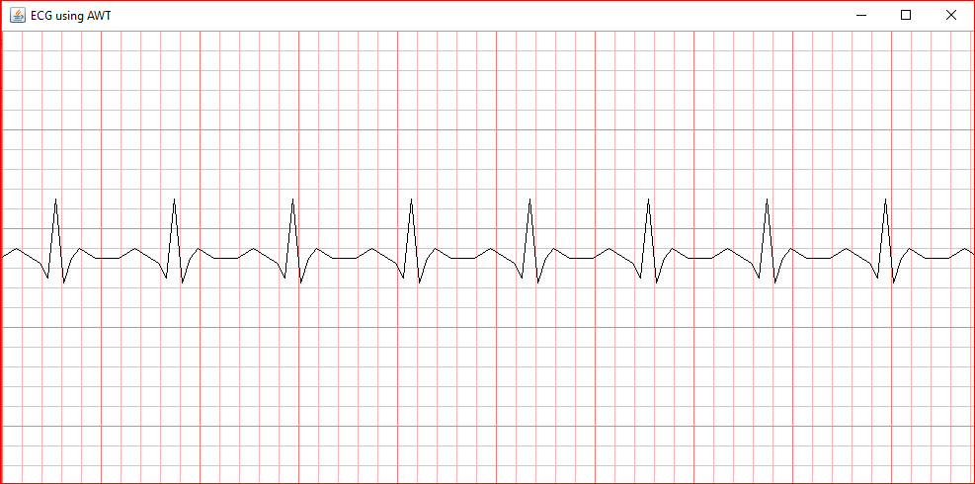

SHAPES:

import java.awt.*;
import java.awt.event.*;

public class MovingBicycle extends Frame implements Runnable {

int x = 50;
int angle = 0;
Thread t;

MovingBicycle() {
setTitle("Bold Handle Bicycle Animation");
setSize(800, 400);
setVisible(true);

t = new Thread(this);
t.start();

addWindowListener(new WindowAdapter() {
public void windowClosing(WindowEvent e) {
System.exit(0);
}
});
}

public void paint(Graphics g) {

setBackground(new Color(173, 216, 230)); // sky

int y = 220;

// ----- Wheels (Bold Blue) -----
g.setColor(Color.blue);
drawBoldOval(g, x, y, 100, 100);
drawBoldOval(g, x + 200, y, 100, 100);

// Spokes
g.setColor(Color.gray);
drawSpokes(g, x + 50, y + 50);
drawSpokes(g, x + 250, y + 50);

// ----- Frame (Bold Red) -----
g.setColor(Color.red);
drawBoldLine(g, x + 50, y + 50, x + 150, y - 20);
drawBoldLine(g, x + 150, y - 20, x + 250, y + 50);
drawBoldLine(g, x + 100, y + 50, x + 200, y + 50);
drawBoldLine(g, x + 150, y - 20, x + 130, y + 50);

// ----- Seat (Bold Black) -----
g.setColor(Color.black);
drawBoldLine(g, x + 120, y - 40, x + 180, y - 40);

// ----- LONG HANDLEBAR (Bold Green) -----
g.setColor(Color.green);
drawBoldLine(g, x + 250, y + 50, x + 300, y - 30);
drawBoldLine(g, x + 260, y - 30, x + 340, y - 30);

// ----- Pedal (Bold Magenta) -----
g.setColor(Color.magenta);
drawPedal(g, x + 150, y + 50);
}

// ----- Bold Line -----
void drawBoldLine(Graphics g, int x1, int y1, int x2, int y2) {
g.drawLine(x1, y1, x2, y2);
g.drawLine(x1+1, y1+1, x2+1, y2+1);
}

// ----- Bold Oval -----
void drawBoldOval(Graphics g, int x, int y, int w, int h) {
g.drawOval(x, y, w, h);
g.drawOval(x+1, y+1, w, h);
}

void drawSpokes(Graphics g, int cx, int cy) {
double rad = Math.toRadians(angle);
int r = 40;

g.drawLine(cx, cy,
cx + (int)(r * Math.cos(rad)),
cy + (int)(r * Math.sin(rad)));

g.drawLine(cx, cy,
cx - (int)(r * Math.cos(rad)),
cy - (int)(r * Math.sin(rad)));
}

void drawPedal(Graphics g, int cx, int cy) {
double rad = Math.toRadians(angle);
int r = 30;

int px = cx + (int)(r * Math.cos(rad));
int py = cy + (int)(r * Math.sin(rad));

drawBoldLine(g, cx, cy, px, py);
g.fillRect(px - 6, py - 4, 12, 8);
}

public void run() {
while (true) {
x += 5;
angle += 15;

if (x > 800)
x = -300;

repaint();

try {
Thread.sleep(100);
} catch (Exception e) {}
}
}

public static void main(String[] args) {
new MovingBicycle();
}
}

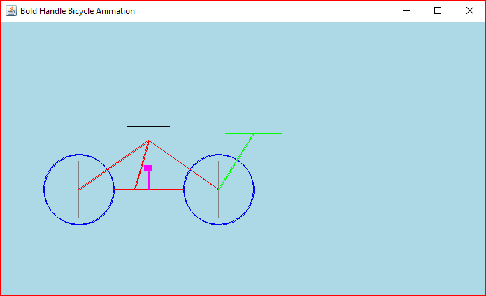

APPLET:

import java.applet.Applet;
import java.awt.*;
import java.awt.event.*;
public class HelloApplet extends Applet implements ActionListener {

Button option1, option2, option3, option4;
Choice showAnswerChoice;
Label answerLabel;
Color feedbackColor = Color.RED;

String correctAnswer = "Java";
String feedbackMessage = "";

@Override
public void init() {
setLayout(null);
option1 = new Button("C++");
option2 = new Button("Python");
option3 = new Button("Java");
option4 = new Button("HTML");

Button[] options = { option1, option2, option3, option4 };
int x = 80, y = 110;
for (int i = 0; i < options.length; i++) {
options[i].setBounds(x, y, 120, 35);
options[i].addActionListener(this);
options[i].setBackground(new Color(255, 220 - i * 30, 180));
add(options[i]);

if (i % 2 == 0)
x = 240;
else {
x = 80;
y += 45;
}
}
}

// 🎨 Gradient + Text Drawing
@Override
public void paint(Graphics g) {
Graphics2D g2 = (Graphics2D) g;

// Gradient background
GradientPaint gp = new GradientPaint(
0, 0, new Color(33, 147, 176),
0, getHeight(), new Color(109, 213, 237)
);
g2.setPaint(gp);
g2.fillRect(0, 0, getWidth(), getHeight());

// Heading
g2.setFont(new Font("Arial", Font.BOLD, 22));
g2.setColor(Color.WHITE);
g2.drawString("Java Quiz Applet", 550, 40);

// Question
g2.setFont(new Font("Arial", Font.BOLD, 16));
g2.setColor(Color.BLACK);
g2.drawString(
"Which language is used to write Java applets?",
40, 80
);
// Feedback
g2.setColor(feedbackColor);
g2.drawString("Feedback: " + feedbackMessage, 40, 250);
}

@Override
public void actionPerformed(ActionEvent e) {
if (e.getActionCommand().equals(correctAnswer)) {
feedbackMessage = "Correct Answer!";
feedbackColor = Color.GREEN;
} else {
feedbackMessage = "Wrong Answer! Try again.";
feedbackColor = Color.RED;
}
repaint();
}
}

