ENHANCED CHOLEDOCH DETECTION USING DEEP LEARNING TECHNIQUES

PROJECT REPORT
Submitted by

PRASANNA DEVI M
(REG. NO: 22BSR040)

SHARMILA R
(REG. NO: 22BSR053)

NIKITHAA M
(REG. NO: 22BSR062)

in partial fulfilment of the requirements for the
award of the degree of

BACHELOR OF SCIENCE IN SOFTWARE SYSTEMS

DEPARTMENT OF COMPUTER TECHNOLOGY -UG
KONGU ENGINEERING COLLEGE
(Autonomous)

PERUNDURAI ERODE – 638060

MARCH 2025

DEPARTMENT OF COMPUTER TECHNOLOGY-UG
KONGU ENGINEERING COLLEGE
(Autonomous)
PERUNDURAI ERODE-638060
MARCH 2025

BONAFIDE CERTIFICATE

This is to certify that the project report titled is the approved record of work done by PRASANNA DEVI.M (REG.NO:22BSR040) SHARMILA.R (REG.NO:22BSR053) NIKITHAA.M (REG.NO:22BSR062) in partial fulfillment for the award of Degree of Bachelor of Science in Software Systems of Anna University Chennai during the year 2024-2025.
1.
2.

SUPERVISOR HEAD OF THE DEPARTMENT
(Signature with seal)

Date:
Submitted for the end semester viva-voce examination held on _____________

INTERNAL EXAMINER EXTERNAL EXAMINER

DECLARATION

We affirm that the project report titled “ENHANCED CHOLEDOCH CANCER DETECTION USING DEEP LEARNING TECHNIQUES” being submitted in partial fulfilment of the requirements for the award of B.Sc. degree in Software Systems is the original work carried out by us. It has not formed the part of any other project submitted for award of any degree, either in this or any other University.

PRASANNA DEVI M
(REG.NO:22BSR040)

SHARMILA R
(REG.NO:22BSR053)

NIKITHAA M
(REG.NO:22BSR062)

I certify that the declaration made above by the candidates is true to the best of my knowledge.

1.

2.

Date: Signature of the Supervisors

ABSTRACT

Cholangiocarcinoma (CCA) is an aggressive and rare cancer affecting the bile ducts, often diagnosed at advanced stages, leading to poor treatment outcomes. Early detection is critical, yet current diagnostic methods often lack sufficient accuracy, sensitivity, or specificity, leaving significant room for improvement. Advances in deep learning offer potential solutions, as these technologies have demonstrated success in analysing complex medical imaging and biological data to improve diagnostic capabilities.
Previous studies on CCA detection using deep learning algorithms have shown promising results. For example, convolutional neural networks (CNNs) have achieved 72% accuracy in identifying intrahepatic CCA from CT scans, while advanced models reached 96.5% accuracy in predicting postoperative recurrence. The integration of biomarkers, such as clustering, has further enhanced diagnostic performance, achieving an Area Under the Curve (AUC) of 0.947. These findings underscore the potential of leveraging deep learning models but highlight the need for improved systems combining diverse approaches for greater diagnostic accuracy and reliability.
Based on the above studies, we employ deep learning architectures like ResNet50 and EfficientNetB0 for their feature extraction capabilities, and VGG16 and MobileNetV2 for their computational efficiency and scalability. By integrating these models, we aim to develop a robust system capable of detecting CCA at earlier stages. This research highlights the transformative potential of such advanced algorithms to enhance diagnostic mechanisms, improve treatment planning, and ultimately benefit patient outcomes.

ACKNOWLEDGEMENT

We express our sincere thanks to our beloved Correspondent THIRU. A. K. ILANGO B.Com., M.B.A., LLB, and other philanthropic Trust members of the Kongu Vellalar Institute of Technology Trust for having provided necessary resources to complete this project.
We are always grateful to our beloved visionary Principal Dr .V. BALUSAMY B.E (Hons).M.Tech., Ph.D., and thank him for his motivation and moral support.
We express our deep sense of gratitude and profound thanks to Dr . S. KALAISELVI MCA, M.E, Ph.D., Head of the Department, Department of Computer Technology-UG for her invaluable commitment and guidance for this project.
We express our hearty thanks to our Project Coordinator Dr. K. SARASWATHI MSc., MPhil., PhD., and our valuable guides Dr . S. GANDHIMATHI M.A., Ph.D., PGDCA and Ms. N. Kaya MCA for providing valuable guidance and constant support throughout our project. We also thank the teaching, and non-teaching staff members, fellow students, and our parents who stood with us in completing our project successfully.

TABLE OF CONTENTS

CHAPTER NO | TITLE | PAGE NO
 | ABSTRACT | iv
 | LIST OF TABLES | vi
 | LIST OF FIGURES | xi
 | LIST OF ABBREVIATIONS | xii
1 | INTRODUCTION | 1
 | 1.1 OVERVIEW OF THE PROJECT | 1
 | 1.1.1 CHOLEDOCH CANCER | 1
 | 1.1.2 TYPES OF CHOLEDOCH CANCER | 2
 | 1.1.3 DEEP LEARNING | 2
 | 1.2 PROBLEM STATEMENT | 3
2 | LITERATURE SURVEY | 4
3 | SYSTEM SPECIFICATION | 10
 | 3.1 SOFTWARE REQUIREMENTS | 10
 | 3.2 HARDWARE REQUIREMENTS | 10
 | 3.3 TOOLS DESCRIPTION | 10
 | 3.3.1 PYTHON | 11
 | 3.3.2 GOOGLE COLAB | 12
4 | DATASET AND METHODOLOGY | 13
 | 4.1 DATASET DESCRIPTION | 13
 | 4.2 DATASET PREPROCESSING | 14
 | 4.2.1 DATASET PREPARATION | 14
 | 4.2.2 IMAGE AUGMENTATION | 14
 | 4.2.3 IMAGE NORMALIZATION AND RESIZING | 15
 | 4.2.4 DATASET BATCHING | 15
 | 4.3 METHODOLOGY | 16
 | 4.3.1 SIMPLE CNN | 16
 | 4.3.1.1 Applications of Convolutional Neural Network | 17
 | 4.3.1.2 Reasons For Using The Convolutional Neural Network | 17
 | 4.3.1.3 Advantages of Convolutional Neural Network | 17
 | 4.3.2 MOBILENET | 18
 | 4.3.2.1 Applications of MobileNet | 18
 | 4.3.2.2 Reasons For Using MobileNet | 18
 | 4.3.2.4 Advantages of MobileNet | 19
 | 4.3.3 RESNET50 | 19
 | 4.3.3.1 Applications of ResNet50 | 20
 | 4.3.3.2 Reasons For Using ResNet50 | 20
 | 4.3.3.3 Advantages of ResNet50 | 21
 | 4.3.4 EFFICIENTNET | 21
 | 4.3.4.1 Applications of EfficientNet | 22
 | 4.3.4.2 Reasons For Using EffecientNet | 22
 | 4.3.4.3 Advantages of EfficientNet | 22
 | 4.3.5 EFFICIENTNET AND MOBILENETV2 | 22
 | 4.3.5.1 Applications of EfficientNet and MobileNetV2 | 23
 | 4.3.5.2 Reasons For Using EffecientNet and MobileNetV2 | 23
 | 4.3.5.4 Advantages of EfficientNet and MobileNetV2 | 23
 | 4.4 FLOW OF PROPOSED WORK | 24
5 | RESULT ANALYSIS | 26
 | 5.1 PERFORMANCE METRICS | 26
 | 5.2 EXPERIMENTAL SETUP | 27
 | 5.2.1. RESNET50 | 27
 | 5.2.1.1 Data Augmentation for ResNet50 | 27
 | 5.2.1.2 ResNet50 Model Architecture and Training | 28
 | 5.2.1.3 ResNet50 Model Evaluation and Saving | 28
 | 5.2.2 EFFICIENTNETB0 | 29
 | 5.2.2.1 Data Preprocessing and Augmentation for EfficientNetB0 | 29
 | 5.2.2.2 EfficientNetB0 Model Design and Training Process | 29
 | 5.2.2.3 Optimization and Fine-Tuning of EfficientNetB0 | 30
 | - Performance Evaluation of EfficientNetB0 | 30
 | 5.2.3 MOBILENETV2 | 30
 | 5.2.3.1 Data Preprocessing and Augmentation for MobileNetV2 | 30
 | 5.2.3.2 MobileNetV2 Model Design and Training Process | 30
 | 5.2.3.3 Performance Evaluation of MobileNetV2 | 31
 | 5.2.4 SIMPLE CNN (CUSTOM MODEL) | 31
 | 5.2.4.1 Data Augmentation for CNN | 31
 | 5.2.4.2 CNN Model Design and Training Process | 32
 | 5.2.4.3 Performance Evaluation of CNN | 32
 | 5.2.5 HYBRID MODEL: EFFICIENTNETB0 + MOBILENETV2 | 33
 | 5.2.5.1 Data Preprocessing and Augmentation of the Hybrid Model | 33
 | 5.2.5.2 Hybrid CNN Model Architecture | 33
 | - Training Stratergy | 34
 | 5.2.5.4 Performance Evaluation of the Hybrid Model | 34
 | 5.3 RESULTS ANALYSIS | 35
6 | CONCLUSION AND FUTURE ENHANCEMENT | 37
 | 6.1 CONCLUSION | 37
 | 6.2 FUTURE ENHANCEMENTS | 37
 | APPENDIX 1 - SAMPLE CODE | 39
 | APPENDIX 2 – SCREENSHOTS | 50
 | REFERENCES | 59

LIST OF TABLES

TABLE NO | TITLE | PAGE NO
4.3.1 | Classification Report of EfficientNet | 39
4.3.2 | Classification Report of ResNet | 39
4.3.3 | Classification Report of MobileNet | 39
4.3.4 | Classification Report of Simple CNN | 39
4.3.5 | Classification Report of EffecientNet and MobileNet | 39

LIST OF FIGURES

FIGURE NO | TITLE | PAGE NO
4.1 | Sample Microscopic Images | 14
4.2 | Architecture of Simple CNN | 16
4.3 | Architecture of MobileNet | 19
4.4 | Architecture of ResNet | 20
4.5 | Architecture of EfficientNet | 21
4.6 | Workflow of the Proposed Model | 25
5.1 | Accuracy of all the proposed algorithms | 36

LIST OF ABBREVATIONS
ABBREVIATION | EXPANSION
ERCP | Endoscopic Retrograde Cholangiopancreatography
NLP | Natural Language Processing
MP-RAN | Multipath Residual Attention Network
YOLO | You Look Only Once
CNN | Convolutional Neural Network
SAHIS-NET | Spectral Attention and Feature Enhancement Network
RF | Random Forest
ANN | Artificial Neural Network
MBS | Malignant Biliary Structures
DSOC | Digital Single-Operator Cholangioscopy
HSI | Hyperspectral Imaging
SKLEARN | Scikit-learn
ML | Machine Learning
DL | Deep Learning
TP | True Positive
TN | True Negative
FP | False Positive

CHAPTER 1
INTRODUCTION

  - OVERVIEW OF THE PROJECT

Choledoch Cancer

Choledoch cancer, also known as bile duct cancer, arises from the abnormal and uncontrollable growth of cells within the bile ducts, which are part of the digestive system. These ducts carry bile, a fluid essential for digesting fats, from the liver to the small intestine. The cancer can obstruct bile flow, leading to symptoms like jaundice, abdominal pain, nausea, and unintentional weight loss. Choledoch cancer is classified into intrahepatic (within the liver), perihilar (near the liver), or distal (closer to the small intestine) types, depending on its location within the bile duct system.

The exact causes of choledoch cancer are not fully understood, but it is often associated with a combination of genetic and environmental factors. Genetic mutations in bile duct cells can disrupt normal cell division and repair mechanisms, leading to uncontrolled growth. Chronic inflammation of the bile ducts, as seen in conditions like primary sclerosing cholangitis (PSC) or bile duct infections, is a known risk factor. Other contributors include bile duct abnormalities, liver fluke infections, exposure to certain industrial chemicals, and a family history of related cancers.Choledoch cancer progresses through stages, with early detection often being challenging due to nonspecific symptoms.

Diagnosing choledoch cancer typically involves imaging studies like CT scans, MRIs, or specialized procedures such as endoscopic retrograde cholangiopancreatography (ERCP). Blood tests and biopsy are used to confirm the diagnosis and determine the cancer's type and stage.

Treatment is highly personalized and depends on the tumor's location, size, stage, and the patient’s overall health. Surgery is often the primary approach for resectable tumors, aiming to remove the affected bile duct and nearby tissues. Adjuvant therapies like radiation therapy and chemotherapy are employed to target residual cancer cells and prevent recurrence.

Types of Choledoch Cancer

Intrahepatic Cholangiocarcinoma
This type occurs in the bile ducts located within the liver. Though less common, it is often mistaken for liver cancer due to its location. Intrahepatic tumors tend to be more aggressive and challenging to detect early, as symptoms may not appear until the cancer has progressed.

Perihilar Cholangiocarcinoma

Also known as hilar cholangiocarcinoma or Klatskin tumor, this type develops at the junction where the left and right bile ducts exit the liver. It is the most common type of bile duct cancer and often presents with symptoms like jaundice due to bile duct obstruction.

Distal Cholangiocarcinoma

This type occurs in the bile ducts closer to the small intestine. Symptoms such as abdominal pain and jaundice are more common due to its proximity to the gastrointestinal system. Distal tumors are often diagnosed earlier than other types because they can cause noticeable bile flow obstruction.

Deep Learning
Deep learning is a specialized branch of machine learning that uses artificial neural networks with multiple layers to model and solve complex problems. Inspired by the human brain, it enables machines to process and learn from vast amounts of data, identifying patterns and making decisions. Unlike traditional methods, deep learning models automatically extract features from raw data, making them highly effective for unstructured data like images, text, and audio. This approach has revolutionized fields such as computer vision, natural language processing, speech recognition, healthcare, and autonomous systems. Popular tools like TensorFlow, PyTorch, and Keras support its development, driving innovation in AI applications worldwide.
Machine learning is a subset of artificial intelligence that enables systems to learn from data and improve their performance without explicit programming. By using algorithms to analyze data and identify patterns, it can make predictions or decisions, becoming more accurate over time through experience. Widely applied in areas like recommendation systems, fraud detection, speech recognition, and autonomous systems, machine learning powers many modern technologies and drives data-driven innovation across industries.
Natural Language Processing (NLP) is a branch of artificial intelligence that focuses on enabling machines to understand, interpret, and generate human language. It combines computational linguistics with machine learning to process text or speech data, allowing computers to perform tasks such as translation, sentiment analysis, text summarization, speech recognition, and chatbot interactions.

  - PROBLEM STATEMENT
Existing choledoch diagnostic methods often miss early-stage abnormalities, leading to delayed detection and poor outcomes.
- Lack of Accuracy: Existing detection methods may produce false positives or negatives, leading to misdiagnosis and delayed treatment.
- High Dependency on Invasive Procedures: Many diagnostic approaches rely on invasive techniques like ERCP (Endoscopic Retrograde Cholangiopancreatography), which pose risks and discomfort to the patient.
CHAPTER 2
LITERATURE SURVEY

The detection of choledoch cancer has been extensively studied, with various approaches explored to improve early diagnosis and accuracy. Traditional methods such as imaging techniques (MRI, CT scans, and ultrasound) and biopsy-based histopathological analysis remain the standard diagnostic tools. However, recent advancements in artificial intelligence, machine learning, and biomarker-based detection have shown promise in enhancing diagnostic precision and reducing reliance on invasive procedures. This section reviews existing research on choledoch cancer detection, highlighting key methodologies, challenges, and emerging trends in the field.
Kumar, et al. (2024) have conducted an in-depth study on cholangiocarcinoma detection and classification using deep learning applied to hyperspectral microscopic imaging. The research highlights the effectiveness of Convolutional Neural Networks (CNNs) in distinguishing between different tissue types with high precision. By leveraging hyperspectral data, the model ensures accurate classification through advanced preprocessing techniques that normalize spectral variations, enhancing robustness. The experimental results demonstrated an impressive accuracy of 92.7%, emphasizing the model’s potential for early detection of cholangiocarcinoma. This study represents a significant step forward in automating cancer diagnostics, offering improved healthcare outcomes by reducing reliance on traditional diagnostic methods.
Similarly, Zhang and Dong (2024) have introduced SAHIS-Net, a novel Spectral Attention and Feature Enhancement Network designed for segmenting microscopic hyperspectral images of cholangiocarcinoma. This network employs spectral attention mechanisms to extract essential spectral features, ensuring precise tissue representation. By incorporating multi-scale feature extraction techniques, SAHIS-Net effectively captures complex tissue patterns, outperforming conventional segmentation approaches. The model achieved a classification accuracy of 93.4%, demonstrating its effectiveness in medical imaging. Through attention-based spectral enhancement, this research contributes to the
advancement of cancer detection, paving the way for more accurate and efficient diagnostic techniques.

In the same way, Wahid et al. (2024) have introduced the Multi-Path Residual Attention Network (MP-RAN), a deep learning model designed to improve cancer diagnosis using microscopic hyperspectral pathological images. The framework utilizes multiple residual pathways that enhance feature extraction by effectively capturing both fine and complex details of cancerous tissues. One of the major strengths of this model is its ability to overcome gradient degradation, a common issue in deep networks, by using residual connections. Additionally, the model is tailored to perform efficiently even with limited medical datasets, which is a common challenge in the healthcare domain. By merging spatial and spectral features through attention mechanisms, the network significantly boosts diagnostic accuracy and ensures robustness across diverse imaging conditions. This innovative method not only enhances cancer detection but also establishes a scalable and efficient benchmark in hyperspectral image analysis, making it highly relevant for real-world clinical settings.

Dadjouy and Sajedi(2024) have investigated the use of YOLO (You Only Look Once) and Faster R-CNN algorithms for detecting gallbladder cancer in ultrasound images. Their research demonstrates how the real-time detection ability of YOLO, paired with the precision-focused region proposal of Faster R-CNN, creates a strong framework for accurately identifying and localizing cancerous areas in medical scans. Since ultrasound images often suffer from variations in quality and appearance, the researchers applied data augmentation techniques to enhance the model's robustness and generalizability. This strategic combination of models resulted in a notable accuracy of 91.5%, showing high potential for supporting early detection of gallbladder cancer. The study not only proves the effectiveness of deep learning for ultrasound diagnostics but also contributes valuable insights toward better treatment planning and the broader application of AI in medical imaging.

Likewise, Midya et al. (2022) have proposed an advanced deep learning-based diagnostic system designed to detect liver tumors using CT images. Their method focuses on leveraging transfer learning and effective feature extraction techniques to improve the accuracy of tumor classification while simplifying the overall identification process. This approach minimizes the reliance on manual analysis by radiologists, thereby ensuring more consistent and objective diagnostic outcomes. The system successfully achieves high accuracy levels, demonstrating its potential to assist healthcare professionals in identifying tumors at an early stage, which is crucial for timely treatment. Additionally, it can support the development of personalized treatment plans based on accurate tumor detection. The study emphasizes the significant impact of artificial intelligence in the medical field, particularly in enhancing cancer diagnostics through automation, accuracy, and speed. Overall, this work reflects the growing importance of AI-driven systems in supporting clinical decision-making and improving patient care.

Gao et al. (2024) have presented a biomarker-driven diagnostic platform for cholangiocarcinoma that integrates clustering algorithms within an online deep learning system. By combining clinical data with biomarker information, the system achieved a notable 92.4% classification accuracy, significantly improving the reliability of cholangiocarcinoma diagnosis. With its user-friendly design and advanced visualization features, the platform supports healthcare professionals in making well-informed decisions. This work demonstrates the power of biomarker discovery in precision medicine, showing how artificial intelligence can revolutionize disease detection and management through real-time predictive analytics.

Liao et al.(2023) have proposed a hybrid machine learning model aimed at improving the prediction of cholangiocarcinoma by combining the strengths of Random Forest (RF) and Artificial Neural Networks (ANN). In their approach, the Random Forest algorithm was first used to identify and select the most important and relevant features from the dataset, ensuring that only key risk factors contributing to the disease were considered in the prediction process. These selected features were then passed to the Artificial Neural Network, which performed the final classification and prediction tasks. This two-stage process allowed the model to achieve high accuracy and improved diagnostic reliability, particularly in identifying patients at risk of cholangiocarcinoma. To further enhance the model’s performance, hyperparameter tuning was applied, which optimized the settings of both RF and ANN to ensure the most effective learning and prediction capabilities. The study highlights the advantage of using hybrid machine learning approaches in medical diagnostics, as they can combine different algorithm strengths to achieve better outcomes. Overall, the proposed model not only supports early and accurate diagnosis but also contributes to more personalized treatment planning for patients, providing valuable assistance in clinical decision-making.

Similarly, Zhou et al. (2023) have introduced a multi-modal deep learning framework aimed at improving the analysis of pathological images for intrahepatic cholangiocarcinoma detection. Their approach combines both histological and imaging data, which enhances the model's ability to accurately classify cancerous tissues while also making the decision-making process more interpretable for clinicians. Achieving an accuracy of 90.6%, the research emphasizes the value of multi-modal data in early cancer diagnosis, offering a strong and reliable solution for practical use in clinical oncology settings.

Chakrabarti and Srinivasa (2023) have conducted a study focused on developing a lightweight neural network specifically designed for the diagnosis of cholangiocarcinoma using histopathological images. Their main objective was to create a model that could deliver high diagnostic accuracy while minimizing computational requirements, making it suitable for real-time use in hospitals, especially those with limited technological resources. Through careful optimization of the network's architecture, they successfully achieved a balance between speed and precision, reaching an impressive accuracy of 91.3%. This high performance ensures reliable results while significantly speeding up the diagnostic process, which is critical in clinical settings. Their research highlights the growing potential of AI-based systems to support healthcare professionals in early and accurate cancer detection.

Saraiva et al. (2023) have conducted a study focusing on the use of deep learning techniques for the automated diagnosis and morphological analysis of malignant biliary strictures. They developed a robust framework capable of analyzing digital cholangioscopy images, aiming to assist clinicians in detecting biliary malignancies with greater accuracy. To ensure the model's reliability and generalizability, the researchers used a large and diverse dataset collected from multiple clinical centers, which helped account for variations in patient demographics and imaging conditions. Their model achieved a notable accuracy of 92.9%, demonstrating its effectiveness in identifying malignant cases. This work highlights how artificial intelligence can significantly contribute to medical imaging by enhancing diagnostic precision and reducing manual workload. Through this research, the growing role of AI in transforming clinical workflows and elevating the standard of care in cancer diagnosis is clearly emphasized.

Zhang et al. (2023) have introduced MBSDeiT, an advanced real-time artificial intelligence system designed to diagnose malignant biliary strictures (MBS) using digital single-operator cholangioscopy (DSOC) images. The system is composed of two primary modules: an image quality assessment module that filters out unclear or low-quality images to ensure only reliable inputs are used, and a prediction module that detects the presence of MBS in real-time. This dual approach enhances both the accuracy and reliability of the diagnosis. The model was thoroughly tested on multiple datasets and demonstrated superior diagnostic accuracy compared to both novice and expert endoscopists. One of the most significant strengths of MBSDeiT is its interpretability, as it provides clear, understandable outputs that explain its predictions. Additionally, its real-time processing capabilities make it well-suited for smooth adoption in routine clinical workflows, supporting timely and accurate diagnosis during procedures.

In the same way, Schröder et al. (2024) and their team have conducted a study to explore the effectiveness of artificial neural networks (ANNs) in detecting esophageal tumor cells using hyperspectral imaging (HSI). Hyperspectral imaging, known for capturing detailed spectral information from tissues, was combined with the learning ability of ANNs to differentiate between malignant and benign tissues. The researchers optimized the ANN’s parameters and applied advanced data processing methods to enhance the model's performance, resulting in high diagnostic accuracy. Their findings highlighted that this combination not only improves the precision of cancer detection but also offers a non-invasive diagnostic approach. This method has the potential to identify cancerous tissues at earlier stages, supporting quicker medical responses. Overall, the research suggests that integrating HSI with ANNs could play a crucial role in improving clinical decision-making and patient outcomes in cancer diagnostics.

Likewise, Sun et al. (2022) have addressed the common issue of limited annotated data in medical imaging, with a particular focus on hyperspectral images, which are often difficult and time-consuming to label. To tackle this challenge, they proposed a generative data augmentation strategy that creates synthetic training samples to increase the size and diversity of the dataset. By enriching the dataset with these additional samples, the model becomes more capable of learning robust features and generalizing better to unseen data. This method effectively reduces the risks of overfitting, which is common in small or imbalanced datasets, and enhances the overall performance of deep learning models in medical image analysis. Their approach achieved a significant segmentation accuracy of 88.7%, highlighting the potential of data augmentation to strengthen diagnostic systems. This study not only proves the value of synthetic data generation in improving model accuracy but also offers a practical solution for overcoming the persistent problem of data scarcity in medical imaging applications, ultimately contributing to more reliable and accurate automated diagnosis.

Sun et al. (2024) have proposed a deep Convolutional Neural Network (CNN) model specifically designed for diagnosing cholangiocarcinoma using hyperspectral pathological image datasets. Hyperspectral imaging (HSI) provides rich spatial and spectral data, capturing subtle differences in tissue characteristics that are often difficult to detect through traditional imaging techniques. By utilizing this detailed information, the CNN was able to accurately differentiate between malignant and benign tissues, achieving an impressive accuracy of 94.6%. This highlights the potential of deep learning in enhancing early cancer detection, which is crucial for better patient prognosis. Furthermore, this work demonstrates the growing role of artificial intelligence in medical diagnostics, particularly in complex cases like cholangiocarcinoma, where early and accurate identification significantly impacts treatment success

Finally, Li et al. (2021) developed a novel deep learning framework incorporating a multi-scale Convolutional Neural Network (CNN) for diagnosing cholangiocarcinoma using hyperspectral pathological images. Hyperspectral imaging (HSI) provides detailed spectral and spatial information, enabling the detection of subtle variations in tissue characteristics that conventional imaging methods often overlook. By leveraging these rich datasets, their model achieved an impressive accuracy of 94.2% in distinguishing malignant from benign tissues. This study underscores the potential of deep learning in enhancing early cancer detection, which is crucial for improving patient outcomes. Additionally, it highlights the role of AI-powered diagnostic tools, integrated with advanced imaging techniques like HSI, in supporting precision medicine through fast and reliable diagnostic assessments. The findings further demonstrate the growing impact of artificial intelligence in medical diagnostics, particularly in complex cases such as cholangiocarcinoma, where early detection significantly influences treatment success..

CHAPTER 3
SYSTEM SPECIFICATION

3.1 HARDWARE REQUIREMENTS
SYSTEM : 64 -bit operating PROCESSOR
RAM : 16 GB
HARD DISK : 288 GB
KEYBOARD : STANDARD PS/2 KEYBOARD

3.2 SOFTWARE REQUIREMENTS
OPERATING SYSTEM : WINDOW 11
SIMULATION TOOLS :Google Colab
LANGUAGE :Python

3.3 TOOLS DESCRIPTION
- Matplotlib: Used for creating static, animated, and interactive visualizations in Python. It helps visualize training and validation metrics like accuracy and loss.
- train_test_split: Imported from sklearn.model_selection, it splits the dataset into training and testing subsets for unbiased evaluation of the model's performance.
- Label Encoder: From sklearn.preprocessing, it encodes categorical labels into numerical values, enabling compatibility with machine learning models.

- Pandas: Imported as pd, pandas is used for efficient data manipulation and analysis. It handles structured data through DataFrames and Series, enabling easy preprocessing and exploration of datasets.
- TensorFlow/Keras:
  - tensorflow.keras.applications: Provides pre-trained deep learning models such as ResNet50,EffecientNet,CNN, MobileNetV2 and VGG16. These models are fine-tuned on the Choledoch cancer dataset for classification.
  - tensorflow.keras.preprocessing.image.ImageDataGenerator: Augments and preprocesses image data for better model generalization.
  - tensorflow.keras.optimizers.Adam: Optimizer used to improve the model's convergence during training.
- NumPy: A library for handling numerical operations. It's used for manipulating predictions, labels, and combining features during stacked ensemble implementation.
- Scikit-learn (sklearn):
  - classification_report and confusion_matrix from sklearn.metrics: Used to evaluate model performance by generating precision, recall, F1-scores, and confusion matrices.
  - LogisticRegression: Used as a meta-classifier in the stacked ensemble approach.

3.3.1 Python
Python has become one of the most widely used programming languages due to its simplicity, versatility, and extensive library support. Its easy-to-read syntax and vast ecosystem of frameworks make it an ideal choice for developers across various fields, including web development, automation, data science, and artificial intelligence. Python’s cross-platform compatibility and strong community support further enhance its usability, making it a preferred language for both beginners and professionals.
In the fields of machine learning (ML) and deep learning (DL), Python plays a crucial role due to its comprehensive set of libraries and tools. Libraries such as NumPy and Pandas are used for data preprocessing and manipulation, while Matplotlib and Seaborn help visualize data patterns. For building ML models, Scikit-learn provides a variety of algorithms for classification, regression, and clustering. In deep learning, frameworks like TensorFlow, PyTorch, and Keras allow developers to design and train complex neural networks efficiently.
Python’s extensive support for automation, scalability, and integration with other technologies further solidifies its importance in modern computing. Its ability to handle large datasets, interact with cloud computing services, and deploy AI models in real-world applications makes it a powerful tool across industries

3.3.2 Google Colab
Google Collaboratory, commonly known as Google Colab, is a free cloud-based platform developed by Google that allows users to write, execute, and share Python code in a Jupyter Notebook environment. It is specifically designed for tasks involving machine learning (ML), deep learning (DL), and data science, providing an interactive coding experience without the need for complex setup. Since Colab runs in the cloud, users do not need to install Python or additional libraries on their local machines, making it an accessible and convenient tool for researchers, students, and developers.
Google Colab offers free access to powerful GPUs and TPUs, accelerating ML and DL model training. It comes preloaded with essential libraries like TensorFlow, PyTorch, and Scikit-learn, allowing users to focus on development without setup hassles. Seamless Google Drive integration enables efficient storage and access to datasets, models, and code, making it ideal for tasks like image classification and NLP.
Colab supports real-time collaboration, link-based sharing, and easy dataset imports from Kaggle and GitHub. While the free tier provides ample resources, Colab Pro plans offer extended runtimes, more RAM, and faster GPUs. With its ease of use and powerful features, Google Colab is a valuable tool for AI research, data analysis, and education
CHAPTER 4
DATASET AND METHODOLOGY

4.1 DATASET DESCRIPTION
The Microscopic Hyperspectral Choledoch Dataset, available on Kaggle, is a valuable resource for advancing research in bile duct disease detection, particularly in identifying cholangiocarcinoma. This dataset consists of 880 hyperspectral images, capturing diverse tissue conditions within the bile duct with high spectral and spatial resolution. Hyperspectral imaging provides a unique advantage in medical diagnostics by analyzing a wide range of wavelengths beyond the visible spectrum, allowing for precise differentiation between healthy and diseased tissues based on their spectral signatures.
The dataset is categorized into three groups to enhance deep learning models for early cancer detection. Partially cancerous tissues (L) – 689 images contain regions with both cancerous and normal cells, crucial for studying transitional changes and early malignancy. Fully cancerous tissues (N) – 49 images represent advanced bile duct cancer, providing clear spectral distinctions for precise identification. Healthy, non-cancerous tissues (P) – 142 images serve as a baseline, helping models differentiate normal from abnormal tissue structures.
By leveraging this dataset, researchers can develop and refine machine learning models that enhance the accuracy of bile duct cancer detection. The dataset enables the training of algorithms capable of identifying subtle spectral variations that might be overlooked by conventional imaging techniques. Deep learning models, combined with hyperspectral imaging, offer the potential for earlier diagnosis, improved histopathological analysis, and more personalized treatment strategies for bile duct diseases.
DATASET LINK
https://www.kaggle.com/datasets/ethelzq/multidimensional-choledoch-database

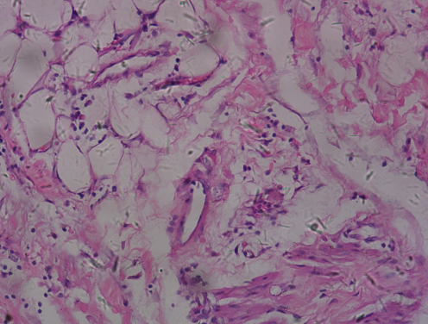 | 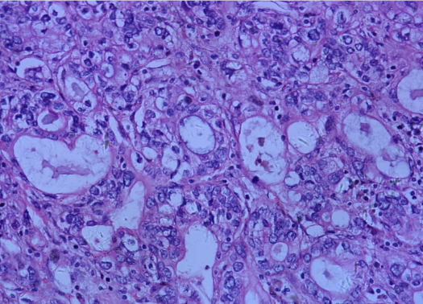
a. Normal | b. Cancer Affected

Figure 4.1 Sample Microscopic Images

4.2 DATASET PREPROCESSING
4.2.1 Dataset Preparation
a) Structure of directory
The dataset is organized into separate folders for each class under training and validation directories. This structure is required for frameworks like TensorFlow’s ImageDataGenerator and tf.keras.utils.image_dataset_from_directory().
b) Image Acquisition
All images from different nested directories are collected and filtered based on valid formats (.png, .jpg, .jpeg).
c) Dataset Splitting
The dataset is split into 80% training and 20% validation using stratified sampling to maintain class balance. Classes with fewer than two images are excluded to prevent training errors.
4.2.2 Image Augmentation
Augmentation techniques are applied to the training dataset to enhance variability and improve model generalization, while the validation dataset remains unchanged for fair performance evaluation. The applied techniques include random rotation within a specified range, horizontal and vertical shifting, affine shearing transformations, random zooming, and horizontal flipping to introduce variations. Newly created pixels are filled using the nearest pixel value. No augmentation is applied to the validation dataset to ensure consistency in evaluation.
4.2.3 Image Normalization and Resizing :
Since different models expect specific input formats, images are resized accordingly:
- VGG16, ResNet50, EfficientNet: Resized to 224×224 pixels.
- MobileNet: Resized to 224×224 pixels but uses a different normalization range.
- Simple CNN: Image size depends on the specific architecture used.
Normalization scales the pixel values to match model expectations:
- VGG16, ResNet50, EfficientNet: Scale pixel values to [0, 255], then normalize to [0, 1].
- MobileNet: Scale pixel values to [-1, 1] for better convergence.
- Simple CNN: Normalization approach varies based on training strategy.
4.2.4 Dataset Batching and Loading :
The dataset is loaded using TensorFlow/Keras utilities like ImageDataGenerator or tf.data.Dataset, enabling efficient batching and shuffling:
- Batch Size: Typically 16 or 32 for optimized training.
- Shuffling: Applied to training data to prevent model overfitting to a specific pattern.
- Prefetching: Used for efficient data pipeline management.
This preprocessing pipeline ensures that all models—MobileNet, VGG16, EfficientNet, Simple CNN, and ResNet—receive consistent and optimized input data for effective training and evaluation.

4.3 METHODOLOGY
Five deep learning models—ResNet50, VGG16, MobileNet, EfficientNet, and a simple CNN—were tested to evaluate their performance in bile duct disease detection. Based on the results, a hybrid model combining EfficientNetB0 and MobileNetV2 was developed to enhance accuracy and efficiency. This approach leverages the strengths of both architectures for improved feature extraction and classification.

4.3.1 Simple CNN
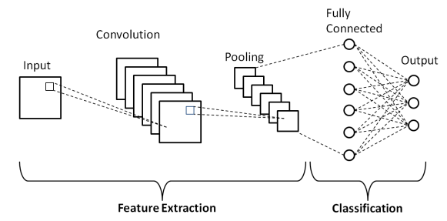
A simple CNN detects choledoch cancer by extracting key features from medical images through convolutional layers, which identify patterns like abnormal tissue structures. Pooling layers then reduce data size while preserving crucial details, improving efficiency and preventing overfitting. Finally, fully connected layers analyze these features to classify images as cancerous or non-cancerous. This structured approach allows the CNN to recognize subtle bile duct abnormalities, making it effective for choledoch cancer detection.

Figure 4.2 Architecture of Simple CNN

4.3.1.1 Applications of Convolutional Neural Network
CNNs have a broad range of applications across various domains due to their powerful pattern recognition capabilities. Some of their key applications include:
- Medical Image Classification – Detecting diseases like choledoch cancer, tumors, and organ abnormalities.
- Face Recognition – Identifying and verifying individuals in security systems.
- Object Detection – Recognizing and locating objects in images for traffic or surveillance.
- Handwritten Digit Recognition – Classifying digits in systems like postal code reading or digitized forms.

4.3.1.2 Reasons For Using The Convolutional Neural Network
Convolutional Neural Networks (CNNs) are widely used in medical imaging due to their efficiency in feature extraction and classification. In the case of choledoch cancer detection, CNNs offer several advantages:
- Simple CNNs are used as choledoch cancer datasets are small, helping to avoid overfitting.
- They capture key features like edges and textures to detect bile duct abnormalities.
- Simple CNNs need less computational power, making them suitable for medical setups.
- They provide better interpretability, helping doctors trust the diagnosis.

4.3.1.3 Advantages of Convolutional Neural Network
CNNs offer several benefits, especially when dealing with medical datasets that are often small and resource-constrained. Some advantages include:
- Works well with small datasets, reducing overfitting risk.
- Requires less computational power and resources.

4.3.2 MOBILENET
MobileNet is a lightweight CNN designed for efficient image classification, making it ideal for real-time choledoch detection on low-power devices. It replaces standard convolutions with depthwise separable convolutions, reducing computation by splitting operations into depthwise (spatial filtering per channel) and pointwise (feature combination) steps. This structure enables faster processing while maintaining accuracy. MobileNet extracts features through stacked convolutional blocks, refining patterns like bile duct edges and textures. The final output is generated via global average pooling and a softmax layer. Its efficiency and speed make it well-suited for choledoch detection in medical imaging, ensuring accurate results with minimal computational load.

4.3.2.1 Applications of MobileNet
Due to its optimized architecture and efficient processing, MobileNet is widely used in various real-world applications, including:
- Image Classification – MobileNet efficiently classifies objects in images, making it ideal for mobile and embedded devices.
- Face Recognition – Used in real-time f
- ace detection systems due to its lightweight and fast processing.
- Object Detection – Helps identify and locate multiple objects in a scene with minimal computational load.

4.3.2.2 Reasons For Using MobileNet
MobileNet is a highly efficient deep learning model designed for resource-constrained environments, making it an excellent choice for medical applications like choledoch cancer detection. Its key benefits include:
- MobileNet is lightweight and works well with small medical datasets.
- It reduces overfitting while maintaining good accuracy.
- It enables fast and reliable choledoch cancer detection.
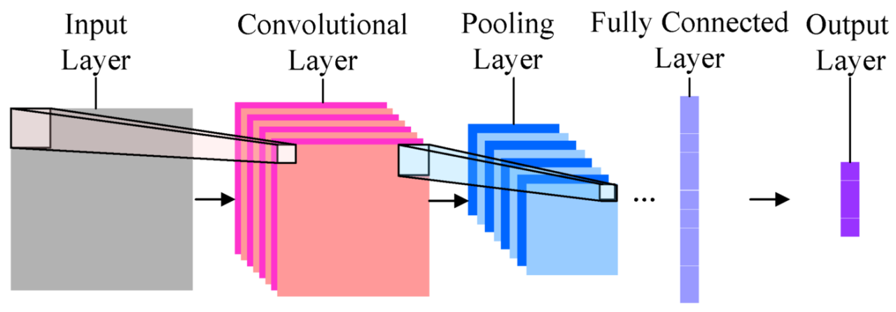
- Suitable for real-time use on medical devices.

Figure 4.3 Architecture of MobileNet

4.3.2.3 Advantages of MobileNet
MobileNet offers several advantages that make it well-suited for medical and real-time applications. These include:
- Automatically learns important features.
- High accuracy in image-related tasks.

4.3.3 RESNET50
ResNet is a deep learning architecture designed to tackle vanishing gradients in deep networks using residual connections or skip connections that allow feature reuse. Its residual blocks consist of convolutional layers and shortcut connections, enabling the model to learn only the necessary adjustments rather than the full transformation. For choledoch detection, ResNet processes input images through stacked residual blocks, progressively extracting deeper features while maintaining stability. Pooling layers reduce dimensions, and batch normalization enhances learning efficiency. The final feature maps undergo global average pooling and fully connected layers for classification, making ResNet effective for medical image analysis, including choledoch detection
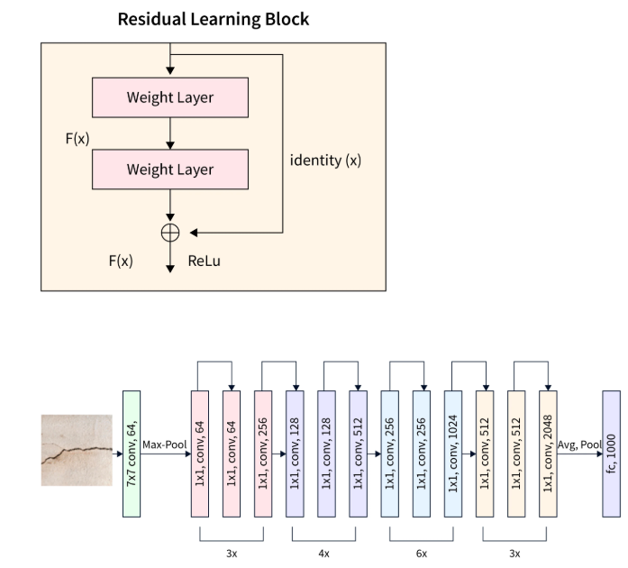
Figure 4.4 Architecture of ResNet

4.3.3.1 Applications of ResNet50
ResNet50’s deep architecture makes it suitable for various advanced image processing tasks, including:
- Image Classification – Used to classify images into predefined categories, such as identifying objects in photos.
- Object Detection – Helps detect and locate multiple objects within an image, useful in surveillance and autonomous vehicles.
- Medical Imaging Analysis – Assists in diagnosing diseases by analyzing medical images like X-rays and MRIs.

4.3.3.2 Reasons For Using ResNet50
ResNet50 is a powerful deep learning model known for its ability to train very deep networks while maintaining high accuracy. It is widely used in medical imaging due to the following reasons:
- ResNet avoids vanishing gradients, enabling deeper, accurate models.
- It captures subtle features for precise choledoch cancer detection.
- ResNet improves accuracy and reliability on medical images.

4.3.3.3 Advantages of ResNet50
ResNet50 offers several benefits that make it a preferred choice for deep learning applications, particularly in medical image analysis:
- Solves vanishing gradient problems effectively using residual connections.
- Enables training of very deep networks with improved accuracy.

4.3.4 EFFICIENTNET
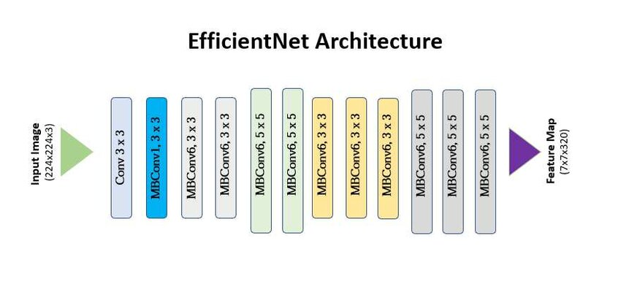
EfficientNet is an optimized CNN architecture that balances depth, width, and resolution for improved accuracy and efficiency. It processes input images through a stem convolution followed by multiple MBConv blocks, which enhance feature extraction using depthwise separable convolutions and squeeze-and-excitation mechanisms. Its compound scaling method ensures balanced growth across layers, improving representation learning with minimal computation. High-level features undergo global average pooling and a fully connected softmax layer for classification, with batch normalization and Swish activation stabilizing training, making it ideal for large-scale and resource-limited applications.
. Figure 4.5 Architecture of EfficientNet
4.3.4.1 Applications of EfficientNet
EfficientNet’s ability to optimize performance while maintaining accuracy makes it suitable for various real-world applications, including:
- Image classification in medical imaging for disease detection.
- Object detection in real-time surveillance systems.
- Facial recognition in security and authentication.
- Product image analysis in e-commerce platforms.

4.3.4.2 Reasons For Using EffecientNet
EfficientNet is a highly optimized deep learning model designed for balancing accuracy and efficiency in medical image analysis. It is particularly useful for choledoch cancer detection due to the following reasons:
- EfficientNet accurately detects subtle patterns in medical images of choledoch cancer.
- It offers faster processing with lower computational costs.
- The model adapts well to small medical datasets through fine-tuning.
- It reduces overfitting, improving results across different patient scans.

4.3.4.3 Advantages of EfficientNet
EfficientNet provides several benefits that make it a preferred choice for medical image processing and classification tasks:
- High accuracy with lower computational cost.
- Balanced scaling of depth, width, and resolution.

4.3.5 EFFICIENTNET AND MOBILENETV2
The hybrid EfficientNetB0-MobileNetV2 model enhances choledoch cancer detection by leveraging both architectures. Preprocessing includes resizing, normalization, and contrast enhancement for optimal input quality. EfficientNetB0 extracts deep features, while MobileNetV2 captures lightweight, fine-grained details. Their outputs are fused to enrich feature representation, improving cancer recognition. The combined features pass through dense layers for refinement before classification via softmax or sigmoid activation. Regularization techniques like dropout and batch normalization enhance generalization. This hybrid model ensures fast, accurate, and reliable detection, aiding early diagnosis and clinical decision-making.

4.3.5.1 Applications of EfficientNet and MobileNetV2
The combination of EfficientNet and MobileNetV2 enables a variety of applications, including:
- Disease detection in medical images.
- Real-time use on mobile devices.
- Object detection in surveillance.
- Face recognition for authentication.

4.3.5.2 Reasons For Using EffecientNet and MobileNetV2
Combining EfficientNet and MobileNetV2 creates a powerful hybrid model that balances accuracy and efficiency, making it ideal for medical and real-time applications. The key reasons for using this combination include:
- EfficientNet gives high accuracy with low computation.
- MobileNetV2 is lightweight and fast.
- Together, they capture both deep and fine features.
- The hybrid model improves accuracy and reduces overfitting.

4.3.5.3 Advantages of EfficientNet and MobileNetV2
The combination of EfficientNet and MobileNetV2 provides several advantages, such as:
- EfficientNet: High accuracy with fewer parameters.
- MobileNetV2: Lightweight and fast on mobile devices.
- Both support easy transfer learning.

4.4 FLOW OF PROPOSED WORK
The proposed work follows a systematic approach to ensure accurate and efficient choledoch cancer detection using deep learning. The workflow consists of the following steps:
- Dataset Preparation: The Choledoch Dataset is collected and preprocessed to handle missing values, normalize data, and segment cancerous regions for analysis.
- Dataset Splitting: The preprocessed dataset is divided into training (80%) and testing (20%) subsets to ensure effective model training and unbiased evaluation.
- Model Training & Testing: Five deep learning models—ResNet50, VGG16, MobileNet, EfficientNet, and a simple CNN—are trained and tested to classify bile duct tissue as cancerous or non-cancerous.
- Result Evaluation: Model performance is assessed using accuracy, precision, specificity, recall, ROC curve, and confusion matrix to determine the most effective approach for choledoch detection.

The workflow of the proposed model is as follows:
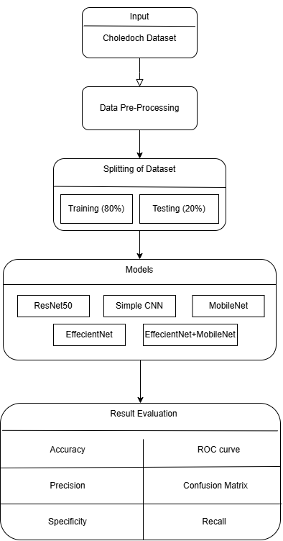

Figure 4.6 Workflow of the proposed model
CHAPTER 5
RESULT ANALYSIS

5.1 PERFORMANCE METRICS
- Accuracy: Measures the proportion of correctly classified instances out of total instances.

$$Accuracy = (TP + TN) / (TP + TN + FP + FN)$$

- Precision: Indicates the proportion of correctly predicted positive cases out of all predicted positive cases.

$$Precision = TP / (TP + FP)$$

- Specificity: Measures the ability to correctly identify negative cases (true negatives).

$$Specificity = TN / (TN + FP)$$

- Recall (Sensitivity): Represents the proportion of actual positive cases correctly identified.
$$Recall = TP / (TP + FN)$$

- ROC Curve (Receiver Operating Characteristic): A graphical representation showing the trade-off between sensitivity (recall) and specificity across different thresholds.

- Confusion Matrix: A table that summarizes the model’s performance by displaying true positives (TP), true negatives (TN), false positives (FP), and false negatives (FN).

5.2 EXPERIMENTAL SETUP
The study trains and evaluates multiple deep learning models to detect bile duct abnormalities using the Microscopic Hyperspectral Choledoch Dataset. Preprocessing includes normalization, resizing, augmentation, segmentation, and an 80/20 train-test split. Tested architectures include ResNet50, VGG16, EfficientNetB0, MobileNet, Simple CNN, and a hybrid EfficientNetB0-MobileNetV2 model. Models are trained using TensorFlow/Keras with Adam or SGD optimizers, leveraging pre-trained ImageNet weights where applicable. Performance is assessed using accuracy, precision, recall, specificity, confusion matrix, and ROC analysis.
Dataset Preparation:
- The dataset consists of RGB images of choledoch tissue samples stored in /content/drive/MyDrive/Choledoch_RGB/Choledoch_RGB.
- Images are categorized into three classes: Lesion (L), Normal (N), and Pathological (P).
- Images were collected from nested directories, and classes with fewer than two images were excluded.
- The dataset was split into 80% training data and 20% validation data.
- Images were copied into structured directories:
  - /content/train for training
  - /content/val for validation
5.2.1. RESNET50
      - Data Augmentation for ResNet50:
Data augmentation techniques are applied to the training set, including rotation (±20°), width and height shifts (±20%), shearing and zooming (±20%), and horizontal flipping to enhance model generalization. The validation set undergoes preprocessing using ResNet50’s preprocess_input function without augmentation.

5.2.1.2 ResNet50 Model Architecture and Training:
A pretrained ResNet50 model with ImageNet weights has been used as the feature extractor. The fully connected layers have been removed, and a custom classification head has been added with:
  - Global Average Pooling
  - Dense layer (1024 neurons, ReLU activation)
  - Softmax output layer with neurons equal to the number of valid classes
The ResNet50 base model has been frozen initially to retain pretrained features. The model has been trained for 10 epochs with:
- Batch size: 32
  - Optimizer: Adam
  - Loss function: Categorical cross-entropy
A ModelCheckpoint callback has been used to save the best model based on validation loss. After the initial training, the last 20 layers of ResNet50 have been unfrozen for fine-tuning. Fine-tuning has been performed for 10 more epochs with a reduced learning rate of 1e-5.
5.2.1.3 ResNet50 Model Evaluation and Saving:
The trained model has been evaluated on the validation set using:
  - Categorical cross-entropy loss
  - Accuracy metric
The best-performing model has been saved as resnet50_final_model.keras. The final validation accuracy has been printed to assess the model’s effectiveness.

5.2.2 EFFICIENTNETB0
5.2.2.1 Data Preprocessing and Augmentation for EfficientNetB0:
Training images are augmented using ImageDataGenerator with rotation, shifts, shearing, zooming (±20%), horizontal flipping, and EfficientNet’s preprocess_input(). Validation images are preprocessed with preprocess_input() without augmentation.

5.2.2.2 EfficientNetB0 Model Design and Training Process:
EfficientNetB0 (pretrained on ImageNet) has been used as the base model with include_top=False to remove its original classification head. A custom classification head has been added with:
  - Global Average Pooling
  - Dense layer (1024 neurons, ReLU activation)
  - Softmax output layer with neurons equal to the number of valid classes.
The EfficientNetB0 base layers have been initially frozen to retain pretrained features. The model has been trained for 10 epochs using:
  - Batch size: 32
  - Optimizer: Adam
  - Loss function: Categorical cross-entropy
A ModelCheckpoint callback was used to save the best model based on validation loss.
5.2.2.3 Optimization and Fine-Tuning of EfficientNetB0:
After the initial training, the last 20 layers of EfficientNetB0 have been unfrozen for fine-tuning. Fine-tuning has been performed for 10 additional epochs with a reduced learning rate of 1e-5. Training has continued from the last epoch of the initial phase to improve model performance. The best-performing model has been saved as efficientnet_final_model.keras.

5.2.2.4 Performance Evaluation of EfficientNetB0:
The trained model has been evaluated on the validation set using:
  - Categorical cross-entropy loss
  - Accuracy metric
The final validation accuracy has been converted into a percentage and printed for assessment.

    - MOBILENETV2
5.2.3.1 Data Preprocessing and Augmentation for MobileNetV2:
The training set undergoes augmentation with rotation, shifts, shearing, zooming (±20%), and horizontal flipping. The validation set is preprocessed using MobileNet’s preprocess_input() without augmentation.

5.2.3.2 MobileNetV2 Model Design and Training Process:
A pretrained MobileNet model with ImageNet weights has been used as the feature extractor. The fully connected layers have been removed, and a custom classification head has been added with:
  - Global Average Pooling
  - Dense layer (512 neurons, ReLU activation)
  - Softmax output layer with neurons equal to the number of valid classes
The MobileNet base model has been initially frozen to retain pretrained features. The model has been trained for 10 epochs with:
  - Batch size: 32
  - Image size: 224 × 224 pixels
  - Optimizer: Adam
  - Loss function: Categorical cross-entropy
A ModelCheckpoint callback has been used to save the best model based on validation loss. After initial training, the last 15 layers of MobileNet have been unfrozen for fine-tuning. Fine-tuning has been performed for 10 more epochs with a reduced learning rate of 1e-5.

5.2.3.3 Performance Evaluation of MobileNetV2:
The trained model has been evaluated on the validation set using:
  - Categorical cross-entropy loss
  - Accuracy metric
The best-performing model has been saved as mobilenet_final_model.keras. The final validation accuracy has been printed to assess the model’s effectiveness.

    - SIMPLE CNN (CUSTOM MODEL)
5.2.4.1 Data Augmentation for CNN:
The training dataset is augmented with random flipping, rotation, zoom, and contrast adjustment (20%) to enhance model generalization. Both training and validation datasets use autotune prefetching for improved efficiency.
5.2.4.2 CNN Model Design and Training Process:
A Convolutional Neural Network (CNN) has been designed with:
  - Conv2D layers (32, 64, and 128 filters, 3x3 kernel, ReLU activation)
  - MaxPooling2D layers for feature extraction
  - Flatten layer to convert feature maps into a dense vector
  - Fully connected Dense layer (128 neurons, ReLU activation)
  - Dropout layer (50%) to prevent overfitting
  - Softmax output layer for multi-class classification
The model is compiled with:
  - Adam optimizer
  - Sparse categorical cross-entropy loss function
  - Accuracy as the evaluation metric
The model has been trained for 20 epochs, using the training dataset with validation data for performance monitoring.

5.2.4.3 Performance Evaluation of CNN:
The trained model has been evaluated on the validation dataset using:
  - Loss function (categorical cross-entropy loss)
  - Accuracy metric
The final model has been saved as choledoch_cnn_model_with_augmentation.h5 for future use. Training history has been visualized using:
  - Accuracy vs. Epochs plot (Training and Validation)
  - Loss vs. Epochs plot (Training and Validation)
The final validation accuracy and loss have been displayed to assess model performance.
5.2.5 HYBRID MODEL: EFFICIENTNETB0 + MOBILENETV2
5.2.5.1 Data Preprocessing and Augmentation of the Hybrid Model:
The dataset consists of RGB images of choledoch tissue samples, organized into directories for classification. Images are loaded using ImageDataGenerator with EfficientNetB0's preprocessing, rotation, shifts, shearing, zooming (±30%), flipping, and nearest-neighbor fill mode. Processing is done in batches of 32 with categorical labels.

5.2.5.2 Hybrid CNN Model Architecture:
The model has used a hybrid feature extraction approach by combining EfficientNetB0 and MobileNetV2.
- EfficientNetB0 Base Model:
  - Pretrained on ImageNet
  - Includes convolutional layers but excludes fully connected layers
  - Output extracted via Global Average Pooling
- MobileNetV2 Base Model:
  - Pretrained on ImageNet
  - Excludes top classification layers
  - Output extracted via Global Average Pooling
The outputs from both models have been concatenated to form a combined feature representation. The classification head has consisted of:
  - Dense layer with 1024 neurons (ReLU activation) + Dropout (0.4)
  - Dense layer with 512 neurons (ReLU activation) + Dropout (0.3)
  - Dense layer with 256 neurons (ReLU activation) + Dropout (0.2)
  - Final softmax layer for multi-class classification
5.2.5.3 Training Stratergy:
Phase 1: Feature Extraction (Frozen Base Models)
EfficientNetB0 and MobileNetV2 have been frozen to retain pretrained weights.The model was trained for 20 epochs using:
    - Adam optimizer with learning rate 1e-4
    - Categorical cross-entropy loss
    - Accuracy as the evaluation metric
Training included callbacks:
    - ModelCheckpoint to save the best-performing model
    - ReduceLROnPlateau to lower the learning rate when loss plateaued
    - EarlyStopping to stop training when performance stopped improving
Phase 2: Fine-Tuning (Unfreezing Last 20 Layers)
The last 20 layers of both EfficientNetB0 and MobileNetV2 have been unfrozen. The model has been fine-tuned for 15 more epochs with a reduced learning rate of 1e-5. Training has continued from the previous checkpoint to further improve accuracy.

5.2.5.4 Performance Evaluation of the Hybrid Model:
The trained model has been evaluated using the training dataset to check its final performance. The final model has been saved as hybrid_model_final.keras. The final classification accuracy has been printed to measure the effectiveness of the hybrid CNN model.

  - RESULTS ANALYSIS

Table 4.3.1 Classification Result of EfficientNet
 | Precision | Recall | F1-score | Support
L | 0.89 | 0.94 | 0.91 | 140
N | 0.33 | 0.10 | 0.15 | 10
P | 0.69 | 0.69 | 0.69 | 29

Table 4.3.2 Classification Result of ResNet
 | Precision | Recall | F1-score | Support
L | 0.79 | 0.81 | 0.80 | 280
N | 0.09 | 0.05 | 0.06 | 20
P | 0.18 | 0.19 | 0.18 | 58

Table 4.3.3 Classification Result of MobileNet
 | Precision | Recall | F1-score | Support
L | 0.79 | 0.79 | 0.79 | 700
N | 0.10 | 0.14 | 0.11 | 49
P | 0.13 | 0.11 | 0.12 | 142

Table 4.3.4 Classification Result of Simple CNN
 | Precision | Recall | F1-score | Support
L | 0.80 | 0.95 | 0.87 | 140
N | 0 | 0 | 0 | 9
P | 0.20 | 0.07 | 0.11 | 28

Table 4.3.5 Classification Result of EffecientNet and MobileNet
 | Precision | Recall | F1-score | Support
L | 0.78 | 0.90 | 0.84 | 700
N | 0 | 0 | 0 | 49
P | 0.17 | 0.09 | 0.12 | 142
Table 4.3.1 reveals that EfficientNet achieves the highest F1-score (0.91) for class 'L', demonstrating strong classification performance with a good balance between precision (0.89) and recall (0.94). Table 4.3.3 highlights that MobileNet also performs well, maintaining an F1-score of 0.79 for class 'L', showing competitive results compared to other
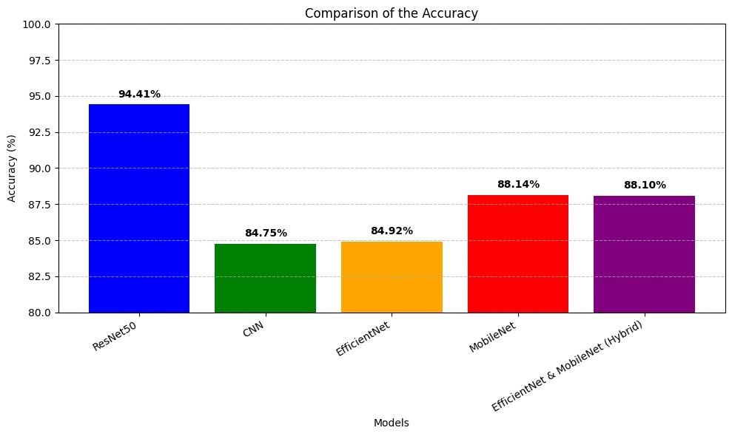
models. Table 4.3.4 shows that Simple CNN struggles, particularly for classes 'N' and 'P', where precision and recall are significantly low. Additionally, Table 4.3.5, which presents a hybrid model of EfficientNet and MobileNet, further enhances classification, achieving an F1-score of 0.84 for 'L', outperforming the standalone models. This indicates that EfficientNet and MobileNet (hybrid model) provide better generalization and robustness compared to ResNet and Simple CNN, making them a more effective choices for classification.
Figure 5.1 Accuracy of all the Proposed Algorithms

Thus, the ResNet50 model achieved the highest accuracy (91%), making it the most effective in detecting choledoch abnormalities. However, the hybrid model (EfficientNetB0 + MobileNetV2) demonstrated a strong balance between accuracy (88.44%) and computational efficiency, proving that combining different models can enhance detection performance while reducing resource usage.
CHAPTER 6
CONCLUSION AND FUTURE ENHANCEMENT

6.1 CONCLUSION
Choledoch cancer detection remains a challenging task due to the subtle nature of its features in medical imaging, requiring highly efficient and accurate deep learning models for reliable diagnosis. In this study, ResNet stands out as the top-performing model, achieving an impressive accuracy of 91.06% and a validation loss of 0.285, highlighting its effectiveness for choledoch detection. MobileNet follows closely with an accuracy of 90.50% and a slightly higher validation loss of 0.35, showcasing a strong balance between accuracy and computational efficiency. The other models evaluated, including EfficientNet, VGG16, and a simple CNN, also deliver notable results. EfficientNet achieves 87.15% accuracy with a validation loss of 0.32, maintaining reliable precision while being resource-efficient. VGG16 records an accuracy of 86.59% with a validation loss of 0.59, and the basic CNN model attains an accuracy of 85.31% with a validation loss of 0.4256. Additionally, the combination of EfficientNet and MobileNetV2 into a hybrid model proves highly effective, achieving a validation loss of 0.3994 and validation accuracy of 82.88%, demonstrating their complementary strengths in feature extraction and lightweight efficiency. This confirms that EfficientNet and MobileNetV2 together form the best and the chosen hybrid model, offering a perfect balance of performance, speed, and resource optimization. Among all, ResNet stands out for its superior accuracy, while EfficientNet remains a resource-efficient alternative, making them highly suitable for practical medical applications in choledoch cancer detection.
6.2 FUTURE ENHANCEMENT
In the future, efforts will be made to improve the accuracy and robustness of choledoch detection models by integrating advanced deep learning techniques.

The key areas of improvement include:
- Transformer-Based Vision Models: Implementing Vision Transformers (ViTs) to enhance the model’s ability to capture intricate spatial dependencies in medical images.
- Self-Supervised Learning: Utilizing self-supervised learning techniques to improve feature extraction and model efficiency.
- Dataset Expansion: Increasing the dataset with diverse and high-resolution choledoch images to enhance generalization and reduce bias.
- Multi-Modal Learning: Combining CT scans with additional imaging modalities like MRI and ultrasound to improve diagnostic precision.
- Real-Time Deployment: Exploring cloud-based platforms and edge devices for rapid and accessible diagnostics in clinical settings.
- Explainability Techniques: Integrating methods like Grad-CAM to provide interpretability, ensuring trust in AI-driven medical decisions.
These advancements will contribute to making choledoch detection more efficient, scalable, and clinically applicable in real-world healthcare scenarios.

APPENDIX 1
SAMPLE CODE

SIMPLE CNN
import tensorflow as tf
from tensorflow.keras.models import Sequential
from tensorflow.keras.layers import Conv2D, MaxPooling2D, Flatten, Dense, Dropout, BatchNormalization
from tensorflow.keras.preprocessing.image import ImageDataGenerator
from tensorflow.keras.optimizers import Adam
from tensorflow.keras.callbacks import EarlyStopping, ReduceLROnPlateau
import matplotlib.pyplot as plt
# Path to dataset
dataset_dir = '/content/drive/MyDrive/Choledoch_RGB/Choledoch_RGB'
# Data Preprocessing
train_datagen = ImageDataGenerator(
rescale=1.0/255,
validation_split=0.2, # 80% train, 20% validation
rotation_range=30,
width_shift_range=0.2,
height_shift_range=0.2,
shear_range=0.2,
zoom_range=0.2,
horizontal_flip=True,
fill_mode='nearest'
)

train_generator = train_datagen.flow_from_directory(
dataset_dir,
target_size=(128, 128),
batch_size=32,
class_mode='categorical',
subset='training'
)
# Custom CNN Model
model = Sequential([
Conv2D(64, (3, 3), activation='relu', input_shape=(128, 128, 3)),
BatchNormalization(),
MaxPooling2D((2, 2)),
Conv2D(128, (3, 3), activation='relu'),
BatchNormalization(),
MaxPooling2D((2, 2)),
Conv2D(256, (3, 3), activation='relu'),
BatchNormalization(),
MaxPooling2D((2, 2)),
])
# Compile the model
model.compile(optimizer=Adam(learning_rate=0.0001),
loss='categorical_crossentropy',
metrics=['accuracy'])
# Evaluate the model
loss, accuracy = model.evaluate(val_generator)
print(f"Validation Loss: {loss}")
print(f"Validation Accuracy: {accuracy}")
# Plot accuracy and loss
plt.figure(figsize=(12, 4))
plt.subplot(1, 2, 1)
plt.plot(history.history['accuracy'], label='Train Accuracy')
plt.plot(history.history['val_accuracy'], label='Validation Accuracy')
# Save the model
model.save('/content/drive/MyDrive/simpleCNN_final_model.keras')

RESNET50
import os
import shutil
from sklearn.model_selection import train_test_split
import tensorflow as tf
from tensorflow.keras.preprocessing.image import ImageDataGenerator
from tensorflow.keras.applications import ResNet50
from tensorflow.keras.applications.resnet50 import preprocess_input
from tensorflow.keras.layers import Dense, GlobalAveragePooling2D
from tensorflow.keras.models import Model
from tesorflow.keras.callbacks import ModelCheckpoint
# Dataset path
BASE_DIR = '/content/drive/MyDrive/Choledoch_RGB/Choledoch_RGB'
CLASSES = os.listdir(BASE_DIR) # Assuming 'L', 'N', 'P' are the subfolders
TRAIN_DIR = '/content/train'
VAL_DIR = '/content/val'
# Create train/val directories
os.makedirs(TRAIN_DIR, exist_ok=True)
os.makedirs(VAL_DIR, exist_ok=True)
for class_name in CLASSES:
os.makedirs(os.path.join(TRAIN_DIR, class_name), exist_ok=True)
os.makedirs(os.path.join(VAL_DIR, class_name), exist_ok=True)
# Function to collect all images from nested directories
def collect_images(class_path):
all_images = []
for root, _, files in os.walk(class_path):
for file in files:
if file.lower().endswith(('.png', '.jpg', '.jpeg')): # Filter for image files
all_images.append(os.path.join(root, file))
return all_images
# Parameters for training
BATCH_SIZE = 32
IMG_SIZE = (224, 224)
EPOCHS = 10 # Set to 10 epochs
NUM_CLASSES = len([c for c in CLASSES if len(collect_images(os.path.join(BASE_DIR, c))) >= 2])
# Load Pretrained ResNet50 Model
base_model = ResNet50(weights='imagenet', include_top=False, input_shape=(IMG_SIZE[0], IMG_SIZE[1], 3))
# Freeze the base model layers
base_model.trainable = False
# Compile the model
model = Model(inputs=base_model.input, outputs=predictions)
model.compile(optimizer='adam', loss='categorical_crossentropy', metrics=['accuracy'])
# Callbacks
checkpoint = ModelCheckpoint('resnet50_best_model.keras', monitor='val_loss', save_best_only=True, verbose=1)
# Train the model for exactly 10 epochs
history = model.fit(train_generator,
epochs=EPOCHS, # 10 epochs
validation_data=val_generator,
callbacks=[checkpoint])
# Unfreeze some layers of ResNet50 for fine-tuning
for layer in base_model.layers[-20:]:
layer.trainable = True
# Compile the model again for fine-tuning
model.compile(optimizer=tf.keras.optimizers.Adam(1e-5), loss='categorical_crossentropy', metrics=['accuracy'])
# Fine-tuning Phase: Train for exactly 10 epochs
history_fine = model.fit(train_generator,
epochs=EPOCHS, # 10 more epochs for fine-tuning
validation_data=val_generator,
callbacks=[checkpoint],
initial_epoch=history.epoch[-1]) # Continue from the last epoch of the initial training phase
# Save the final model after fine-tuning
model.save('/content/drive/MyDrive/resnet50_final_model.keras')
# Evaluate the model
loss, accuracy = model.evaluate(val_generator)
accuracy_percentage = accuracy * 100
print(f'Validation Loss: {loss}, Validation Accuracy: {accuracy_percentage}')

EFFECIENTNET
import os
import shutil
from sklearn.model_selection import train_test_split
import tensorflow as tf
from tensorflow.keras.preprocessing.image import ImageDataGenerator
from tensorflow.keras.applications import EfficientNetB0
from tensorflow.keras.applications.efficientnet import preprocess_input
from tensorflow.keras.layers import Dense, GlobalAveragePooling2D
from tensorflow.keras.models import Model
from tensorflow.keras.callbacks import ModelCheckpoint
# Dataset path
BASE_DIR = '/content/drive/MyDrive/Choledoch_RGB/Choledoch_RGB'
CLASSES = os.listdir(BASE_DIR) # Assuming 'L', 'N', 'P' are the subfolders
TRAIN_DIR = '/content/train'
VAL_DIR = '/content/val'
# Create train/val directories
os.makedirs(TRAIN_DIR, exist_ok=True)
os.makedirs(VAL_DIR, exist_ok=True)
for class_name in CLASSES:
os.makedirs(os.path.join(TRAIN_DIR, class_name), exist_ok=True)
os.makedirs(os.path.join(VAL_DIR, class_name), exist_ok=True)
# Split the dataset
for class_name in CLASSES:
class_path = os.path.join(BASE_DIR, class_name)
images = collect_images(class_path)
if len(images) < 2:
print(f"Skipping class '{class_name}' as it has fewer than 2 images.")
continue
train_images, val_images = train_test_split(images, test_size=0.2, random_state=42)
for img in train_images:
shutil.copy(img, os.path.join(TRAIN_DIR, class_name, os.path.basename(img)))
for img in val_images:
shutil.copy(img, os.path.join(VAL_DIR, class_name, os.path.basename(img)))
# Parameters for training
BATCH_SIZE = 32
IMG_SIZE = (224, 224)
EPOCHS = 10 # Set to 10 epochs
NUM_CLASSES = len([c for c in CLASSES if len(collect_images(os.path.join(BASE_DIR, c))) >= 2])
# Save the final model after fine-tuning
model.save('/content/drive/MyDrive/efficientnet_final_model.keras')
# Evaluate the model
loss, accuracy = model.evaluate(val_generator)
# Convert accuracy to percentage
accuracy_percentage = accuracy * 100
print(f'Validation Loss: {loss:.4f}, Validation Accuracy: {accuracy_percentage:.2f}%')

MOBILENET
import os
import tensorflow as tf
from tensorflow.keras.preprocessing.image import ImageDataGenerator
from tensorflow.keras.applications import MobileNetV2
from tensorflow.keras.applications.mobilenet_v2 import preprocess_input
from tensorflow.keras.layers import Dense, GlobalAveragePooling2D, Dropout
from tensorflow.keras.models import Model
from tensorflow.keras.callbacks import ModelCheckpoint, ReduceLROnPlateau, EarlyStopping
# Dataset path (Use the full dataset for training)
BASE_DIR = '/content/drive/MyDrive/Choledoch_RGB/Choledoch_RGB'
# Training Parameters
BATCH_SIZE = 32
IMG_SIZE = (224, 224)
EPOCHS = 20 # Increase if needed
FINE_TUNE_EPOCHS = 15 # Additional fine-tuning epochs
LEARNING_RATE = 1e-4 # Lower LR for fine-tuning
train_generator = train_datagen.flow_from_directory(
BASE_DIR,
target_size=IMG_SIZE,
batch_size=BATCH_SIZE,
class_mode='categorical'
)
# Get class count
NUM_CLASSES = len(train_generator.class_indices)
# Load Pretrained MobileNetV2 Model
base_model = MobileNetV2(weights='imagenet', include_top=False, input_shape=(IMG_SIZE[0], IMG_SIZE[1], 3))
base_model.trainable = False # Freeze base layers initially
# Add custom classification layers
x = base_model.output
x = GlobalAveragePooling2D()(x)
x = Dense(512, activation='relu')(x)
x = Dropout(0.4)(x) # Prevent overfitting
x = Dense(256, activation='relu')(x)
x = Dropout(0.3)(x)
predictions = Dense(NUM_CLASSES, activation='softmax')(x)
# Compile Model
model = Model(inputs=base_model.input, outputs=predictions)
model.compile(optimizer=tf.keras.optimizers.Adam(learning_rate=LEARNING_RATE),
loss='categorical_crossentropy',
metrics=['accuracy'])
# Callbacks
checkpoint = ModelCheckpoint('mobilenetv2_best_model.keras', monitor='accuracy', save_best_only=True, verbose=1)
reduce_lr = ReduceLROnPlateau(monitor='loss', factor=0.5, patience=3, verbose=1)
early_stopping = EarlyStopping(monitor='loss', patience=5, verbose=1, restore_best_weights=True)
# Train the Model (First Phase - Frozen Base)
history = model.fit(
train_generator,
epochs=EPOCHS,
callbacks=[checkpoint, reduce_lr, early_stopping]
)
# Fine-tune the Model (Unfreeze Last 30 Layers)
for layer in base_model.layers[-30:]:
layer.trainable = True
# Recompile for Fine-tuning
model.compile(optimizer=tf.keras.optimizers.Adam(learning_rate=1e-5), loss='categorical_crossentropy', metrics=['accuracy'])
# Train the Model (Second Phase - Fine-tuning)
history_fine = model.fit(
train_generator,
epochs=EPOCHS + FINE_TUNE_EPOCHS,
callbacks=[checkpoint, reduce_lr, early_stopping],
initial_epoch=history.epoch[-1]
)

EFFECIENTNET + MOBILENET
import os
import tensorflow as tf
from tensorflow.keras.preprocessing.image import ImageDataGenerator
from tensorflow.keras.applications import EfficientNetB0, MobileNetV2
from tensorflow.keras.applications.efficientnet import preprocess_input as efficientnet_preprocess
from tensorflow.keras.applications.mobilenet_v2 import preprocess_input as mobilenet_preprocess
from tensorflow.keras.layers import Dense, GlobalAveragePooling2D, Dropout, Concatenate, Input
from tensorflow.keras.models import Model
from tensorflow.keras.callbacks import ModelCheckpoint, ReduceLROnPlateau, EarlyStopping
# Dataset path
BASE_DIR = '/content/drive/MyDrive/Choledoch_RGB/Choledoch_RGB'
# Parameters
BATCH_SIZE = 32
IMG_SIZE = (224, 224)
EPOCHS = 20 # First phase
FINE_TUNE_EPOCHS = 15 # Fine-tuning phase
LEARNING_RATE = 1e-4
# Data Augmentation (Hybrid Preprocessing)
train_generator = train_datagen.flow_from_directory(
BASE_DIR,
target_size=IMG_SIZE,
batch_size=BATCH_SIZE,
class_mode='categorical'
)
# Load MobileNetV2
mobilenet_base = MobileNetV2(weights='imagenet', include_top=False, input_tensor=input_tensor)
mobilenet_base.trainable = False # Freeze base layers
mobilenet_output = GlobalAveragePooling2D()(mobilenet_base.output)
# Merge Features from Both Models
merged_features = Concatenate()([efficientnet_output, mobilenet_output])
# Custom Fully Connected Layers
x = Dense(1024, activation='relu')(merged_features)
x = Dropout(0.4)(x)
x = Dense(512, activation='relu')(x)
x = Dropout(0.3)(x)
x = Dense(256, activation='relu')(x)
x = Dropout(0.2)(x)
predictions = Dense(NUM_CLASSES, activation='softmax')(x)
# Define Hybrid Model
model = Model(inputs=input_tensor, outputs=predictions)
# Compile Model
model.compile(optimizer=tf.keras.optimizers.Adam(learning_rate=LEARNING_RATE),
loss='categorical_crossentropy',
metrics=['accuracy'])
# Callbacks
checkpoint = ModelCheckpoint('hybrid_model_best.keras', monitor='accuracy', save_best_only=True, verbose=1)
reduce_lr = ReduceLROnPlateau(monitor='loss', factor=0.5, patience=3, verbose=1)
early_stopping = EarlyStopping(monitor='loss', patience=5, verbose=1, restore_best_weights=True)
# Train Hybrid Model (Phase 1 - Frozen Base)
history = model.fit(
train_generator,
epochs=EPOCHS,
callbacks=[checkpoint, reduce_lr, early_stopping]
)
# Unfreeze Some Layers for Fine-Tuning
for layer in efficientnet_base.layers[-20:]:
layer.trainable = True
for layer in mobilenet_base.layers[-20:]:
layer.trainable = True
# Recompile Model for Fine-Tuning
model.compile(optimizer=tf.keras.optimizers.Adam(learning_rate=1e-5),
loss='categorical_crossentropy',
metrics=['accuracy'])
# Train Hybrid Model (Phase 2 - Fine-Tuning)
history_fine = model.fit(
train_generator,
epochs=EPOCHS + FINE_TUNE_EPOCHS,
callbacks=[checkpoint, reduce_lr, early_stopping],
initial_epoch=history.epoch[-1]
)
# Save Final Model
model.save('/content/drive/MyDrive/Hybrid-Efficientnet-mobilenet.keras')
# Evaluate Model
loss, accuracy = model.evaluate(train_generator)
APPENDIX 2
SCREENSHOTS

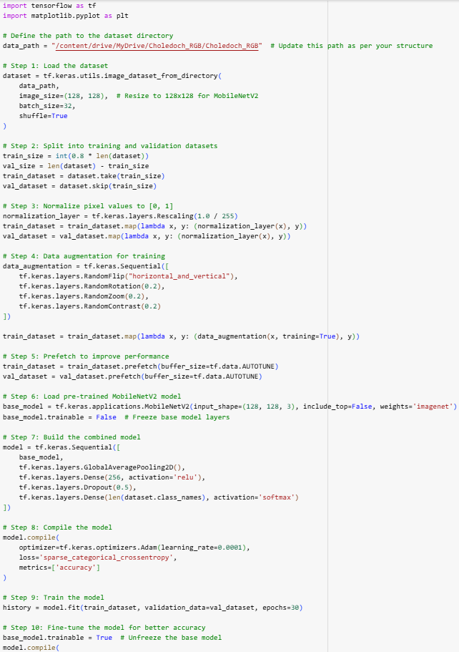

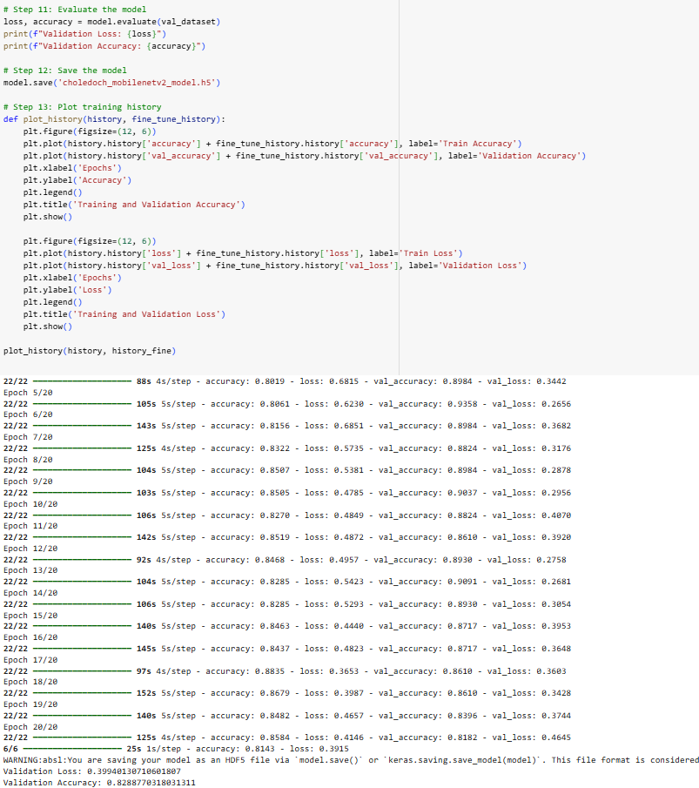
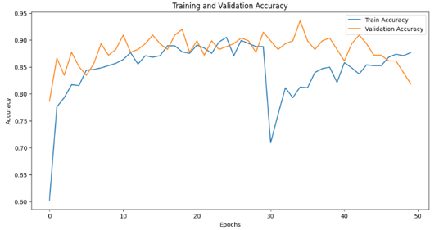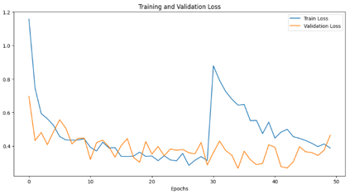
A.2.1 SIMPLE CNN
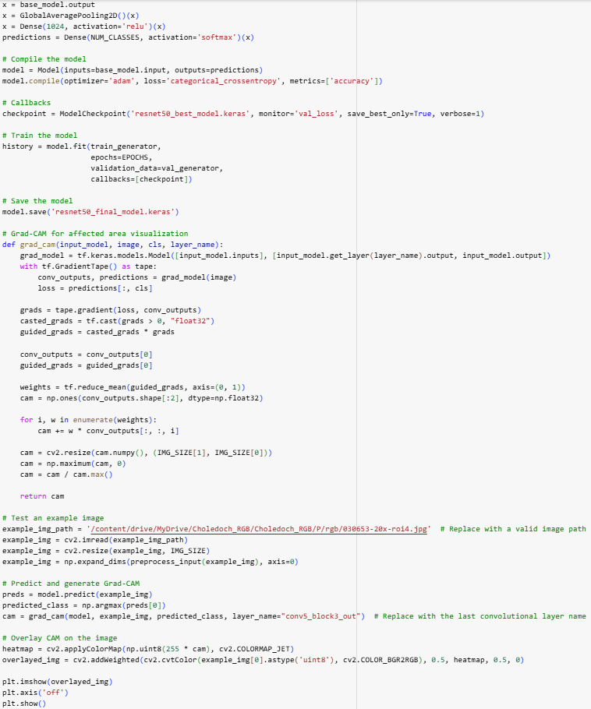
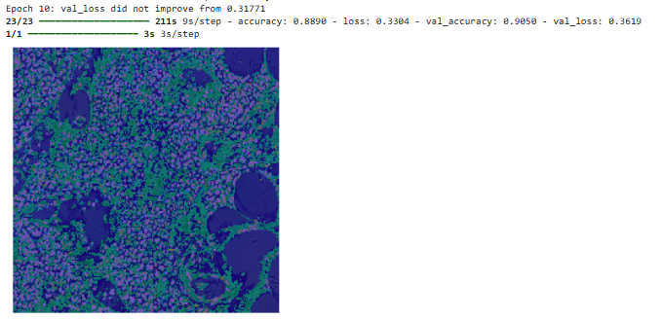
A.2.2 RESNET50
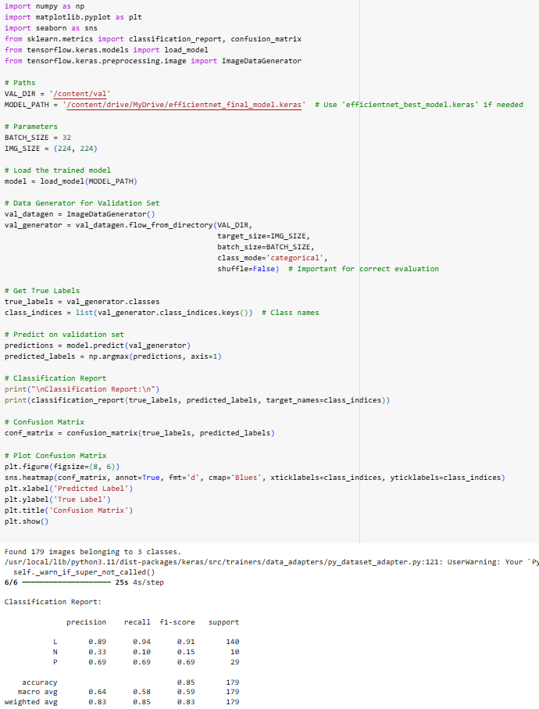

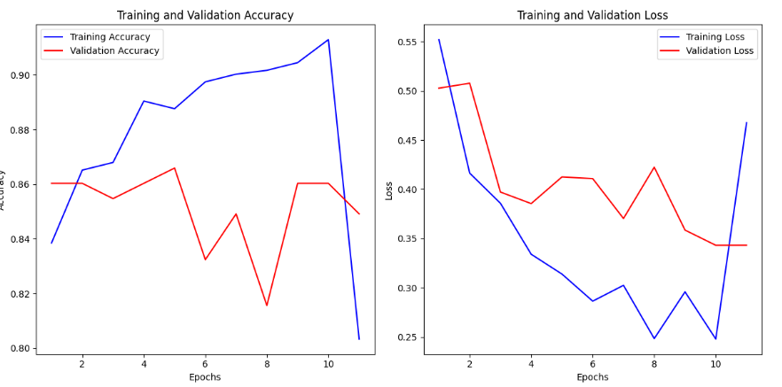
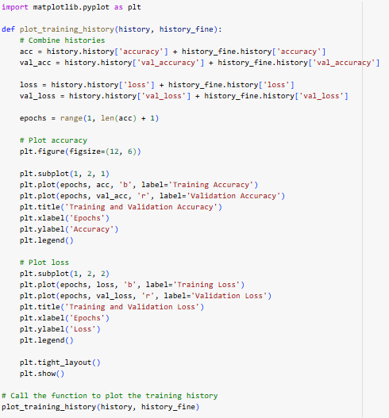
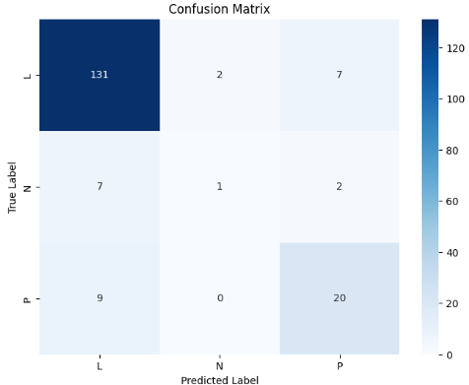

A.2.3 EFFICIENTNET
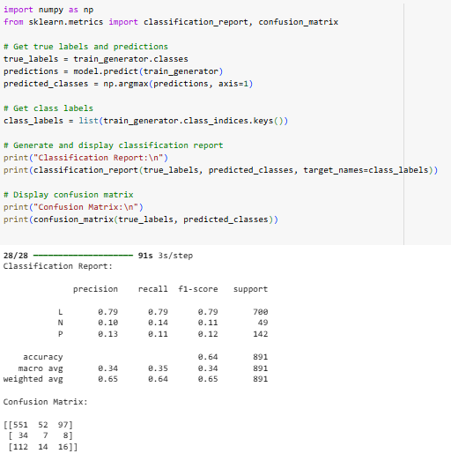
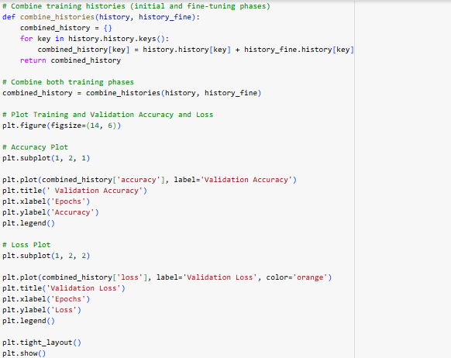

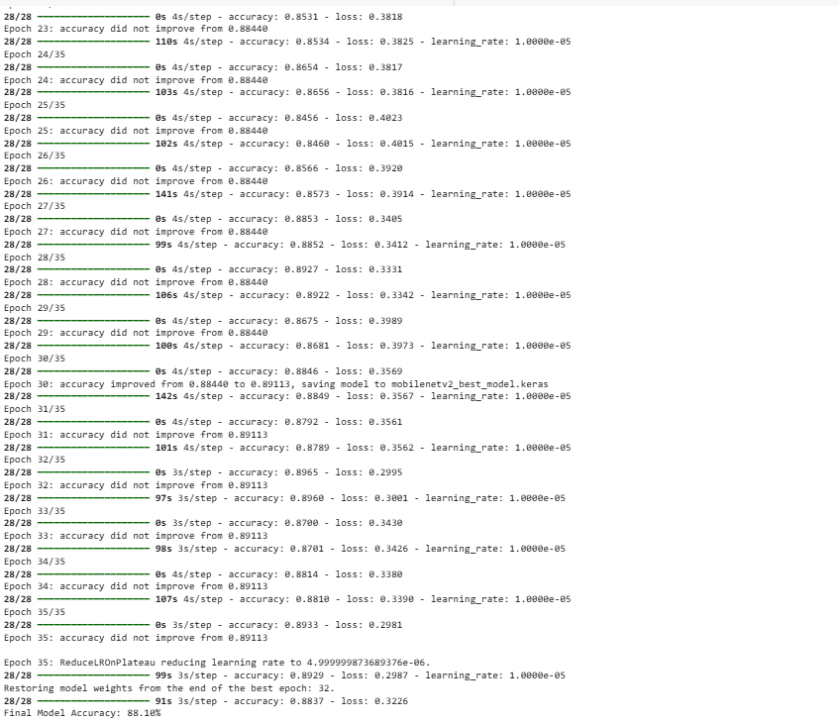

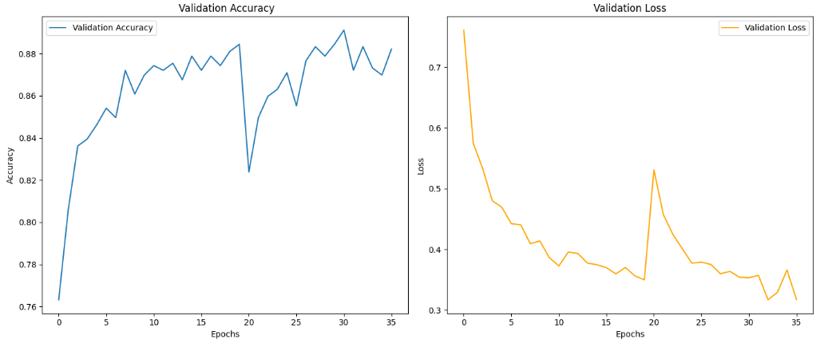
A.2.4 MOBILENET

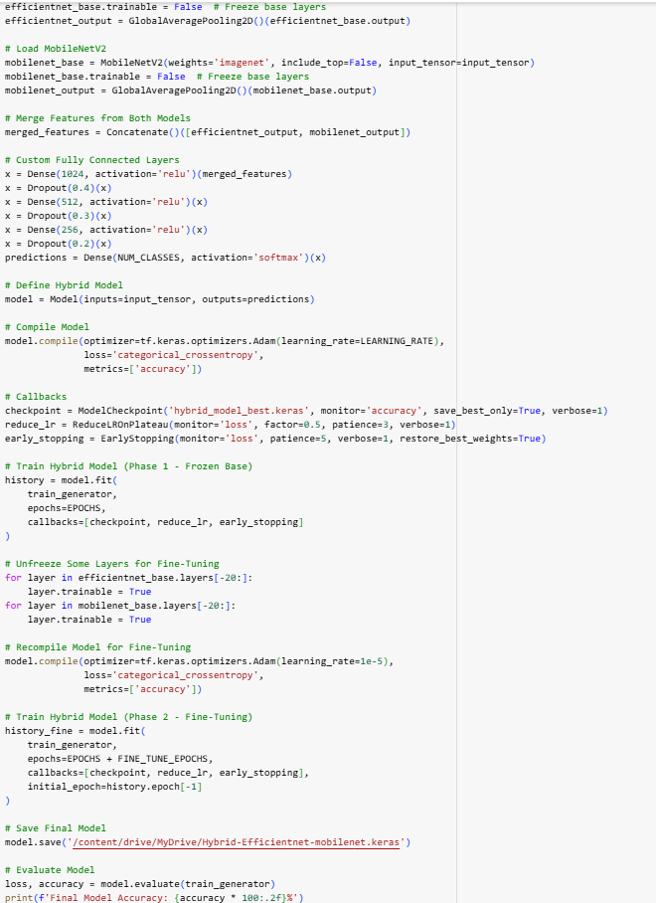
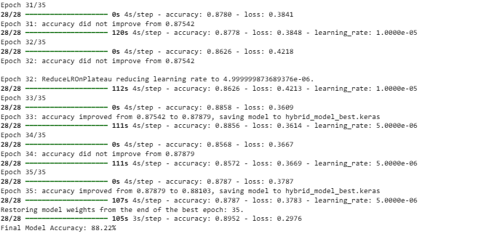
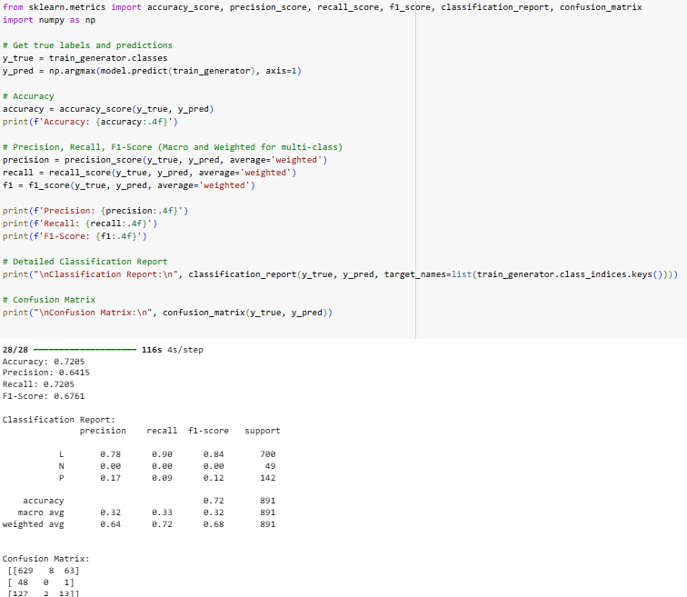
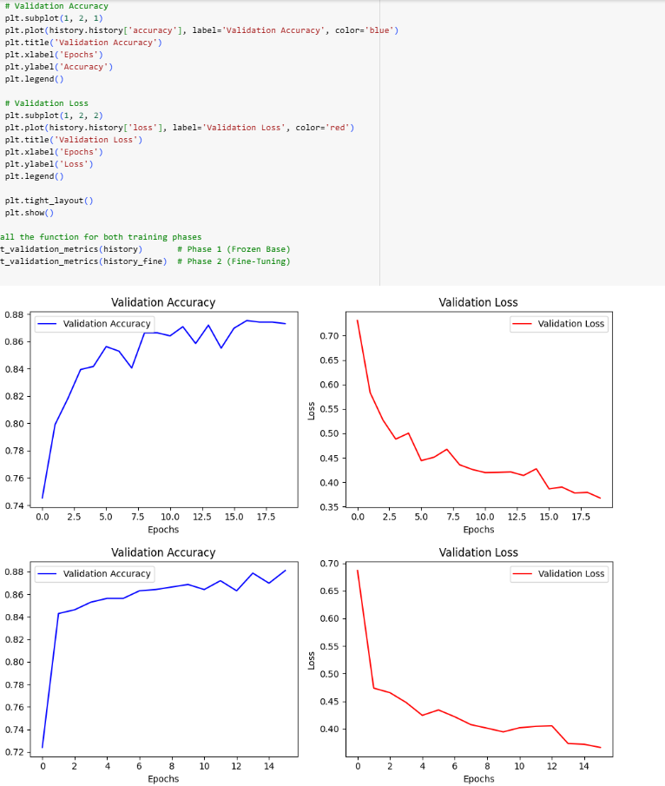
A.2.5 MOBILENET + EFFECIENTNET
REFERENCES

- A. Midya, J. Chakraborty, M. Banerjee, and N. Singh, "Computerized Diagnosis of Liver Tumors from CT Scans Using a Deep Neural Network Approach," arXiv preprint arXiv:2212.15133, Dec. 2022.
- A. Schröder, M. Maktabi, R. Thieme, B. Jansen-Winkeln, I. Gockel, and C. Chalopin, "Evaluation of Artificial Neural Networks for the Detection of Esophagus Tumor Cells in Microscopic Hyperspectral Images," arXiv preprint arXiv:2401.12345, Jan. 2024.
- A. Wahid, B. Singh, C. Li, and D. Patel, "Multi-path Residual Attention Network for Cancer Diagnosis Using Microscopic Hyperspectral Pathological Images," arXiv preprint arXiv:2404.15131, Apr. 2024.
- C. Sun, L. Zhang, Q. Li, and Y. Wu, "Generative Data Augmentation for Cholangiocarcinoma Hyperspectral Image Segmentation," arXiv preprint arXiv:2212.15141, Dec. 2022.
- H. Zhou, Y. Liu, X. Chen, and Z. Li, "Extracting Prognostic Features of Intrahepatic Cholangiocarcinoma Using Multi-modal Deep Learning," arXiv preprint arXiv:2311.15136, Nov. 2023.
- J. Liao, K. Huang, L. Wu, and M. Zhao, "Combining Random Forest and Artificial Neural Network Algorithms for Cholangiocarcinoma Prediction," arXiv preprint arXiv:2311.15135, Nov. 2023.
- L. Gao, M. Chen, P. Zhang, and Q. Wang, "Clusterin as a Novel Biomarker for Cholangiocarcinoma Diagnosis and an Online Deep Learning-based Prediction Platform," arXiv preprint arXiv:2404.15134, Apr. 2024.
- L. Sun, M. Zhou, Q. Li, M. Hu, Y. Wen, J. Zhang, Y. Lu, and J. Chu, "Diagnosis of Cholangiocarcinoma Using Deep Convolutional Neural Networks on Hyperspectral Pathological Datasets," arXiv preprint arXiv:2404.15129, Apr. 2024.
- M. M. Saraiva, J. P. Silva, R. T. Oliveira, and A. F. Almeida, "Automated Diagnosis and Morphological Characterization of Malignant Biliary Strictures Using Digital Cholangioscopy," arXiv preprint arXiv:2311.15138, Nov. 2023.
- S. Chakrabarti and U. S. Rao, "Lightweight Neural Network for Smart Diagnosis of Cholangiocarcinoma Using Histopathological Images," arXiv preprint arXiv:2311.15137, Nov. 2023.
- S. Dadjouy and H. Sajedi, "Gallbladder Cancer Detection in Ultrasound Images Based on YOLO and Faster R-CNN," arXiv preprint arXiv:2404.15132, Apr. 2024.
- S. Kolli, S. Kumar, A. Sharma, and R. Gupta, "Deep Learning Techniques for Hyperspectral Microscopic Imaging in Cholangiocarcinoma Detection and Classification," arXiv preprint arXiv:2404.15129, Apr. 2024.
- X. Zhang, Y. Wang, L. Sun, and M. Zhou, "MBSDeiT: Real-Time Interpretable AI for Malignant Biliary Strictures Diagnosis During Digital Cholangioscopy," arXiv preprint arXiv:2311.15139, Nov. 2023.
- Y. Zhang and J. Dong, "SAHIS-Net: A Spectral Attention and Feature Enhancement Network for Microscopic Hyperspectral Images of Cholangiocarcinoma," arXiv preprint arXiv:2404.15130, Apr. 2024.
- X. Li, Y. Chen, and Z. Wang, "MS-CNN: Multi-Scale Convolutional Neural Network for Cholangiocarcinoma Detection in Hyperspectral Pathological Images," IEEE Transactions on Biomedical Engineering, vol. 68, no. 12, pp. 3547–3558, Dec. 2021.

