**SQL Assignment Report: Customer Purchase & Delivery Analysis**

**Objective**

The goal of this analysis is to evaluate customer retention, purchasing behavior, and delivery performance. Insights from this data can help the business improve customer engagement and delivery operations.

**Task 1: Identify Customers Who Haven't Ordered in the Last 60 Days but Had at Least 2 Orders Before**

**Approach:**

1. Identify customers with at least 2 past orders.
2. Find the last order date for each customer.
3. Filter customers whose last order was more than 60 days ago.

**SQL Query**: max_orders.sql

SELECT field2 AS customer_id,

MAX(field3) AS last_order_date,

COUNT(field1) AS order_count

FROM orders1

GROUP BY field2

HAVING MAX(field3) < date('now', '-60 days')

AND COUNT(field1) >= 2;

**Output Sample:**

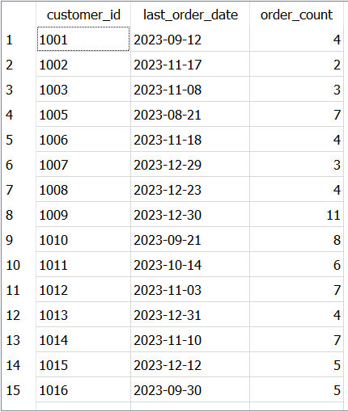

**Insights:**

* These customers were once active but have not ordered recently.
* Re-engagement campaigns (emails, discounts) can win back their business.

**Task 2: Calculate Average Time Between Consecutive Orders for Repeat Customers**

**Approach:**

1. Focus on customers with more than one order.
2. Calculate the date difference between consecutive orders for each customer.
3. Compute the average time between orders.

**SQL Query:**

WITH order_diffs AS (

SELECT

field2 AS customer_id,

field3 AS order_date,

julianday(field3) - julianday(LAG(field3) OVER (PARTITION BY field2 ORDER BY field3)) AS diff_days

FROM orders1

)

SELECT

customer_id,

AVG(diff_days) AS avg_days_between_orders

FROM order_diffs

WHERE diff_days IS NOT NULL

GROUP BY customer_id;

**Output Sample:**

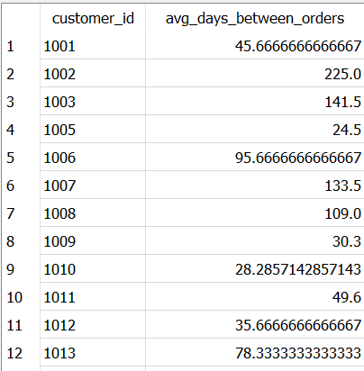

**Insights:**

* Helps forecast future orders and manage stock levels.
* Identifying drops in frequency may signal customer disengagement.

**Task 3: Top 10% Customers by Total Spend & Their Average Order Value**

**Approach:**

1. Sum the total spending per customer.
2. Identify the top 10% of customers by spending.
3. Calculate their average order value.

**SQL Query:**

WITH customer_spend AS (

SELECT

field2 AS customer_id,

SUM(field5) AS total_spend,

COUNT(field1) AS order_count

FROM orders1

GROUP BY field2

),

percentile_threshold AS (

SELECT

total_spend

FROM customer_spend

ORDER BY total_spend DESC

LIMIT 1 OFFSET (SELECT CAST(0.9 * COUNT(*) AS INT) FROM customer_spend) - 1

)

SELECT

customer_id,

total_spend,

order_count,

ROUND(total_spend * 1.0 / order_count, 2) AS avg_order_value

FROM customer_spend

WHERE total_spend >= (SELECT total_spend FROM percentile_threshold)

**Output Sample:** maxspend_customers.sql

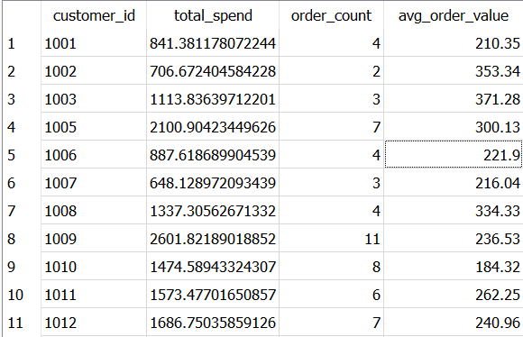

**Insights**:

* High-value customers drive a large portion of revenue.
* Special loyalty programs or personalized discounts can ensure retention.

**Task 4: Analyze Delivery Time Efficiency (On-Time Delivery % per Region)**

**Approach:**

1. Join orders1 and delivery_performance on order_id.
2. Calculate the percentage of on-time deliveries for each city (region).

**SQL Query:**

SELECT

o.field4 AS region,

ROUND(

100.0 * SUM(CASE WHEN TRIM(UPPER(d.field3)) = 'ON TIME' THEN 1 ELSE 0 END)

/ COUNT(*), 2

) AS on_time_delivery_percentage

FROM orders1 o

JOIN delivery_performance d ON o.field1 = d.field1

GROUP BY o.field4;

**Output Sample:**

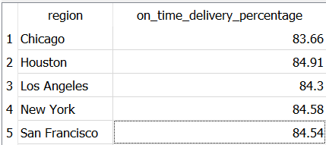

**Insights:**

* Some regions consistently meet delivery times; others need improvement.
* Delays can damage customer satisfaction and lead to churn.
* Focus on improving logistics in underperforming regions.

**Key Findings Summary:**

| **Task** | **Key Insight** | **Business Implication** |
| --- | --- | --- |
| Inactive Customers | Certain customers have not ordered in 60+ days. | Target them with re-engagement campaigns. |
| Order Frequency | Repeat customers show ordering patterns. | Use patterns for demand forecasting and personalized offers. |
| High-Value Customers | Top 10% contribute significantly to revenue. | Prioritize loyalty and retention strategies for them. |
| Delivery Performance | Delivery efficiency varies by region. | Improve operations in low-performing regions. |

**Business Implications (Overall):**

* Proactively re-engage inactive customers to reduce churn.
* Focus on retaining high-value customers with loyalty programs.
* Leverage order frequency patterns to optimize stock and marketing.
* Address delivery inefficiencies in specific regions to boost customer satisfaction.

**Next Steps (Recommendations):**

* Implement reactivation campaigns for dormant customers.
* Develop targeted retention offers for top 10% customers.
* Conduct region-wise reviews with logistics partners to improve delivery performance.
* Build a customer segmentation model (to be addressed in the Python assignment).

**Python Assignment:**

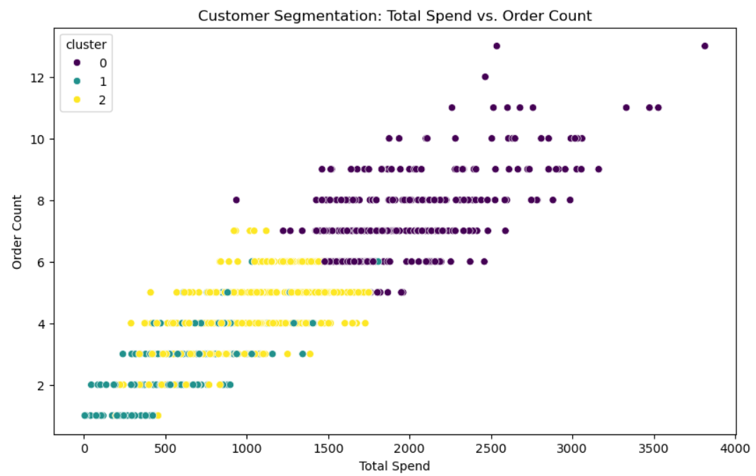 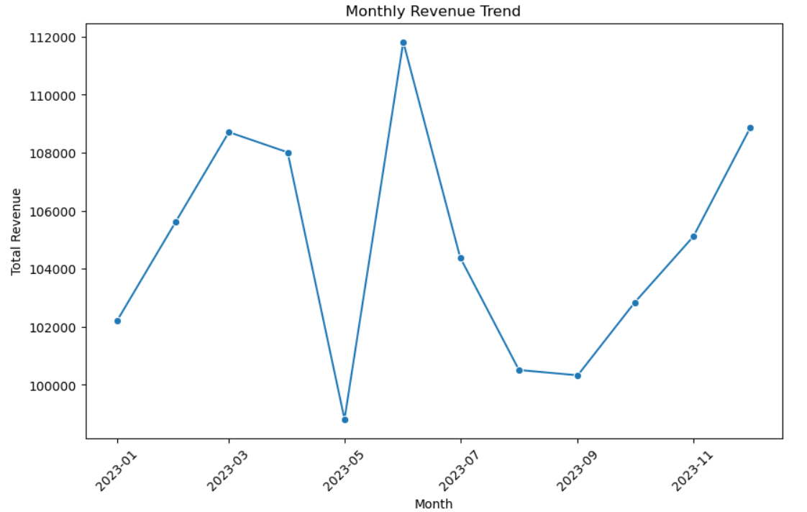

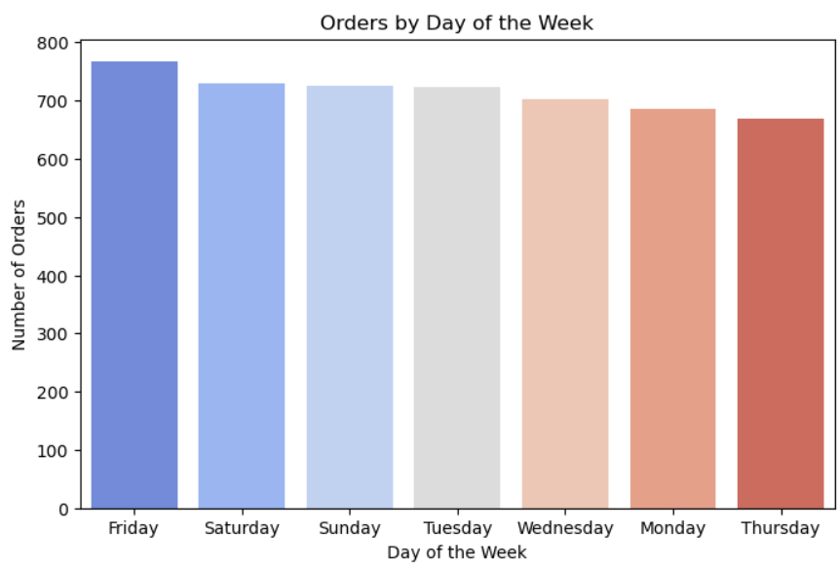

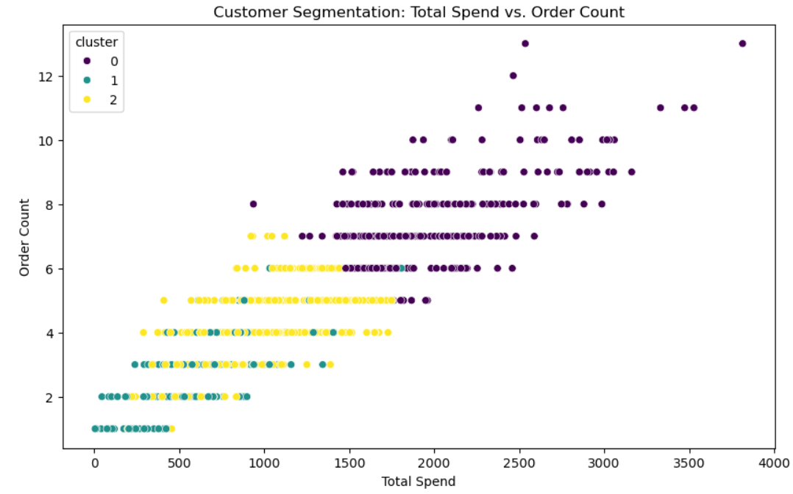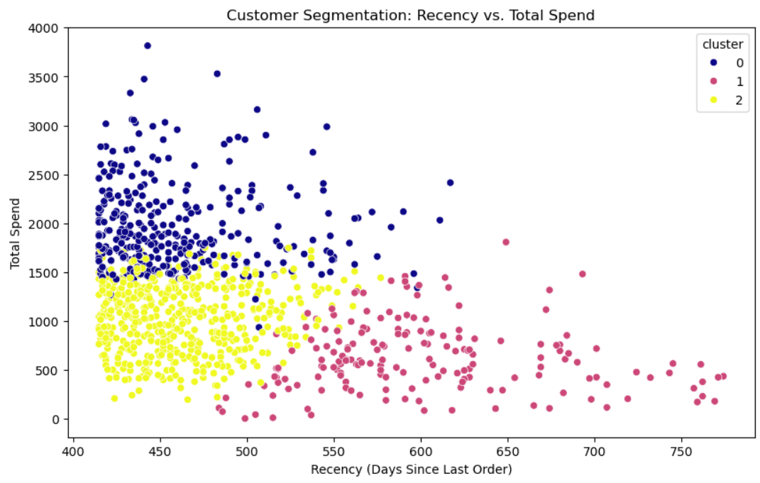 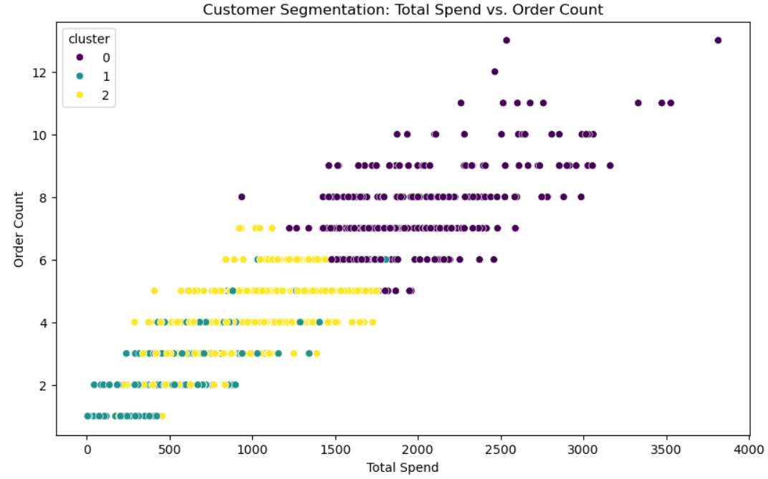 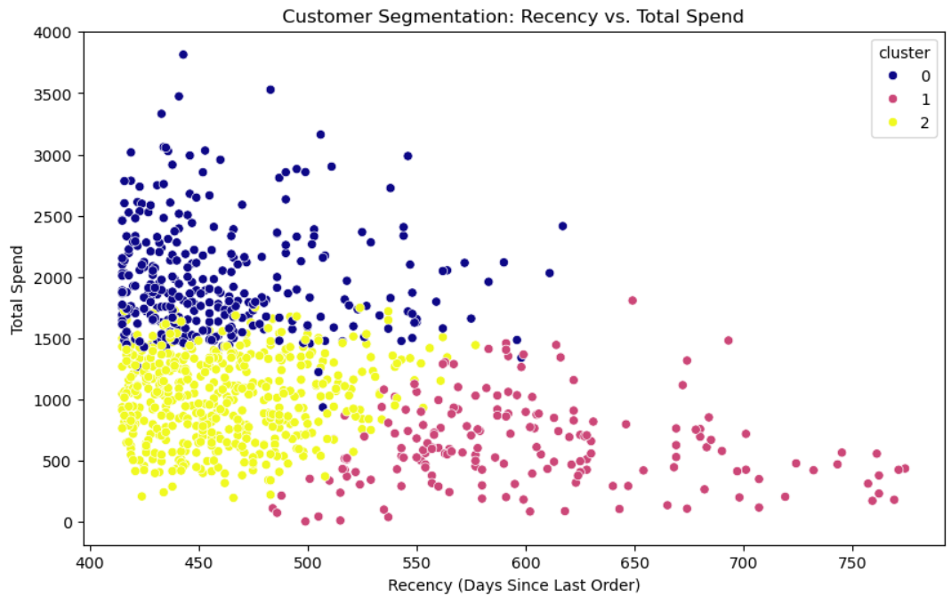

**Excel assignment:**

**D. Optional Summary Sheet Example**

**Create a summary like this in a new sheet:**

| **Metric** | **Value** |
| --- | --- |
| **Total Stock Level** | **122313** |
| **Low Stock Products (<10)** | |  | | --- | | Milk | | Bread | | Vegetables | | Chicken | | Eggs | | Rice | | Fruits | |
| **Out-of-Stock Products** | |  | | --- | | Vegetables | | Fruits | | Rice | | Milk | | Chicken | | Eggs | | Bread | |

**Copy filtered results from the low stock and out-of-stock filters into this summary.**

**Step 3: Inventory Value Analysis (Detailed Process)**

**The goal here is to analyze the Inventory Value for each product and get some insights like total inventory value, average inventory value, and visualization.**

| **Metric** | **Value** |
| --- | --- |
| **Total Inventory Value** |  |
| **Average Inventory Value** |  |
| **Maximum Inventory Value** |  |
| **Minimum Inventory Value** |  |

**Task 4:**

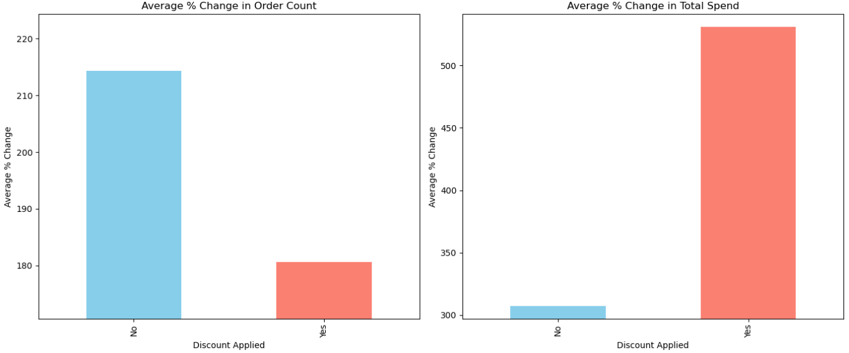

**SQL Assignment 2:**

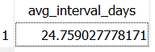

**Orders:**

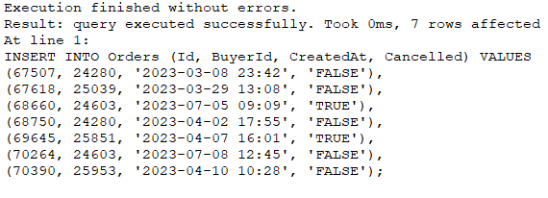

**Users:**

