2ND ROUND ASSIGNMENT

**DOCUMENTATION**

Date: 28 Oct 2020

Source: <https://fastapi.tiangolo.com/>

Topic: FastAPI, Flask

Insights:

**FastAPI**

Installation (cmd line)

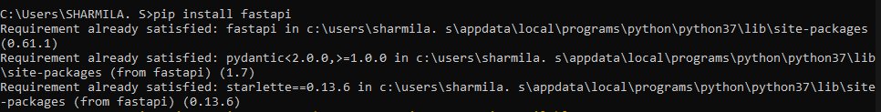

Importing FastAPI



Using FastAPI to perform get request

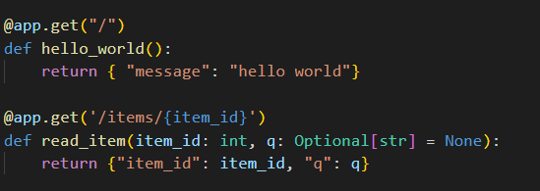

**uvicorn** module is used to detect changes in the file and reloads whenever any change has been detected. It prevents us from running the file again and again while working.

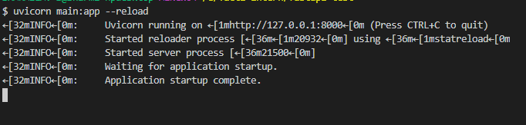

Get request to the root route ‘/’

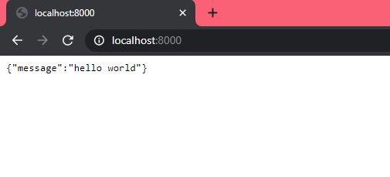

Get request to the custom route ‘/items/{item_id}’

To access values from url parameters, parameter to be accessed is given a variable name which is enclosed within curly braces ( { } ). Values can be accessed within the function definition using the variable name.

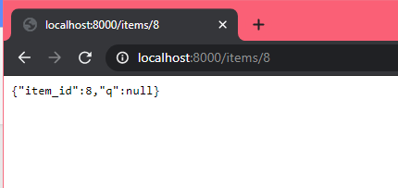

Get request to the custom route ‘/items/{item_id}’ providing optional parameter

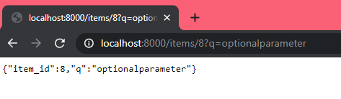

Defining a model for accepting values from body in PUT request

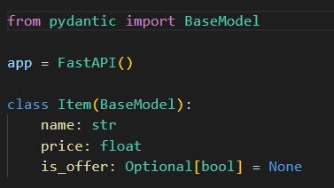

**BaseModel** from **pydantic** is used to define model for the data to be accepted.

For the PUT request, the data submitted from body(here, item{} ) could be received by **update_item** function

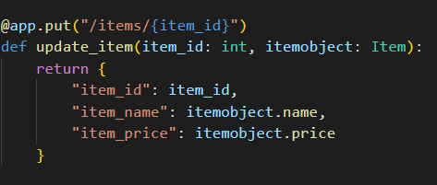

Using Swagger UI ( localhost:8000/docs ) PUT request could be tested.

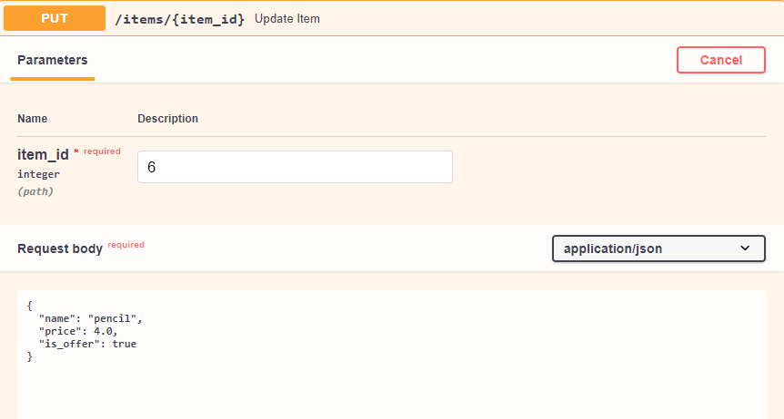

Response received:

{ "item_id": 6, "item_name": "pencil", "item_price": 4 }