RESUME
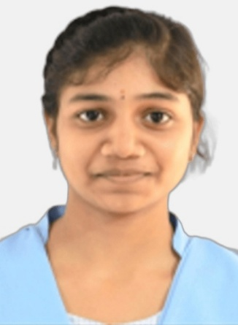
SHARMILA GUBBALA
+91 9391694652
 gubbalasharmila999@gmail.com
Andhra Pradesh , India
CAREER OBJECTIVE :
Motivated and detail-oriented graduate seeking an entry-level position where I can apply my technical knowledge, problem-solving skills, and strong work ethic to contribute to organization growth while enhancing my professional skills.
SKILLS:
TECHNICAL SKILLS
- Basic Python & C Programming
- Java Programming
- HTML & CSS
- Basic AWS
SOFT SKILLS:

- Communication Skills
- Teamwork
- Leadership Qualities
- Time Management
EDUCATION:
- Bachelor of Computer Science, Aditya Degree College, Amalapuram, 2023-Pursuring, CGPA: 8.5
- Senior Secondary (12th), Board of Intermediate Education AP | 2023, Percentage:89.7%
- Secondary(10th), Board of Secondary Education AP | 2021, Percentage:95%
PROJECTS:
Project1: My Portfolio Website
- Developed a responsive personal portfolio website using HTML, CSS, and JavaScript to showcase projects, skills, and experience. Implemented modern UI design principles, interactive elements, and cross-browser compatibility to enhance user experience.
Project2: Food Delivery App
- Developed a full-stack food delivery application using the MERN stack (MongoDB, Express.js, React.js, Node.js) with features including user authentication, restaurant listings, cart management, and order processing. Implemented RESTful APIs and ensured seamless front-end and back-end integration.
CERTIFICATIONS:
- Python Essential 1&2
- Hackthon- Adhoc Tech
- MepPro English Proficiency Certification
LANGUAGES KNOWN:
- English
- Telugu

