**1.15 FIND LARGE GROUPS IN A STRING**

**AIM**:

To identify large groups (3 or more consecutive identical characters) in a string s and return their intervals [start, end].

**ALGORITHM:**

1.Initialize result = [].

2. Use two pointers:

• i = start index of a group.

• Traverse the string with j.

3. While traversing:

• If s[j] != s[i], it means the group ended at j-1.

• Check if group length (j-1 - i + 1) >= 3.

• If yes → append [i, j-1] to result.

• Update i = j (start new group).

4. After loop ends, check the last group as well.

5. Return result.

**PROGRAM:**

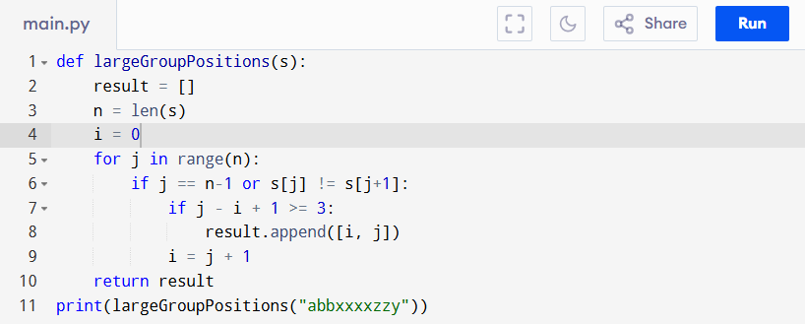

Input:

s = "abbxxxxzzy"

Output:

**RESULT:**

Thus the program is successfully executed, and the output is verified.

**PERFORMANCE ANALYSIS:**

• Time Complexity: O(n) (one pass through string).

• Space Complexity: O(1) (excluding result storage).