**1.16 CONWAY’S GAME OF LIFE – NEXT STATE OF THE GRID**

**AIM**:

To compute the next state of an m x n grid based on the rules of Conway’s Game of Life, where each cell updates simultaneously depending on its neighbors.

**ALGORITHM:**

1. Create a copy of the board (since updates are simultaneous).

2. For each cell (i, j):

• Count live neighbors (check 8 possible directions).

• Apply the four rules to determine its next state.

3. Update the original board with computed values.

4. Return the updated board.

**PROGRAM:**

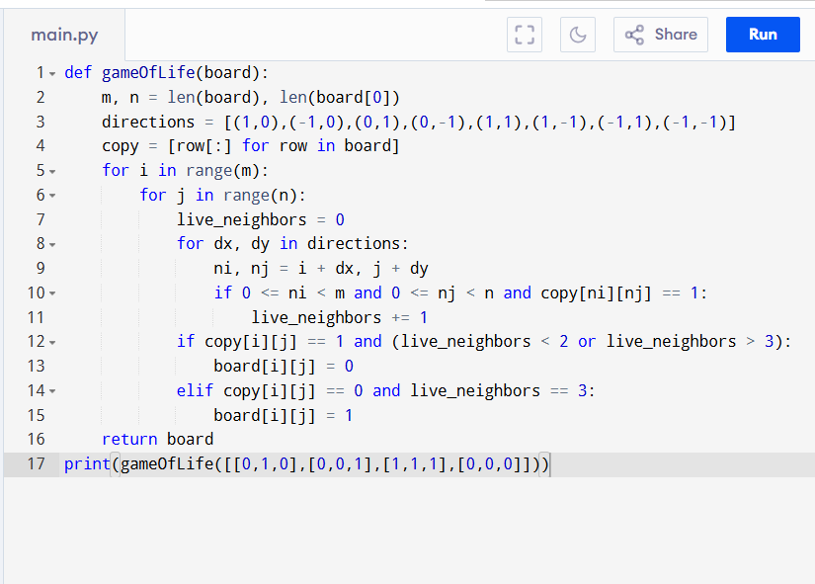

Input:

board = [[0,1,0],

[0,0,1],

[1,1,1],

[0,0,0]]

Output:

**RESULT:**

Thus the program is successfully executed, and the output is verified.

**PERFORMANCE ANALYSIS:**

• Time Complexity: O(m * n) → each cell is visited once, checking 8 neighbors.

• Space Complexity: O(m * n) if using a copy, or O(1) if updating in-place with state markers.